Lesson 4

Objective: Make a ten to add and subtract within 20.

Suggested Lesson Structure

 Fluency Practice (15 minutes)

 Concept Development (25 minutes)

 Application Problem (10 minutes)

 Student Debrief (10 minutes)

**Total Time (60 minutes)**

Fluency Practice (15 minutes)

* Take from Ten **2.OA.2** (5 minutes)
* Make a Ten to Add **2.OA.2** (6 minutes)
* Say Ten Counting from 25 to 9 **2.NBT.1** (4 minutes)

Take from Ten (5 minutes)

Materials: (S) Personal white boards

Note: Take from Ten develops the automaticity necessary to subtract fluently from the ten when subtracting from the teens.

T: When I say 1, you say 9, because the game is to take the number I say from 10. Ready? 2.

S: 8.

Continue with the following sequence: 3, 6, 5, and 9.

T: This time, after you say how many are left, write the number sentence on your personal white board. 5.

S: 5.

S: (Write the number sentence on their boards.)

T: Show the number sentence.

S: (Show 10 – 5 = 5.)

Continue with the following possible sequence: 7, 8, 6, 9, and 4.

Make a Ten to Add (6 minutes)

|  |  |
| --- | --- |
|  | NOTES ON  MULTIPLE MEANS OF ENGAGEMENT: |

Support oral responses for Make a Ten to Add by providing personal white boards and ten-frames to students as needed. Draw a ten-frame on the board so students can visualize the ten being made.

|  |  |  |  |  |
| --- | --- | --- | --- | --- |
| O | O | O | O | O |
| O | O | O | O | X |

X

9 + 2 = 10 + 1

Note: Reviewing making ten allows students to add within the teens during the lesson and see the distinction.

T: Let’s make ten to add. I say 9 + 2, and you say   
9 + 2 = 10 + 1. Ready? 9 + 2.

S: 9 + 2 = 10 + 1.

T: Answer?

S: 11.

T: 9 + 5.

S: 9 + 5 = 10 + 4

T: Answer?

S: 14.

Continue with the following possible sequence: 9 + 7; 9 + 6;   
9 + 8; 8 + 3; 8 + 7; 7 + 4; and 7 + 6.

Say Ten Counting from 25 to 9 (4 minutes)

Materials: (T) Hide Zero cards (Lesson 2 Template 1), Rekenrek

Note: Today’s lesson involves using basic sums and differences within ten to solve problems in the teens that do not cross the ten. This relies on a solid grasp of the structure of ten.

T: (Show 12 with Hide Zero cards.) 2 more than 10, not in Say Ten way?

S: 12.

[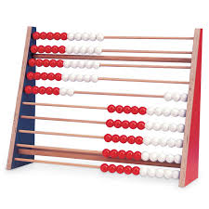](http://www.google.com/imgres?hl=en&biw=1476&bih=588&tbm=isch&tbnid=kiYDJDizmYMxMM:&imgrefurl=http://www.enasco.com/product/TB22814J&docid=fBt2svwX6gYduM&imgurl=http://www.enasco.com/prod/images/products/05/AC045101l.jpg&w=600&h=600&ei=JOJqUaD1GpHqiQKFxIGICw&zoom=1&ved=1t:3588,r:30,s:0,i:185&iact=rc&dur=1133&page=2&tbnh=148&tbnw=157&start=16&ndsp=25&tx=94&ty=77)T: (Pull cards apart.) The Say Ten way to say 12?

S: 1 ten 2.

T: (Show 13.) What is the Say Ten way for 13?

S: 1 ten 3.

T: (Pull cards apart.) That’s right!

T: Let’s count the Say Ten way starting from 25 on the Rekenrek. As I move the beads, count aloud. What is the Say Ten way for 25?

S: 2 tens 5.

Show 25 with beads pulled to the left on the Rekenrek.

S: 2 tens 5, 2 tens 4, 2 tens 3, 2 tens 2, 2 tens 1, 2 tens, 1 ten 9, 1 ten 8, 1 ten 7, 1 ten 6, 1 ten 5, 1 ten 4, 1 ten 3, 1 ten 2, 1 ten 1, 1 ten, 9.

Concept Development (25 minutes)

Materials: (T) Two-sided counters and a ten-frame card showing 10 (Lesson 3 Template)   
(S) 1-ten-strip (Template) and 10 two-sided counters per student

Note: Two-sided counters can be any available objects that allow students to see two distinct parts (e.g., linking cubes in two different colors, spray painted beans, two-color counters). Prior to the lesson, cut out 1 ten-strip per student from the template.

Part 1: Adding within the teens.

Present three counters in one set and two in another directly to the right.

T: What addition sentence combines these two sets?

**13 + 2 = 15**

**/ \**

**10 3**

**3 + 12 = 15**

**/ \**

**2 10**



S: 3 + 2 = 5.

Place a ten-frame card next to the three ones.

T: What is 10 + 3 + 2?

S: 15.

T: What is 13 + 2?

S: 15.

T: (Move the ten-frame card next to the 2.)   
What is 3 + 10 + 2?

S: 15.

T: What is 3 + 12?

S: 15.

T: (Write 13 + 2 = 15 and 3 + 12 = 15.) Discuss with your partner why these addition sentences have the same answer. Use our model to help you.

S: Both are equal to 10 + 5. 🡪 Both used the same basic fact in the ones, 3 + 2 = 5.

T: Discuss with your partner what our friend might mean by *basic fact*.

S: We learned 3 + 2 in Kindergarten so it’s basic. 🡪 We already know how to do it. 🡪 Yeah, but it helps us solve other problems.

T: Yes! Even fourth-grade problems like 3 sevenths + 2 sevenths! Or, 3 million + 2 million.

T: (Pass out ten-strips and two-sided counters.)

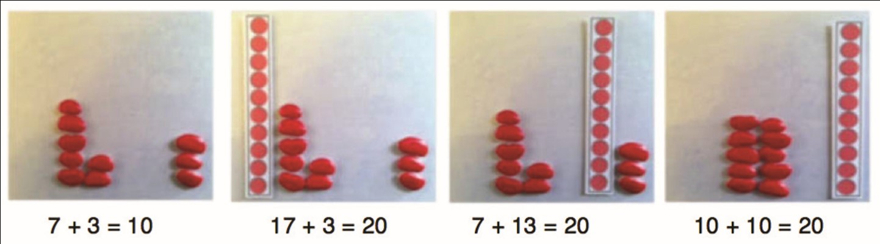Have students work in pairs. Both show 7 + 3. Then Partner A models 17 + 3 and Partner B models 7 + 13 (see picture below). As students recognize that the ones equal 10, move on to paper and pencil work.

T: Talk with your partner and compare 13 + 7 = 20 and 17 + 3 = 20.

S: They both have a 3 and a 7 in the ones place. 🡪 3 and 7 make another ten. 🡪 It’s just like the last problem we did. The ones digits are switched but the answer is the same.

T: Write at least one set of similar problems.

Circulate and choose two students’ work, one that completes the ten and one that does not, but does show the associative and commutative properties.

S: 12 + 8 and 18 + 2. 🡪 12 + 4 = 16 and 14 + 12 = 26.

T: (Record on board.) Excellent choices.

S: But the second doesn’t use a basic fact that equals ten!

T: Charles, can you defend your response?

**MP.3**

S: I think it is the same, because both problems show the switch around in the ones place.

S: Yeah, both pairs use one basic fact.

S: The teacher didn’t say exactly what had to be the same. Charles just didn’t make a ten.

T: Is he wrong or right? Discuss it with your partner.

Part 2: Subtracting within the teens.

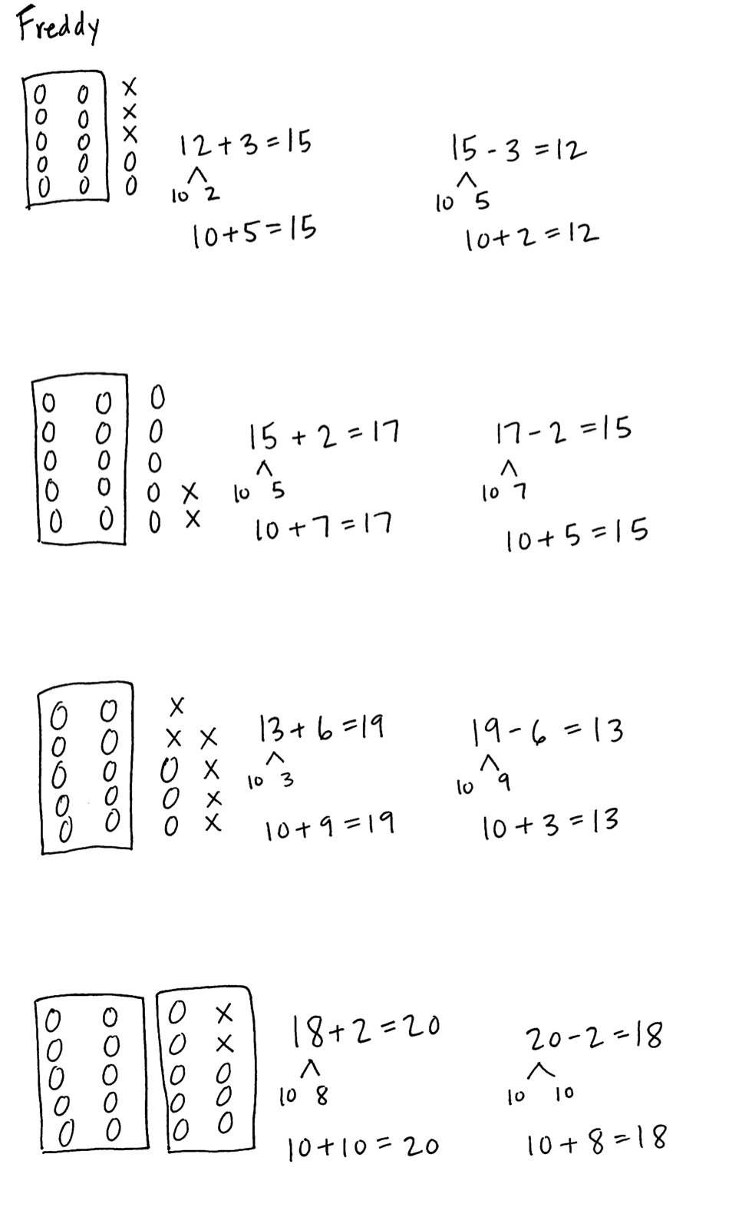Present five counters in one column.

T: What subtraction sentence takes away this set   
(cover 3 red)?

S: 5 – 3 = 2.

T: (Place a ten-frame card next to the five counters.)

T: What is 10 + 5 – 3? Subtract 3 from 5 first because there are enough ones in the ones place!

T: 5 – 3 is…?

S: 2.

T: 10 + 2 is…?

S: 12.

T: What is 15 – 3…?

S: 12.

T: (Write 10 + 2 = 12 and 15 – 3 = 12.) Show using a picture why these number sentences have the same answer.

S: The 2 is what is left after you take away 3 ones from 5 ones. 🡪 Cover up the tens. It says 5 – 3 is 2. Then, just add the ten again. 🡪 It’s using a basic fact.

T: We can take 3 from the ones because there are enough ones. What if we had 15 – 6? Do we have enough ones then?

S: No!

T: With your partner, come up with at least two examples where there are not enough ones to subtract from the ones.

Part 3: Adding and subtracting within the teens

Note: In this final activity the two concepts of addition and subtraction come together using a part–whole model to represent related facts.

T: (Model the problems 12 + 3 = 15 and 15 – 3 = 12 with a ten-frame card and number bonds.)

T: What basic addition fact is related to 12 + 3 = 15?

Repeat with the following problems: 15 + 2 = 17, 17 – 2 = 15; 13 + 6 = 19, 19 – 6 = 13; 18 + 2 = 20, 20 – 2 = 18.

Problem Set (10 minutes)

|  |  |
| --- | --- |
|  | NOTES ON  APPLICATION PROBLEMS: |
| These are the four steps of the problem-solving process:   1. Read. 2. Draw. 3. Write a sentence. 4. Write a word sentence.   This process provides accommodation for SWD and English language learners students since it is both visual and kinesthetic. The exemplar of MP.2 to the left is a guided process, which also certainly supports the same subgroups.  To challenge advanced students, consider assigning them Problem 2 instead of engaging them in guided practice for Problem 1. | |
|  | |

Students should do their personal best to complete the Problem Set within the allotted 10 minutes. For some classes, it may be appropriate to modify the assignment by specifying which problems they work on first. Some problems do not specify a method for solving. Students should solve these problems using the RDW approach used for Application Problems.

Application Problem (10 minutes)

Problem 1

Melia and Maya both love animals. Melia counted 17 puppies in one cage at the animal shelter and 3 in another cage. Maya counted 13 kittens in one cage and 7 in another.

1. How many kittens are there in all?
2. How many puppies are there in all?
3. Write a sentence comparing the number of puppies and kittens.

Problem 2

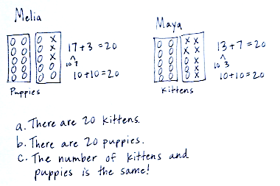Melia and Maya both love animals. Melia counted 47 puppies in one cage at the animal shelter and 3 in another cage. Maya counted 43 kittens in one cage and 7 in another.

1. How many animals are there in all?
2. Explain how you know using a drawing, number sentences, and word sentences.

Note: Problem 2 is designed for students who do not require guided practice. Both problems are an application of today’s lesson, in which students added the basic facts in the ones place to add within 20.

The intention of this lesson is for students to use number bonds and arrive at 10 + 3 + 7 = 10 + 10 and   
10 + 7 + 3 = 10 + 10. Help them notice the commutative property in these equations, since G2–M1–Lesson 3 focused on the associative property.

To demonstrate the commutative property, call on three students to stand in a line. Have them switch positions, and then elicit from students that no matter what position they are in, they are still the same three students.

Student Debrief (10 minutes)

|  |  |
| --- | --- |
|  | NOTES ON  MULTIPLE MEANS OF REPRESENTATION: |

During the Debrief, students use personal white boards to write related problems. Students working above grade level can be challenged to write as many problems as possible in a time frame. Give these students a purpose by placing extra problems in a bonus box to be used for future homework assignments, with credit given to the author.

**Lesson Objective:** Make a ten to add and subtract within 20.

The Student Debrief is intended to invite reflection and active processing of the total lesson experience.

Invite students to review their solutions for the Problem Set. They should check work by comparing answers with a partner before going over answers as a class. Look for misconceptions or misunderstandings that can be addressed in the Debrief. Guide students in a conversation to debrief the Problem Set and process the lesson.

You may choose to use any combination of the questions below to lead the discussion.

* Talk to your partner and write a problem related to   
  17 + 3 on your personal board.

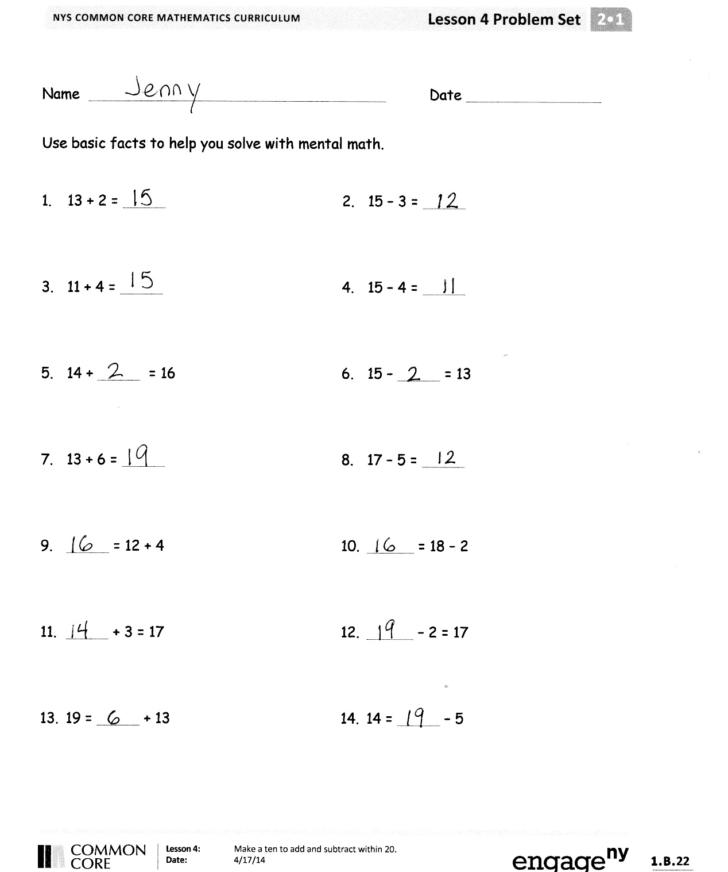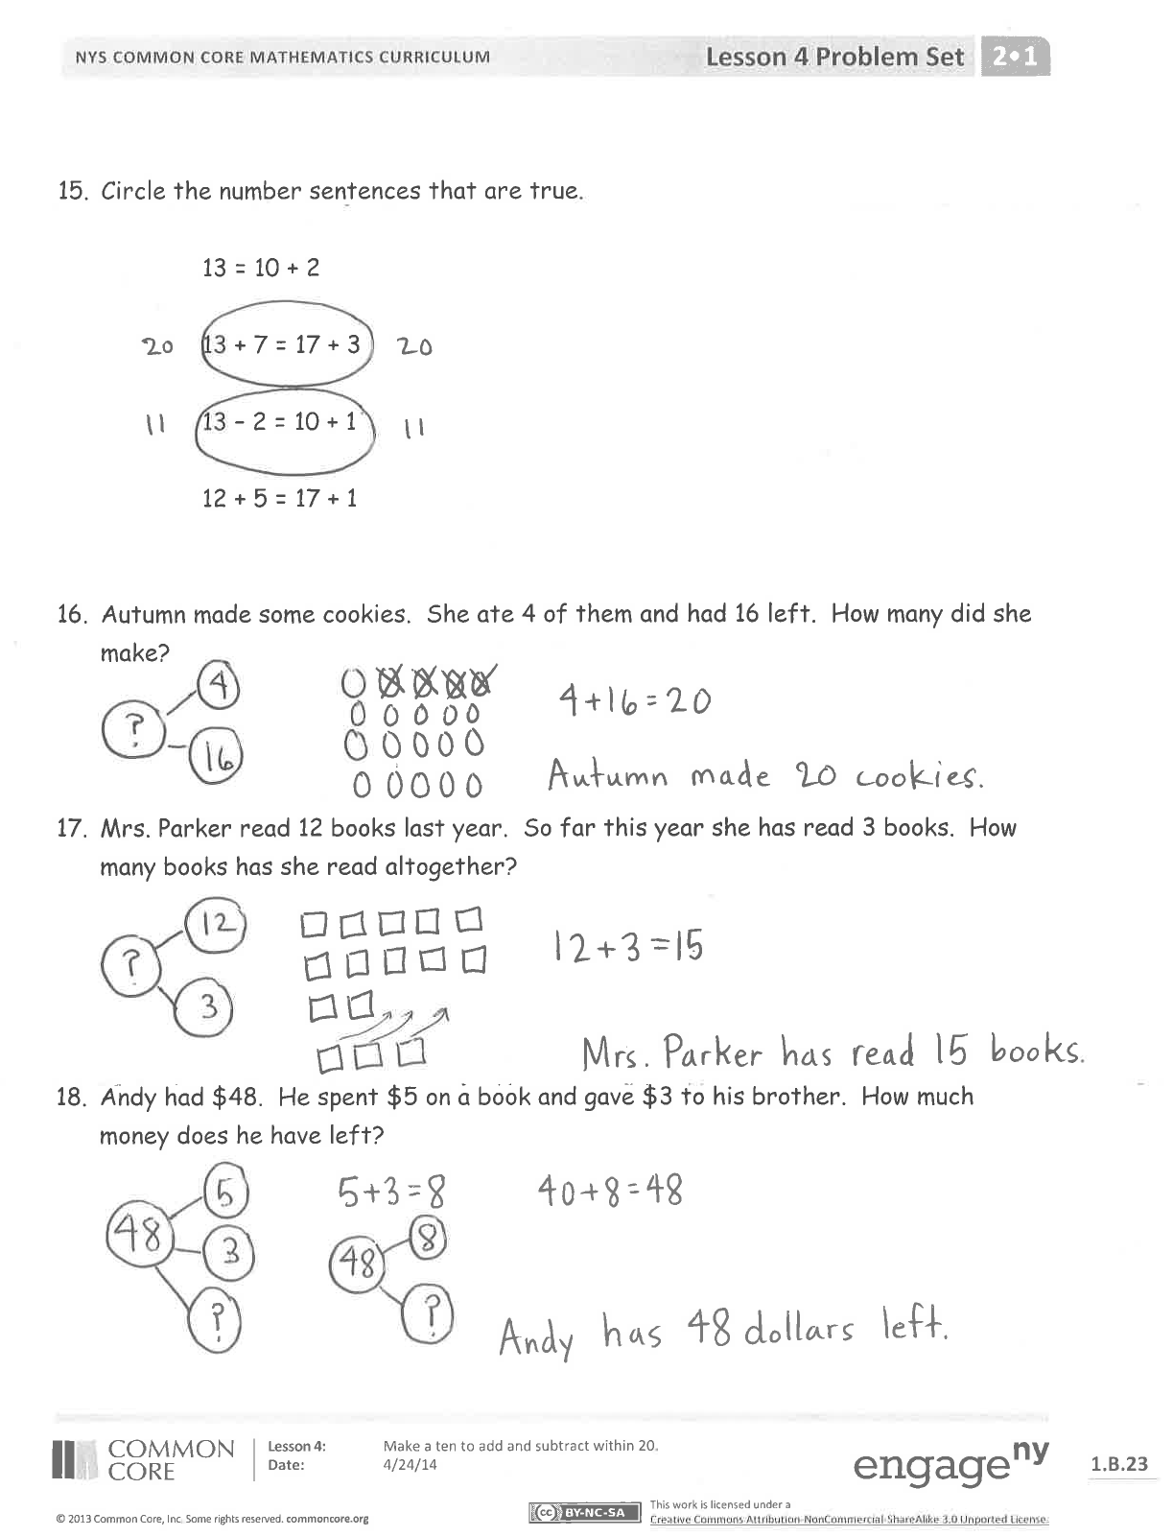

* Talk to your partner and write a problem related to 16 – 2 on your personal board.
* Look at the first page of the Problem Set. Talk to your partner about any connections you notice between the problems.
* Talk to your partner about what you think our lesson’s focus is today.

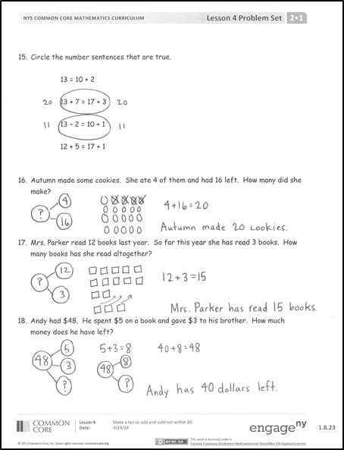Exit Ticket (3 minutes)

After the Student Debrief, instruct students to complete the Exit Ticket. A review of their work will help you assess the students’ understanding of the concepts that were presented in the lesson today and plan more effectively for future lessons. You may read the questions aloud to the students.

Name Date

Use basic facts to help you solve with mental math.

|  |  |
| --- | --- |
| 1. 13 + 2 = | 1. 15 – 3 = |
| 1. 11 + 4 = | 1. 15 – 4 = |
| 1. 14 + = 16 | 1. 15 – = 13 |
| 1. 13 + 6 = | 1. 17 – 5 = |
| 1. = 12 + 4 | 1. = 18 – 2 |
| 1. + 3 = 17 | 1. – 2 = 17 |
| 1. 19 = + 13 | 1. 14 = – 5 |

1. Circle the number sentences that are true.

13 = 10 + 2

13 + 7 = 17 + 3

13 – 2 = 10 + 1

12 + 5 = 17 + 1

1. Autumn made some cookies. She ate 4 of them and had 16 left. How many did she make?
2. Mrs. Parker read 12 books last year. So far this year she has read 3 books. How many books has she read altogether?
3. Andy had $48. He spent $5 on a book and gave $3 to his brother. How much money does he have left?

Name Date

Solve the problems. Write the basic fact that helps you solve each one. The first one is done for you.

1. 14 – 1 = 13

Basic Fact: 4 – 1 = 3

1. 14 + 1 =

Basic Fact:

1. 15 + 3 =

Basic Fact:

1. 18 + 2 =

Basic Fact:

1. 17 – 6 =

Basic Fact:

1. 19 + 7 =

Basic Fact:

1. 16 + 4 =

Basic Fact:

1. 12 + 8 =

Basic Fact:

Name Date

Use basic facts to help you solve with mental math.

|  |  |
| --- | --- |
| 1. 16 + 3 = | 1. 13 – 6 = |
| 1. 4 + 15 = | 1. 14 + 5 = |
| 1. 7 + 11 = | 1. 17 + 1 = |
| 1. 17 + 3 = | 1. 13 + 7 = |
| 1. 14 – 4 = | 1. 18 – 8 = |
| 1. 19 – 3 = | 1. 18 – 4 = |
| 1. 16 – 3 = | 1. 17 – 5 = |

1. Circle the number sentences that are true.

17 = 12 + 5

14 + 4 = 13 + 3

11 – 7 = 17 + 1

12 + 5 = 15 + 2

16. Vinny caught 12 baseballs during the first game of the day.  He caught some more during the second game of the day.  If he caught 19 baseballs during both games, how many baseballs did he catch in the second game?

1. Draw ten-frame cards to explain why 14 + 2 = 12 + 4.

[1] 

1. ten-strips