Lesson 3

Objective: Make a ten to add within 20.

Suggested Lesson Structure

 Fluency Practice (15 minutes)

 Concept Development (30 minutes)

 Application Problem (5 minutes)

 Student Debrief (10 minutes)

**Total Time (60 minutes)**

Fluency Practice (15 minutes)

* Break Apart and Put Together by Place Value **2.OA.2** (2 minutes)
* Take Out a Part: Numbers Within Ten **2.OA.2** (2 minutes)
* Pairs to Make Ten with Number Sentences **2.OA.2** (2 minutes)
* Sprint: One More, Ten More **2.OA.2** (9 minutes)

Break Apart and Put Together by Place Value (2 minutes)

Note: Students remember the relevance of their ten plus facts to larger numbers.

T: When I say 10 + 5, you say 15. Ready?

T: 10 + 5.

S: 15.

T: 10 + 2.

S: 12.

Continue with the following possible sequence: 10 + 9, 10 + 4, 20 + 4, 50 + 4, 30 + 8, and 70 + 8.

T: How are 10 + 4 and 50 + 4 the same? How are they different?

T: How is knowing that helpful?

S: (Share.)

T: Now, when I say 13, you say 10 + 3.

T: 13.

S: 10 + 3.

Continue with the following possible sequence: 17, 11, 16, 18, 28, 78, 14, 34, and 94.

Take Out a Part: Numbers Within Ten (2 minutes)

Note: Taking out 1 prepares students for adding 9. The students make a ten, adding 9 and 6 by adding 9 and 1 and 5. Taking out 2 prepares students for adding 8. The students make a ten, adding 8 and 6 by adding 8 and 2 and 4.

T: Let’s take out 1 from each number. I say 5. You say 1 + 4.

T: 5. Get ready.

S: 1 + 4.

T: Now, let’s take out 2. If I say 6, you say 2 + 4.

T: 3.

S: 2 + 1.

Continue with the following possible sequence: 5, 10, 4, 7, 9, 8, and 6.

Pairs to Make Ten with Number Sentences (2 minutes)

Materials: (S) Personal white boards

Note: This is a foundational skill for mastery of sums and differences to 20.

T: I’ll say a number and you write the addition sentence to make 10 on your personal white board.

T: 5. Get ready. Show me your board.

S: (Show 5 + 5 = 10.)

|  |  |
| --- | --- |
|  | NOTES ON  MULTIPLE MEANS OF ACTION AND EXPRESSION: |
| Some students may require extended time for Sprints:   * Create a differentiated Sprint for students whose IEPs warrant extra time by eliminating the last five problems. * Extend time for the task based on individual student needs. * Focus on goals for accomplishment within a time frame. * Give students the opportunity to practice the Sprint beforehand at home to help them remain calm and confident during the timed task. | |

T: 8. Get ready. Show me your board.

S: (Show 8 + 2 = 10.)

Continue with the following possible sequence: 9, 1, 0, 10, 6, 4, 7, and 3.

T: What pattern did you notice that helped you solve the problems?

S: You can just switch the numbers around! 🡪 If you say 8 and the answer is 8 + 2 = 10, then I know that when you say 2 the answer will be 2 + 8 = 10. 🡪 The numbers can switch places!

Sprint: One More, Ten More (9 minutes)

Note: In order to be flexible with adding and subtracting one unit, students first work with 1 more and 10 more.

Materials: (S) One More, Ten More Sprint

Concept Development (30 minutes)

Materials: (T) Two-sided counters (S) Personal white boards, blank paper, ten-frame cards for numbers 8, 9, and 10 (Template), small bag of two-sided counters

Part 1: Making ten from a large common addend (e.g., solving 9 + 4, 9 + 5, 8 + 4, 8 + 5).

Note: Two-sided counters can be any available objects that allow students to see two distinct parts (e.g., linking cubes, spray painted beans, two-color counters). Call students to the carpet and as you move the counters, leave them as shown below so that students can compare solutions.

T: (Present 9 counters in one set and 4 in another set directly to the right, as shown below.)

T: How many are here (signaling the set of 9)?

**9 + 4 = 13**

**/ \**

**1 3**

**9 + 5 = 14**

**/ \**

**1 4**

**9 + 4 = 13**

**10 + 3 = 13**

S: 9.

T: How many are here (signaling the set of 4)?

S: 4.

T: (Move a counter from the 4 to complete the ten.)

T: (Point to the new ten.) How many are here?

S: 10.

T: (Point to the 3 counters.) How many are here?

S: 3.

T: Give an expression that combines these 2 sets?

S: 10 + 3.

T: That’s right. You probably remember from first grade that when you just say 10 + 3 without saying what it equals, we call it an expression. It’s not a full number sentence.

**9 + 5 = 14**

**10 + 4 = 14**

T: Now, give the addition number sentence.

S: 10 + 3 = 13.

T: (Move the 1 back to the original set of 4.)

T: What addition sentence combines these two sets?

S: 9 + 4 = 13.

T: (Repeat the process immediately with 9 + 5.)

T: Turn and talk to your partner to compare 9 + 4 and 9 + 5. (The goal is for students to look for and make use of structure as they complete the unit of ten and add on the ones that are left over.)

S: Both number sentences start with 9. 🡪 I gave 1 to the 9 to make 10. 🡪 For both problems you can make a ten and just add the extra ones.

T: (After the students have analyzed the problems, numerically record the make ten solutions using the number sentences and bonds shown above.)

T: On your personal white boards, draw 8 circles in a ten-frame format.

S: (Draw 8 circles, as shown right.)

T: Draw 4 crosses by completing the ten first. Draw the extras to the right.

S: (Draw 4 crosses, as shown right.)

T: How much more does 8 need to make 10?

S: 2 more.

T: And, how many are remaining to add to 10?

S: 2.

T: 8 + 4 is…?

S: 12.

T: 10 + 2 is…?

S: 12.

T: Record the make ten solution to 8 + 4 with number bonds to show that you broke 4 into 2 and 2 to make ten.

**MP.7**

T: (Continue with 8 + 5.)

T: Show your work to your partner and tell what you notice about adding to 8.

T: (Wait for students to repsond.) Do you remember what you noticed about adding to 9? How are 9 + 4 and 8 + 4 the same and different? Use your linking cubes or your drawing to explain.

S: You have to make 10 with both. 🡪 We used 2 to make 10 when we added to 8, and 1 to make 10 when we added to 9. 🡪 We bonded 4 as 1 and 3 and 2 and 2.

The pencil and paper work below might follow directly after students have engaged with the teacher by

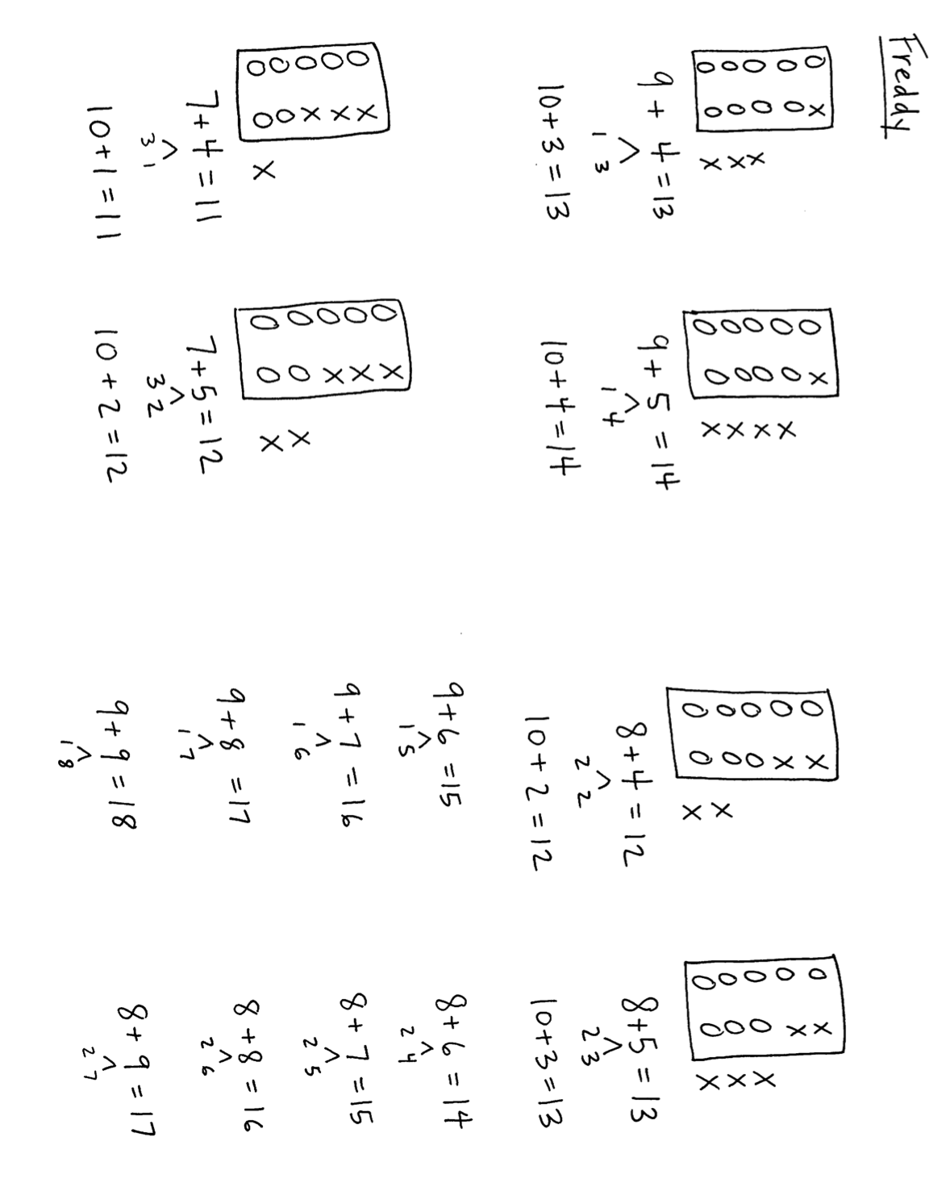working on their personal white boards solving 8 + 4 and 8 + 5.



T: I don’t want you to always need to draw as you solve these problems. Fold your paper so that you

are only looking at the number sentences of 9 + 4 and 9 + 5. (Pause as students do so.)

T: Looking only at the number sentences, talk to your partner about the meaning of each number.

What does 9 refer to as you remember the picture? 4? The bond of 1 and 3? The 13? 10 + 3?

T: Now look at your list of nines facts. Do you notice a pattern that will help you get better at remembering these sums quickly? (The sums increase by one.)

Part 2: Making ten when the smaller addend is the same.

|  |  |
| --- | --- |
|  | NOTES ON  MULTIPLE MEANS OF REPRESENTATION: |
| In Part 2, students use the ten-frame model to reason about making 10 to add to the teens. Using the language of MP.2, “they pause to probe the referents” (i.e., ten-frames) “to relate them to the symbols involved” (numbers).   * Invite students to use models to calculate and explain their reasoning (e.g., 8 + 4 and 9 + 4 with counters, or circles and crosses). * Draw attention to the meaning of the quantities (8 needs 2 to be 10, etc.). * Ask questions that require students to make connections between numbers (associating the 8 with the 2) and operations (e.g., 8 + = 10, 10 – = 8). | |

Note: Give students lots of practice with sets of problems having a common addend, which helps them see relationships.

Directions: Pass out ten-frame cards and counters. Students model 9 + 4 and then 8 + 4 by making a ten. In the final frame of the sample sequence below, students cover 9 + 1 and 8 + 2 with a ten-frame card, clearly showing the 10 + fact within 9 + 4 and 8 + 4. Students write the equivalent statements: 9 + 4 = 10 + 3 and 8 + 4 = 10 + 2.

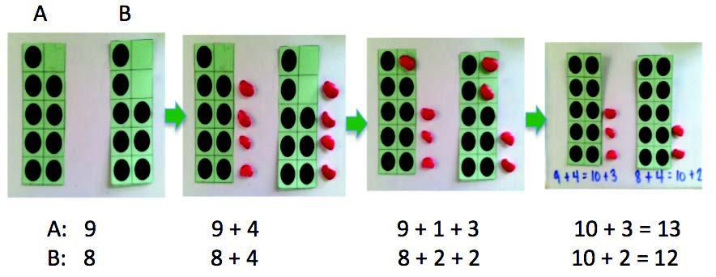

When finished with several sets of problems, students discuss with a partner how the problems within a set are the same and different.

Problem Set (10 minutes)

Students should do their personal best to complete the Problem Set within the allotted 10 minutes. For some classes, it may be appropriate to modify the assignment by specifying which problems they work on first. Some problems do not specify a method for solving. Students should solve these problems using the RDW approach used for Application Problems.

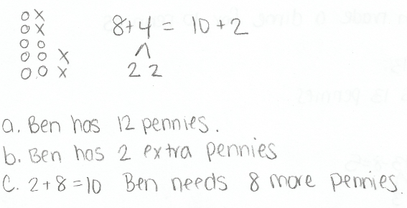Application Problem (5 minutes)

Ben collects dimes. He does it by first collecting pennies and then trading his parents 10 pennies for 1 dime. Ben has 8 pennies. He finds 4 more pennies.

1. How many pennies does Ben have before he trades?
2. How many pennies does Ben have after he trades?
3. How many more pennies will Ben need before he can trade for another dime?

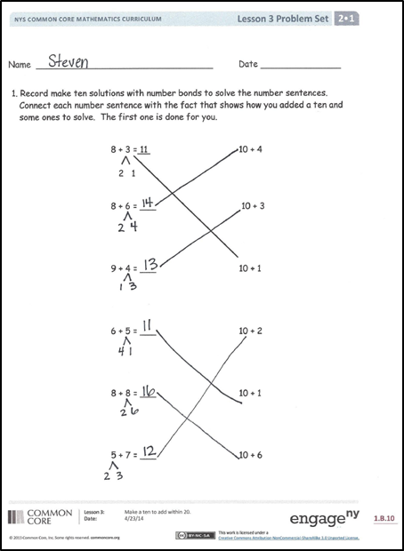Note: This problem allows students to apply today’s concept of make a ten to add within 20 in a real world context. Five minutes have been allotted for this   
time-frame task.

Student Debrief (10 minutes)

**Lesson Objective:** Make a ten to add within 20.

The Student Debrief is intended to invite reflection and active processing of the total lesson experience.

Invite students to review their solutions for the Problem Set. They should check work by comparing answers with a partner before going over answers as a class. Look for misconceptions or misunderstandings that can be addressed in the Debrief. Guide students in a conversation to debrief the Problem Set and process the lesson.

You may choose to use any combination of the questions below to lead the discussion.

* 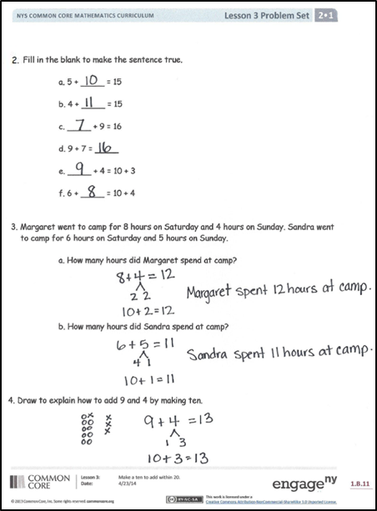Let’s look at page one of your Problem Set. How are 8 + 3 and 10 + 1 related?
* Talk to your partner about how we can explain that relationship using a drawing.
* How can you relate 19 + 5 and 20 + 4 to 9 + 5 and 10 + 4?
* What would be another set of problems to relate to 9 + 5 and 10 + 4?
* Talk to your partner about what you think our lesson’s focus is today.

Exit Ticket (3 minutes)

After the Student Debrief, instruct students to complete the Exit Ticket. A review of their work will help you assess the students’ understanding of the concepts that were presented in the lesson today and plan more effectively for future lessons. You may read the questions aloud to the students.

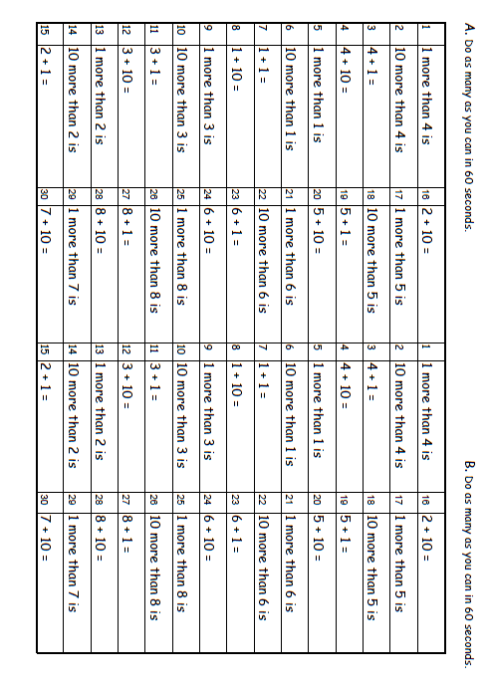

Name Date

1. Record make ten solutions with number bonds to solve the number sentences.

Connect each number sentence with the fact that shows how you added a ten and

some ones to solve. The first one is done for you.

8 + 3 = 11 10 + 4

2 1

8 + 6 = ___ 10 + 3

9 + 4 = ___ 10 + 1

6 + 5 = ___ 10 + 2

8 + 8 = ___ 10 + 1

5 + 7 = ___ 10 + 6

1. Fill in the blank to make the sentence true.
2. 5 + = 15
3. 4 + = 15
4. + 9 = 16
5. 9 + 7 =
6. + 4 = 10 + 3
7. 6 + = 10 + 4
8. Margaret went to camp for 8 hours on Saturday and 4 hours on Sunday. Sandra went to camp for 6 hours on Saturday and 5 hours on Sunday.
   1. How many hours did Margaret spend at camp?
   2. How many hours did Sandra spend at camp?
9. Make a drawing to explain how to add 9 and 4 by making ten.

Name Date

1. Make a drawing to explain 8 + 6 = 10 + 4.
2. Fill in the blank to make the sentence true.
3. 9 + 7 = + 6
4. + 3 = 10 + 2
5. 7 + = 10 + 1

Name Date

* 1. Record make ten solutions with number bonds to solve the number sentences.

Connect each number sentence with the fact that shows how you added a ten and

some ones to solve. The first one is done for you.

9 + 4 = 13 10 + 4

1 3

7 + 6 = ___ 10 + 3

6 + 6 = ___ 10 + 3

7 + 9 = ___ 10 + 2

6 + 8 = ___ 10 + 6

7 + 7 = ___ 10 + 4

* 1. Jennifer has 9 markers at school and 6 at home. Orlando has 7 markers at school and 8 at home.
  2. How many markers does Jennifer have?
  3. How many markers does Orlando have?
  4. Fill in the blank to make the sentence true.

1. 9 + 5 = + 4
2. 4 + 8 = 10 +
3. 8 + = 10 + 5
4. + 5 = 10 + 2
   1. Two teams are playing a baseball game. Team Tigers has 9 players on the field and 4 players on the bench. Team Lions has 9 players on the field and 7 players on the bench.
   2. How many players does Team Tigers have?
   3. How many players does Team Lions have?
   4. Draw to explain how to add 7 and 6 by making ten.



[1]

[2]



[3]

1. ten-frame cards
2. ten-frame cards
3. ten-frame cards