Lesson 2

Objective: Make number bonds through ten with a subtraction focus and apply to one-step word problems.

Suggested Lesson Structure

 Fluency Practice (15 minutes)

 Concept Development (25 minutes)

 Application Problem (10 minutes)

 Student Debrief (10 minutes)

**Total Time (60 minutes)**

Fluency Practice (15 minutes)

* Happy Counting 9–25 **2.NBT.2** (2 minutes)
* Say Ten Counting from 5 to 25 **2.NBT.1** (6 minutes)
* Ten Plus Number Sentences **2.OA.2** (3 minutes)
* Make Ten by Identifying the Missing Part **2.OA.2** (4 minutes)

Happy Counting 9–25 (2 minutes)

Note: Students practice fluently crossing the ten on Day 2, meaning they work up and down especially focusing on 8, 9, 10, 11, 12, 11, 10, 9, 8 and 18, 19, 20, 21, 22, 21, 20, 19, 18.

T: Watch my hand to know whether to count up or down. A closed hand means stop. (Show signals as you explain.)

T: Let’s count by ones starting at zero. Ready? (Rhythmically point up until a change is desired. Show a closed hand then point down. Continue, mixing it up.)

S: 9, 10, 11, 12, 13, 14 (stop) 13, 12, 11 (stop) 12, 13, 14, 15, 16, 17, 18 (stop) 17, 16, 15, 14 (stop) 15, 16, 17, 18, 19, 20 (stop) 19, 18, 17 (stop) 18, 19, 20, 21, 22, 23 (stop) 22, 21, 20, 19 (stop) 20, 21, 22, 23, 24, 25.

T: Excellent! Try it for 30 seconds with your partner. Partner B, you are the teacher today.

Say Ten Counting from 5 to 25 (6 minutes)

Note: Research substantiates that unit form counting, or Say Ten counting, supports number sense in that the naming of the numbers reveals the base ten to students. In *A Story of Units* students have been counting this way since Kindergarten.

Hide Zero cards and the Rekenrek (both pictured below) parallel Say Ten counting.

T: The Say Ten way to say 11 is 1 ten 1. (Pull the Hide Zero cards apart to show the 10 and the 1.) In Say Ten counting, we first state the number of tens and then state the number of ones.

T: (Show 12 with place value cards.) 2 more than 10, not in Say Ten way?

S: 12.

T: (Pull cards apart.) The Say Ten way to say 12?

S: 1 ten 2.

[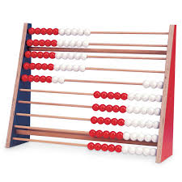](http://www.google.com/imgres?hl=en&biw=1476&bih=588&tbm=isch&tbnid=kiYDJDizmYMxMM:&imgrefurl=http://www.enasco.com/product/TB22814J&docid=fBt2svwX6gYduM&imgurl=http://www.enasco.com/prod/images/products/05/AC045101l.jpg&w=600&h=600&ei=JOJqUaD1GpHqiQKFxIGICw&zoom=1&ved=1t:3588,r:30,s:0,i:185&iact=rc&dur=1133&page=2&tbnh=148&tbnw=157&start=16&ndsp=25&tx=94&ty=77)T: (Show 13.) What is the Say Ten way for 13?

S: 1 ten 3.

T: (Pull cards apart.) Yes!

T: Let’s count the Say Ten way starting from 5 on the Rekenrek. As I move the beads, count aloud.

Beads on the Rekenrek start out pushed to the right. To show 5, a row of 5 are pulled to the left. To show 1 ten 1, a row of ten and a second row of one are pulled to the left, etc.

S: 5, 6, 7, 8, 9, 10, 1 ten 1, 1 ten 2, 1 ten 3, 1 ten 4, 1 ten 5, 1 ten 6, 1 ten 7, 1 ten 8, 1 ten 9.

T: 2 tens (show two rows of ten beads pulled to the left), and the pattern begins again.

S: 2 tens 1, 2 tens 2, 2 tens 3, 2 tens 4, 2 tens 5.

T: Partner B, tell your partner what patterns you noticed as you counted numbers 11–19.

T: Talk with your partner about how Say Ten counting numbers 11–19 relates to counting numbers 20–29.

Ten Plus Number Sentences (3 minutes)

Materials: (T) Large ten-frame cards from Lesson 1, Hide Zero cards (Template 1)

Note: Students should be able to claim proficiency with their ten plus facts. “My ten plus facts are easy! I just know them. 10 + 9 is 19. See I didn’t have to count.” Clearly this then extends into knowing 20 + 9 and later understanding expanded form without difficulty.

T: I will flash two ten-frame cards, ten and another card. Wait for the signal. Then tell me the addition sentence that combines the numbers. Let’s say numbers the regular way.

T: (Flash 10 and 5.)

S: 10 + 5 = 15.

Continue with the following possible sequence: 10 and 9, 10 and 1, 10 and 3.

T: Let’s use Hide Zero cards for larger numbers. (Flash 30 and 5.)

Continue with the following possible sequence: 30 and 8, 70 and 8, and 70 and 7.

T: Talk to your partner about 10 + 8 = 18, 30 + 8 = 38, and 70 + 8 = 78. (Write these facts on the board.) What is the same about these facts? What is different?

T: Partner A, explain how one problem helps you solve the other.

T: Partner B, explain how Say Ten counting is like ten plus number sentences.

Make Ten by Identifying the Missing Part (4 minutes)

Materials: (S) Personal white boards

Note: Students need this skill as they add 8 and 6 using the ten and subsequently add 18 and 6 or 80 and 60.

T: If I say 9, you say 1, because 9 needs 1 to be 10.

T: Wait for the signal, 5.

S: 5.

Continue with the following possible sequence: 8, 2, 9, and 1.

T: This time I’ll say a number and you write the addition sentence to make ten on your personal white board.

T: 0. Get ready. Show me your board.

S: 0 + 10 = 10.

T: 10. Get ready. Show me your board.

S: 10 + 0 = 10.

Continue with the following possible sequence: 3, 7, 6, and 4.

T: Turn and explain to your partner what pattern you noticed that helped you solve the problems.

S: First, you said 0 and the answer was 0 + 10 = 10; next, you said 10 and the answer was 10 + 0 = 10. The numbers switched places!

Concept Development (25 minutes)

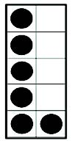Materials: (T) Large ten-frame cards from Lesson 1 (S) Per pair: set of mini ten-frame cards (Lesson 1 Template 1), 10 two-sided counters, blank ten-frame (Template 2), die, piece of blank paper, personal white boards

Note: This lesson builds on the previous lesson as students re-establish their Grade 1 mastery of sums and differences to 10. Students generally build proficiency in addition before subtraction, so today’s Concept Development focuses on subtraction facts to address common misconceptions such as writing 2 – 7 = 5 rather than 7 – 2 = 5.

T: Look at the card I’m holding up. (Hold up a large ten-frame card with 6 dots.)

T: How many dots do you see?

S: 6.

T: In your mind, subtract 1. At the signal tell me the subtraction sentence. Wait for my signal.

S: 6 – 1 = 5.

T: Good. Let’s keep going. As you look at the 6 card, subtract the number I tell you. Wait for the signal. 5. (Signal.)

S: 6 – 5 = 1.

T: Nice work! (Keep going, subtracting 2, 4, 3, and 0 before advancing to the 7 card with a similar sequence.)

T: (Hold up a ten-frame with 7 dots.) Now how many dots do you see?

S: 7.

T: (Continue through the bonds of 7.)

T: Now practice in pairs using the 8 and 9 cards to quiz each other. Partner A, you start with the 8 card. When I say to switch, Partner B will start quizzing Partner A with the 9 card.

T: (Pass out materials for the following activity: 10 two-sided counters, a blank ten-frame template, a die, and a blank piece of paper to hide the counters.)

T: I will tell you the whole amount. Partner B shows the whole using counters on the ten-frame.

T: If I say that the whole is 7, Partner B shows one color of 7 counters on the ten-frame.

T: Now, Partner A, roll the die to determine the part to change color. What part did you roll?

S: 4.

T: Partner B, hide all the counters from Partner A. Flip 4 counters to the other color.

|  |  |
| --- | --- |
|  | NOTES ON  MULTIPLE MEANS OF ENGAGEMENT: |
| Choose one or both Application Problems based on the needs of your students and the time constraint of 15 minutes.  Take care that the connection between the Concept Development and the Application Problems is not made too explicit; the goal is for students to discover these connections: “Oh! This is just ten plus number sentences!” “I can use what I practiced in make 10 to do the apples problem!” Ask questions to probe what students mean and encourage them to articulate their observations, especially during the Debrief when you want the lesson’s objective to become eminently clear to the students. | |

T: Partner A, say the subtraction sentence to find the part that didn’t change color.

S: 7 – 4 = 3. The part that didn’t change color is 3!

T: Partner B, show the counters to prove whether Partner A is correct or incorrect.

T: Continue playing for 30 seconds. I will then say switch. Exchange materials. As I watch and listen to you work and improve, I will pass you on to the next larger number when you are ready. (Move students on to wholes of 8, 9, 10, and beyond.)

Note: Conduct a short debrief to give students time to reflect and share insights.

T: There are some problems that you may do more slowly than others. Which ones slow you down?

S: Subtracting 6 from 9 is hard for me.

T: Who can share a way they subtract 6 from 9 with the class?

S: My fives are easy for me. 9 – 5 is 4, so 9 – 6 is one less, 3. 🡪 I think, 6 plus what is 9? I know that is 3. 🡪 I know my tens. 10 – 6 is 4, so 9 – 6 is one less. 🡪 I know my number pairs. 6 and 3 is 9, so 9 – 6 is 3.

T: Partner B, turn and talk to your partner about one strategy you just heard and understood that is different from the one you used. (Pause.) Partner A, take a turn.

Problem Set (10 minutes)

Students should do their personal best to complete the Problem Set within the allotted 10 minutes. For some classes, it may be appropriate to modify the assignment by specifying which problems they work on first. Some problems do not specify a method for solving. Students should solve these problems using the RDW approach used for Application Problems.

Application Problem (10 minutes)

Problem 1

There are both red and green apples in a bag. (Select a total number of apples as appropriate for your students. Be sure your students are proficient with 7, 8, and 9 before choosing a larger number.) How many red and how many green apples might there be in the bag?

Problem 2

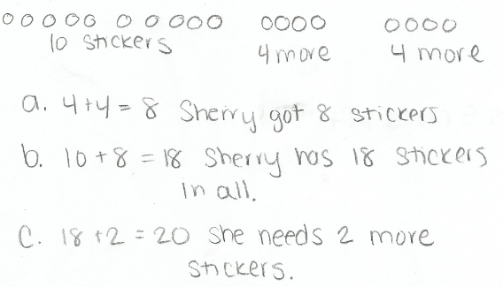Sherry already has 10 stickers. Now her goal is to collect 20 in all. She got 4 more on Monday and 4 again on Tuesday.

1. How many stickers did Sherry get on Monday and Tuesday?
2. How many stickers does she have in all?
3. How many more stickers does she need to make her goal?

Note: Problem 1 relates to the fingernail problem from   
G2–M1–Lesson 1. Instruct students to use the RDW procedure (introduced in Lesson 1) and their personal white boards to complete Problem 1. Problem 2 is more challenging, and the goal is for students to do their best within the allotted time, not necessarily to complete all tasks (time-frame rather than task-frame). The two problems create a differentiation opportunity. Those students who grasp the concept can move on, while those who need more practice can work on Problem 1.

|  |  |
| --- | --- |
|  | NOTES ON  MULTIPLE MEANS OF ACTION AND EXPRESSION: |
| As you circulate during this Application Problem, identify a student who uses an efficient representation or strategy. Ask the student to share her work with the class during the Student Debrief. Select work that advances efficient ways of counting and grouping rather than work that shows scattered representations. | |

Guide students through the problem by rereading it and then drawing and labeling each piece of information as it is given. (Be sure students write the equation and the statement of the answer for each part as it is solved on their personal white boards.) This systematic approach will support students as they work independently on the Problem Set and at home.

T: Let’s read Problem 2 together through Part (a).

S: (Read chorally.)

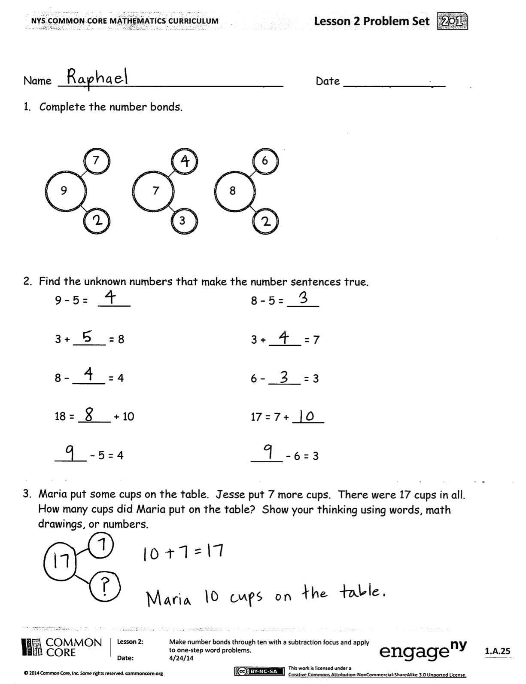T: Tell your partner what you see when you hear the story.

S: (Share with partners.)

T: What can you draw to show Part (a)?

S: Two groups of 4 stickers which equals 8 stickers. 🡪 A total of 8 stickers.

T: What can you draw to show Part (b)?

S: A page with 10 stickers, and then another page that’s getting fuller because she got stickers on Monday and stickers on Tuesday. 🡪 10 stickers and 8 more.

T: I’ll give you two minutes to make your drawing of the story.

T: Explain to your partner what your drawing shows.

T: (Wait until a brief exchange is complete.) How many stickers does Sherry have now?

S: 18.

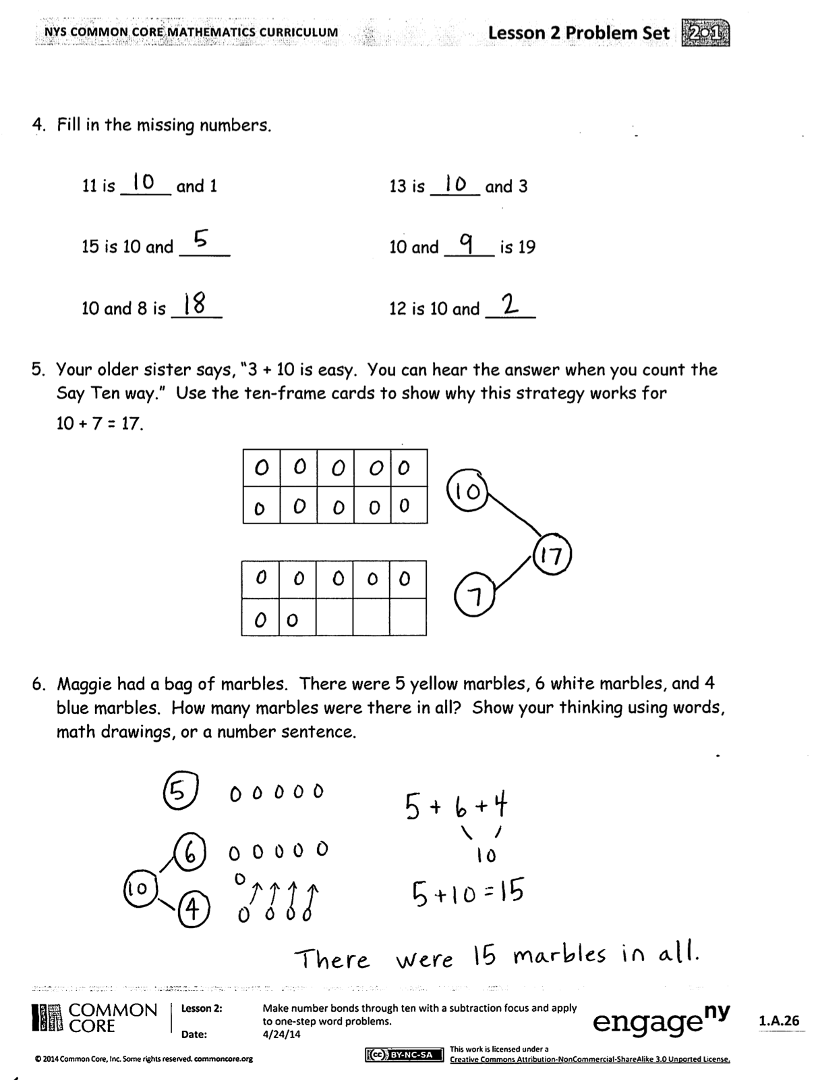T: 18 what? It’s important to always state the unit.

S: 18 stickers.

T: Turn and tell your partner what number sentence you can write to show your drawing.

Continue through the process of having the students write the number sentence and the statement of the answer.

Student Debrief (10 minutes)

**Lesson Objective:** Make number bonds through ten with a subtraction focus and apply to one-step word problems.

The Student Debrief is intended to invite reflection and active processing of the total lesson experience.

Invite students to review their solutions for the Problem Set. They should check work by comparing answers with a partner before going over answers as a class. Look for misconceptions or misunderstandings that can be addressed in the Debrief. Guide students in a conversation to debrief the Problem Set and process the lesson.

You may choose to use any combination of the questions below to lead the discussion.

* (Draw or project selected student work as noted in the UDL box.) Let’s look at some work a classmate did on the sticker problem together. What do you see?

|  |  |
| --- | --- |
|  | NOTES ON  USING MP.3 IN A STUDENT DEBRIEF: |
| In transitioning from the Application Problem to the Student Debrief, anticipate your students needing one minute to organize their materials and find their pre-assigned math partner to come to the rug.  As students organize themselves, quickly project or redraw the student sample you selected, as well as your own solution on the board.  Once students have gathered, wait for 100% attention before beginning. Signal the beginning of the Debrief with a welcoming statement as modeled to the left.  The simple question, “What do you see?” is non-threatening and remarkably effective for eliciting a range of observations and insights that get the conversation started by meeting students where they are. These insights then lead to the opportunity to construct viable arguments and critique the reasoning of others. | |

* Do you agree? Turn and talk to you partner about why you agree or disagree.
* Look at the first and second columns of Problem 2 on the Problem Set. What connections do you see between the problems in each row?
* In Problem 6 which numbers did you add first? Why?

Exit Ticket (3 minutes)

After the Student Debrief, instruct students to complete the Exit Ticket. A quick review of their work will help you assess the students’ understanding of the concepts that were presented in the lesson today. Students have three minutes to complete the Exit Ticket. You may read the questions aloud to the students.

Name Date

1. Complete the number bonds.

 

3

7

6

8

9

7

1. Find the unknown numbers that make the number sentences true.

9 – 5 = 8 – 5 =

3 + = 8 3 + = 7

8 – = 4 6 – = 3

18 = + 10 17 = 7 +

– 5 = 4 – 6 = 3

1. Maria put some cups on the table. Jesse put 7 more cups. There were 17 cups in all. How many cups did Maria put on the table? Show your thinking using words, math drawings, or numbers.
2. Fill in the missing numbers.

11 is and 1 13 is and 3

15 is 10 and 10 and is 19

10 and 8 is 12 is 10 and

1. Your older sister says, “3 + 10 is easy. You can hear the answer when you count the Say Ten way.” Use the ten-frame cards to show why this strategy works for

10 + 7 = 17.

1. Maggie had a bag of marbles. There were 5 yellow marbles, 6 white marbles, and 4 blue marbles. How many marbles were there in all? Show your thinking using words, math drawings, or a number sentence.

Name Date

1. Find the unknown numbers that make the number sentences true.

7 – 4 =

2 + = 8

6 = 9 –

2. Mr. Gardener has a box with 12 tomatoes. He gives 2 tomatoes to his sister and another 7 tomatoes to his neighbor. How many tomatoes does he have left? Show your work with a picture and a number sentence.

Mr. Gardener has tomatoes left.

Name Date

1. Complete the number bonds.

5

7

3

8

7

9

1. Find the unknown numbers that make the number sentences true.

7 – 5 = 9 – 5 =

4 + = 8 10 = 7 +

8 – = 3 7 – = 3

17 = + 10 6 = 5 +

– 5 = 3 – 6 = 3

1. Find the unknown numbers that make the number sentences true.

= 8 + 10 = 7 – 2

= 10 – 5 = 10 + 4

= 10 + 9 = 3 + 6

1. Find the unknown numbers that make the number sentences true.

16 is and 6 11 is 10 and _____

18 is and 10 10 and 7 is _____

15 is ten ones 10 and _____ is 19

1. Mr. Avakian put a stack of 10 plates on the table for a party. He also put out 8 plates of food. How many plates were there in all on the table? Show your thinking using words, math drawings, or a number sentence.
2. Mr. Passerini gave out 10 vanilla, 2 chocolate, and 8 strawberry ice cream cones. How many ice cream cones did he hand out in all? Show your thinking using words, math drawings, or a number sentence.



[1]



[2]

[3]

1. hide zero cards
2. hide zero cards
3. blank ten-frame