Lesson 1

Objective: Make number bonds of ten.

Suggested Lesson Structure

 Fluency Practice (19 minutes)

 Concept Development (21 minutes)

|  |  |
| --- | --- |
|  | NOTES ON  FLUENCY PRACTICE: |
| Think of fluency activities as having three goals:   1. Maintenance (staying sharp on previously learned skills). 2. Preparation (targeted practice for the current lesson). 3. Anticipation (skills that ensure that students will be ready for the  in-depth work of upcoming lessons). | |

 Application Problem (10 minutes)

 Student Debrief (10 minutes)

**Total Time (60 minutes)**

Fluency Practice (19 minutes)

* Happy Counting 1–10 **2.NBT.2** (2 minutes)
* Break Ten in 2 Parts **2.OA.2** (5 minutes)
* Sprint: Add Tens and Some Ones **2.OA.2** (12 minutes)

Happy Counting 1–10 (2 minutes)

Note: On the first day, counting up and down to 10 simply alerts students to the fun and challenge of changing direction and establishing a protocol that will quickly advance to larger numbers as the module unfolds.

Make your hand motions emphatic so the students’ counting is sharp and crisp. Once students get the hang of it, make the counting more challenging by skip-counting or starting at higher numbers. Also, resist the urge to mouth the answers. Students need to do the work, so they have to watch your fingers!

T: Watch my hand to know whether to count up or down. A closed hand means stop. (Show signals as you explain.)

T: Let’s count by ones starting at zero. Ready? (Rhythmically points up until a change is desired. Show a closed hand then point down. Continue, mixing it up.)

S: 0, 1, 2, 3, (stop) 2, 1, 0, (stop) 1, 2, 3, 4, 5, (stop) 4, 3, 2, 1, 0, (stop) 1, 2, 3, 4, 5, 6, 7, (stop) 6, 5, 4, (stop) 5, 6, 7, 8, 9, 10, (stop) 9, 8, 7, 6.

T: Excellent! Try it for 30 seconds with your partner. Partner A, you are the teacher today.

Break Ten in 2 Parts (5 minutes)

Materials: (S) One stick of 10 linking cubes with a color change after the fifth cube

Note: Fluency with the bonds of numbers within 10 is one of the most important foundational skills. By starting at the concrete level, students quickly re-engage with their prior knowledge of these bonds to prepare for the lesson content.

T: Show me your 10 stick.

S: (Show.)

T: Hide it behind your back. I will say the size of one part. Break that part off in one piece. Then without peeking, see if you know how many are in the other part.

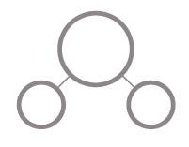T: Ready?

S: Yes!

T: Break off 2. No peeking. At the signal, tell how many are in the other part. (Give signal.)

S: 8.

T: Show your parts and see if you are correct.

S: It’s 8.

T: What parts are you holding?

S: 2 and 8.

T: What’s the whole?

S: 10.

|  |  |
| --- | --- |
|  | NOTES ON  MULTIPLE MEANS OF ACTION AND EXPRESSION: |

For Sprints, a fast pace is essential and builds energy and excitement. To support students who don’t excel under pressure, you may give them the chance to practice the Sprint at home the night before it is administered.

To maintain a high level of energy and enthusiasm, always do a stretch or a movement game in between Sprint A and Sprint B. For example, do jumping jacks while skip-counting by fives.

Continue with the following possible sequences: 3 and 7, 1 and 9, 4 and 6, and 5 and 5. Draw the bond (as pictured above right) and continue with the remaining bonds at an ever-quickening pace.

T: Turn and talk to your partner about how this game is the same as or different from than one you played in first grade.

T: How did knowing that help you play today?

T: Tell your partner which pattern or strategy helped you find the missing part when you couldn’t peek at how many were left.

Sprint: Add Tens and Some Ones (12 minutes)

Materials: (S) Add Tens and Some Ones Sprint

Note: This particular choice brings automaticity back with the *ten plus* sums, which are foundational for the make a ten strategy and expanded form.

Directions for Administration of Sprints

One Sprint has two parts with closely related problems on each. The problems on each part move from simple to complex, creating a challenge for every learner. Before the lesson, cut the Sprint sheet in half to create Sprint A and Sprint B. Students complete the two parts of the Sprint in quick succession with the goal of improving on the second part, even if only by one more. With practice the following routine takes about 8 minutes.

Sprint A

(Put Sprint A face down on desks with instructions to not look at problems until the signal is given.)

T: You will have 60 seconds to do as many problems as you can.

T: I do not expect you to finish all of them. Just do as many as you can, your personal best.

T: Take your mark! Get set! THINK! (When you say THINK, students turn papers over and work furiously to finish as many problems as they can in 60 seconds. Time precisely.)

(After 60 seconds:)

T: Stop! Circle the last problem you did. I will read just the answers. If you got it right, call out “Yes!” If you made a mistake, circle it. Ready?

(Repeat to the end of Sprint A or until no one has any more correct.)

T: Now write your correct number at the top of the page. This is your personal goal for B.

T: How many of you got 1 right? (All hands should go up.)

T: Keep your hand up until I say a number that is 1 more than the number you got right. So, if you got 14 right, when I say 15 your hand goes down. Ready?

T: (Quickly.) How many got 2 right? And 3, 4, 5, etc. (Continue until all hands are down.)

(Optional routine, depending on whether or not the class needs more practice with Sprint A.)

T: Take one minute to do more problems on this half of the Sprint.

(As students work, you might have the person who scored highest on Sprint A pass out Sprint B.)

T: Stop! I will read just answers. If you got it right, call out “Yes!” If you made a mistake, circle it. Ready? (Read the answers to the first half again.)

Note: To keep the energy and fun going, do a stretch or a movement game in between Sprints*.*

Sprint B

(Put Sprint B face down on desks with instructions to not look at the problems until the signal is given. Repeat the procedure for Sprint A up through the show of hands for how many right.)

T: Stand up if you got more correct on the second Sprint than on the first.

S: (Stand.)

T: Keep standing until I say the number that tells how many more you got right on Sprint B. If you got 3 more right on Sprint B than on Sprint A, when I say 3 you sit down. Ready?

T: (Call out numbers starting with 1. Students sit as the number by which they improved is called.)

An alternate method is to choose three students to tell how many they got correct on Sprint A and Sprint B.

For each set of scores, on your signal, the class chorally says the difference. This provides frequent practice with counting on and other mental strategies, and it reinforces the relationship between addition and subtraction.

T: Miguel, how many did you get correct on Sprint A and Sprint B?

S: On Sprint A, I got 12, and on Sprint B I got 17.

T: How many more did Miguel do on Sprint B than on Sprint A? (Pause.)

S: 5!

Students may take Sprints home.

Concept Development (21 minutes)

Materials: (T) Large set of ten-frame cards in the following suggested order: 5, 9, 1, 8, 2, 7, 3, 6, 4, 5, 10   
(S) Mini ten-frame cards that show the numbers 1–10, with an extra card that shows 5 (Template 1), number bond recording sheet (Template 2)

Note: Prior to the lesson, create a set of ten-frame cards 1 through 10 large enough for all students to see for Part 2. These cards will be used throughout the year to review and maintain fluency with the bonds of 10.

Part 1: Make ten.

T: Place your ten-frame cards in order from largest to smallest.

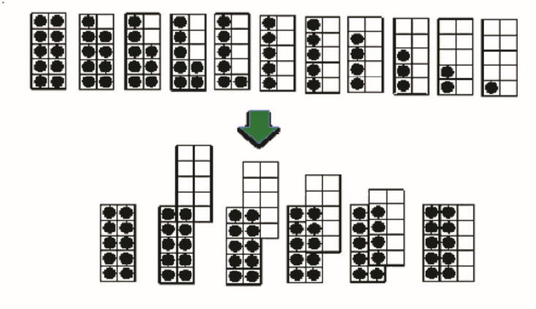T: Move your ten-frames that have 5 or fewer dots to make ten (see model at right).

S: (Move cards, placing the 1 on the 9, etc.)

T: Now go through your bonds of 10 out loud.

S: 10 and 0, 9 and 1, 8 and 2, 7 and 3, etc.

T: Close your eyes and see if you can remember them without looking.

T: Open your eyes and do it again. Who got better at their number bonds of 10?

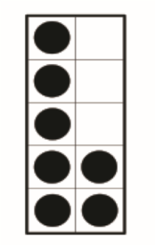Part 2: Ten-Frame Flash: Identify the missing addend to make ten.

Note: This next activity requires students to visualize (for those who still need support) or recall from memory (for those who achieved mastery of partners to 10) the missing addend. It also refreshes their subitizing skills (as students only have a few seconds to recognize the set of 5 and the set of 2 on the image at right as 7) in order to complete the number sentence.

T: Here is a ten-frame card. Tell me the addition sentence to make ten. Wait for the signal. (Flash a large ten-frame card for about two seconds.)

S: 7 + 3 = 10, 5 + 5 = 10, 9 + 1 = 10, 8 + 2 = 10, etc.

T: This time, tell me the subtraction sentence to get to the number of dots shown. Wait for the signal. (Flash a ten-frame card for about two seconds.)

S: 10 – 3 = 7, 10 – 5 = 5, 10 – 9 = 1, 10 – 1 = 9, etc.

T: Partner A, turn over your ten-frame cards to hide the dots.   
1. Show the top card for two seconds.   
2. Wait for Partner B to tell you the addition sentence and subtraction sentence.   
3. Flash the next card.   
4. Keep going until the buzzer sounds after one minute.

T: (Set the timer for one minute.) Partner B, now it’s your turn.

T: Let’s try the class set again. (Repeat the class set. Give verbal praise specific to observed improvement, such as “Students, you really improved at making 10 from 2, 3, and 4, which are usually a greater challenge.”)

|  |  |
| --- | --- |
|  | NOTES ON  MULTIPLE MEANS OF REPRESENTATION: |
| Post the first few problems of each set on the board so students can identify the pattern. Underline, highlight, or use a different color for the digits in the ones place to draw attention to making a ten. | |

T: Partners, talk about how 6 + 4 helps you solve 10 – 6.

T: Now show the number I say with your fingers. Then show the missing part and say the number sentence.

T: Four.

S: (Show 4 fingers. Then show 6.) 4 + 6 = 10.

T: (Continue quickly through the remaining partners to 10.)

Part 3: Record number bonds.

Note: Distribute the number bond template and have students write number bonds of 10 without pictures or manipulatives.  If they get stuck, invite them to visualize ten-frame cards rather than use them.  Close by having partners share their work and look for commonalities.

Once students have written the bonds of 10, briefly continue with addition into teen numbers, numbers to 40, and numbers to 100 as students are able. This adds excitement as students see their sums applying to bigger numbers. Keep a lively pace.

T: 5 + 5 is…?

S: 10.

T 15 + 5 is…?

S: 20.

**MP.2**

T: 25 + 5 is…?

S: 30.

T: 65 + 5 is…?

S: 70.

Repeat the process as time allows, possibly using the following sequence: 7 + 3, 17 + 3, 27 + 3, 57 + 3; 8 + 2, 28 + 2, and 48 + 2.

Problem Set (10 minutes)

Students should do their personal best to complete the Problem Set within the allotted 10 minutes. Some problems do not specify a method for solving. This is an intentional reduction of scaffolding that invokes MP.5, Use Appropriate Tools Strategically. Students should solve these problems using the RDW approach used for Application Problems.

For some classes, it may be appropriate to modify the assignment by specifying which problems students should work on first. With this option, let the purposeful sequencing of the Problem Set guide your selections so that problems continue to be scaffolded. Balance word problems with other problem types to ensure a range of practice. Consider assigning incomplete problems for homework or at another time during the day.

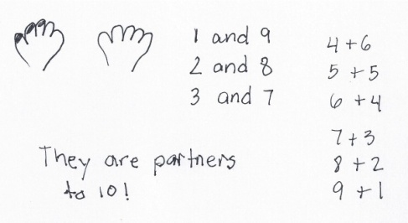Application Problem (10 minutes)

Problem 1

Mrs. Potter paints her fingernails one at a time from left to right. She paints 1 fingernail first. How many fingernails does she have unpainted? If she keeps painting 1 fingernail at a time, how many other combinations of painted and unpainted nails can she have?

Problem 2

The cashier wants each envelope to have exactly 10 bills. How many more bills does he need to put in each of the following envelopes?

1. An envelope with 9 bills. (1)
2. An envelope with 5 bills. (5)
3. An envelope with 1 bill. (9)
4. Find other numbers of bills that might be in an envelope and tell how many more bills the cashier needs to put to make 10 bills.

A different cashier wants each envelope to have exactly 30 bills. How many more bills does he need to put in each of the following envelopes?

1. An envelope with 28 bills. (2)
2. An envelope with 22 bills. (8)
3. An envelope with 24 bills. (6)

Note: Choose one or both problems based on the needs of your students and the time constraint of 10 minutes. These problems are designed to elicit connections between the fingernails, envelopes, and   
ten-frames, which can be explored during the Debrief. Ten minutes have been allotted in order for you to review the Read, Draw, Write (RDW) Process for problem solving.

Directions for the RDW Process: Read the problem, draw and label, write a number sentence, and write a word sentence. The more students participate in reasoning through problems with a systematic approach, the more they internalize those behaviors and thought processes.

(Excerpted from “How to Implement *A Story of Units.*”)

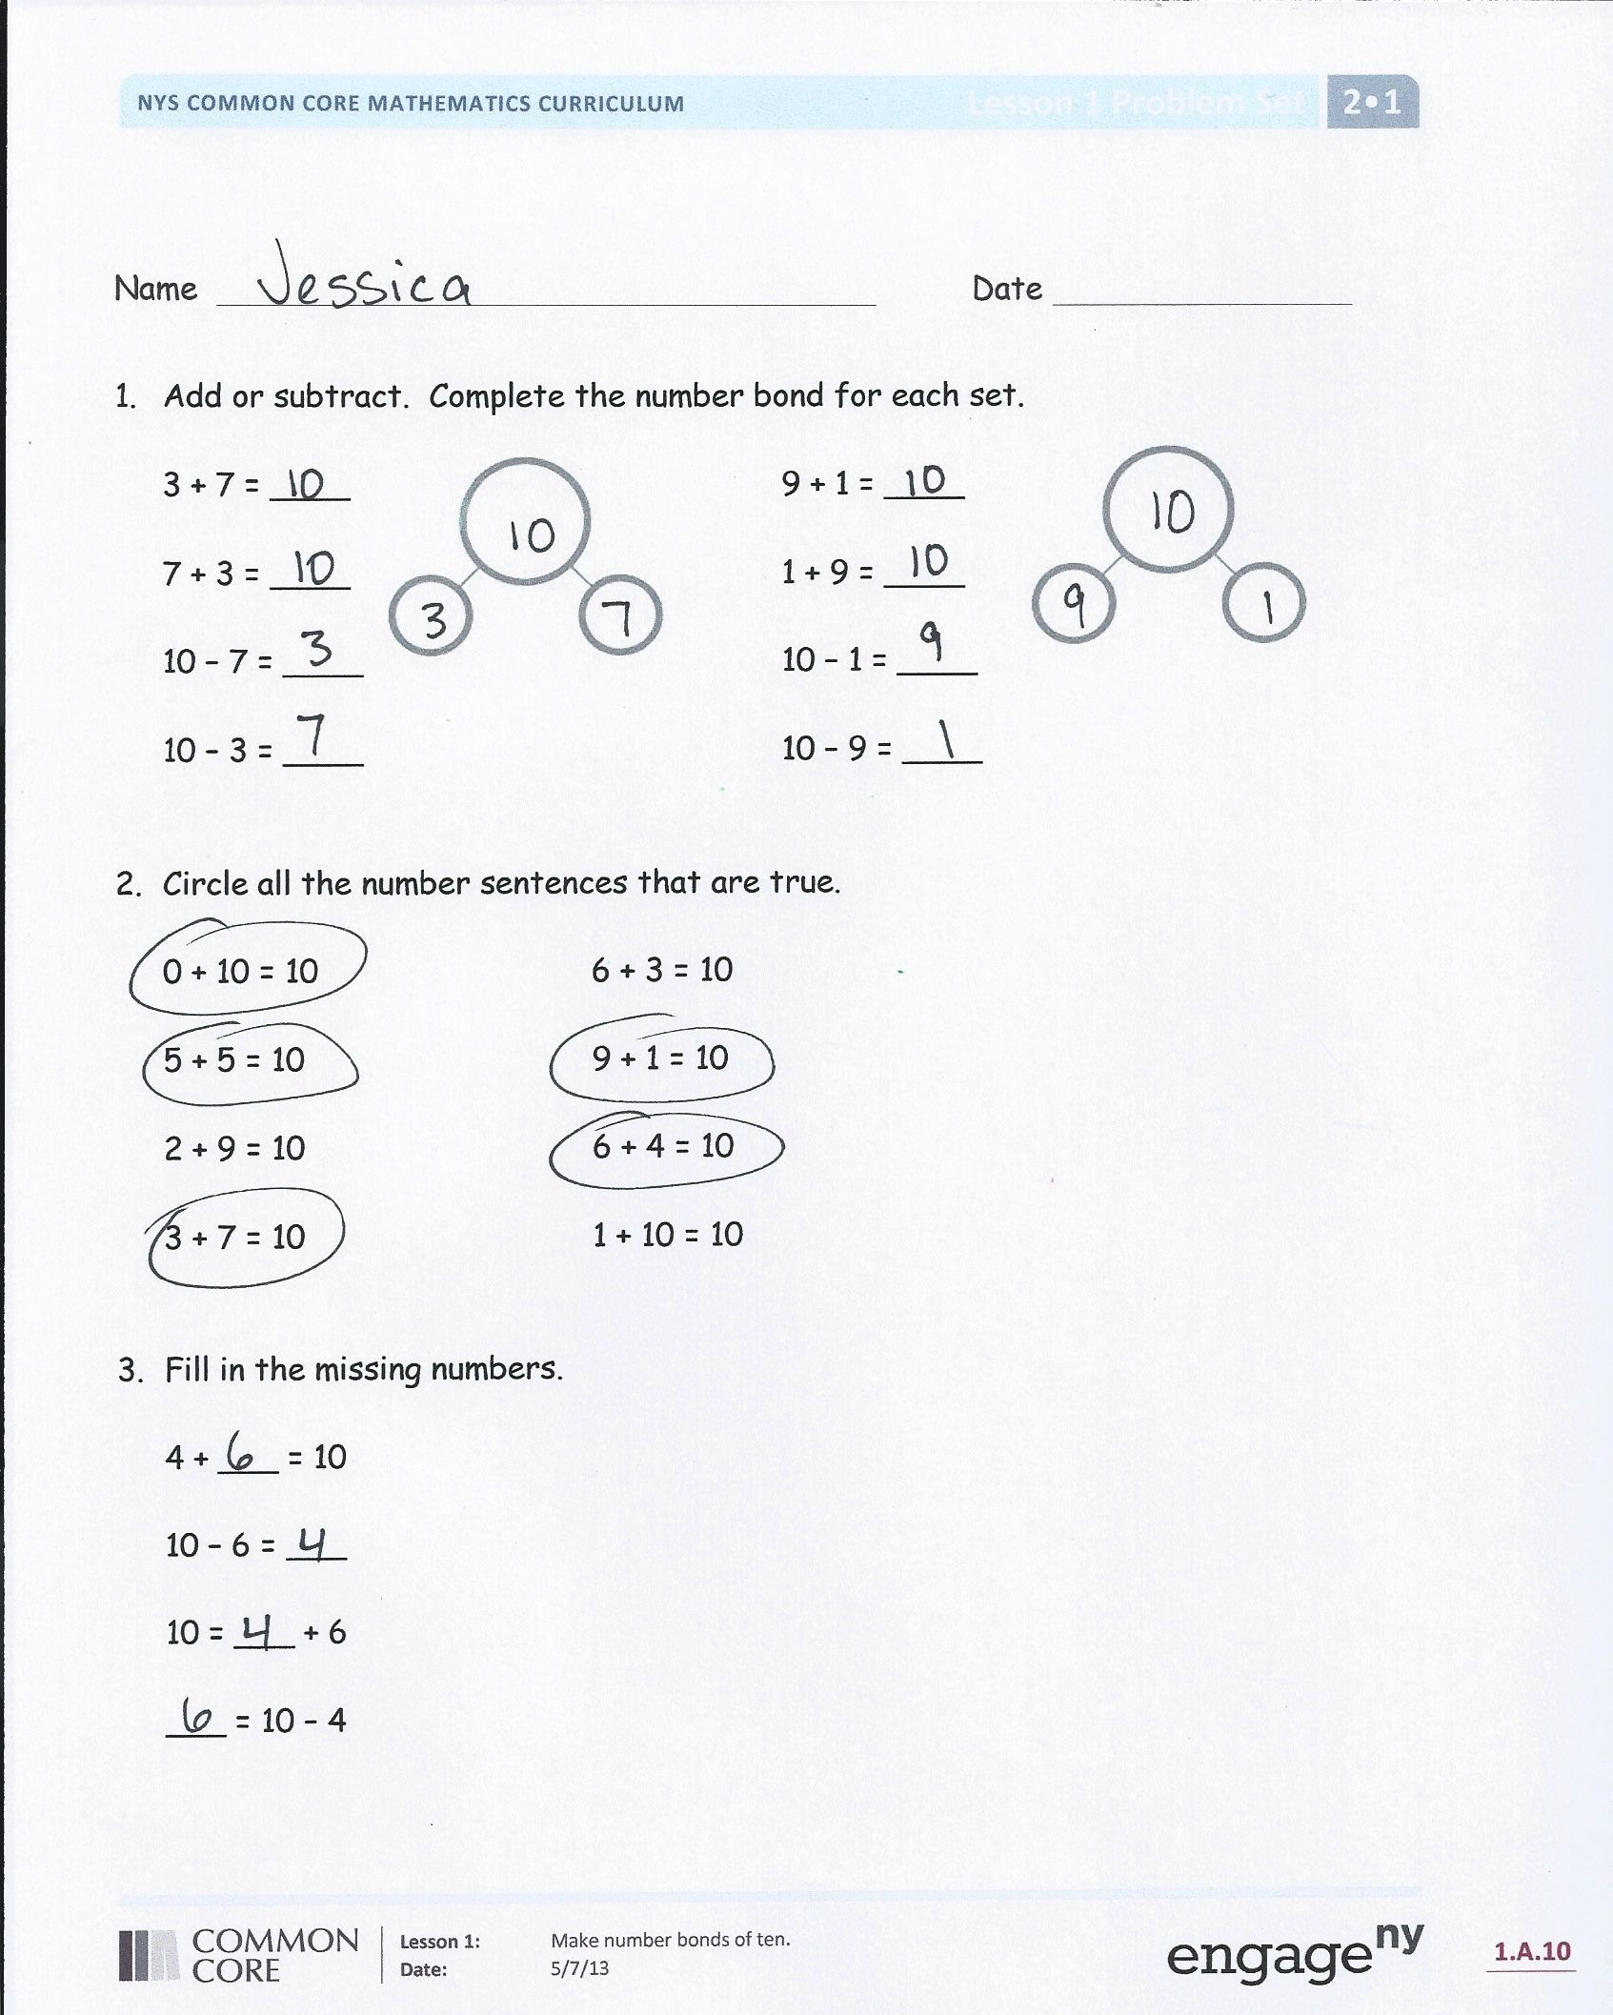Student Debrief (10 minutes)

**Lesson Objective**: Make number bonds of ten.

The Student Debrief is intended to invite reflection and active processing of the total lesson experience.

Invite students to review their solutions for the Problem Set. They should check work by comparing answers with a partner before going over answers as a class. Look for misconceptions or misunderstandings that can be addressed in the Debrief. Guide students in a conversation to debrief the Problem Set and process the lesson.

You may choose to use any combination of the questions below to lead the discussion.

* Compare the envelope problem to the fingernail problem. What is different about the problems? What is the same about them?
* (Hold up a ten-frame card). Why do you think I chose to use the ten-frame cards today?
* 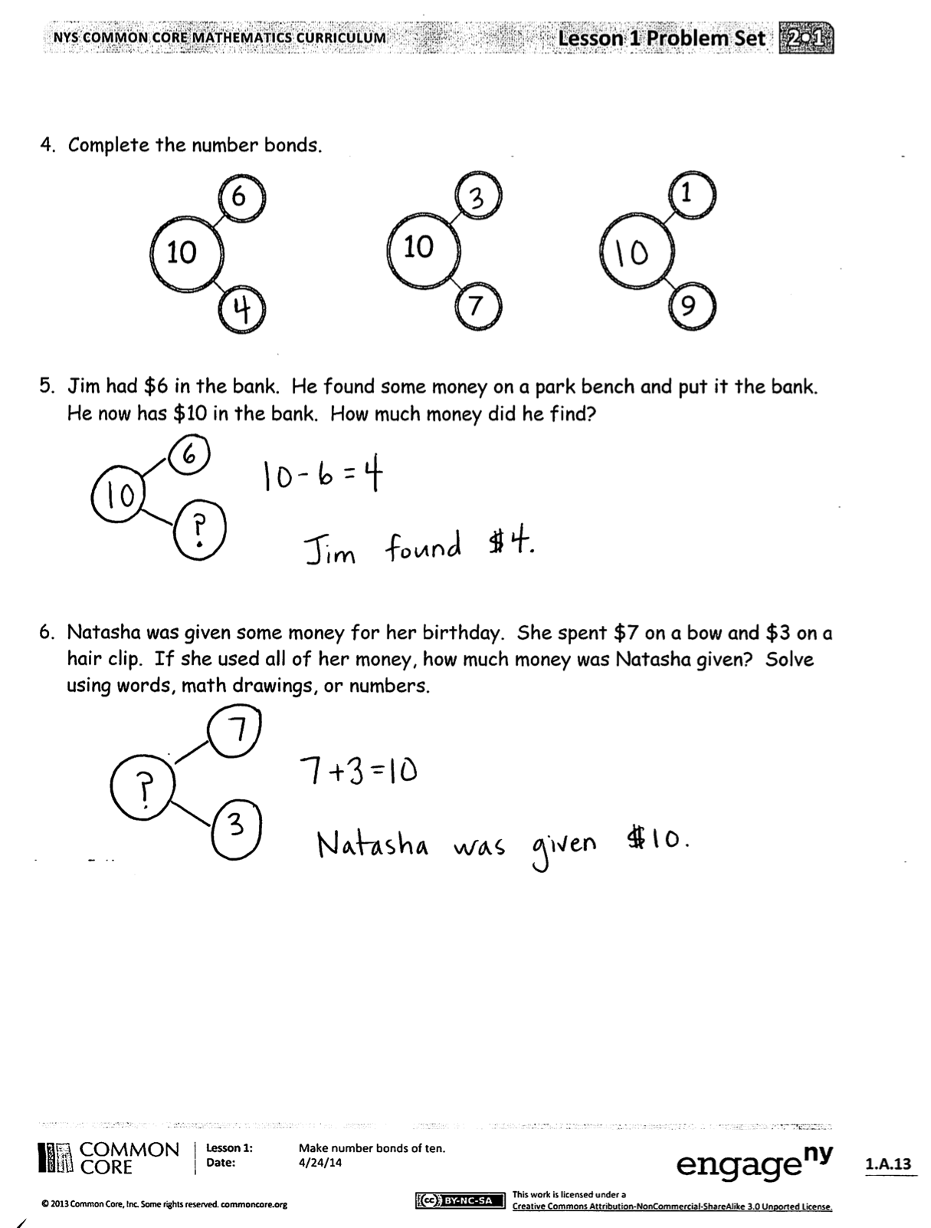(Hold up the ten-stick of linking cubes with the color change after the fifth cube.) How does the color change at the five help us with learning our bonds of ten?
* Instead of a color change, how does the ten-frame show the five?
* How did the first envelope problem help you solve the second one? How does 6 + 4 help you solve 26 + 4?

Exit Ticket (3 minutes)

After the Student Debrief, instruct students to complete the Exit Ticket. A review of their work will help you assess the students’ understanding of the concepts that were presented in the lesson today and plan more effectively for future lessons. You may read the questions aloud to the students.



Name Date

1. Add or subtract. Complete the number bond for each set.

3 + 7 = ____ 9 + 1 = ____

7 + 3 = ____ 1 + 9 = ____

10 – 7 = ____ 10 – 1 = ____

10 – 3 = ____ 10 – 9 = ____

1. Circle all the number sentences that are true.

0 + 10 = 10 6 + 3 = 10

5 + 5 = 10 9 + 1 = 10

2 + 9 = 10 6 + 4 = 10

3 + 7 = 10 1 + 10 = 10

1. Fill in the missing numbers.

4 + ___ = 10

10 – 6 = ___

10 = ___ + 6

___ = 10 – 4

1. Complete the number bonds.



1

6

10

10

9

7

1. Jim had $6 in the bank. He found some money on a park bench and put it the bank. He now has $10 in the bank. How much money did he find?

1. Natasha was given some money for her birthday. She spent $7 on a bow and $3 on a hair clip. If she used all of her money, how much money was Natasha given? Solve using words, math drawings, or numbers.

Name Date

Complete each number bond to make 10. Write at least one addition and one subtraction sentence for each bond.



1

0

____ + ____ = ____ ____ + ____ = ____

____ ____ = ____ ____ ____ = ____





____ + ____ = ____ ____ + ____ = ____

____ ____ = ____ ____ ____ = ____

3

2



5

____ + ____ = ____ ____ + ____ = ____

____ ____ = ____ ____ ____ = ____

4

Name Date

1. Circle all the number sentences that are true.

6 + 4 = 10

10 = 3 + 7

10 – 7 = 4

5 + 5 = 1 + 9

2 + 8 = 7 + 3

8 – 2 = 10

1. Add or subtract.

|  |  |
| --- | --- |
| 1. 10 - 7= ____ | 1. 8 + 2 = ____ |
| 1. 10 – 5 = ____ | 1. 3 + 7 = ____ |
| 1. 10 – 0= ____ |  |

1. Solve the problems.

|  |  |
| --- | --- |
| 1. 1 + 9 = ____ | 1. 59 + 1 = ____ |
| 1. 15 + 5 = ____ | 1. 65 + 5 = ____ |
| 1. 28 + 2 = ____ | 1. 72 + 8 = ____ |
| 1. 33 + 7 = ____ | 1. 87 + 3 = ____ |
| 1. 46 + 4 = ____ | 1. 94 + 6 = ____ |

1. Complete the number bonds.



5

6

10

10

5

8

1. Your little brother has $4. He wants to spend the money on an action figure that costs $10. How much money does he still need to buy the action figure?
2. Daniel found $14. His father gave him some more. Then he had $20. How much money was he given? Write a number sentence to show your thinking.
3. Amy read 24 books. Peter read 30 books. Amy wants to read the same number of books as Peter. Amy thinks she needs to read 7 more books to reach her goal. Is she right? Explain using words, math drawings, or numbers.



[1]

[2]



[3]

Name Date

Draw all the number bonds of 10. The first one is done for you.



10

10

0



10

10

0

[4]

1. mini ten-frame cards
2. mini ten-frame cards
3.
4. number bond recording sheet