Lesson 15: Solving Area Problems Using Scale Drawings

Classwork
Opening Exercise
For each diagram, Drawing 2 is a scale drawing of Drawing 1. Complete the accompanying charts. For each drawing, identify the side lengths, determine the area, and compute the scale factor. Convert each scale factor into a fraction and percent, examine the results, and write a conclusion relating scale factors to area.
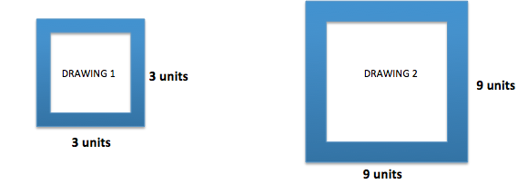

 | Drawing 1 | Drawing 2 | Scale Factor as a Fraction and Percent
Side

Area

Scale Factor: Quotient of Areas:

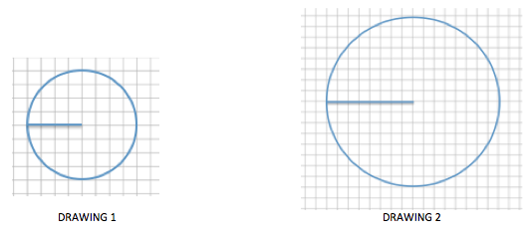

 | Drawing 1 | Drawing 2 | Scale Factor as a Fraction and Percent
Radius

Area

Scale Factor: Quotient of Areas:

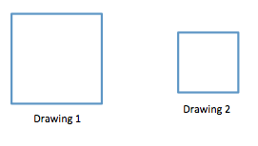
The length of each side in Drawing 1 is $12 units$, and the length of each side in Drawing 2 is $6 units$.

 | Drawing 1 | Drawing 2 | Scale Factor as a Fraction and Percent
Side

Area

Scale Factor: Quotient of Areas:

Conclusion:

Example 1
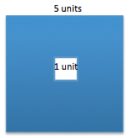
What percent of the area of the large square is the area of the small square?

Example 2
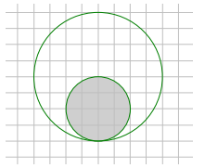
What percent of the area of the large disk lies outside the smaller disk?

Example 3
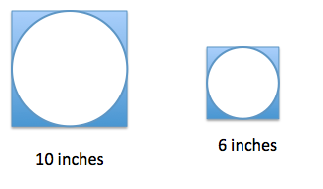
If the area of the shaded region in the larger figure is approximately $21.5$ square inches, write an equation that relates the areas using scale factor and explain what each quantity represents. Determine the area of the shaded region in the smaller scale drawing.

Example 4
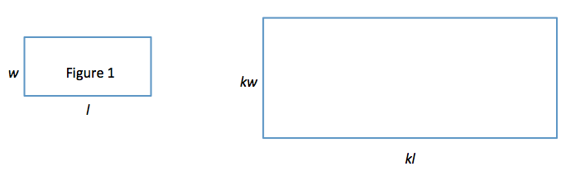
Use Figure 1 below and the enlarged scale drawing to justify why the area of the scale drawing is $k^{2}$ times the area of the original figure.

Explain why the expressions $(kl)(kw)$ and $k^{2}lw$ are equivalent. How do the expressions reveal different information about this situation?

Exercise 1
The Lake Smith basketball team had a team picture taken of the players, the coaches, and the trophies from the season. The picture was $4$ inches by $6$ inches. The team decided to have the picture enlarged to a poster, and then enlarged again to a banner measuring $48$ inches by $72$ inches.
  - Sketch drawings to illustrate the original picture and enlargements.

  - If the scale factor from the picture to the poster is $500\%$, determine the dimensions of the poster.

  - What scale factor is used to create the banner from the picture?

  - What percent of the area of the picture is the area of the poster? Justify your answer using the scale factor and by finding the actual areas.

  - Write an equation involving the scale factor that relates the area of the poster to the area of the picture.

  - Assume you started with the banner and wanted to reduce it to the size of the poster. What would the scale factor as a percent be?

  - What scale factor would be used to reduce the poster to the size of the picture?

Problem Set
Lesson Summary
If the scale factor is represented by $k$, then the area of the scale drawing is $k^{2}$ times the corresponding area of the original drawing.

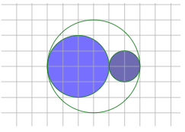
- What percent of the area of the larger circle is shaded?
  - Solve this problem using scale factors.
  - Verify your work in part (a) by finding the actual areas.

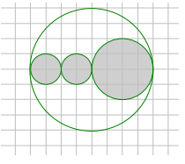
- The area of the large disk is $50.24 {units}^{2}$.
  - Find the area of the shaded region using scale factors. Use $3.14$ as an estimate for $π$.
  - What percent of the large circular region is unshaded?

- Ben cut the following rockets out of cardboard. The height from the base to the tip of the smaller rocket is $20 cm$. The height from the base to the tip of the larger rocket is $120 cm$. What percent of the area of the smaller rocket is the area of the larger rocket?

- In the photo frame depicted below, three $5$ inch by $5$ inch squares are cut out for photographs. If these cut-out regions make up $\frac{3}{16}$ of the area of the entire photo frame, what are the dimensions of the photo frame?

- Kelly was online shopping for envelopes for party invitations and saw these images on a website.

The website listed the dimensions of the small envelope as $6 in.$ by $8 in.$ and the medium envelope as $10 in.$ by $13\frac{1}{3} in$.
  - Compare the dimensions of the small and medium envelopes. If the medium envelope is a scale drawing of the small envelope, what is the scale factor?
  - If the large envelope was created based on the dimensions of the small envelope using a scale factor of $250\%$, find the dimensions of the large envelope.
  - If the medium envelope was created based on the dimensions of the large envelope, what scale factor was used to create the medium envelope?
  - What percent of the area of the larger envelope is the area of the medium envelope?

