Lesson 15: Solving Area Problems Using Scale Drawings

Student Outcomes
- Students solve area problems related to scale drawings and percent by using the fact that an area, $A'$, of a scale drawing is $k^{2}$ times the corresponding area, $A$, in the original drawing, where $k$ is the scale factor.

Lesson Notes
The first three exercises in this lesson employ MP.8. Students will calculate the area in scale drawings and, through repeated calculations, generalize about the relationship between the area and the scale factor.
Scaffolding:
Consider modifying the first three tasks to consist only of rectangles and using grid paper to allow students to calculate area by counting square units. Additionally, using sentence frames, such as, “The area of Drawing 1 is ________ times the area of Drawing 2,” may help students better understand the relationship.

Classwork
Opening Exercise (10 minutes)
Opening Exercise
For each diagram, Drawing 2 is a scale drawing of Drawing 1. Complete the accompanying charts. For each drawing, identify the side lengths, determine the area, and compute the scale factor. Convert each scale factor into a fraction and percent, examine the results, and write a conclusion relating scale factors to area.
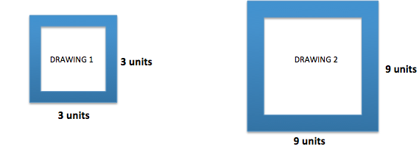
 | Drawing 1 | Drawing 2 | Scale Factor as a Fraction and Percent
Side | $$3 units$$ | $$9 units$$ | $$Quantity=Percent×Whole \\ Drawing 2=Percent×Drawing 1 \\ 9=Percent×3 \\ \frac{9}{3}=\frac{3}{1}=3=300\%$$
Area | $$A=lw \\ A=3∙3 sq. units \\ A=9 sq. units$$ | $$A=lw \\ A=9∙9 sq. units \\ A=81 sq. units$$ | $$Quantity=Percent×Whole \\ Drawing 2 Area=Percent×Drawing 1 Area \\ 81=Percent×9 \\ \frac{81}{9}=\frac{9}{1}=9=900\%$$
Scale factor: $3$ Quotient of areas: $9$
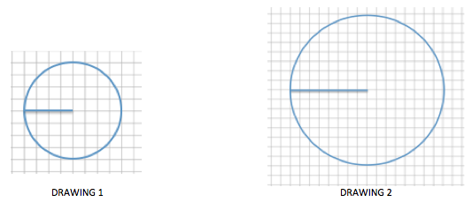

 | Drawing $1$ | Drawing $2$ | Scale Factor as a Percent
Radius | $$4 units$$ | $$8 units$$ | $$Quantity=Percent×Whole \\ Drawing 2=Percent×Drawing 1 \\ 8=Percent×4 \\ \frac{8}{4}=\frac{2}{1}=200\%$$
Area | $$A=πr^{2} \\ A=π{(4)}^{2} \\ A=16π sq. units$$ | $$A=πr^{2} \\ A=π{(8)}^{2} \\ A=64π sq. units$$ | $$Quantity=Percent×Whole \\ Drawing 2 Area=Percent×Drawing 1 Area \\ 64π=Percent×16π \\ \frac{64π}{16π}=\frac{4}{1}=4=400\%$$

Scale factor: $2$ Quotient of areas: $4$

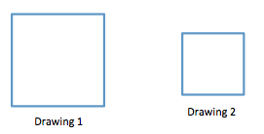
The length of each side in Drawing 1 is $12 units$, and the length of each side in Drawing 2 is $6 units$.

 | Drawing 1 | Drawing 2 | Scale Factor as a Percent
Side | $$12 units$$ | $$6 units$$ | $$Quantity=Percent×Whole \\ Drawing 2=Percent×Drawing 1 \\ 6=Percent×12 \\ \frac{6}{12}=\frac{1}{2}=50\%$$
Area | $$A=lw \\ A=12(12) \\ A=144 sq. units$$ | $$A=lw \\ A=6(6) \\ A=36 sq. units$$ | $$Quantity=Percent×Whole \\ Drawing 2 Area=Percent×Drawing 1 Area \\ 36=Percent×144 \\ \frac{36}{144}=\frac{1}{4}=25\%$$
Scale factor: $\frac{1}{2}$ Quotient of areas: $\frac{1}{4}$
Conclusion: $\left(\frac{1}{2}\right)\left(\frac{1}{2}\right)={\left(\frac{1}{2}\right)}^{2}=\frac{1}{4}$
The quotient of the areas is equal to the square of the scale factor.
Key Points: Overall Conclusion
MP.8
If the scale factor is represented by $k$, then the area of the scale drawing is $k^{2}$ times the corresponding area of the original drawing.

Discussion
- Is it necessary to find the area of each drawing to determine the ratio of areas of the scale drawing to the original drawing, if the scale factor is known?
  - No, once the scale factor of the corresponding sides is determined, the ratio of the area of the scale drawing to the original drawing is the square of the scale factor.
- Why is the scale factor often given as a percent or asked for as a percent but the area relationship is calculated as a fraction? Why can’t a percent be used for this calculation?
MP.2
  - A scale factor given or calculated as a percent allows us to see if the scale drawing is an enlargement or reduction of the original drawing. However, in order to use the percent in a calculation it must be converted to an equivalent decimal or fraction form.
- How is this relationship useful?
  - If none of the side lengths are provided but instead a scale factor is provided, the relationship between the areas can be determined without needing to find the actual area of each drawing. For instance, if only the scale factor and the area of the original drawing are provided, the area of the scale drawing can be determined. (Similarly, if only the scale factor and area of the scale drawing are given, the area of the original drawing can be found.)
- Why do you think this relationship exists?
  - If area is determined by the product of two linear measures and each measure is changed by a factor of $k$, then it stands to reason that the area will increase by a factor of $k∙k$ or $k^{2}$.

Example 1 (2 minutes)
Example 1
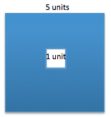
What percent of the area of the large square is the area of the small square?
Scale factor small to large square: $\frac{1}{5}$
Area of small to large:${\left(\frac{1}{5}\right)}^{2}=\frac{1}{25}=\frac{4}{100}=0.04=4\%$

Example 2 (4 minutes)
Example 2
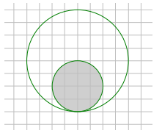
What percent of the area of the large disk lies outside the smaller disk?
Radius of small disk $=2$
Radius of large disk $=4$
Scale factor of shaded disk: $\frac{2}{4}=\frac{1}{2}$
Area of shaded disk to large disk:
$${\left(\frac{1}{2}\right)}^{2}=\frac{1}{4}=25\%$$
Area outside shaded disk: $\frac{3}{4}=75\%$

- Why does this work?
  - The relationship between the scale factor and area has already been determined. So, determining the percent of the area outside the shaded region requires going a step further and subtracting the percent within the shaded region from $100\%$.

Example 3 (4 minutes)
Example 3
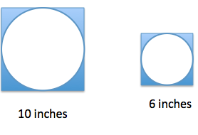
If the area of the shaded region in the larger figure is approximately $21.5$ square inches, write an equation that relates the areas using scale factor and explain what each quantity represents. Determine the area of the shaded region in the smaller scale drawing.
Scale factor of corresponding sides:
$$\frac{6}{10}=\frac{3}{5}=60\%$$

Area of shaded region of smaller figure: Assume $A$ is the area of the shaded region of the larger figure.
$${\left(\frac{3}{5}\right)}^{2}A=\frac{9}{25}A \\ {\left(\frac{3}{5}\right)}^{2}\left(21.5\right)=\frac{9}{25}A \\ \frac{9}{25}\left(21.5\right)=7.74$$
In this equation, the square of the scale factor, ${\left(\frac{3}{5}\right)}^{2}$, multiplied by the area of the shaded region in the larger figure, $21.5 sq. in.$, is equal to the area of the shaded region of the smaller figure, $7.74 sq. in$.
The area of shaded region of the smaller scale drawing is about $7.74 sq. in$.

Example 4 (4 minutes)
Example 4
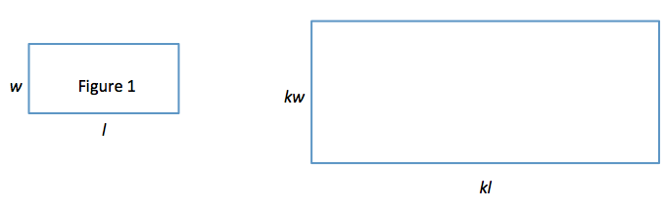
Use Figure 1 below and the enlarged scale drawing to justify why the area of the scale drawing is $k^{2}$ times the area of the original figure.

Area of figure 1: Area of scale drawing:
$Area=lw$ $Area=lw$
$Area=\left(kl\right)\left(kw\right)$
$Area=k^{2}lw$
Since the area of Figure 1 is $lw$, the area of the scale drawing is $k^{2}$multiplied by the area of Figure 1.

Explain why the expressions $(kl)(kw)$ and $k^{2}lw$ are equivalent. How do the expressions reveal different information about this situation?
MP.7
$(kl)(kw)$ is equivalent to $klkw$ by the associative property, which can be written $kklw$ using the commutative property. This is sometimes known as “any order, any grouping.” $kklw$ is equal to $k^{2}lw$ because $k×k=k^{2}$. $(kl)(kw)$ shows the area as the product of each scaled dimension, while $k^{2}lw$ shows the area as the scale factor squared, times the original area ($lw$).

Exercise 1 (14 minutes)
Complete each part of the exercise to reinforce the skills learned in this lesson and the three lessons preceding it.
Exercise 1
The Lake Smith basketball team had a team picture taken of the players, the coaches, and the trophies from the season. The picture was $4$ inches by $6$ inches. The team decided to have the picture enlarged to a poster, and then enlarged again to a banner measuring $48$ inches by $72$ inches.
  - Sketch drawings to illustrate the original picture and enlargements.

  - If the scale factor from the picture to the poster is $500\%$, determine the dimensions of the poster.
$$Quantity=Percent×Whole \\ Poster height=Percent×Picture height \\ Poster height=500\%×4 in. \\ Poster height=(5.00)(4 in.) \\ Poster height=20 in.$$ | $$Quantity=Percent×Whole \\ Poster width=Percent×Picture width \\ Poster width=500\%×6 in. \\ Poster width=(5.00)(6 in.) \\ Poster width=30 in.$$
The dimensions of the poster are $20 in.$ by $30 in$.

  - What scale factor is used to create the banner from the picture?
$$Quantity=Percent×Whole \\ Banner width=Percent×Picture width \\ 72=Percent×6 \\ \frac{72}{6}=Percent \\ 12=1,200\%$$ | $$Quantity=Percent×Whole \\ Banner height=Percent×Picture height \\ 48=Percent×4 \\ \frac{48}{4}=Percent \\ 12=1,200\%$$
The scale factor used to create the banner from the picture is $1,200\%$.

  - What percent of the area of the picture is the area of the poster? Justify your answer using the scale factor and by finding the actual areas.
Area of picture:  $$A=lw \\ A=(4)(6) \\ A=24 \\ Area=24 sq. in.$$ | Area of poster:  $$A=lw \\ A=(20)(30) \\ A=600 \\ Area=600 sq. in.$$
$$Quantity=Percent×Whole \\ Area of Poster=Percent×Area of Picture \\ 600=Percent×24 \\ \frac{600}{24}=Percent \\ 25=2500\%$$
Using scale factor:
Scale factor from picture to poster was given earlier in the problem as $500\%=\frac{500}{100}=5$.
The area of the poster is the square of the scale factor times the corresponding area of the picture. So, the area of the poster is $2500\%$ the area of the original picture.

  - Write an equation involving the scale factor that relates the area of the poster to the area of the picture.
$$Quantity=Percent×Whole \\ Area of Poster=Percent×Area of Picture \\ A=2500\% p \\ A=25p$$

  - Assume you started with the banner and wanted to reduce it to the size of the poster. What would the scale factor as a percent be?
Banner dimensions: $48 in.$ $×72 in.$
Poster dimensions: $20 in.$ $×30 in.$
$$Quantity=Percent×Whole \\ Poster=Percent×Banner \\ 30=Percent×72 \\ \frac{30}{72}=\frac{5}{12}=\frac{5}{12}×100\%=41\frac{2}{3}\%$$

  - What scale factor would be used to reduce the poster to the size of the picture?
Poster dimensions: $20 in.$ $×30 in.$
Picture dimensions: $4 in.$ $×6 in.$
$$Quantity=Percent×Whole \\ Picture width=Percent×Poster width \\ 6=Percent×30 \\ \frac{6}{30}=\frac{1}{5}=0.2=20\%$$

Closing (3 minutes)
- If you know a length in a scale drawing and its corresponding length in the original drawing, how can you determine the relationship between the areas of the drawings?
  - Answers will vary. I could use the formula $Quantity=Percent×Whole$ to solve for the percent. The percent is the scale factor that shows the relationship between the corresponding sides.
- Given a scale factor of $25\%$, would the quotient of the area of the scale drawing to the area of the original drawing be $\frac{1}{4}$?
  - No, the quotient of the areas would be equal to the square of the scale factor. Therefore, the quotient of the scale drawing to the original in this example would be equal to ${\left(\frac{1}{4}\right)}^{2}=\frac{1}{16}$
Lesson Summary
If the scale factor is represented by $k$, then the area of the scale drawing is $k^{2}$ times the corresponding area of the original drawing.

Exit Ticket (4 minutes)

Name Date
Lesson 15: Solving Area Problems Using Scale Drawings

Exit Ticket

Write an equation relating the area of the original (larger) drawing to its smaller scale drawing. Explain how you determined the equation. What percent of the area of the larger drawing is the smaller scale drawing?

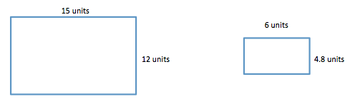

Exit Ticket Sample Solutions

Write an equation relating the area of the original (larger) drawing to its smaller scale drawing. Explain how you determined the equation. What percent of the area of the larger drawing is the smaller scale drawing?

Scale factor:
$$Quantity=Percent×Whole \\ Scale Drawing Length=Percent×Original Length \\ 6=Percent×15 \\ \frac{6}{15}=\frac{2}{5}=\frac{4}{10}=0.4$$
The area of the scale drawing is equal to the square of the scale factor times the area of the original drawing. Using $A$ to represent the area of the original drawing, then the area of the scale is
$${\left(\frac{4}{10}\right)}^{2}A=\frac{16}{100}A.$$
As a percent, $\frac{16}{100}A=0.16A$ .
Therefore, the area of the scale drawing is $16\%$ of the area of the original drawing.

Problem Set Sample Solutions

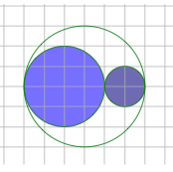
- What percent of the area of the larger circle is shaded?
  - Solve this problem using scale factors.
Scale factors:
Shaded small circle: radius $=1 unit$
Shaded medium circle: radius $=2 units$
Large circle: radius $=3 units$, area $=A$
Area of small circle: ${\left(\frac{1}{3}\right)}^{2}A=\frac{1}{9}A$
Area of medium circle: ${\left(\frac{2}{3}\right)}^{2}A=\frac{4}{9}A$
Area of shaded region: $\frac{1}{9}A+\frac{4}{9}A=\frac{5}{9}A=\frac{5}{9}×100\%$,$A=55\frac{5}{9}\%A$
The area of the shaded region is $55\frac{5}{9}\%$of the area of the entire circle.
  - Verify your work in part (a) by finding the actual areas.
Areas:
Small circle: $A=πr^{2}$
$A=π{\left(1\right)}^{2} square units$
$A=1π square units$
Medium circle: $A=πr^{2}$
$A=π{\left(2\right)}^{2} square units$
$A=4π square units$
Area of shaded circles: $1π+4π=5π$
Large circle: $A=πr^{2}$
$A=π{\left(3\right)}^{2} square units$
$A=9π square units$
Percent of shaded to large circle: $\frac{5π}{9π}=\frac{5}{9}=\frac{5}{9}×100\%=55\frac{5}{9}\%$

- The area of the large disk is $50.24 units^{2}$.
  - Find the area of the shaded region using scale factors. Use $3.14$ as an estimate for $π$.
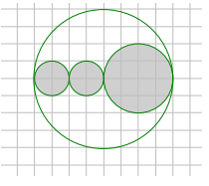
Radius of small shaded circles $=1 unit$
Radius of larger shaded circle $=2 units$
Radius of large disk $=$ $4 units$
Scale factor of shaded region:
Small shaded circles: $\frac{1}{4}$
Large shaded circle: $\frac{2}{4}$
If $A$ represents the area of the large disk, then the total shaded area:
$${\left(\frac{1}{4}\right)}^{2}A+{\left(\frac{1}{4}\right)}^{2}A+{\left(\frac{2}{4}\right)}^{2}A$$
$$\frac{1}{16}A+\frac{1}{16}A+\frac{4}{16}A=\frac{6}{16}A \\ \frac{6}{16}A=\frac{6}{16}\left(50.24\right) units^{2}$$
The area of the shaded region is $18.84 units^{2}$.

  - What percent of the large circular region is unshaded?
Area of the shaded region is $18.84$square units. Area of total is $50.24$square units. Area of the unshaded region is $31.40$ square units. Percent of large circular region that is unshaded is
$$\frac{31.4}{50.24}=\frac{5}{8}=0.625=62.5\%$$

- Ben cut the following rockets out of cardboard. The height from the base to the tip of the smaller rocket is $20 cm$. The height from the base to the tip of the larger rocket is $120 cm$. What percent of the area of the smaller rocket is the area of the larger rocket?
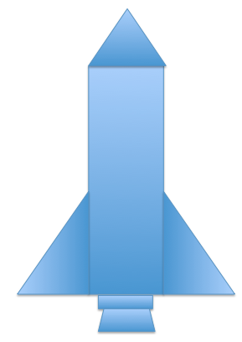
Height of smaller rocket: $20 cm$
Height of larger rocket: $120 cm$
Scale factor:
$$Quantity=Percent×Whole \\ Actual height of larger rocket=Percent×height of smaller rocket \\ 120=Percent×20 \\ 6=Percent$$
$$600\%$$
Area of larger rocket:
$${\left(scale factor\right)}^{2}\left(area of smaller rocket\right)$$
$${\left(6\right)}^{2}(area of smaller rocket)$$
$$36A$$
$$36=36×100\%=3600\%$$
The area of the larger rocket is $3,600\%$ the area of the smaller rocket.

- In the photo frame depicted below, three $5$ inch by $5$ inch squares are cut out for photographs. If these cut-out regions make up$\frac{3}{16}$ of the area of the entire photo frame, what are the dimensions of the photo frame?
Since the cut-out regions make up$\frac{3}{16}$ of the entire photo frame, then each cut-out region makes up$\frac{\frac{3}{16}}{3}=\frac{1}{16}$ of the entire photo frame.
The relationship between the area of the scale drawing is
$$(square factor)^{2}×area of original drawing.$$
The area of each cut-out is$\frac{1}{16}$of the area of the original photo frame. Therefore, the square of the scale factor is$\frac{1}{16}$. Since ${\left(\frac{1}{4}\right)}^{2}=\frac{1}{16}$, the scale factor that relates the cut-out to the entire photo frame is$\frac{1}{4}$, or $25\%$.
To find the dimensions of the square photo frame:
$$Quantity=Percent×Whole \\ Small square side length=Percent×Photo frame side length \\ 5 in.=25\%×Photo frame side length \\ 5 in.=\frac{1}{4}×Photo frame side length \\ 4\left(5\right) in.=4\left(\frac{1}{4}\right)×Photo frame side length \\ 20 in.=Photo frame side length$$
The dimensions of the square photo frame are $20 in.$ by $20 in$.

- Kelly was online shopping for envelopes for party invitations and saw these images on a website.

The website listed the dimensions of the small envelope as $6 in.$ by $8 in.$ and the medium envelope as $10 in.$ by $13\frac{1}{3} in$.
  - Compare the dimensions of the small and medium envelopes. If the medium envelope is a scale drawing of the small envelope, what is the scale factor?
To find the scale factor,
$$Quantity=Percent×Whole \\ Medium height=Percent×small height \\ 10=Percent×6 \\ \frac{10}{6}=\frac{5}{3}=\frac{5}{3}×100\%=166\frac{2}{3}\%$$ | $$Quantity=Percent×Whole \\ Medium width=Percent×Small width \\ 13\frac{1}{3}=Percent×8 \\ \frac{13\frac{1}{3}}{8}=\frac{5}{3}=\frac{5}{3} ×100\%=166\frac{2}{3}\%$$

  - If the large envelope was created based on the dimensions of the small envelope using a scale factor of $250\%$, find the dimensions of the large envelope.
Scale factor is $250\%$, so multiply each dimension of the small envelope by $2.50$.
Large envelope dimensions are as follows:
$6(2.5) in. =15 in.$ $8\left(2.5\right) in. =20 in.$

  - If the medium envelope was created based on the dimensions of the large envelope, what scale factor was used to create the medium envelope?
Scale factor:
$$Quantity=Percent×Whole \\ Medium=Percent×Large \\ 10=Percent×15 \\ \frac{10}{15}=Percent \\ \frac{2}{3}=\frac{2}{3}×100\%=66\frac{2}{3}\%$$ | $$Quantity=Percent×Whole \\ Medium=Percent×Large \\ 13\frac{1}{3}=Percent×20 \\ \frac{13\frac{1}{3}}{20}=Percent \\ \frac{2}{3}=\frac{2}{3}×100\%=66\frac{2}{3}\%$$

  - What percent of the area of the larger envelope is the area of the medium envelope?
Scale factor of larger to medium: $66\frac{2}{3}\%=\frac{2}{3}$
Area: ${\left(\frac{2}{3}\right)}^{2}=\frac{4}{9}=\frac{4}{9}×100\%=44\frac{4}{9}\%$
The area of the medium envelope is $44\frac{4}{9}\%$ of the larger envelope.

