Lesson 14: Computing Actual Lengths from a Scale Drawing

Classwork
Example 1
The distance around the entire small boat is $28.4 units$. The larger figure is a scale drawing of the smaller drawing of the boat. State the scale factor as a percent, and then use the scale factor to find the distance around the scale drawing.
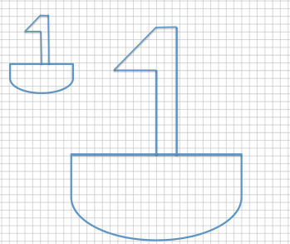

Exercise 1
The length of the longer path is $32.4 units$. The shorter path is a scale drawing of the longer path. Find the length of the shorter path, and explain how you arrived at your answer.
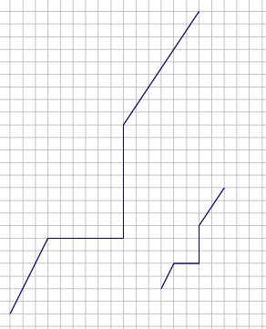

Example 2: Time to Garden
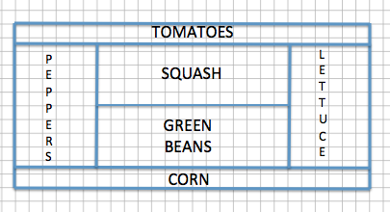
Sherry designed her garden as shown in the diagram above. The distance between any two consecutive vertical grid lines is $1$ foot, and the distance between any two consecutive horizontal grid lines is also $1$ foot. Therefore, each grid square has an area of one square foot. After designing the garden, Sherry decided to actually build the garden $75\%$ of the size represented in the diagram.
  - What are the outside dimensions shown in the blueprint?

  - What will the overall dimensions be in the actual garden? Write an equation to find the dimensions. How does the problem relate to the scale factor?

  - If Sherry plans to use a wire fence to divide each section of the garden, how much fence does she need?

  - If the fence costs $\$3.25$ per foot plus $7\%$ sales tax, how much would the fence cost in total?

Example 3
Race Car #2 is a scale drawing of Race Car #1. The measurement from the front of Car #1 to the back of Car #1 is $12$ feet, while the measurement from the front of Car #2 to the back of Car #2 is $39$ feet. If the height of Car #1 is $4$ feet, find the scale factor, and write an equation to find the height of Car #2. Explain what each part of the equation represents in the situation.
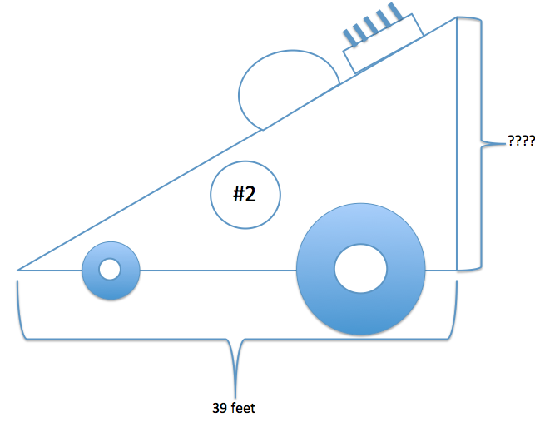
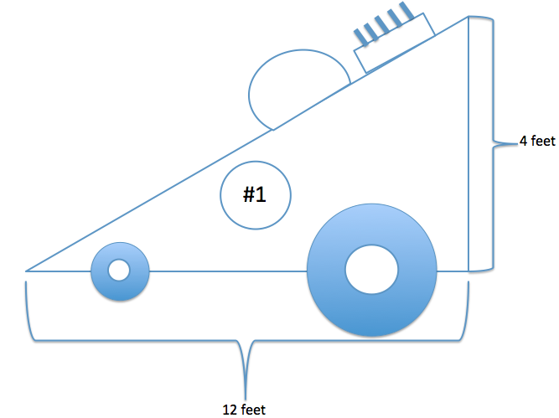

Exercise 2
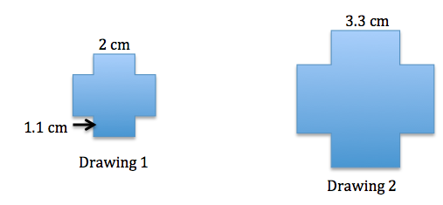
Determine the scale factor, and write an equation that relates the vertical heights of each drawing to the scale factor. Explain how the equation illustrates the relationship.

Exercise 3
The length of a rectangular picture is $8$ inches, and the picture is to be reduced to be $45\frac{1}{2}\%$ of the original picture. Write an equation that relates the lengths of each picture. Explain how the equation illustrates the relationship.

Lesson Summary
The scale factor is the number that determines whether the new drawing is an enlargement or a reduction of the original. If the scale factor is greater than $100\%$, then the resulting drawing will be an enlargement of the original drawing. If the scale factor is less than $100\%$, then the resulting drawing will be a reduction of the original drawing.
To compute actual lengths from a scale drawing, a scale factor must first be determined. To do this, use the relationship $Quantity=Percent×Whole$, where the original drawing represents the whole and the scale drawing represents the quantity. Once a scale factor is determined, then the relationship
$Quantity=Percent×Whole$ can be used again using the scale factor as the percent, the actual length from the original drawing as the whole, and the actual length of the scale drawing as the quantity.

Problem Set

- The smaller train is a scale drawing of the larger train. If the length of the tire rod connecting the three tires of the larger train, as shown below, is $36$ inches, write an equation to find the length of the tire rod of the smaller train. Interpret your solution in the context of the problem.

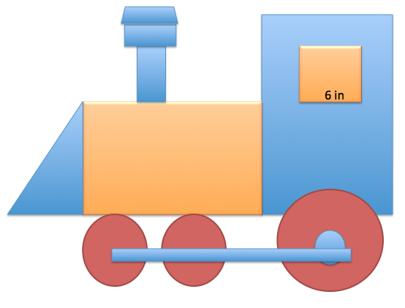
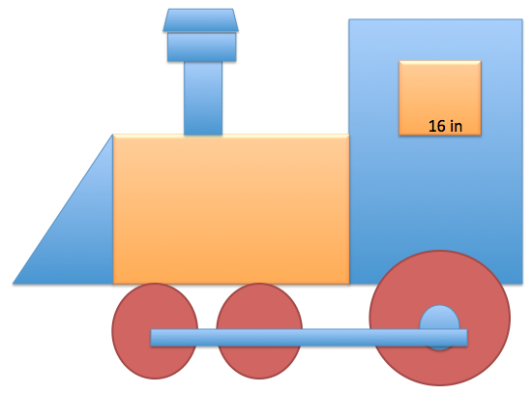

- The larger arrow is a scale drawing of the smaller arrow. The distance around the smaller arrow is $28 units$. What is the distance around the larger arrow? Use an equation to find the distance and interpret your solution in the context of the problem.
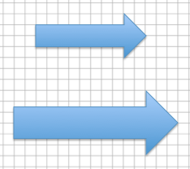

- The smaller drawing below is a scale drawing of the larger. The distance around the larger drawing is $39.3 units$. Using an equation, find the distance around the smaller drawing.
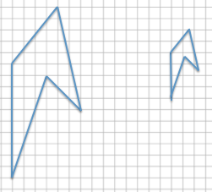

- The figure is a diagram of a model rocket. The length of a model rocket is $2.5$ feet, and the wing span is $1.25$ feet. If the length of an actual rocket is $184$ feet, use an equation to find the wing span of the actual rocket.

