Lesson 14: Computing Actual Lengths from a Scale Drawing

Student Outcomes
- Given a scale drawing, students compute the lengths in the actual picture using the scale factor.

Lesson Notes
The first example is an opportunity to highlight MP.1 as students work through a challenging problem to develop an understanding of how to use a scale drawing to determine the scale factor. Consider asking students to attempt the problem on their own or in groups. Then discuss and compare reasoning and methods.

Classwork
Example 1 (8 minutes)
Scaffolding:
Consider modifying this task to involve simpler figures, such as rectangles, on grid paper.
Example 1
The distance around the entire small boat is $28.4 units$. The larger figure is a scale drawing of the smaller drawing of the boat. State the scale factor as a percent, and then use the scale factor to find the distance around the scale drawing.
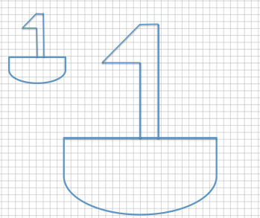

Scale factor:
Horizontal distance of the smaller boat: $8 units$ Vertical sail distance of smaller boat: $6 units$
Horizontal distance of the larger boat: $22 units$ Vertical sail distance of larger boat: $16.5 units$
Scale factor: $Quantity=Percent×Whole$
Smaller boat is the whole.
Total Distance:
Distance around small sailboat $=28.4 units$
Distance around large sailboat $=$ $28.4(275\%)=28.4(2.75)=78.1$
The distance around the large sailboat is $78.1 units$.
$$Length in larger=Percent×Length in smaller \\ 22=P×8 \\ \frac{22}{8}=2.75=275\%$$ | $$Length in larger=Percent×Length in smaller \\ 16.5=P×6 \\ \frac{16.5}{6}=2.75=275\%$$

Discussion
- Recall the definition of the scale factor of a scale drawing.
  - The scale factor is the quotient of any length of the scale drawing and the corresponding length of the actual drawing.
- Since the scale factor is not given, how can the given diagrams be used to determine the scale factor?
  - We can use the gridlines on the coordinate plane to determine the lengths of the corresponding sides and then use these lengths to calculate the scale factor.
- Which corresponding parts did you choose to compare when calculating the scale factor, and why did you choose them?
  - The horizontal segments representing the deck of the sailboat are the only segments where all four endpoints fall on grid lines. Therefore, we can compare these lengths using whole numbers.
- If we knew the measures of all of the corresponding parts in both figures, would it matter which two we compare to calculate the scale factor? Should we always get the same value for the scale factor?
  - Yes. There is no indication in the problem that the horizontal scale factor is different than the vertical scale factor, so the entire drawing is the same scale of the original drawing.
- Since the scale drawing is an enlargement of the original drawing, what percent should the scale factor be?
  - Since it is an enlargement, the scale factor should be larger than $100\%$.
- How did we use the scale factor to determine the total distance around the scale drawing (the larger figure)?
  - Once we knew the scale factor, we found the total distance around the larger sailboat by multiplying the total distance around the smaller sailboat by the scale factor.

Exercise 1 (5 minutes)
Exercise 1
The length of the longer path is $32.4 units$. The shorter path is a scale drawing of the longer path. Find the length of the shorter path, and explain how you arrived at your answer.
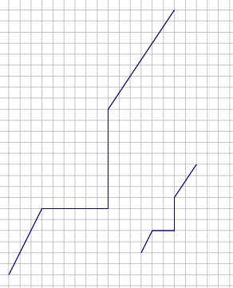

First, determine the scale factor. Since the smaller path is a reduction of the original drawing, the scale factor should be less than $100\%$. Since the smaller path is a scale drawing of the larger, the larger path is the whole in the relationship.
$$Quantity=Percent×Whole$$
To determine the scale factor, compare the horizontal segments of the smaller path to the larger path.
$$Smaller=Percent×Larger \\ 2=Percent×6 \\ \frac{2}{6}=\frac{1}{3}=33\frac{1}{3}\%$$
To determine the length of the smaller path, multiply the length of the larger path by the scale factor.
$32.4\left(\frac{1}{3}\right)=10.8$
The length of the shorter path is $10.8 units$.

Example 2 (14 minutes): Time to Garden
Example 2: Time to Garden
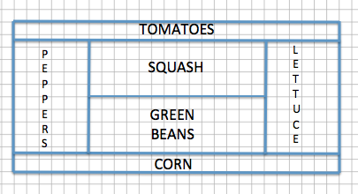
Sherry designed her garden as shown in the diagram above. The distance between any two consecutive vertical grid lines is $1$ foot, and the distance between any two consecutive horizontal grid lines is also $1$ foot. Therefore, each grid square has an area of one square foot. After designing the garden, Sherry decided to actually build the garden $75\%$ of the size represented in the diagram.
  - What are the outside dimensions shown in the blueprint?
Blueprint dimensions: Length: $26$ boxes $=$ $26 ft.$
Width: $12$ boxes $=$ $12 ft.$

  - What will the overall dimensions be in the actual garden? Write an equation to find the dimensions. How does the problem relate to the scale factor?
Actual garden dimensions ($75\%$ of blueprint): $19.5 ft.$ $×9 ft.$
Length: $(26)(0.75)=19.5 ft.$
Width: $(12)(0.75)=9 ft.$
Since the scale factor was given as $75\%$, each dimension of the actual garden should be $75\%$ of the original corresponding dimension. The actual length of the garden,$19.5 ft$., is $75\%$ of $26$, and the actual width of the garden, $9 ft$., is $75\%$ of $12$.

  - If Sherry plans to use a wire fence to divide each section of the garden, how much fence does she need?
Dimensions of the blueprint:
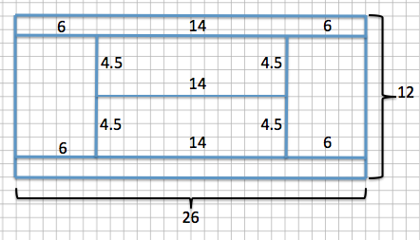

Total amount of wire needed for the blueprint:
$26(4)+12(2)+4.5\left(4\right)+14=160$
The amount of wire needed is $160 ft.$
New dimensions of actual garden:
Length: $19.5 ft.$(from part (b))
Width: $9 ft.$ (from part (b))
Inside borders: $4.5\left(0.75\right)=3.375$; $3.375 ft.$
$14(0.75)=10.5$; $10.5 ft.$
The dimensions of the inside borders are $3.375 ft.$ by $10.5 ft$.

Total wire with new dimensions:
$19.5(4)+9(2)+3.375\left(4\right)+10.5=120$
OR
$160(0.75)=120$
Total wire with new dimensions is $120 ft$.
Simpler way: $75\%$ of $160 ft.$is $120 ft$.

  - If the fence costs $\$3.25$ per foot plus $7\%$ sales tax, how much would the fence cost in total?
$$3.25\left(120\right)=390$$
$390\left(1.07\right)=417.30$
The total cost is $\$417.30$.

Discussion
- Why is the actual garden a reduction of the garden represented in the blueprint?
  - The given scale factor was less than $100\%$, which results in a reduction.
- Does it matter if we find the total fencing needed for the garden in the blueprint and multiply the total by the scale factor versus finding each dimension of the actual garden using the scale factor and then determining the total fencing needed by finding the sum of the dimensions? Why or why not? What mathematical property is being illustrated?
  - No, it does not matter. If you determine each measurement of the actual garden first by using the scale factor and then add them together, the result is the same as if you were to find the total first and then multiply it by the scale factor. If you find the corresponding side lengths first, then you are using the distributive property to distribute the scale factor to every measurement.
$$(0.75)(104+24+18+14)=78+18+13.5+10.5 \\ (0.75)(160)=120 \\ 120=120$$
- By the distributive property, the expressions $(0.75)(104+24+18+14)$ and $(0.75)(160)$ are equivalent, but each reveals different information. The first expression implies $75\%$ of a collection of lengths, while the second is $75\%$ of the total of the lengths.
- If we found the total cost, including tax, for one foot of fence and then multiplied that cost by the total amount of feet needed, would we get the same result as if we were to first find the total cost of the fence, and then calculate the sales tax on the total? Justify your reasoning with evidence. How does precision play an important role in the problem?
  - It should not matter; however, if we were to calculate the price first, including tax, per foot, the answer would be $(3.25)(1.07)=3.4775$. When we solve a problem involving money, we often round to two decimal places; doing so gives us a price of $\$3.48$ per foot in this case. Then, to determine the total cost, we multiply the price per foot by the total amount, giving us $(3.48)(120)=\$417.60$. If the before-tax total is calculated, then we would get $\$417.30$, leaving a difference of $\$0.30$. Rounding in the problem early on is what caused the discrepancy. Therefore, to obtain the correct, precise answer, we should not round in the problem until the very final answer. If we had not rounded the price per foot, then the answers would have agreed.
$$\left(3.4775\right)\left(120\right)=417.30$$
- Rounding aside, what is an equation that shows that it does not matter which method we use to calculate the total cost? What property justifies the equivalence?
  - $\left(3.25\right)\left(1.07\right)\left(120\right)=(120)(3.25)(1.07)$. These expressions are equivalent due to the commutative property.

Example 3 (5 minutes)
Example 3
Race Car #2 is a scale drawing of Race Car #1. The measurement from the front of Car #1 to the back of Car #1 is $12$ feet, while the measurement from the front of Car #2 to the back of Car #2 is $39$ feet. If the height of Car #1 is $4$ feet, find the scale factor, and write an equation to find the height of Car #2. Explain what each part of the equation represents in the situation.
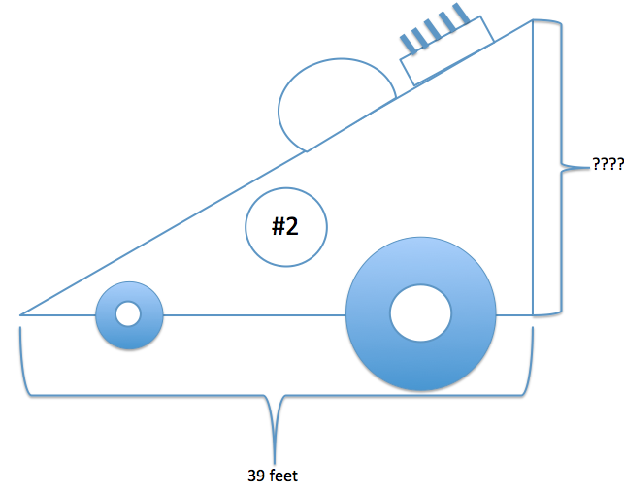
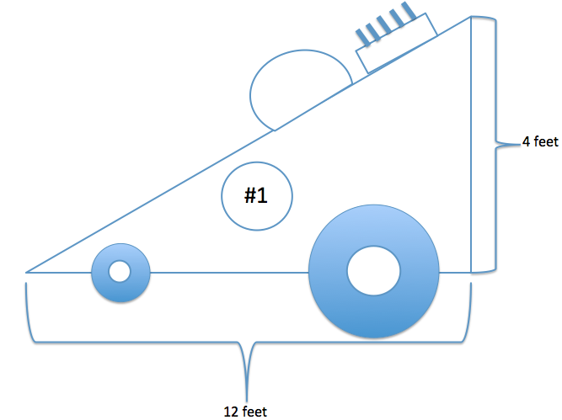

Scale Factor: The larger race car is a scale drawing of the smaller. Therefore, the smaller race car is the whole in the relationship.
$$Quantity=Percent×Whole \\ Larger=Percent×Smaller \\ 39=Percent×12 \\ \frac{39}{12}=3.25=325\%$$
Height: $4\left(3.25\right)=13$
The height of Car #2 is $13 ft$.
The equation shows that the smaller height, $4 ft.$, multiplied by the scale factor of $3.25$, equals the larger height, $13 ft$.

Discussion
- By comparing the corresponding lengths of Race Car #2 to Race Car #1, we can conclude that Race Car #2 is an enlargement of Race Car #1. If Race Car #1 were a scale drawing of Race Car #2, how and why would the solution change?
  - The final answer would still be the same. The corresponding work would be different―when Race Car #2 is a scale drawing of Race Car #1, the scale drawing is an enlargement, resulting in a scale factor greater than $100\%$. Once the scale factor is determined, we find the corresponding height of Race Car #2 by multiplying the height of Race Car #1 by the scale factor, which is greater than $100\%$. If Race Car #1 were a scale drawing of Race Car #2, the scale drawing would be a reduction of the original, and the scale factor would be less than $100\%$. Once we find the scale factor, we then find the corresponding height of Race Car #2 by dividing the height of Race Car #1 by the scale factor.

Exercise 2 (4 minutes)
Exercise 2
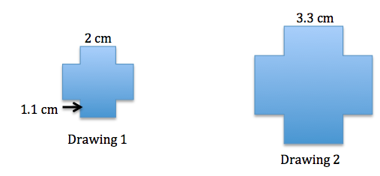
Determine the scale factor, and write an equation that relates the vertical heights of each drawing to the scale factor. Explain how the equation illustrates the relationship.

Equation: $1.1(scale factor)=vertical height in Drawing 2$
First find the scale factor:
$$Quantity=Percent×Whole \\ Drawing 2=Percent×Drawing 1 \\ 3.3=Percent×2 \\ \frac{3.3}{2}=1.65=165\%$$
Equation: $\left(1.1\right)\left(1.65\right)=1.815$
The vertical height of Drawing 2 is $1.815 cm$.
Once we determine the scale, we can write an equation to find the unknown vertical distance by multiplying the scale factor by the corresponding distance in the original drawing.

Exercise 3 (2 minutes)
Exercise 3
The length of a rectangular picture is $8$ inches, and the picture is to be reduced to be $45\frac{1}{2}\%$ of the original picture. Write an equation that relates the lengths of each picture. Explain how the equation illustrates the relationship.
$$8\left(0.455\right)=3.64$$
The length of the reduced picture is $3.64 in$. The equation shows that the length of the reduced picture, $3.64$, is equal to the original length, $8$, multiplied by the scale factor, $0.455$.

Closing (2 minutes)
- How do you compute the scale factor when given a figure and a scale drawing of that figure?
  - Using the formula $Quantity=Percent×Whole$, I can use corresponding lengths from the original and the scale drawing as the whole and the quantity. The answer will be a percent which is also the scale factor.
- How do you use the scale factor to compute the lengths of segments in the scale drawing and the original figure?
  - I can convert the scale factor to a percent and then use the formula $Quantity=Percent×Whole$. Then, I would replace either the quantity or the whole with the given information and solve for the unknown value.

Lesson Summary
The scale factor is the number that determines whether the new drawing is an enlargement or a reduction of the original. If the scale factor is greater than $100\%$, then the resulting drawing will be an enlargement of the original drawing. If the scale factor is less than $100\%$, then the resulting drawing will be a reduction of the original drawing.
To compute actual lengths from a scale drawing, a scale factor must first be determined. To do this, use the relationship $Quantity=Percent×Whole$, where the original drawing represents the whole and the scale drawing represents the quantity. Once a scale factor is determined, then the relationship
$Quantity=Percent×Whole$ can be used again using the scale factor as the percent, the actual length from the original drawing as the whole, and the actual length of the scale drawing as the quantity.

Exit Ticket (5 minutes)

Name Date
Lesson 14: Computing Actual Lengths from a Scale Drawing

Exit Ticket

Each of the designs shown below is to be displayed in a window using strands of white lights. The smaller design requires $225$ feet of lights. How many feet of lights does the enlarged design require? Support your answer by showing all work and stating the scale factor used in your solution.

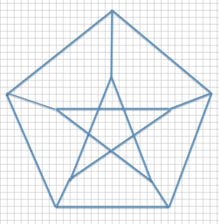

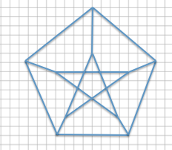
Exit Ticket Sample Solutions

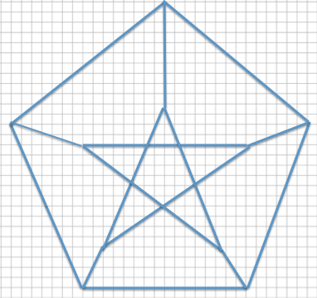
Each of the designs shown below is to be displayed in a window using strands of white lights. The smaller design requires $225$ feet of lights. How many feet of lights does the enlarged design require? Support your answer by showing all work and stating the scale factor used in your solution.

Scale Factor:
Bottom horizontal distance of the smaller design: $8$
Bottom horizontal distance of the larger design: $16$
The smaller design will represent the whole since we are going from the smaller to the larger.
$$Quantity=Percent×Whole \\ Larger=Percent×Smaller \\ 16=Percent×8 \\ \frac{16}{8}=2=200\%$$
Number of feet of lights needed for the larger design:
$225 ft.\left(200\%\right)=225 ft.\left(2\right)=450 ft$.

Problem Set Sample Solutions

- The smaller train is a scale drawing of the larger train. If the length of the tire rod connecting the three tires of the larger train, as shown below, is $36$ inches, write an equation to find the length of the tire rod of the smaller train. Interpret your solution in the context of the problem.
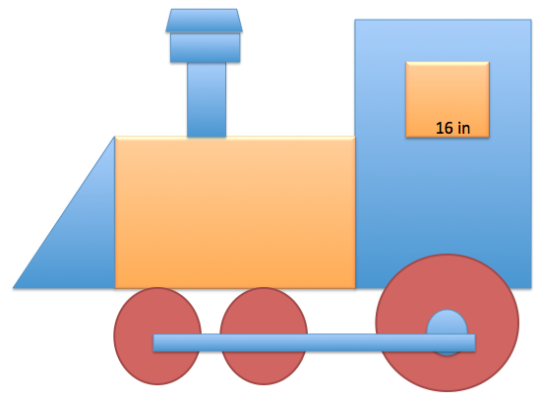
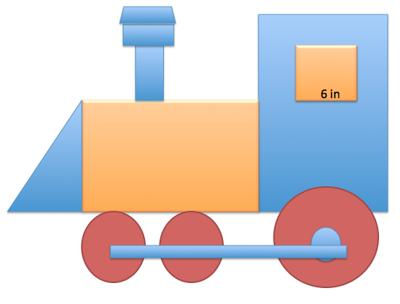

Scale factor:
$$Smaller=Percent×Larger \\ 6=Percent×16 \\ \frac{6}{16}=0.375=37.5\%$$
Tire rod of small train: $\left(36\right)\left(0.375\right)=13.5$
The length of the tire rod of the small train is $13.5 in$.
Since the scale drawing is smaller than the original, the corresponding tire rod is the same percent smaller as the windows. Therefore, finding the scale factor using the windows of the trains allows us to then use the scale factor to find all other corresponding lengths.

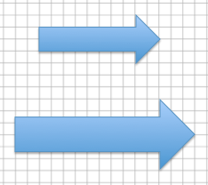
- The larger arrow is a scale drawing of the smaller arrow. If the distance around the smaller arrow is $28 units$. What is the distance around the larger arrow? Use an equation to find the distance and interpret your solution in the context of the problem.
Horizontal distance of small arrow: $8 units$
Horizontal distance of larger arrow: $12 units$
Scale factor:
$$Larger=Percent×Smaller \\ 12=Percent×8 \\ \frac{12}{8}=1.5=150\%$$
Distance around larger arrow:
$$\left(28\right)\left(1.5\right)=42$$
The distance around the larger arrow is $42 units$.
An equation where the distance of the smaller arrow is multiplied by the scale factor results in the distance around the larger arrow.
- The smaller drawing below is a scale drawing of the larger. The distance around the larger drawing is $39.3 units$. Using an equation, find the distance around the smaller drawing.
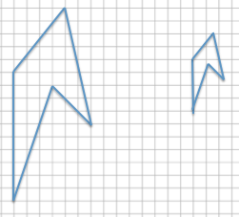
Vertical distance of large drawing: $10 units$
Vertical distance of small drawing: $4 units$
Scale factor:
$$Smaller=Percent×Larger \\ 4=Percent×10 \\ \frac{4}{10}=0.4=40\%$$
Total distance:
$$\left(39.3\right)\left(0.4\right)=15.72$$
The total distance around the smaller drawing is $15.72 units$.

- The figure is a diagram of a model rocket. The length of a model rocket is $2.5$ feet, and the wing span is $1.25$ feet. If the length of an actual rocket is $184$ feet, use an equation to find the wing span of the actual rocket.
Length actual rocket: $184 ft.$
Length of model rocket: $2.5 ft.$
Scale Factor:
$$Actual=Percent×Model \\ 184=Percent×2.5 \\ \frac{184}{2.5}=73.60=7,360\%$$

Wing span:
Model rocket wing span: $1.25 ft.$
Actual: $\left(1.25\right)\left(73.60\right)=92$
The wing span of the actual rocket is $92 ft.$

