Lesson 13: Changing Scales

Classwork
Opening Exercise
Scale factor: $\frac{length in SCALE drawing}{Corresponding length in ORIGINAL drawing}$

Describe, using percentages, the difference between a reduction and an enlargement.

Use the two drawings below to complete the chart. Calculate the first row (Drawing 1 to Drawing 2) only.

 | Quotient of Corresponding Horizontal Distances | Quotient of Corresponding Vertical Distances | Scale Factor as a Percent | Reduction or Enlargement?
Drawing 1 to Drawing 2
Drawing 2 to Drawing 1

Compare Drawing 2 to Drawing 1. Using the completed work in the first row, make a conjecture (statement) about what the second row of the chart will be. Justify your conjecture without computing the second row.

Compute the second row of the chart. Was your conjecture proven true? Explain how you know.

Example 1
The scale factor from Drawing 1 to Drawing 2 is $60\%$. Find the scale factor from Drawing 2 to Drawing 1. Explain your reasoning.
$$1$$
$$2$$

Example 2
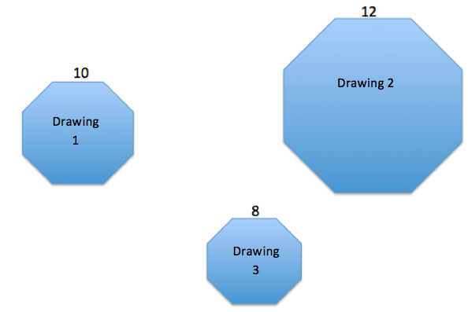
A regular octagon is an eight-sided polygon with side lengths that are all equal. All three octagons are scale drawings of each other. Use the chart and the side lengths to compute each scale factor as a percent. How can we check our answers?

Actual Drawing to Scale Drawing | Scale Factor | Equation to Illustrate Relationship
Drawing 1 to Drawing 2
Drawing 1 to Drawing 3
Drawing 2 to Drawing 1
Drawing 2 to Drawing 3
Drawing 3 to Drawing 1
Drawing 3 to Drawing 2
Example 3
The scale factor from Drawing 1 to Drawing 2 is $112\%$, and the scale factor from Drawing 1 to Drawing 3 is $84\%$. Drawing 2 is also a scale drawing of Drawing 3. Is Drawing 2 a reduction or an enlargement of Drawing 3? Justify your answer using the scale factor. The drawing is not necessarily drawn to scale.
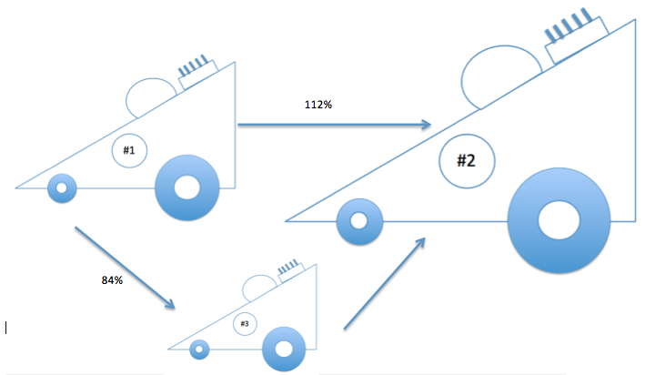

Explain how you could use the scale factors from Drawing 1 to Drawing 2 ($112\%$) and from Drawing 2 to Drawing 3 ($75\%$) to show that the scale factor from Drawing 1 to Drawing 3 is $84\%$.

Problem Set
Lesson Summary
To compute the scale factor from one drawing to another, use the representation:
$$Quantity=Percent×Whole$$
where the whole is the length in the actual or original drawing and the quantity is the length in the scale drawing.
If the lengths of the sides are not provided but two scale factors are provided, use the same relationship but use the scale factors as the whole and quantity instead of the given measurements.

- The scale factor from Drawing 1 to Drawing 2 is $41\frac{2}{3}\%$. Justify why Drawing 1 is a scale drawing of Drawing 2 and why it is an enlargement of Drawing 2. Include the scale factor in your justification.
1
2

- The scale factor from Drawing 1 to Drawing 2 is $40\%$, and the scale factor from Drawing 2 to Drawing 3 is $37.5\%$. What is the scale factor from Drawing 1 to Drawing 3? Explain your reasoning, and check your answer using an example.

- Traci took a photograph and printed it to be a size of $4 units$ by $4 units$as indicated in the diagram. She wanted to enlarge the original photograph to a size of $5 units$ by $5 units$ and $10 units$ by $10 units$.
  - Sketch the different sizes of photographs.
  - What was the scale factor from the original photo to the photo that is $5 units$by$5 units$?
  - What was the scale factor from the original photo to the photo that is $10 units$by$10 units$?
  - What was the scale factor from the $5×5$ photo to the $10×10$ photo?
  - Write an equation to verify how the scale factor from the original photo to the enlarged $10×10$ photo can be calculated using the scale factors from the original to the $5×5$, and then from the $5×5$ to the $10×10$.

- The scale factor from Drawing 1 to Drawing 2 is $30\%$, and the scale factor from Drawing 1 to Drawing 3 is $175\%$. What are the scale factors of each given relationship? Then, answer the question that follows.
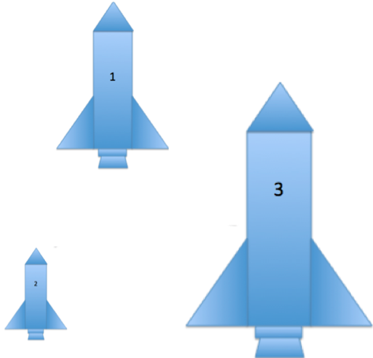
  - Drawing 2 to Drawing 3
  - Drawing 3 to Drawing 1
  - Drawing 3 to Drawing 2
  - How can you check your answers?

