Lesson 13: Changing Scales

Student Outcomes
- Given Drawing 1 and Drawing 2 (a scale model of Drawing 1 with scale factor), students understand that Drawing 1 is also a scale model of Drawing 2 and compute the scale factor.
- Given three drawings that are scale drawings of each other and two scale factors, students compute the other related scale factor.

Classwork
Opening Exercise (8 minutes)
Scaffolding:
To assist in determining the difference between a reduction and enlargement, fill in the blanks.
A scale drawing is a reduction of the actual drawing when the corresponding lengths of the scale drawing are smaller than the lengths in the actual drawing and when the scale factor is less than $100\%$.
A scale drawing is an enlargement of the actual drawing when the corresponding lengths of the scale drawing are larger than the lengths in the actual drawing and when the scale factor is greater than $100\%$.

Students compare two drawings and determine the scale factor of one drawing to the second drawing and also decide whether one drawing is an enlargement of the original drawing or a reduction.
Opening Exercise
Scale factor: $\frac{length in SCALE drawing}{Corresponding length in ORIGINAL drawing}$

Describe, using percentages, the difference between a reduction and an enlargement.
A scale drawing is a reduction of the original drawing when the lengths of the scale drawing are smaller than the lengths in the original drawing. The scale factor is less than $100\%$.
MP.2
A scale drawing is an enlargement of the original drawing when the lengths of the scale drawing are greater than the lengths in the original drawing. The scale factor is greater than $100\%$.

Use the two drawings below to complete the chart. Calculate the first row (Drawing 1 to Drawing 2) only.
 | Quotient of Corresponding Horizontal Distances | Quotient of Corresponding Vertical Distances | Scale Factor as a Percent | Reduction or Enlargement?
Drawing 1 to Drawing 2 | $$\frac{3.92}{2.45}=1.6$$ | $$\frac{2.4}{1.5}=1.6$$ | $$1.6=\frac{160}{100}=160\%$$ | Enlargement
Drawing 2 to Drawing 1

Compare Drawing 2 to Drawing 1. Using the completed work in the first row, make a conjecture (statement) about what the second row of the chart will be. Justify your conjecture without computing the second row.
Drawing 1 will be a reduction of Drawing 2. I know this because the corresponding lengths in Drawing 1 are smaller than the corresponding lengths in Drawing 2. Therefore, the scale factor from Drawing 2 to Drawing 1 would be less than $100\%$.
MP.3
Since Drawing 2 increased by $60\%$ from Drawing 1, students may incorrectly assume the second row is $60\%$ from the percent increase and $40\%$ after subtracting $100\%-60\%=40\%$.
Compute the second row of the chart. Was your conjecture proven true? Explain how you know.
The conjecture was true because the calculated scale factor from Drawing 2 to Drawing 1 was $62.5\%$. Since the scale factor is less than $100\%$, the scale drawing is indeed a reduction.

 | Quotient of Corresponding Horizontal Distances | Quotient of Corresponding Vertical Distances | Scale Factor as a Percent | Reduction or Enlargement?
Drawing 1 to Drawing 2 | $$\frac{3.92}{2.45}=1.6$$ | $$\frac{2.4}{1.5}=1.6$$ | $$1.6=\frac{160}{100}=160\%$$ | Enlargement
Drawing 2 to Drawing 1 | $$\frac{2.45}{3.92}=0.625$$ | $$\frac{1.5}{2.40}=0.625$$ | $$0.625=\frac{62.5}{100}=62.5\%$$ | Reduction
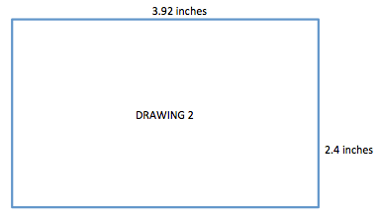

Discussion (7 minutes)
- If Drawing 2 is a scale drawing of Drawing 1, would it be a reduction or an enlargement? How do you know?
  - It would be an enlargement because the scale factor as a percent will be larger than $100\%$.
If students do not use scale factor as part of their rationale, ask the following question:
- We were working with the same two figures. Why was one comparison a reduction and the other an enlargement?
  - Drawing 1 is a reduction of Drawing 2 because the corresponding lengths in Drawing 1 are smaller than the corresponding lengths in Drawing 2. Drawing 2 is an enlargement of Drawing 1 because the corresponding lengths in Drawing 2 are larger than the corresponding lengths in Drawing 1.

- If you reverse the order and compare Drawing 2 to Drawing 1, it appears Drawing 1 is smaller; therefore, it is a reduction. What do you know about the scale factor of a reduction?
  - The scale factor as a percent would be smaller than $100\%$.
- Recall that the representation from earlier lessons was $Quantity=Percent×Whole$. It is important to decide the whole in each problem. In every scale drawing problem the whole is different. Does the whole have to be a length in the larger drawing?
  - No, the whole is a length in the original or actual drawing. It may be the larger drawing, but it does not have to be.
- So, it is fair to say the whole in the representation $Quantity=Percent×Whole$ is a length in the actual or original drawing.
- To go from Drawing 1 to Drawing 2, a length in Drawing 1 is the whole. Using this relationship, the scale factor of Drawing 1 to Drawing 2 was calculated to be $160\%$. Does this mean Drawing 2 is $60\%$ larger than Drawing 1? Explain how you know.
  - Yes, the original drawing, Drawing 1, is considered to have a scale factor of $100\%$. The scale factor of Drawing 1 to Drawing 2 is $160\%$. Since it is greater than $100\%$, the scale drawing is an enlargement of the original drawing. Drawing 2 is $60\%$ larger than Drawing 1 since the scale factor is $60\%$ larger than the scale factor of Drawing 1.
- Since Drawing 2 is $60\%$ larger than Drawing 1, can I conclude that Drawing 1 is $60\%$ smaller than Drawing 2, meaning the scale factor is $100\%-60\%=40\%$? Is this correct? Why or why not?
  - No. To go from Drawing 2 to Drawing 1, a length in Drawing 2 is the whole. So, using the same relationship, a length in Drawing 1 equals percent ($P$) of a corresponding length in Drawing 2. Therefore, $2.45=P\left(3.92\right)$. When we solve, we get$\frac{2.45}{3.92}=P$, which becomes $62.5\%$, not $40\%$. To determine scale factors as percents, we should never add or subtract percents; they must be calculated using multiplication or division.
- In this example, we used the given measurements to calculate the scale factors. How could we create a scale drawing of a figure given the scale factor?
  - The original drawing represents $100\%$ of the drawing. An enlargement drawing would have a scale factor greater than $100\%$, and a reduction would have a scale factor less than $100\%$. If you are given the scale factor, then the corresponding distances in the scale drawing can be found by multiplying the distances in the original drawing by the scale factor.
- Using this method, how can you work backwards and find the scale factor from Drawing 2 to Drawing 1 when only the scale factor from Drawing 1 to Drawing 2 was given?
  - Since the scale factor for Drawing 2 was given, you can divide $100\%$ (the original drawing) by the scale factor for Drawing 2. This will determine the scale factor from Drawing 2 to Drawing 1.
- Justify your reasoning by using the drawing above as an example.
  - Drawing 1 to Drawing 2 scale factor is $160\%$. (Assume this is given.)
  - Drawing 1 represents $100\%$.
  - The scale factor from Drawing 2 to Drawing 1 would be the following:
$$length in Drawing 1=percent×length in Drawing 2$$
$$100\% length in Drawing 1=percent×160\% length in Drawing 2$$
$100÷160=0.625$or $\frac{625}{ 1000}=\frac{5}{8}$
- Why is it possible to substitute a percent for the quantity, percent, and whole in the relationship
$Quantity=Percent×Whole$?
  - The percent, which is being substituted for the quantity or whole, is the scale factor. The scale factor is the quotient of a length of the scale drawing and the corresponding length of the actual drawing. The percent that is being substituted into the formula is often an equivalent fraction of the scale factor. For instance, the scale factor for Drawing 2 to Drawing 1 was calculated to be $62.5\%$. In the formula, we could substitute $62.5\%$ for the length; however, any of the following equivalent fractions would also be true:
$$\frac{62.5}{100}=\frac{625}{1,000}=\frac{125}{200}=\frac{25}{40}=\frac{2.45}{3.92}=\frac{245}{392}=\frac{5}{8}.$$

Example 1 (4 minutes)
Example 1
The scale factor from Drawing 1 to Drawing 2 is $60\%$. Find the scale factor from Drawing 2 to Drawing 1. Explain your reasoning.

$$1$$
$$2$$

The scale drawing from Drawing 2 to Drawing 1 will be an enlargement. Drawing 1 is represented by $100\%$, and Drawing 2, a reduction of Drawing 1, is represented by $60\%$. A length in Drawing 2 will be the whole, so the scale factor from Drawing 2 to 1 is $length in Drawing 1=percent×length in Drawing 2$.
$$100\%=percent×60\%$$
$$\frac{100\%}{60\%}=\frac{1}{0.60}=\frac{1}{\frac{3}{5}}=\frac{5}{3}=166\frac{2}{3}\%$$

Example 2 (10 minutes)
As a continuation to the Opening Exercise, now the task is to find the scale factor, as a percent, for each of three drawings.
Example 2
A regular octagon is an eight-sided polygon with side lengths that are all equal. All three octagons are scale drawings of each other. Use the chart and the side lengths to compute each scale factor as a percent. How can we check our answers?
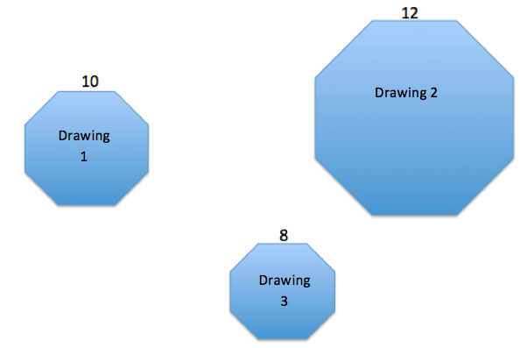

Actual Drawing to Scale Drawing | Scale Factor | Equation to Illustrate Relationship
Drawing 1 to Drawing 2 | $$Quantity=Percent×Whole \\ length in Drawing 2=Percent×length in Drawing 1 \\ 12=Percent×10 \\ \frac{12}{10}=1.20=120\%$$ | $$10(1.2)=12$$
Drawing 1 to Drawing 3 | $$length in Drawing 3=Percent×length in Drawing 1 \\ 8=Percent×10 \\ \frac{8}{10}=0.8=80\%$$ | $$10(0.80)=8$$
Drawing 2 to Drawing 1 | $$length in Drawing 1 =Percent×length in Drawing 2 \\ 10=Percent×12 \\ \frac{10}{12}=\frac{5}{6}=83\frac{1}{3}\%$$ | $$12\left(0.8\overline{3}\right)=10$$

Drawing 2 to Drawing 3 | $$length in Drawing 3=Percent×length in Drawing 2 \\ 8=Percent×12 \\ \frac{8}{12}=\frac{2}{3}=66\frac{2}{3}\%$$ | $$12\left(0.\overline{6}\right)=8$$
Drawing 3 to Drawing 1 | $$length in Drawing 1=Percent×length in Drawing 3 \\ 10=Percent×8 \\ \frac{10}{8}=1.25=125\%$$ | $$8(1.25)=10$$
Drawing 3 to Drawing 2 | $$length in Drawing 2=Percent×length in Drawing 3 \\ 12=Percent×8 \\ \frac{12}{8}=1.5=150\%$$ | $$8(1.5)=12$$
To check our answers, we can start with $10$ (the length of the original Drawing 1) and multiply by the scale factors we found to see whether we get the corresponding lengths in Drawings 2 and 3.
Drawing 1 to 2: $10\left(1.20\right)=12$
Drawing 2 to 3: $12\left(\frac{2}{3}\right)=8$

- Why are all three octagons scale drawings of each other?
  - The octagons are scale drawings of each other because their corresponding side lengths are proportional to each other. Some of the drawings are reductions while others are enlargements. The drawing with side lengths that are larger than the original is considered an enlargement, whereas the drawings whose side lengths are smaller than the original are considered reductions. The ratio comparing these lengths is called the scale factor.

Example 3 (5 minutes)
Scaffolding:
For all tasks involving scale drawings, consider modifying by (1) placing the drawings on grid paper and (2) using simpler figures, such as regular polygons or different quadrilaterals.
Example 3
The scale factor from Drawing 1 to Drawing 2 is $112\%$, and the scale factor from Drawing 1 to Drawing 3 is $84\%$. Drawing 2 is also a scale drawing of Drawing 3. Is Drawing 2 a reduction or an enlargement of Drawing 3? Justify your answer using the scale factor. The drawing is not necessarily drawn to scale.
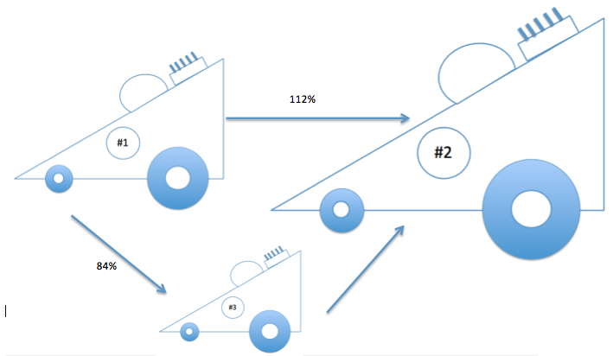

First, I needed to find the scale factor of Drawing 3 to Drawing 2 by using the relationship
$Quantity=Percent×Whole$.
Drawing 3 is the whole. Therefore,
$$Drawing 2=Percent×Drawing 3 \\ 112\%=Percent×84\% \\ \frac{1.12}{0.84}=\frac{112}{84}=\frac{4}{3}=133\frac{1}{3}\%$$
Since the scale factor is greater than $100\%$, Drawing 2 is an enlargement of Drawing 3.

Explain how you could use the scale factors from Drawing 1 to Drawing 2 ($112\%$) and from Drawing 2 to Drawing 3 ($75\%$) to show that the scale factor from Drawing 1 to Drawing 3 is $84\%$.
The scale factor from Drawing 1 to Drawing 2 is $112\%$, and the scale factor from Drawing 2 to Drawing 3 is $75\%$; therefore, I must find $75\%$ of $112\%$ to get from Drawing 2 to Drawing 3. $\left(0.75\right)\left(1.12\right)=0.84$. Comparing this answer to the original problem, the resulting scale factor is indeed what was given as the scale factor from Drawing 1 to
Drawing 3.

Closing (3 minutes)
- When given three drawings and only two scale factors, explain how to find the third scale factor.
  - I can use the scale factors as the whole and the quantity in the equation
$Quantity=Percent×Whole$. The percent is the scale factor.
- How are scale factors computed when two of the corresponding lengths are given?
  - The length in the original object is the whole and the corresponding length in the scale drawing is the quantity. Using the equation $Quantity=Percent×Whole$, I can solve for the percent, which is the scale factor.
Lesson Summary
To compute the scale factor from one drawing to another, use the representation
$Quantity=Percent×Whole$,
where the whole is the length in the actual or original drawing and the quantity is the length in the scale drawing.
If the lengths of the sides are not provided but two scale factors are provided, use the same relationship but use the scale factors as the whole and quantity instead of the given measurements.

Exit Ticket (8 minutes)

Name Date
Lesson 13: Changing Scales

Exit Ticket

- Compute the scale factor, as a percent, for each given relationship. When necessary, round your answer to the nearest tenth of a percent.
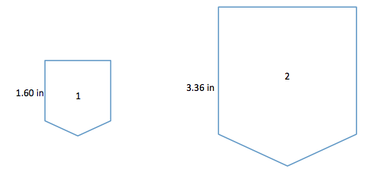

  - Drawing 1 to Drawing 2

  - Drawing 2 to Drawing 1

  - Write two different equations that illustrate how each scale factor relates to the lengths in the diagram.

- Drawings 2 and 3 are scale drawings of Drawing 1. The scale factor from Drawing 1 to Drawing 2 is $75\%$, and the scale factor from Drawing 2 to Drawing 3 is $50\%$. Find the scale factor from Drawing 1 to Drawing 3.

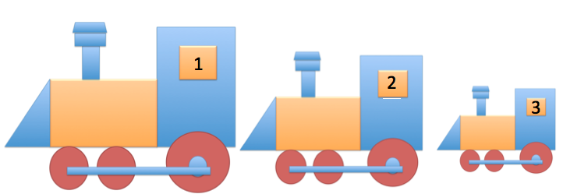
Exit Ticket Sample Solutions

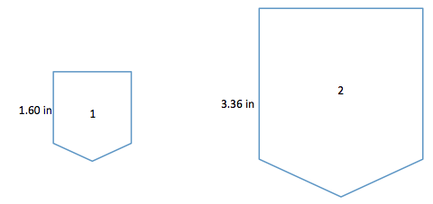
- Compute the scale factor, as a percent, of each given relationship. When necessary, round your answer to the nearest tenth of a percent.

  - Drawing 1 to Drawing 2
$$Drawing 2=Percent×Drawing 1 \\ 3.36=Percent×1.60 \\ \frac{3.36}{1.60}=2.10=210\%$$

  - Drawing 2 to Drawing 1
$$Drawing 1=Percent×Drawing 2 \\ 1.60=Percent×3.36 \\ \frac{1.60}{3.36}=\frac{1}{2.10}≈0.476190476≈47.6\%$$

  - Write two different equations that illustrate how each scale factor relates to the lengths in the diagram.
Drawing 1 to Drawing 2:
$1.60\left(2.10\right)=3.36$
Drawing 2 to Drawing 1:
$3.36\left(0.476\right)=1.60$

- Drawings 2 and 3 are scale drawings of Drawing 1. The scale factor from Drawing 1 to Drawing 2 is $75\%$, and the scale factor from Drawing 2 to Drawing 3 is $50\%$. Find the scale factor from Drawing 1 to Drawing 3.

Drawing 1 to 2 is $75\%$. Drawing 2 to 3 is $50\%$. Therefore, Drawing 3 is $50\%$ of $75\%$, so
$(0.50)(0.75)=0.375$. To determine the scale factor from Drawing 1 to Drawing 3, we went from $100\%$ to $37.5\%$. Therefore, the scale factor is $37.5\%$. Using the relationship:
$$Drawing 3=Percent×Drawing 1 \\ 37.5\%=Percent×100\% \\ 0.375=Percent \\ =37.5\%$$
Problem Set Sample Solutions

- The scale factor from Drawing 1 to Drawing 2 is $41\frac{2}{3}\%$. Justify why Drawing 1 is a scale drawing of Drawing 2 and why it is an enlargement of Drawing 2. Include the scale factor in your justification.
1
2

$$Quantity=Percent×Whole \\ Length in Drawing 1=Percent×Length in Drawing 2 \\ 100\%=Percent×41\frac{2}{3}\% \\ \frac{100\%}{41\frac{2}{3}\%}=\frac{100∙3}{41\frac{2}{3}∙3}=\frac{300}{125}=\frac{12}{5}=2.40=240\%$$
Drawing 1 is a scale drawing of Drawing 2 because the lengths of Drawing 1 would be larger than the corresponding lengths of Drawing 2.
Since the scale factor is greater than $100\%$, the scale drawing is an enlargement of the original drawing.

- The scale factor from Drawing 1 to Drawing 2 is $40\%$, and the scale factor from Drawing 2 to Drawing 3 is $37.5\%$. What is the scale factor from Drawing 1 to Drawing 3? Explain your reasoning, and check your answer using an example.

To find the scale factor from Drawing 1 to 3, I needed to find $37.5\%$ of $40\%$, so $\left(0.375\right)\left(0.40\right)=0.15$. The scale factor from Drawing 1 to Drawing 3 would be $15\%$.
Check: Assume the length of Drawing 1 is $10$. Then, using the scale factor for Drawing 2, Drawing 2 would be $4$. Then, applying the scale factor to Drawing 3, Drawing 3 would be $4\left(0.375\right)=1.5$. To go directly from Drawing 1 to Drawing 3, which was found to have a scale factor of $15\%$, then $10\left(0.15\right)=1.5$.
- Traci took a photograph and printed it to be a size of $4 units$ by $4 units$ as indicated in the diagram. She wanted to enlarge the original photograph to a size of $5 units$ by $5 unit$s and $10 units$ by $10 units$.
  - Sketch the different sizes of photographs.
$$4$$
$$10$$
$$5$$

  - What was the scale factor from the original photo to the photo that is $5 units$ by $5 units$?
The scale factor from the original to the $5$ by $5$ enlargement is $\frac{5}{4}=1.25=125\%$.

  - What was the scale factor from the original photo to the photo that is $10 units$ by $10 units$?
The scale factor from the original to the $10$ by $10$ photo is $\frac{10}{4}=2.5=250\%$.

  - What was the scale factor from the $5×5$ photo to the $10×10$ photo?
The scale factor from the $5×5$ photo to the $10×10$ photo is $\frac{10}{5}=2=200\%$.

  - Write an equation to verify how the scale factor from the original photo to the enlarged $10×10$ photo can be calculated using the scale factors from the original to the $5×5$ and then from the $5×5$ to the $10×10$.
Scale factor original to $5×5$: $\left(125\%\right)$
Scale factor $5×5$ to $10×10$: $\left(200\%\right)$
$$4\left(1.25\right)=5$$
$$5\left(2.00\right)=10$$
Original to $10×10$, scale factor $=250\%$
$$4\left(2.50\right)=10$$
The true equation $4(1.25)\left(2.00\right)=4(2.50)$ verifies that a single scale factor of $250\%$ is equivalent to a scale factor of $125\%$ followed by a scale factor of $200\%$.

- The scale factor from Drawing 1 to Drawing 2 is $30\%$, and the scale factor from Drawing 1 to Drawing 3 is $175\%$. What are the scale factors of each given relationship? Then, answer the question that follows.
  - Drawing 2 to Drawing 3
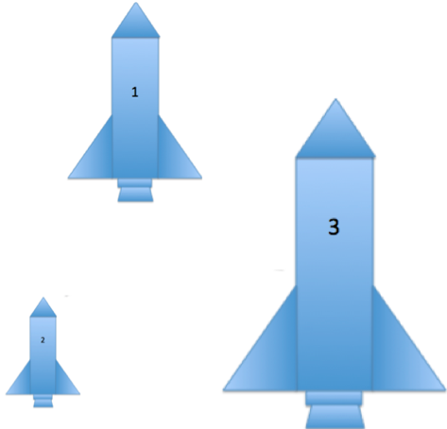
The scale factor from Drawing 2 to Drawing 3 is
$$\frac{175\%}{30\%}=\frac{1.75}{0.30}=\frac{175}{30}=\frac{35}{6}=55\frac{5}{6}=583\frac{1}{3}\%\text{.}$$

  - Drawing 3 to Drawing 1
The scale factor from Drawing 3 to Drawing 1 is
$$\frac{1}{1.75}=\frac{100}{175}=\frac{4}{7}≈57.14\%\text{.}$$

  - Drawing 3 to Drawing 2
The scale factor from Drawing 3 to Drawing 2 is
$$\frac{0.3}{1.75}=\frac{30}{175}=\frac{6}{35}≈17.14\%\text{.}$$

  - How can you check your answers?
To check my answers I can work backwards and multiply the scale factor from Drawing 1 to Drawing 3 of $175\%$ to the scale factor from Drawing 3 to Drawing 2, and I should get the scale factor from Drawing 1 to Drawing 2.
$\left(1.75\right)(0.1714)≈0.29995≈0.30=30\%$

