Lesson 12: The Scale Factor as a Percent for a Scale Drawing

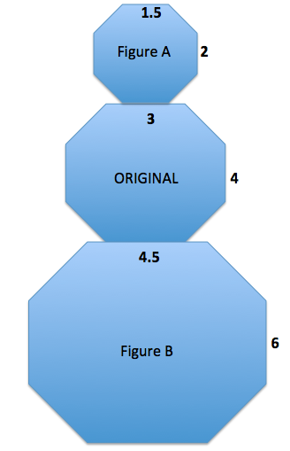
Classwork
Compare the corresponding lengths of Figure A to the original octagon in the middle. This is an example of a particular type of scale drawing called a
. Explain why it is called that.

Compare the corresponding lengths of Figure B to the original octagon in the middle. This is an example of a particular type of scale drawing called an
. Explain why it is called that.

The scale factor is the quotient of any length in the scale drawing to its corresponding length in the actual drawing.
Use what you recall from Module 1 to determine the scale factors between the original figure and Figure A and the original figure and Figure B.

Using the diagram, complete the chart to determine the horizontal and vertical scale factors. Write answers as a percent and as a concluding statement using the previously learned reduction and enlargement vocabulary.
 | Horizontal Measurement in Scale Drawing | Vertical Measurement in Scale Drawing | Concluding Statement
Figure A
Figure B

Example 1
Create a snowman on the accompanying grid. Use the octagon given as the middle of the snowman with the following conditions:
  - Calculate the width, neck, and height for the figure at the right.

  - To create the head of the snowman, make a scale drawing of the middle of the snowman with a scale factor of $75\%$. Calculate the new lengths for the width, neck, and height.

  - To create the bottom of the snowman, make a scale drawing of the middle of the snowman with a scale factor of $125\%$. Calculate the new lengths for the width, neck, and height.

  - Is the head a reduction or enlargement of the middle?

  - Is the bottom a reduction or enlargement of the middle?

  - What is the significance of the scale factor as it relates to $100\%$? What happens when such scale factors are applied?

  - Use the dimensions you calculated in parts (b) and (c) to draw the complete snowman.

Example 2
Create a scale drawing of the arrow below using a scale factor of $150\%$.
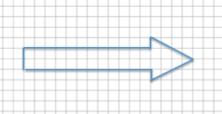

Example 3: Scale Drawing Where the Horizontal and Vertical Scale Factors Are Different
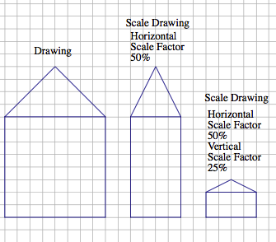
Sometimes it is helpful to make a scale drawing where the horizontal and vertical scale factors are different, such as when creating diagrams in the field of engineering. Having differing scale factors may distort some drawings. For example, when you are working with a very large horizontal scale, you sometimes must exaggerate the vertical scale in order to make it readable. This can be accomplished by creating a drawing with two scales. Unlike the scale drawings with just one scale factor, these types of scale drawings may look distorted. Next to the drawing below is a scale drawing with a horizontal scale factor of $50\%$ and vertical scale factor of $25\%$ (given in two steps). Explain how each drawing is created.

Exercise 1
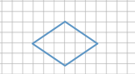
Create a scale drawing of the following drawing using a horizontal scale factor of $183\frac{1}{3}\%$ and a vertical scale factor of $25\%$.

Exercise 2
Chris is building a rectangular pen for his dog. The dimensions are $12 units$ long and $5 units$ wide.
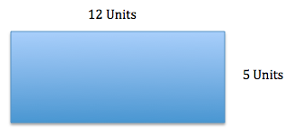

Chris is building a second pen that is $60\%$ the length of the original and$125\%$the width of the original. Write equations to determine the length and width of the second pen.

Lesson Summary
The scale factor is the number that determines whether the new drawing is an enlargement or a reduction of the original. If the scale factor is greater than $100\%$, then the resulting drawing will be an enlargement of the original drawing. If the scale factor is less than $100\%$, then the resulting drawing will be a reduction of the original drawing.
When a scale factor is mentioned, assume that it refers to both vertical and horizontal factors. It will be noted if the horizontal and vertical factors are intended to be different.
To create a scale drawing with both the same vertical and horizontal factors, determine the horizontal and vertical distances of the original drawing. Using the given scale factor, determine the new corresponding lengths in the scale drawing by writing a numerical equation that requires the scale factor to be multiplied by the original length. Draw new segments based on the calculations from the original segments. If the scale factors are different, determine the new corresponding lengths the same way but use the unique given scale factor for each of the horizontal length and vertical length.

Problem Set

- Use the diagram below to create a scale drawing using a scale factor of $133\frac{1}{3}\%$. Write numerical equations to find the horizontal and vertical distances in the scale drawing.
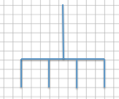

- Create a scale drawing of the original drawing given below using a horizontal scale factor of $80\%$ and a vertical scale factor of $175\%$. Write numerical equations to find the horizontal and vertical distances.
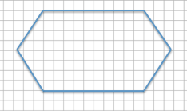

- The accompanying diagram shows that the length of a pencil from its eraser to its tip is $7 units$and that the eraser is $1.5 units$ wide. The picture was placed on a photocopy machine and reduced to $66\frac{2}{3}\%$. Find the new size of the pencil and sketch a drawing. Write numerical equations to find the new dimensions.
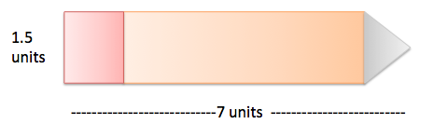

- Use the diagram to answer each question.
  - What are the corresponding horizontal and vertical distances in a scale drawing if the scale factor is $25\%$?
Use numerical equations to find your answers.
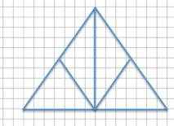

  - What are the corresponding horizontal and vertical distances in a scale drawing if the scale factor is $160\%$? Use a numerical equation to find your answers.

- Create a scale drawing of the original drawing below using a horizontal scale factor of $200\%$ and a vertical scale factor of $250\%$.

- Using the diagram below, on grid paper sketch the same drawing using a horizontal scale factor of $50\%$ and a vertical scale factor of $150\%$.
