Lesson 12: The Scale Factor as a Percent for a Scale Drawing

Student Outcomes
- Given a scale factor as a percent, students make a scale drawing of a picture or geometric figure using that scale, recognizing that the enlarged or reduced distances in a scale drawing are proportional to the corresponding distances in the original picture.
- Students understand scale factor to be the constant of proportionality.
- Students make scale drawings in which the horizontal and vertical scales are different.

Lesson Notes
In Module 1, students were introduced to proportional relationships within the context of scale drawings. Given a scale drawing, students identified the scale factor as the constant of proportionality. They compared the scale drawing with the original drawing to determine whether the scale drawing is a reduction or an enlargement of the original drawing by interpreting the scale factor. Students calculate the actual lengths and areas of objects in the scale drawing by using the scale factor.
In this module, Lessons 12–15 build on what students learned in Module 1. These lessons require students to create scale drawings when given a scale factor as a percent or to determine the scale factor as a percent when given the original drawing and the scale drawing. Students make scale drawings in which the horizontal and vertical scales are different. Students compute the scale factor of several drawings with different scales, determine actual lengths from scale drawings, and solve area problems using scale drawings. Although these concepts may seem similar to those covered in Module 1, this module emphasizes the connection between percent of change and the rescaling of figures accordingly. It is also important to note that the scale factor may still be written as a ratio, as in $1:5$, $1$ to $5$, or “one inch represents five inches.”
This module includes an examination of horizontal and vertical scale factors. It is important to note that if only a scale factor is named, we conventionally apply it to both vertical and horizontal measures unless otherwise stated.

Classwork
Opening (7 minutes)
Review the definitions of scale drawing, reduction, enlargement, and scale factor from Module 1, Lessons 16 and 17. To review such definitions, refer to the drawing below and engage the students in a discussion about each definition.
Scaffolding:
The word scale has several meanings (mostly nouns) that might cause confusion. To make this new definition of the word clear, show visuals of the other meanings of the word.

Opening
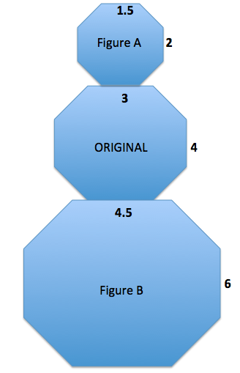
Compare the corresponding lengths of Figure A to the original octagon in the middle. This is an example of a particular type of scale drawing called a reduction. Explain why it is called that.
A scale drawing is a reduction of the original drawing when the side lengths of the scale drawing are smaller than the corresponding side lengths of the original figure or drawing.

Compare the corresponding lengths of Figure B to the original octagon in the middle. This is an example of a particular type of scale drawing called an enlargement. Explain why it is called that.
A scale drawing is an enlargement of the original drawing when the side lengths of the scale drawing are larger than the corresponding side lengths of the original figure or drawing.

The scale factor is the quotient of any length in the scale drawing and its corresponding length in the original drawing.
Use what you recall from Module 1 to determine the scale factors between the original figure and Figure A and the original figure and Figure B.
Scale factor between original and Figure A: $\frac{1.5}{3}=\frac{1}{2}$ or $\frac{2}{4}=\frac{1}{2}$
Scale factor between original and Figure B: $\frac{4.5}{3}=\frac{3}{2}$ or $\frac{6}{4}=\frac{3}{2}$

Use the diagram to complete the chart below to determine the horizontal and vertical scale factors. Write answers as a percent and as a concluding statement using the previously learned reduction and enlargement vocabulary.

 | Horizontal Measurement in Scale Drawing | Vertical Measurement in Scale Drawing | Concluding Statement
Figure A | $$\frac{1.5}{3}=\frac{1}{2}=50\%$$ | $$\frac{2}{4}=\frac{1}{2}=50\%$$ | Figure A is a reduction of the original figure. A length in Figure A is $50\%$ of the corresponding length in the original drawing.
Figure B | $$\frac{4.5}{3}=\frac{1.5}{1}=150\%$$ | $$\frac{6}{4}=\frac{1.5}{1}=150\%$$ | Figure B is an enlargement of the original figure. A length in Figure B is $150\%$ of the corresponding length in the original drawing.

MP.3
Example 1 (10 minutes)
Example 1
Create a snowman on the accompanying grid. Use the octagon given as the middle of the snowman with the following conditions:
  - Calculate the width, neck, and height for the figure at the right.
Width: $20$
Neck: $12$
Height: $12$

  - To create the head of the snowman, make a scale drawing of the middle of the snowman with a scale factor of $75\%$. Calculate the new lengths for the width, neck, and height.
Width: $75\%\left(20\right)=(0.75)(20)=15$
Scaffolding:
As necessary, give students specific instructions on creating a scale drawing.
First, determine the original lengths for any horizontal or vertical distance that can be obtained by counting the boxes in the coordinate grid. Using the scale factor, determine the new corresponding lengths in the scale drawing. Draw new segments based on the calculations from the original segments. There may be more than one correct drawing. The head and bottom may be the correct lengths but may be off-center. To ensure the drawing is not off-center, the corresponding length needs to align with the original drawing. A corresponding length, such as $9$, may need to be drawn in half-unit segment increments followed by $8$ units, followed by a half-unit. This would offer an equal number of boxes from each endpoint of the scale drawing. Lastly, any diagonal segment should be drawn by connecting the vertical and horizontal corresponding segments.
Neck: $75\%(12)=(0.75)(12)=9$
Height: $75\%(12)=(0.75)(12)=9$

  - To create the bottom of the snowman, make a scale drawing of the middle of the snowman with a scale factor of $125\%$. Calculate the new lengths for the width, neck, and height.
Width: $125\%(20)=(1.25)(20)=25$
Waist: $125\%(12)=(1.25)(12)=15$
Height: $125\%(12)=(1.25)(12)=15$

  - Is the head a reduction or an enlargement of the middle?
The head is a reduction of the middle since the lengths of the sides are smaller than the lengths in the original drawing and the scale factor is less than $100\%$ ($75\%$).

  - Is the bottom a reduction or an enlargement of the middle?
The bottom is an enlargement of the middle since the lengths of the scale drawing are larger than the lengths in the original drawing, and the scale factor is greater than $100\%$ ($125\%$).

  - What is the significance of the scale factor as it relates to $100\%$? What happens when such scale factors are applied?
A scale factor of $100\%$ would create a congruent drawing because the new drawing would be the same size as the original drawing, and it would be neither an enlargement nor reduction. A scale factor of less than $100\%$ results in a scale drawing that is a reduction of the original drawing. A scale factor of greater than $100\%$ results in a scale drawing that is an enlargement of the original drawing.
MP.3

  - Use the dimensions you calculated in parts (b) and (c) to draw the complete snowman.
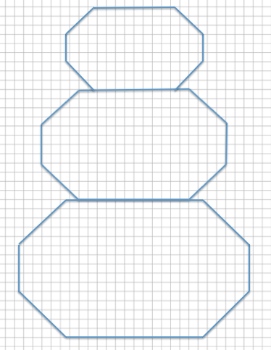
Answer:

Discussion
Scaffolding:
Review the meanings of the words: horizontal, vertical, and diagonal. Have each student hold an arm up in the air to model each word’s meaning as it relates to the orientation of a line segment.
- Recall that when working with percents, the percent must be converted to a decimal or fraction for use in calculating the scale drawing lengths. How do we convert a percent or fraction to a decimal? How do we convert a fractional percent to a decimal?
  - To convert a percent to a decimal, divide the percent by $100$ and express the quotient as a decimal. Also, the percent can be written as a decimal by moving the decimal point two places to the left. To convert a fractional percent to a decimal, divide the percent by $100$; e.g., $5\frac{1}{3}\%=\frac{16}{3}\%=\frac{16}{3}÷100=\frac{16}{300}=\frac{4}{75}=0.053\overline{3}$.
- How are the diagonal corresponding segments drawn in the scale drawings?
  - Once the horizontal and vertical segment lengths of the scale drawing are calculated and drawn, then any diagonal lengths can be drawn by connecting the horizontal and vertical segments.
- How are scale factor, unit rate, and constant of proportionality used?
  - They are the same; the scale factor is the unit rate or the constant of proportionality. When every length of the original drawing is multiplied by the scale factor, the corresponding length in the scale drawing is obtained.
- Summarize the effects of the scale factor as a percent of a scale drawing.
  - The scale factor is the number that determines whether the new drawing is an enlargement or a reduction of the original. If the scale factor is greater than $100\%$, then the resulting drawing will be an enlargement of the original drawing. If the scale factor is less than $100\%$, then the resulting drawing will be a reduction of the original drawing. The resulting enlarged or reduced distances are proportional to the original distances.

Example 2 (4 minutes)
Example 2

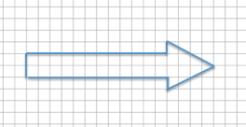
Create a scale drawing of the arrow below using a scale factor of $150\%$.

Answer:
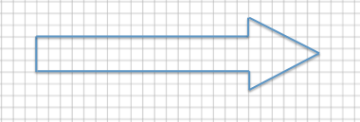

Example 3 (4 minutes): Scale Drawings Where the Horizontal and Vertical Scale Factors Are Different
Example 3: Scale Drawings Where the Horizontal and Vertical Scale Factors Are Different
Sometimes it is helpful to make a scale drawing where the horizontal and vertical scale factors are different, such as when creating diagrams in the field of engineering. Having differing scale factors may distort some drawings. For example, when you are working with a very large horizontal scale, you sometimes must exaggerate the vertical scale in order to make it readable. This can be accomplished by creating a drawing with two scales. Unlike the scale drawings with just one scale factor, these types of scale drawings may look distorted. Next to the drawing below is a scale drawing with a horizontal scale factor of $50\%$ and vertical scale factor of $25\%$ (given in two steps). Explain how each drawing is created.
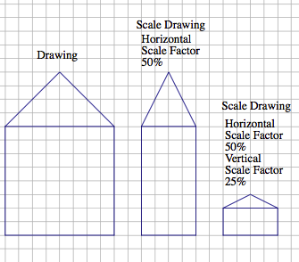
Each horizontal distance in the scale drawing is $50\%$ (or half) of the corresponding length in the original drawing. Each vertical distance in the scale drawing is $25\%$ (or one-fourth) of the corresponding length in the original drawing.
Horizontal distance: $8\left(0.50\right)=8\left(\frac{1}{2}\right)=4$
Vertical distance of house: $8\left(0.25\right)=8\left(\frac{1}{4}\right)=2$
Vertical distance of top of house:
$$4\left(0.25\right)=4\left(\frac{1}{4}\right)=1$$
Exercise 1 (5 Minutes)
Exercise 1
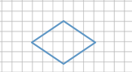
Create a scale drawing of the following drawing using a horizontal scale factor of $183\frac{1}{3}\%$ and a vertical scale factor of $25\%$.

Horizontal scale factor: $\frac{183\frac{1}{3} ∙ 3}{100 ∙ 3}=\frac{550}{300}=\frac{11}{6}$
Horizontal distance: $6\left(\frac{11}{6}\right)=11$
Vertical scale factor: $\frac{25}{100}=\frac{1}{4}$
Vertical distance: $4\left(\frac{1}{4}\right)=1$
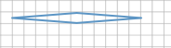
New sketch:

- When a scale factor is given as a percent, why is it best to convert the percent to a fraction?
  - All percents can be written as fractions by dividing the percent by $100$. This strategy is particularly helpful when the percent is a fractional percent. Also, sometimes the percent written as a decimal would be a repeating decimal, which may result in an approximate answer. Therefore, writing the percent as a fraction will ensure a precise answer.
- To convert a percent to a fraction, the percent is divided by $100$. When the percent is a fractional percent, the quotient is written as a complex fraction. How do you find an equivalent simple fraction?
  - You convert all mixed numbers to improper fractions, then multiply both the numerator and denominator by the reciprocal of the denominator, and follow the rules of multiplying fractions. Another option is to write the fractional percent divided by $100$ and multiply both the numerator and denominator by the denominator of the fractional percent, reducing the answer. For example, $152\frac{1}{3}\%$can be written as $\frac{152\frac{1}{3}}{100}=\frac{\frac{457}{3}}{100}=\frac{457}{3}×\frac{1}{100}=\frac{457}{300}$ or $\frac{152\frac{1}{3}×3}{100×3}=\frac{457}{300}$.

Exercise 2 (3 Minutes)
Exercise 2
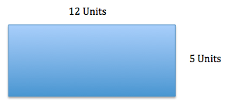
Chris is building a rectangular pen for his dog. The dimensions are $12 units$ long and $5 units$ wide.

Chris is building a second pen that is $60\%$ the length of the original and $125\%$ the width of the original. Write equations to determine the length and width of the second pen.
Length: $12×0.60=7.2$
The length of the second pen is $7.2 units$.
Width: $5×1.25=6.25$
The width of the second pen is $6.25 units$.

Closing (4 minutes)
- To clarify, when a scale factor is mentioned, assume that it refers to both vertical and horizontal factors. It will be noted if the horizontal and vertical factors are intended to be different.
- When the scale factor is given as a percent, how do you determine if the scale drawing is an enlargement or a reduction of the original drawing?
  - If the scale factor is greater than $100\%$, the scale drawing will be an enlargement. If the scale factor is less than $100\%$, the scale drawing will be a reduction.
- Can a scale drawing have different horizontal and vertical scale factors? If it can, how do you create a scale drawing with different horizontal and vertical scale factors?
  - Yes, it can. I would apply the scale factors to the appropriate side lengths. For example, if I am given a horizontal scale factor, I would use this to change the lengths of all the horizontal sides.
- How are the corresponding lengths in a scale drawing and an original drawing related?
  - The corresponding lengths should be proportional to one another. The lengths of all sides in the new image are calculated by multiplying the lengths of the sides in the original by the scale factor.
- How does the scale factor relate to the constant of proportionality that we have been studying?
  - The scale factor is the constant of proportionality.

Lesson Summary
The scale factor is the number that determines whether the new drawing is an enlargement or a reduction of the original. If the scale factor is greater than $100\%$, then the resulting drawing will be an enlargement of the original drawing. If the scale factor is less than $100\%$, then the resulting drawing will be a reduction of the original drawing.
When a scale factor is mentioned, assume that it refers to both vertical and horizontal factors. It will be noted if the horizontal and vertical factors are intended to be different.
To create a scale drawing with both the same vertical and horizontal factors, determine the horizontal and vertical distances of the original drawing. Using the given scale factor, determine the new corresponding lengths in the scale drawing by writing a numerical equation that requires the scale factor to be multiplied by the original length. Draw new segments based on the calculations from the original segments. If the scale factors are different, determine the new corresponding lengths the same way but use the unique given scale factor for each of the horizontal length and vertical length.

Exit Ticket (8 minutes)

Name Date
Lesson 12: The Scale Factor as a Percent for a Scale Drawing

Exit Ticket

- Create a scale drawing of the picture below using a scale factor of $60\%$. Write three equations that show how you determined the lengths of three different parts of the resulting picture.

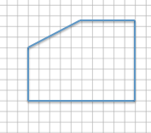

- Sue wants to make two picture frames with lengths and widths that are proportional to the ones given below.
Note: The illustration shown below is not drawn to scale.
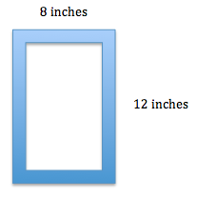

  - Sketch a scale drawing using a horizontal scale factor of $50\%$ and a vertical scale factor of $75\%$. Determine the dimensions of the new picture frame.

  - Sketch a scale drawing using a horizontal scale factor of $125\%$ and a vertical scale factor of $140\%$. Determine the dimensions of the new picture frame.
Exit Ticket Sample Solutions

- Create a scale drawing of the picture below using a scale factor of $60\%$. Write three equations that show how you determined the lengths of three different parts of the resulting picture.

Scale factor: $60\%=\frac{60}{100}=\frac{3}{5}$
Horizontal distances: $10\left(\frac{3}{5}\right)=6$
$5\left(\frac{3}{5}\right)=3$
Vertical distances: $5\left(\frac{3}{5}\right)=3$
$7\frac{1}{2}\left(\frac{3}{5}\right)=\frac{15}{2}\left(\frac{3}{5}\right)=\frac{9}{2}=4.5$
Scale drawing:
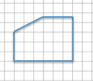

Equations:
Left vertical distance: $5×0.60=3$
Right vertical distance: $7. 5×0.60=4.5$
Top horizontal distance: $5×0.60=3$
Bottom horizontal distance: $10×0.60=6$

- Sue wants to make two picture frames with lengths and widths that are proportional to the ones given below. Note: The illustration shown below is not drawn to scale.

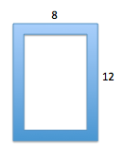
  - Sketch a scale drawing using a horizontal scale factor of $50\%$ and a vertical scale factor of $75\%$. Determine the dimensions of the new picture frame.
Horizontal measurement: $8\left(0.50\right)=4$
Vertical measurement: $12\left(0.75\right)=9$

$4 in.$ by $9 in.$

  - Sketch a scale drawing using a horizontal scale factor of $125\%$ and a vertical scale factor of $140\%$. Determine the dimensions of the new picture frame.
Horizontal measurement: $8\left(1.25\right)=10$
Vertical measurement: $12\left(1.40\right)=16.8$

$10 in.$ by $16.8 in.$

Problem Set Sample Solutions

- Use the diagram below to create a scale drawing using a scale factor of $133\frac{1}{3}\%$. Write numerical equations to find the horizontal and vertical distances in the scale drawing.
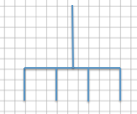

Scale factor: $\frac{133\frac{1}{3} ∙ 3}{100 ∙ 3}=\frac{400}{300}=\frac{4}{3}$
Horizontal distance: $9\left(\frac{4}{3}\right)=12$
Vertical distance forks: $3\left(\frac{4}{3}\right)=4$
Vertical distance handle: $6\left(\frac{4}{3}\right)=8$
Scale drawing:
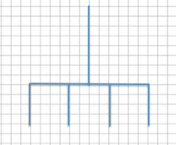

- Create a scale drawing of the original drawing given below using a horizontal scale factor of $80\%$ and a vertical scale factor of $175\%$. Write numerical equations to find the horizontal and vertical distances.
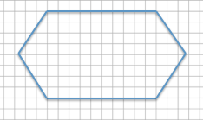

Horizontal scale factor: $80\%=\frac{80}{100}=\frac{4}{5}$
Horizontal segment lengths: $10\left(0.80\right)=8$ or $10\left(\frac{4}{5}\right)=8$
Horizontal distance: $15\left(\frac{4}{5}\right)=12$
Vertical scale factor: $175\%=\frac{175}{100}=\frac{7}{4}$
Vertical distance: $8\left(\frac{7}{4}\right)=14$
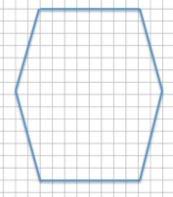
Scale drawing:

- The accompanying diagram shows that the length of a pencil from its eraser to its tip is $7 units$ and that the eraser is $1.5 units$ wide. The picture was placed on a photocopy machine and reduced to $66\frac{2}{3}\%$. Find the new size of the pencil and sketch a drawing. Write numerical equations to find the new dimensions.
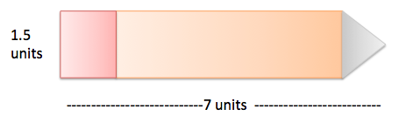

Scale factor: $66\frac{2}{3}\%=\frac{66\frac{2}{3} ∙ 3}{100 ∙ 3}=\frac{200}{300}=\frac{2}{3}$
Pencil length: $7\left(\frac{2}{3}\right)=4\frac{2}{3}$
Eraser: $\left(1\frac{1}{2}\right)\left(\frac{2}{3}\right)=\left(\frac{3}{2}\right)\left(\frac{2}{3}\right)=1$

- Use the diagram to answer each question.
  - What are the corresponding horizontal and vertical distances in a scale drawing if the scale factor is $25\%$? Use numerical equations to find your answers.
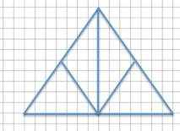
Horizontal distance on original drawing: $14$
Vertical distance on original drawing: $10$
Scale drawing:
Scale factor: $25\%$
$\frac{25}{100}=\frac{1}{4}$
Horizontal distance: $14\left(\frac{1}{4}\right)=3.5$
Vertical distance: $10\left(\frac{1}{4}\right)=2.5$

  - What are the corresponding horizontal and vertical distances in a scale drawing if the scale factor is $160\%$? Use a numerical equation to find your answers.
Horizontal distance on original drawing: $14$
Vertical distance on original drawing: $10$
Scale drawing:
Scale factor: $160\%$
$\frac{160}{100}=\frac{8}{5}$
Horizontal distance: $14\left(\frac{8}{5}\right)=22.4$
Vertical distance: $10\left(\frac{8}{5}\right)=16$

- Create a scale drawing of the original drawing below using a horizontal scale factor of $200\%$ and a vertical scale factor of $250\%$.
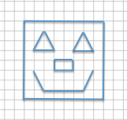

Answer:
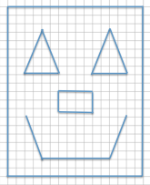

- Using the diagram below, on grid paper sketch the same drawing using a horizontal scale factor of $50\%$ and a vertical scale factor of $150\%$.
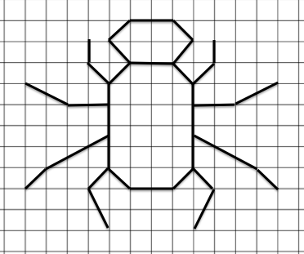

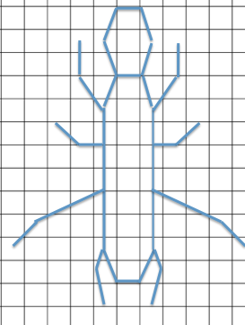
Answer:

