Lesson 5: Finding One Hundred Percent Given Another Percent

Student Outcomes
- Students find $100\%$ of a quantity (the whole) when given a quantity that is a percent of the whole by using a variety of methods including finding $1\%$, equations, mental math using factors of $100$, and double number line models.
- Students solve word problems involving finding $100\%$ of a given quantity with and without using equations.

Classwork
Opening Exercise (5 minutes)
Students recall factors of $100$ and their multiples to complete the table below. The discussion that follows introduces students to a means of calculating whole quantities through the use of a double number line.
Opening Exercise
What are the whole number factors of $100$? What are the multiples of those factors? How many multiples are there of each factor (up to $100$)?
Factors of $100$ | Multiples of the Factors of $100$ | Number of Multiples
$$100$$ | $100$ | $$1$$
$$50$$ | $50, 100$ | $$2$$
$$25$$ | $25, 50, 75, 100$ | $$4$$
$$20$$ | $20, 40, 60, 80, 100$ | $$5$$
$$10$$ | $10, 20, 30, 40, 50, 60, 70, 80, 90, 100$ | $$10$$
$$5$$ | $5, 10, 15, 20, 25, 30, 35, 40, 45, 50, …, 75, 80, 85, 90, 95, 100$ | $$20$$
$$4$$ | $4, 8, 12, 16, 20, 24, 28, 32, 36, 40,…, 80, 84, 88, 92, 96, 100$ | $$25$$
$$2$$ | $2, 4, 6, 8, 10, 12,14, 16, 18, 20, 22, …, 88, 90, 92, 94, 96, 98, 100$ | $$50$$
$$1$$ | $1, 2, 3, 4, 5, 6, …, 98, 99, 100$ | $$100$$

- How do you think we can use these whole number factors in calculating percents on a double number line?
  - The factors represent all ways by which we could break $100\%$ into equal-sized whole number intervals. The multiples listed would be the percents representing each cumulative interval. The number of multiples would be the number of intervals.

Example 1 (5 minutes): Using a Modified Double Number Line with Percents
The use of visual models is a powerful strategy for organizing and solving percent problems. In this example (and others that follow), the double number line is modified so that it is made up of a percent number line and a bar model. This model provides a visual representation of how quantities compare and what percent they correspond with. We use the greatest common factor of the given percent and $100$ to determine the number of equal-sized intervals to use.
Example 1: Using a Modified Double Number Line with Percents
The$42$students who play wind instruments represent $75\%$ of the students who are in band. How many students are in band?

- Which quantity in this problem represents the whole?
  - The total number of students in band is the whole, or $100\%$.
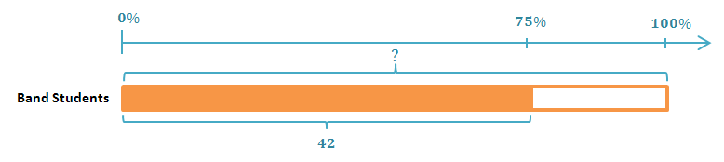
- Draw the visual model shown with a percent number line and a tape diagram.
MP.2
&
MP.4

- Use the double number line to find the total number of students in band.
  - $100\%$ represents the total number of students in band, and $75\%$ is $\frac{3}{4}$ of $100\%$. The greatest common factor of $75$ and $100$ is $25$.

The greatest common factor of $75$ and $100$ is $25$. So, I divided the tape diagram into four equal-sized sections, each representing $25\%$. There are three intervals of $25\%$ in $75\%$. Each of these intervals would represent $14$ band students; I determined this by dividing $42$ by $3$. The last interval also represents $25\%$, or $14$ students, making four groups of $14$ band students in each. $14×4=56$
There are $56$ students in the band.

Exercises 1–3 (10 minutes)
Solve Exercises 1–3 using a modified double number line.
Exercises 1–3
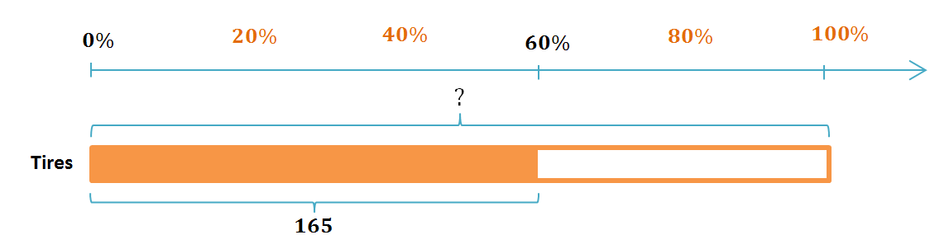
- Bob’s Tire Outlet sold a record number of tires last month. One salesman sold $165$ tires, which was $60\%$ of the tires sold in the month. What was the record number of tires sold?
The salesman’s total is being compared to the total number of tires sold by the store, so the total number of tires sold is the whole quantity. The greatest common factor of $60$ and $100$ is $20$, so I divided the percent line into five equal-sized intervals of $20\%$. $60\%$ is three of the $20\%$ intervals, so I divided the salesman’s $165$ tires by $3$ and found that $55$tires corresponds with each $20\%$ interval. $100\%$ consists of five $20\%$ intervals, which corresponds to five groups of $55$ tires. Since $5∙55=275$, the record number of tires sold was $275$ tires.

- Nick currently has $7,200$ points in his fantasy baseball league, which is $20\%$ more points than Adam. How many points does Adam have?
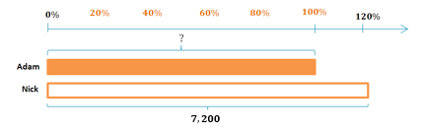
Nick’s points are being compared to Adam’s points, so Adam’s points are the whole quantity. Nick has $20\%$ more points than Adam, so Nick really has $120\%$ of Adam’s points. The greatest common factor of $120$ and $100$ is $20$, so I divided the $120\%$ on the percent line into six equal-sized intervals. I divided Nick’s $7,200$ points by $6$ and found that $1,200$ points corresponds to each $20\%$ interval. Five intervals of $20\%$ make $100\%$, and five intervals of $1,200$ points totals $6,000$ points. Adam has $6,000$ points in the fantasy baseball league.

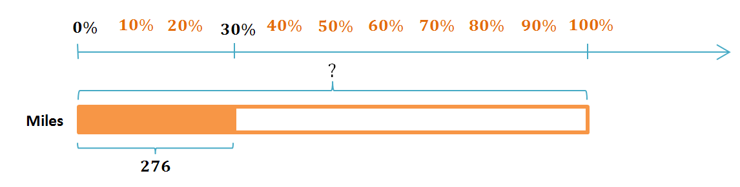
- Kurt has driven $276$ miles of his road trip but has $70\%$ of the trip left to go. How many more miles does Kurt have to drive to get to his destination?
With $70\%$ of his trip left to go, Kurt has only driven $30\%$ of the way to his destination. The greatest common factor of $30$ and $100$ is $10$, so I divided the percent line into ten equal-sized intervals. $30\%$ is three of the $10\%$ intervals, so I divided $276$ miles by $3$ and found that $92$ miles corresponds to each $10\%$ interval. Ten intervals of $10\%$ make $100\%$, and ten intervals of $92$miles totals $920$ miles. Kurt has already driven $276$ miles, and $920-276=644$, so Kurt has $644$ miles left to get to his destination.
Example 2 (10 minutes): Mental Math Using Factors of $100$
Students use mental math and factors of $100$ to determine the whole quantity when given a quantity that is a percent of that whole.
Example 2: Mental Math Using Factors of $100$
Answer each part below using only mental math, and describe your method.
  - If $39$ is $1\%$ of a number, what is that number? How did you find your answer?
$39$ is $1\%$ of $3,900$. I found my answer by multiplying $39∙100$ because $39$ corresponds with each $1\%$ in $100\%$, and $1\%∙100=100\%$, so $39∙100=3,900$.

  - If $39$ is $10\%$ of a number, what is that number? How did you find your answer?
$39$ is $10\%$ of $390$. $10$is a factor of $100$, and there are ten $10\%$ intervals in $100\%$. The quantity $39$ corresponds to $10\%$, so there are $39∙10$ in the whole quantity, and $39∙10=390$.

  - If $39$ is $5\%$ of a number, what is that number? How did you find your answer?
$39$ is $5\%$ of $780$. $5$ is a factor of $100$, and there are twenty $5\%$ intervals in $100\%$. The quantity $39$ corresponds to $5\%$, so there are twenty intervals of $39$ in the whole quantity.
$39∙20$
$39∙2∙10$ Factored $20$ for easier mental math.
$78∙10=780$

  - If $39$ is $15\%$ of a number, what is that number? How did you find your answer?
$39$ is $15\%$ of $260$. $15$ is not a factor of $100$, but $15$ and $100$ have a common factor of $5$. If $15\%$ is $39$, then because $5=\frac{15}{3}$ , $5\%$ is $13=\frac{39}{3}$. There are twenty $5\%$ intervals in $100\%$, so there are twenty intervals of $13$ in the whole.
$13∙20$
$13∙2∙10$ Factored $20$ for easier mental math.
$26∙10=260$

  - If $39$ is $25\%$ of a number, what is that number? How did you find your answer?
$39$ is $25\%$ of $156$. $25$ is a factor of $100$, and there are four intervals of $25\%$ in $100\%$. The quantity $39$ corresponds with $25\%$, so there are $39∙4$ in the whole quantity.
$39∙4$
$39∙2∙2$ Factored $4$ for easier mental math.
$$78∙2=156$$

Exercises 4–5 (8 minutes)
Solve Exercises 4 and 5 using mental math and factors of $100$. Describe your method with each exercise.
Exercises 4–5
- Derrick had a $0.250$ batting average at the end of his last baseball season, which means that he got a hit $25\%$ of the times he was up to bat. If Derrick had $47$ hits last season, how many times did he bat?
The decimal $0.250$ is $25\%$, which means that Derrick had a hit $25\%$ of the times that he batted. His number of hits is being compared to the total number of times he was up to bat. The $47$ hits corresponds with $25\%$, and since $25$ is a factor of $100$, $100=25∙4$. I used mental math to multiply the following:
$$47∙4$$
$(50-3)∙4$ Used the distributive property for easier mental math
$$200-12=188$$
Derrick was up to bat $188$ times last season.

- Nelson used $35\%$ of his savings account for his class trip in May. If he used $\$140$ from his savings account while on his class trip, how much money was in his savings account before the trip?
$35\%$ of Nelson’s account was spent on the trip, which was $\$140$. The amount that he spent is being compared to the total amount of savings, so the total savings represents the whole. The greatest common factor of $35$ and $100$ is $5$. $35\%$ is seven intervals of $5\%$, so I divided $\$140$ by $7$ to find that $\$20$ corresponds to $5\%$. $100\%=5\%∙20$, so the whole quantity is $\$20∙20=\$400$. Nelson’s savings account had $\$400$ in it before his class trip.

Closing (2 minutes)
- What does the modified double number line method and the factors of $100$ method have in common?
  - Both methods involve breaking $100\%$ into equal-sized intervals using the greatest common factor of $100$ and the percent corresponding to the part.
- Can you describe a situation where you would prefer using the modified double number line?
  - Answers will vary.
- Can you describe a situation where you would prefer using the factors of $100$?
  - Answers will vary.
Lesson Summary
To find $100\%$ of the whole, you can use a variety of methods, including factors of $100$ ($1$, $2$, $4$, $5$, $10$, $20$, $25$, $50$, and $100$) and double number lines. Both methods will require breaking $100\%$into equal-sized intervals. Use the greatest common factor of $100$ and the percent corresponding to the part.

Exit Ticket (5 minutes)

Name Date
Lesson 5: Finding One Hundred Percent Given Another Percent

Exit Ticket

- A tank that is $40\%$ full contains $648$ gallons of water. Use a double number line to find the maximum capacity of the water tank.

- Loretta picks apples for her grandfather to make apple cider. She brings him her cart with $420$ apples. Her grandfather smiles at her and says, “Thank you, Loretta. That is $35\%$ of the apples that we need.”
Use mental math to find how many apples Loretta’s grandfather needs. Describe your method.

Exit Ticket Sample Solutions

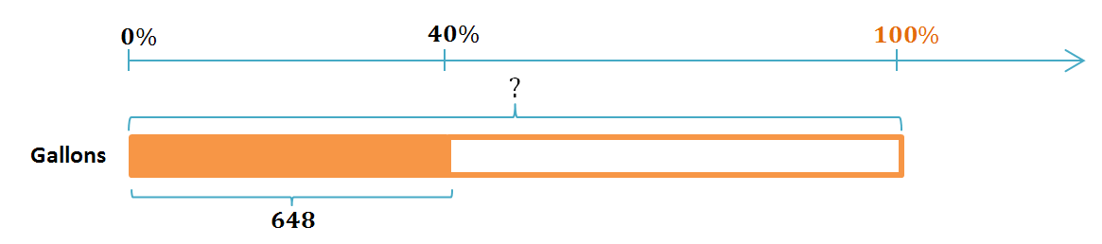
- A tank that is $40\%$ full contains $648$ gallons of water. Use a double number line to find the maximum capacity of the water tank.
I divided the percent line into intervals of $20\%$ making five intervals of $20\%$ in $100\%$. I know that I have to divide $\frac{40}{2}$ to get $20$, so I divided $\frac{648}{2}$ to get $324$ that corresponds with $20\%$. Since there are five $20\%$ intervals in $100\%$, there are five $324$ gallon intervals in the whole quantity, and $324∙5=1,620$. The capacity of the tank is $1,620$ gallons.

- Loretta picks apples for her grandfather to make apple cider. She brings him her cart with $420$ apples. Her grandfather smiles at her and says “Thank you, Loretta. That is $35\%$ of the apples that we need.”
Use mental math to find how many apples Loretta’s grandfather needs. Describe your method.
$420$ is $35\%$ of $1,200$. $35$ is not a factor of $100$, but $35$ and $100$ have a common factor of $5$. There are seven intervals of $5\%$ in $35\%$, so I divided $420$ apples into seven intervals; $\frac{420}{7}=60$. There are $20$ intervals of $5\%$ in $100\%$, so I multiplied as follows:
$60∙20$
$60∙2∙10$
$120∙10=1,200$
Loretta’s grandfather needs a total of $1,200$ apples to make apple cider.

Problem Set Sample Solutions

Use a double number line to answer Problems 1–5.
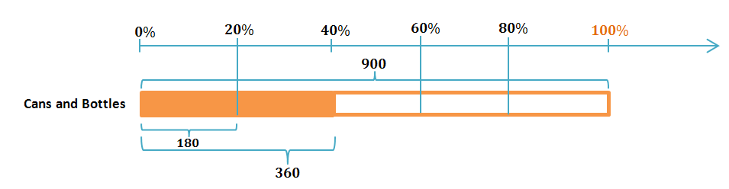
- Tanner collected $360$cans and bottles while fundraising for his baseball team. This was $40\%$ of what Reggie collected. How many cans and bottles did Reggie collect?
The greatest common factor of $40$ and $100$ is $20$.
$\frac{1}{2}\left(40\%\right)=20\%$, and $\frac{1}{2}\left(360\right)=180$, so $180$ corresponds with $20\%$. There are five intervals of $20\%$ in $100\%$, and $5\left(180\right)=900$, so Reggie collected $900$ cans and bottles.
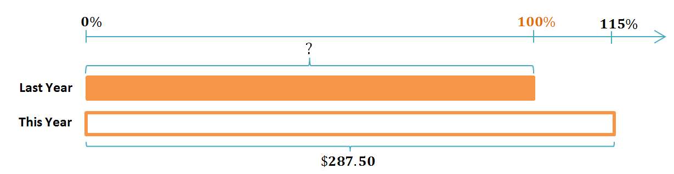
- Emilio paid $\$287.50$ in taxes to the school district that he lives in this year. This year’s taxes were a $15\%$increase from last year. What did Emilio pay in school taxes last year?
The greatest common factor of $100$ and $115$ is $5$. There are $23$ intervals of $5\%$ in $115\%$, and $\frac{287.5}{23}=12.5$, so $12.5$ corresponds with $5\%$. There are $20$ intervals of $5\%$ in $100\%$, and $20\left(12.5\right)=250$, so Emilio paid $\$250$ in school taxes last year.

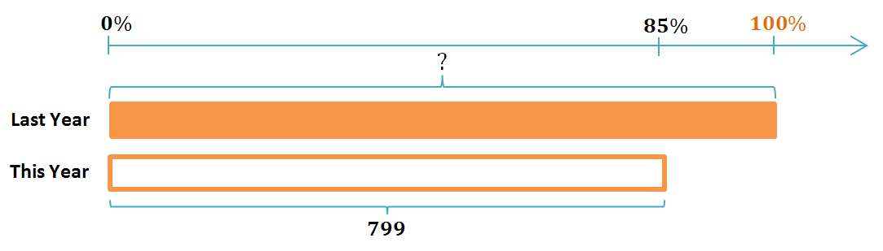
- A snowmobile manufacturer claims that its newest model is $15\%$ lighter than last year’s model. If this year’s model weighs$799 lb.$, how much did last year’s model weigh?
$15\%$ lighter than last year’s model means $15\%$ less than $100\%$ of last year’s model’s weight, which is $85\%$. The greatest common factor of $85$ and $100$ is $5$. There are $17$ intervals of $5\%$ in $85\%$, and $\frac{799}{17}=47$, so $47$ corresponds with $5\%$. There are $20$ intervals of $5\%$ in $100\%$, and $20\left(47\right)=940$, so last year’s model weighed $940$ pounds.

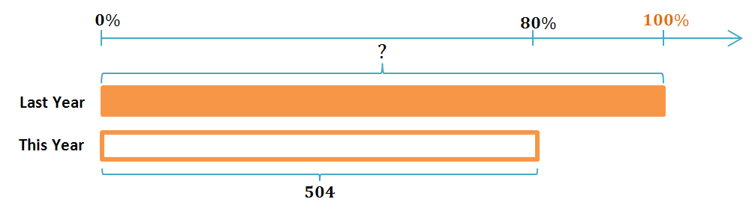
- Student enrollment at a local school is concerning the community because the number of students has dropped to $504$, which is a $20\%$ decrease from the previous year. What was the student enrollment the previous year?
A $20\%$ decrease implies that this year’s enrollment is $80\%$ of last year’s enrollment. The greatest common factor of $80$ and $100$ is $20$. There are $4$ intervals of $20\%$ in $80\%$, and $\frac{504}{4}=126$, so $126$ corresponds to $20\%$. There are $5$ intervals of $20\%$ in $100\%$, and $5\left(126\right)=630$, so the student enrollment from the previous year was $630$ students.

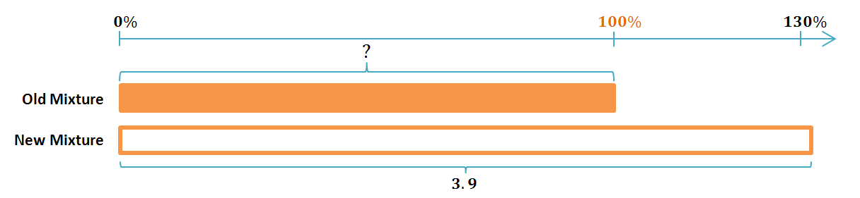
- The color of paint used to paint a race car includes a mixture of yellow and green paint. Scotty wants to lighten the color by increasing the amount of yellow paint $30\%$. If a new mixture contains $3.9$ liters of yellow paint, how many liters of yellow paint did he use in the previous mixture?
The greatest common factor of $130$ and $100$ is $10$. There are $13$ intervals of $10\%$ in $130\%$, and $\frac{3.9}{13}=0.3$, so $0.3$
corresponds to $10\%$. There are $10$ intervals of $10\%$ in $100\%$, and $10\left(0.3\right)=3$, so the previous mixture included $3$ liters of yellow paint.

Use factors of $100$ and mental math to answer Problems 6–10. Describe the method you used.
- Alexis and Tasha challenged each other to a typing test. Alexis typed $54$words in one minute, which was $120\%$ of what Tasha typed. How many words did Tasha type in one minute?
The greatest common factor of $120$ and $100$ is $20$, and there are $6$ intervals of $20\%$ in $120\%$, so I divided $54$ into $6$ equal-sized intervals to find that $9$ corresponds to $20\%$. There are five intervals of $20\%$ in $100\%$, so there are five intervals of $9$ words in the whole quantity. $9∙5=45$, so Tasha typed $45$ words in one minute.

- Yoshi is $5\%$ taller today than she was one year ago. Her current height is $168 cm$. How tall was she one year ago?
$5\%$ taller means that Yoshi’s height is $105\%$ of her height one year ago. The greatest common factor of $105$ and $100$ is $5$, and there are $21$ intervals of $5\%$ in $105\%$, so I divided $168$ into $21$ equal-sized intervals to find that $8 cm$ corresponds to $5\%$. There are $20$ intervals of $5\%$ in $100\%$, so there are $20$ intervals of $8 cm$ in the whole quantity. $20 ∙8 cm =160 cm$, so Yoshi was $160 cm$ tall one year ago.

- Toya can run one lap of the track in $1 min. 3 sec.$, which is $90\%$of her younger sister Niki’s time. What is Niki’s time for one lap of the track?
$1 min. 3 sec =63 sec$. The greatest common factor of $90$ and $100$ is $10$, and there are nine intervals of $10$ in $90$, so I divided $63 sec.$ by $9$ to find that $7 sec.$ corresponds to $10\%$. There are $10$ intervals of $10\%$ in $100\%$, so $10$intervals of $7 sec.$ represents the whole quantity, which is $70 sec$. $70 sec. =1 min. 10 sec$. Niki can run one lap of the track in $1 min. 10 sec$.

- An animal shelter houses only cats and dogs, and there are $25\%$ more cats than dogs. If there are $40$ cats, how many dogs are there, and how many animals are there total?
$25\%$ more cats than dogs means that the number of cats is $125\%$ the number of dogs. The greatest common factor of $125$ and $100$ is $25$. There are $5$ intervals of $25\%$ in $125\%$, so I divided the number of cats into $5$ intervals to find that $8$ corresponds to $25\%$. There are four intervals of $25\%$ in $100\%$, so there are four intervals of $8$ in the whole quantity. $8∙4=32$. There are $32$ dogs in the animal shelter.
The number of animals combined is $32+40=72$, so there are $72$ animals in the animal shelter.

- Angie scored $91$ points on a test but only received a $65\%$ grade on the test. How many points were possible on the test?
The greatest common factor of $65$ and $100$ is $5$. There are 13 intervals of $5\%$ in $65\%$, so I divided $91$ points into $13$ intervals and found that $7$ points corresponds to $5\%$. There are $20$ intervals of $5\%$ in $100\%$, so I multiplied $7$ points times $20$, which is $140$ points. There were $140$ points possible on Angie’s test.
For Problems 11–17, find the answer using any appropriate method.
- Robbie owns $15\%$ more movies than Rebecca, and Rebecca owns $10\%$ more movies than Joshua. If Rebecca owns $220$ movies, how many movies do Robbie and Joshua each have?
Robbie owns $253$ movies, and Joshua owns $200$ movies.

- $20\%$ of the seventh-grade students have math class in the morning. $16\frac{2}{3}\%$ of those students also have science class in the morning. If $30$ seventh-grade students have math class in the morning but not science class, find how many seventh-grade students there are.
There are $180$ seventh-grade students.

- The school bookstore ordered three-ring notebooks. They put $75\%$ of the order in the warehouse and sold $80\%$ of the rest in the first week of school. There are $25$ notebooks left in the store to sell. How many three-ring notebooks did they originally order?
The store originally ordered $500$ three-ring notebooks.

- In the first game of the year, the modified basketball team made $62.5\%$ of their foul shot free throws. Matthew made all $6$ of his free throws, which made up for $25\%$ of the team’s free throws. How many free throws did the team miss altogether?
The team attempted $24$ free throws, made $15$ of them, and missed $9$.

- Aiden’s mom calculated that in the previous month, their family had used $40\%$ of their monthly income for gasoline, and $63\%$ of that gasoline was consumed by the family’s SUV. If the family’s SUV used $\$261.45$ worth of gasoline last month, how much money was left after gasoline expenses?
The amount of money spent on gasoline was $\$415$; the monthly income was $\$1037.50$. The amount left over after gasoline expenses was $\$622.50$.

- Rectangle A is a scale drawing of Rectangle B and has $25\%$ of its area. If Rectangle A has side lengths of $4 cm$ and $5 cm$, what are the side lengths of Rectangle B?
A
B
$5$cm
$4$cm
$Area_{A}=length×width$
$Area_{A}=(5 cm)(4 cm)$
$$Area_{A}=20 cm^{2}$$
The area of Rectangle A is $25\%$ of the area of Rectangle B.
$$25\%×4=100\%$$
$20×4=80$
So, the area of Rectangle B is $80 cm^{2}$.
The value of the ratio of area $A$ to area $B$ is the square of the scale factor of the side lengths $A:B$.
The value of the ratio of area $A:B$ is$\frac{20}{80}=\frac{1}{4}$ , and$\frac{1}{4}={\left(\frac{1}{2}\right)}^{2}$, so the scale factor of the side lengths $A:B$ is$\frac{1}{2}$.
So, using the scale factor:
$$\frac{1}{2}\left(length_{B}\right)=5 cm\text{;} length_{B}=10 cm$$
$$\frac{1}{2}\left(width_{B}\right)=4 cm; width_{B}=8 cm$$
The dimensions of Rectangle B are $8 cm$and $10 cm$.
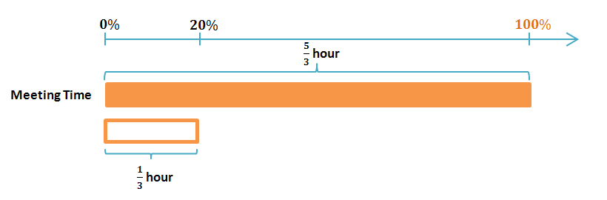
- Ted is a supervisor and spends $20\%$ of his typical work day in meetings and $20\%$ of that meeting time in his daily team meeting. If he starts each day at 7:30 a.m., and his daily team meeting is from 8:00 a.m. to 8:20 a.m., when does Ted’s typical work day end?
$20$ minutes is $\frac{1}{3}$ of an hour since $\frac{20}{60}=\frac{1}{3}$.
Ted spends $\frac{1}{3}$ hour in his daily team meeting, so $\frac{1}{3}$ corresponds to $20\%$ of his meeting time. There are $5$ intervals of $20\%$ in $100\%$, and $5\left(\frac{1}{3}\right)=\frac{5}{3}$, so Ted spends $\frac{5}{3}$ hours in meetings.
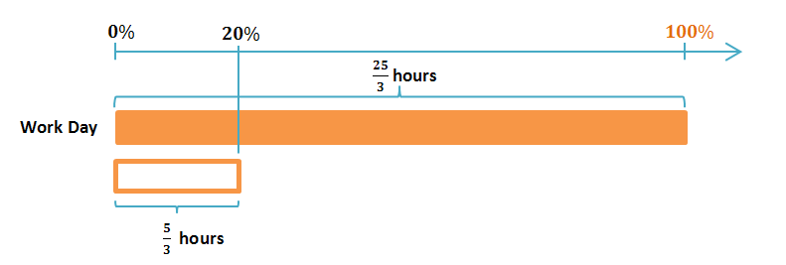
$\frac{5}{3}$ of an hour corresponds to $20\%$ of Ted’s work day.
There are $5$ intervals of $20\%$ in $100\%$, and $5\left(\frac{5}{3}\right)=\frac{25}{3}$, so Ted spends $\frac{25}{3}$ hours working. $\frac{25}{3}$ hours $=8\frac{1}{3}$ hours. Since $\frac{1}{3}$hour $=20$minutes, Ted works a total of $8$hours$20$minutes. If he starts at 7:30 a.m., he works $4$hours$30$minutes until 12:00 p.m., and since $8\frac{1}{3}-4\frac{1}{2}=3\frac{5}{6}$, Ted works another $3\frac{5}{6}$ hours after 12:00 p.m.
$\frac{1}{6}$hour$=10$minutes, and $\frac{5}{6}$ hour $=50$minutes, so Ted works $3$hours$50$minutes after 12:00 p.m., which is 3:50 p.m. Therefore, Ted’s typical work day ends at 3:50 p.m.

