Lesson 1: Percent

Classwork
Opening Exercise 1: Matching
Match the percents with the correct sentence clues.

$$25\%$$ | I am half of a half.  $5$ cubic inches of water filled in a $20$ cubic inch bottle.
$$50\%$$ | I am less than $\frac{1}{100}$.  $25$ out of $5,000$contestants won a prize.
$$30\%$$ | I am the chance of birthing a boy or a girl.  Flip a coin, and it will land on heads or tails.
$$1\%$$ | I am less than a half but more than one-fourth.  $15$ out of$50$play drums in a band.
$$10\%$$ | I am equal to $1$.  $35$ question out of $35$ questions were answered correctly.
$$100\%$$ | I am more than $1$.  Instead of the $\$1,200$ expected to be raised, $\$3,600$ was collected for the school’s fundraiser.
$$300\%$$ | I am a tenth of a tenth.  One penny is this part of one dollar.
$$\frac{1}{2}\%$$ | I am less than a fourth but more than a hundredth.  $\$11$ out of $\$110$ earned is saved in the bank.

Opening Exercise 2
Color in the grids to represent the following fractions:
- $\frac{30}{100}$ | - $\frac{3}{100}$ | - $\frac{\frac{1}{3}}{100}$
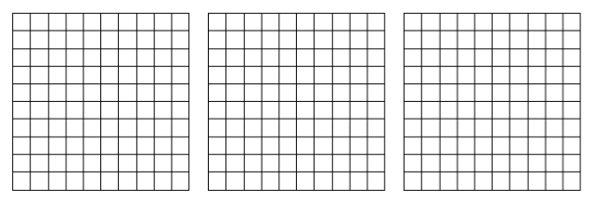

Example 1
Use the definition of the word percent to write each percent as a fraction and then as a decimal.
Percent | Fraction | Decimal
$$37.5\%$$
$$100\%$$
$$110\%$$
$$1\%$$
$$\frac{1}{2}\%$$

Example 2
Fill in the chart by converting between fractions, decimals, and percents. Show your work in the space below.

Fraction | Decimal | Percent
 |  | $$350\%$$
 | $$0.025$$
$$\frac{1}{8}$$

Exercise 1: Class Card Activity
Read your card to yourself (each student will have a different card), and work out the problem. When the exercise begins, listen carefully to the questions being read. When you have the card with the equivalent value, respond by reading your card aloud.

Examples:
$0.22$ should be read “twenty two-hundredths.”
$\frac{\frac{1}{5}}{1000}$should be read “one-fifth thousandths” or “one-fifth over one thousand.”
$\frac{7}{300}$should be read “seven-three hundredths” or “seven over three hundred.”
$\frac{200}{100}$ should be read “two hundred-hundredths” or “two hundred over one hundred$.$”

Lesson Summary
- Percent means per hundred. $P$ percent is the same as $\frac{P}{100}$. Use $\%$ as a symbol for percent.
- Usually, there are three ways to write a number: a percent, a fraction, and a decimal. Fraction and decimal forms of the percent, $P$, are equivalent to $\frac{P}{100}$.

Problem Set

- Create a model to represent the following percents.
- $90\%$ | - $0.9\%$ | - $900\%$ | - $\frac{9}{10}\%$

- Benjamin believes that$\frac{1}{2}\%$ is equivalent to $50\%$. Is he correct? Why or why not?

- Order the following from least to greatest:
$100\%$,$\frac{1}{100}$,$0.001\%$,$\frac{1}{10}$, $0.001$, $1.1$,$10$, and$\frac{10,000}{100}$

- Fill in the chart by converting between fractions, decimals, and percents. Show work in the space below.
Fraction | Decimal | Percent
 |  | $$100\%$$
 | $$0.0825$$
 | $$6.25$$
 |  | $$\frac{1}{8}\%$$
$$\frac{2}{300}$$
 |  | $$33.3\%$$
$$\frac{\frac{3}{4}}{100}$$
 |  | $$250\%$$
 | $$0.005$$
$$\frac{150}{100}$$
$$\frac{5\frac{1}{2}}{100}$$ | $$0.055$$ | $$5\frac{1}{2}\%$$

