Lesson 23: The Volume of a Right Prism

Classwork
Opening Exercise
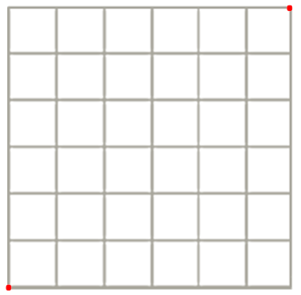
The volume of a solid is a quantity given by the number of unit cubes needed to fill the solid. Most solids—rocks, baseballs, people—cannot be filled with unit cubes or assembled from cubes. Yet such solids still have volume. Fortunately, we do not need to assemble solids from unit cubes in order to calculate their volume. One of the first interesting examples of a solid that cannot be assembled from cubes but whose volume can still be calculated from a formula is a right triangular prism.
What is the area of the square pictured on the right? Explain.

Draw the diagonal joining the two given points; then, darken the grid lines within the lower triangular region. What is area of that triangular region? Explain.

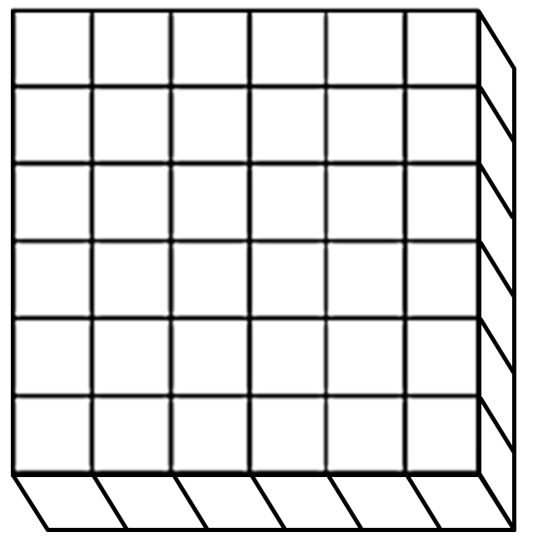
Exploratory Challenge: The Volume of a Right Prism
What is the volume of the right prism pictured on the right? Explain.

Draw the same diagonal on the square base as done above; then, darken the grid lines on the lower right triangular prism. What is the volume of that right triangular prism? Explain.

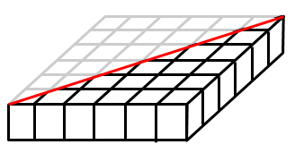
How could we create a right triangular prism with five times the volume of the right triangular prism pictured to the right, without changing the base? Draw your solution on the diagram, give the volume of the solid, and explain why your solution has five times the volume of the triangular prism.

What could we do to cut the volume of the right triangular prism pictured on the right in half without changing the base? Draw your solution on the diagram, give the volume of the solid, and explain why your solution has half the volume of the given triangular prism.

To find the volume ($V$) of any right prism …

Example: The Volume of a Right Triangular Prism
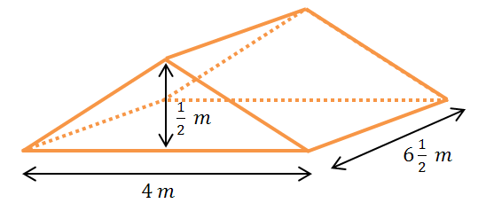
Find the volume of the right triangular prism shown in the diagram using $V=Bh$.

Exercise: Multiple Volume Representations
The right pentagonal prism is composed of a right rectangular prism joined with a right triangular prism. Find the volume of the right pentagonal prism shown in the diagram using two different strategies.
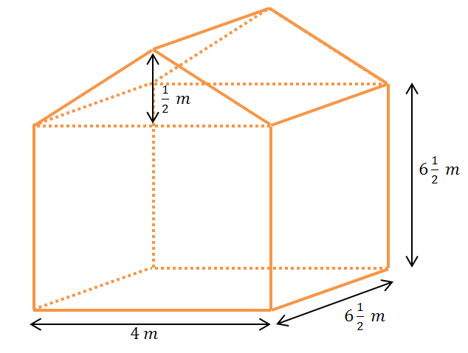

Problem Set

- Calculate the volume of each solid using the formula $V=Bh$ (all angles are $90$ degrees).
$$8 cm$$
$$12\frac{1}{2} cm$$
$7 cm$
  - b.
$$\frac{3}{4} in.$$
$$\frac{3}{4} in.$$
$$\frac{3}{4} in.$$

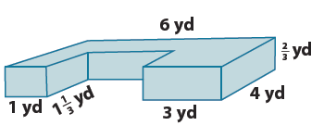
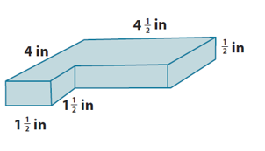
  - d.

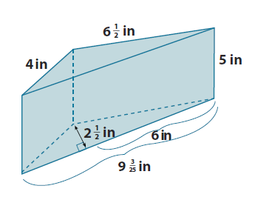
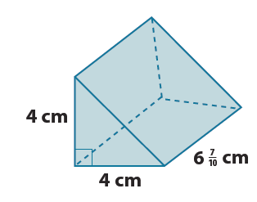
  - f.

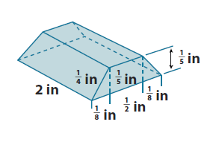
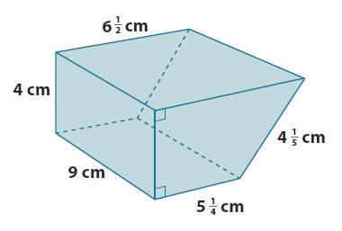
  - h.

- Let $l$ represent length, $w$ the width, and $h$ the height of a right rectangular prism. Find the volume of the prism when:
  - $l=3 cm$, $w=2\frac{1}{2} cm$, and $h=7 cm$.
  - $l=\frac{1}{4} cm$, $w=4 cm$, and $h=1\frac{1}{2} cm$.

- Find the length of the edge indicated in each diagram.
$Area=22 in^{2}$
$?$
$Volume =93\frac{1}{2} in^{3}$

What are possible dimensions of the base?
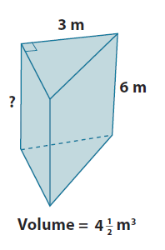
?

.

- The volume of a cube is $3\frac{3}{8} in^{3}$. Find the length of each edge of the cube.

- Given a right rectangular prism with a volume of $7\frac{1}{2} ft^{3}$, a length of $5 ft.$, and a width of $2 ft.$, find the height of the prism.

