|  |
| --- |
|  |

Lesson 23: The Volume of a Right Prism

Student Outcomes

* Students use the known formula for the volume of a right rectangular prism ().
* Students understand the volume of a right prism to be the area of the base times the height.
* Students compute volumes of right prisms involving fractional values for length.

Lesson Notes

Students extend their knowledge of obtaining volumes of right rectangular prisms via dimensional measurements to understand how to calculate the volumes of other right prisms. This concept will later be extended to finding the volumes of liquids in right prism-shaped containers and extended again (in Module 6) to finding the volumes of irregular solids using displacement of liquids in containers. The Problem Set scaffolds in the use of equations to calculate unknown dimensions.

Classwork

Opening Exercise (5 minutes)

Opening Exercise

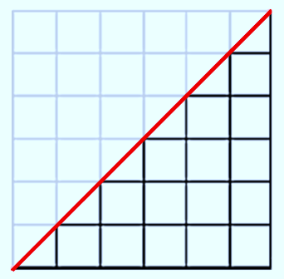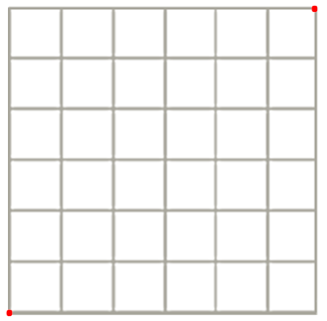The volume of a solid is a quantity given by the number of unit cubes needed to fill the solid. Most solids—rocks, baseballs, people—cannot be filled with unit cubes or assembled from cubes. Yet such solids still have volume. Fortunately, we do not need to assemble solids from unit cubes in order to calculate their volume. One of the first interesting examples of a solid that cannot be assembled from cubes but whose volume can still be calculated from a formula is a right triangular prism.

What is the area of the square pictured on the right? Explain.

*The area of the square is because the region is filled with square regions that are by , or .*

Draw the diagonal joining the two given points; then, darken the grid lines within the lower triangular region. What is area of that triangular region? Explain.

*The area of the triangular region is . There are unit squares from the original square and triangular regions that are. The triangles can be paired together to form . All together the area of the triangular region is .*

* How do the areas of the square and the triangular region compare?
  + *The area of the triangular region is half the area of the square region.*

**Exploratory Challenge (15 minutes): The Volume of a Right Prism**

Exploratory Challenge is a continuation of the Opening Exercise.

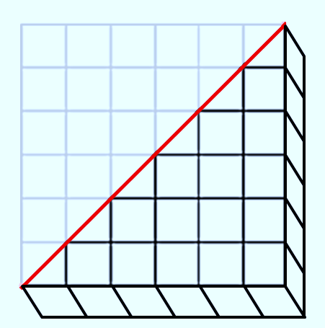  
Exploratory Challenge: The Volume of a Right Prism

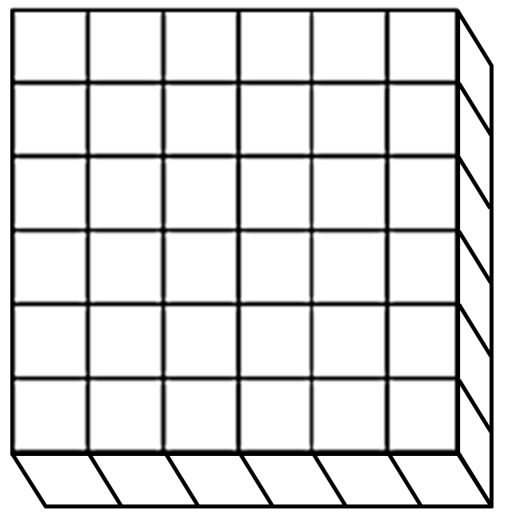What is the volume of the right prism pictured on the right? Explain.

*The volume of the right prism is because the prism is filled with cubes that are long, wide, and high, or .*

Draw the same diagonal on the square base as done above; then, darken the grid lines on the lower right triangular prism. What is the volume of that right triangular prism? Explain.

*The volume of the right triangular prism is . There are cubes from the original right prism and right triangular prisms that are each half of a cube. The right triangular prisms can be paired together to form cubes, or . All together the area of the right triangular prism is .*

* In both cases, slicing the square (or square face) along its diagonal divided the area of the square into two equal-sized triangular regions. When we sliced the right prism, however, what remained constant?
  + *The height of the given right rectangular prism and the resulting triangular prism are unchanged at .*

The argument used here is true in general for all right prisms. Since polygonal regions can be decomposed into triangles and rectangles, it is true that the polygonal base of a given right prism can be decomposed into triangular and rectangular regions that are bases of a set of right prisms that have heights equal to the height of the given right prism.

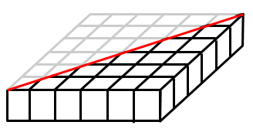How could we create a right triangular prism with five times the volume of the right triangular prism pictured to the right, without changing the base? Draw your solution on the diagram, give the volume of the solid, and explain why your solution has five times the volume of the triangular prism.

*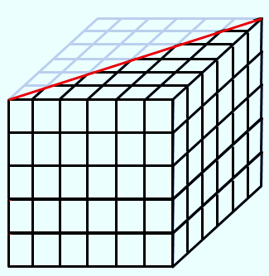If we stack five exact copies of the base (or bottom floor), the prism then has five times the number of unit cubes as the original, which means it has five times the volume, or .*

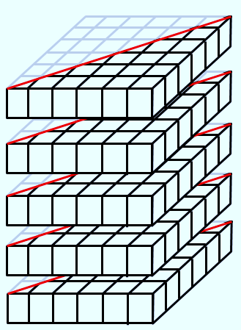

What could we do to cut the volume of the right triangular prism pictured on the right in half without changing the base? Draw your solution on the diagram, give the volume of the solid, and explain why your solution has half the volume of the given triangular prism.

*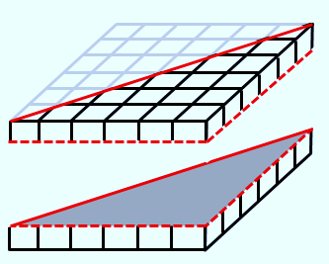If we slice the height of the prism in half, each of the unit cubes that make up the triangular prism will have half the volume as in the original right triangular prism. The volume of the new right triangular prism is .*

*Scaffolding:*

Students often form the misconception that changing the dimensions of a given right prism will affect the prism’s volume by the same factor. Use this exercise to show that the volume of the cube is cut in half because the height is cut in half. If all dimensions of a unit cube were cut in half, the resulting volume would be , which is not equal to .

* What can we conclude about how to find the volume of any right prism?
  + *The volume of any right prism can be found by multiplying the area of its base times the height of the prism.*
  + *If we let represent the volume of a given right prism, let represent the area of the base of that given right prism, and let represent the height of that given right prism, then:*

Have students complete the sentence below in their student materials.

To find the volume () of any right prism …

Multiply the area of the right prism’s base () times the height of the right prism (), .

Example (5 minutes): The Volume of a Right Triangular Prism

Students calculate the volume of a triangular prism that has not been decomposed from a rectangle.

**Example: The Volume of a Right Triangular Prism**

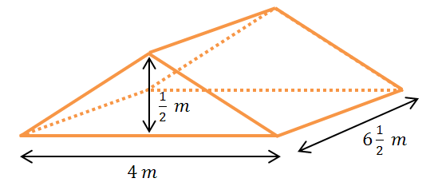Find the volume of the right triangular prism shown in the diagram using .

***The volume of the triangular prism is* .**

Exercise (10 minutes): Multiple Volume Representations

Students find the volume of the right pentagonal prism using two different strategies.

**Exercise: Multiple Volume Representations**

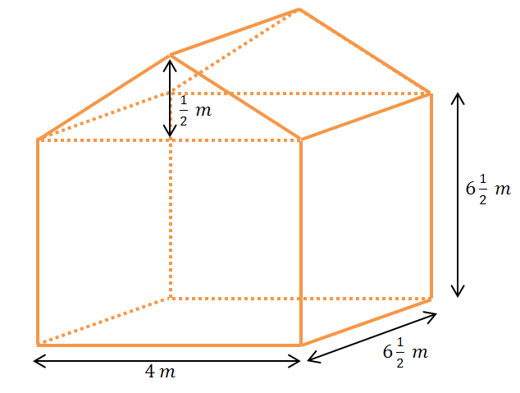The right pentagonal prism is composed of a right rectangular prism joined with a right triangular prism. Find the volume of the right pentagonal prism shown in the diagram using two different strategies.

**Strategy #1**

**The volume of the pentagonal prism is equal to the sum of the volumes of the rectangular and triangular prisms.**

So the total volume of the pentagonal prism is .

*Scaffolding:*

An alternative method that will help students visualize the connection between the area of the base, the height, and the volume of the right prism is to create pentagonal “floors” or “layers” with a depth of unit. Students can physically pile the “floors” to form the right pentagonal prism. This example involves a fractional height so representation or visualization of a “floor” with a height ofunit is necessary. See below.



Strategy #2

The volume of a right prism is equal to the area of its base times its height. The base is a rectangle and a triangle.

The volume of the right pentagonal prism is .

Closing (2 minutes)

* What are some strategies that we can use to find the volume of three-dimensional objects?
  + *Find the area of the base, then multiply times the prism’s height; decompose the prism into two or more smaller prisms of the same height, and add the volumes of those smaller prisms.*
* The volume of a solid is always greater than or equal to zero.
* If two solids are identical, they have equal volumes.
* If a solid is the union of two non-overlapping solids and , then the volume of solid is equal to the sum of the volumes of solids and .

Exit Ticket (8 minutes)

Name Date

Lesson 23: The Volume of a Right Prism

Exit Ticket

The base of the right prism is a hexagon composed of a rectangle and two triangles. Find the volume of the right hexagonal prism using the formula .

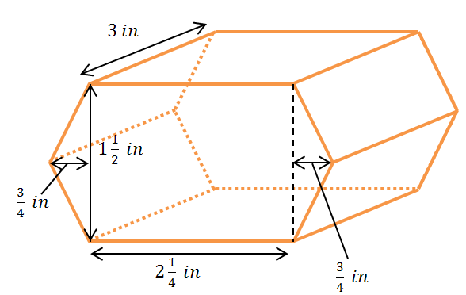

Exit Ticket Sample Solutions

The base of the right prism is a hexagon composed of a rectangle and two triangles. Find the volume of the right hexagonal prism using the formula .

The area of the base is the sum of the areas of the rectangle and the two triangles.

*The volume of the hexagonal prism is.*

Problem Set Sample Solutions

1. Calculate the volume of each solid using the formula (all angles are degrees).

*The volume of the solid is* .

*The volume of the cube is* .

* 1. 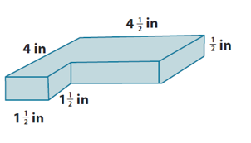

*The volume of the solid is* .

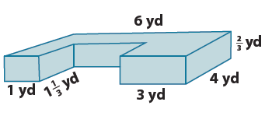



*The volume of the solid is* .

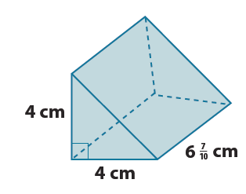

*The volume of the solid is* .

* 1. 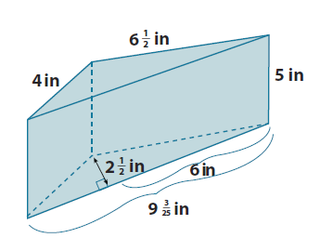

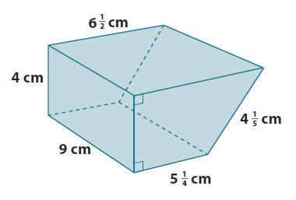 *The volume of the solid is* .

*The volume of the solid is* .

* 1. 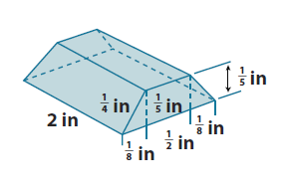

.

*The volume of the solid is* .

1. Let represent length, the width, and the height of a right rectangular prism. Find the volume of the prism when:
   1. , , and .

*The volume of the prism is* .

* 1. , , and .

*The volume of the prism is* .

1. Find the length of the edge indicated in each diagram.

* 1. *Let represent the number of inches in the height of the prism.*

*The height of the right rectangular prism is* .

What are possible dimensions of the base?

*by* , *or* *by*

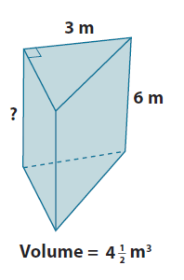

**?**

* 1. *Let represent the number of meters in the height of the triangular base of the prism.*

*The height of the triangle is*.

1. The volume of a cube is . Find the length of each edge of the cube.

, and since the volume is a fraction, the edge length must also be fractional.

*The lengths of the edges of the cube are*

1. Given a right rectangular prism with a volume of , a length of , and a width of , find the height of the prism.

Let represent the number of feet in the height of the prism.

*The height of the right rectangular prism is* *(or* *)*.