Lesson 22: Surface Area

Classwork
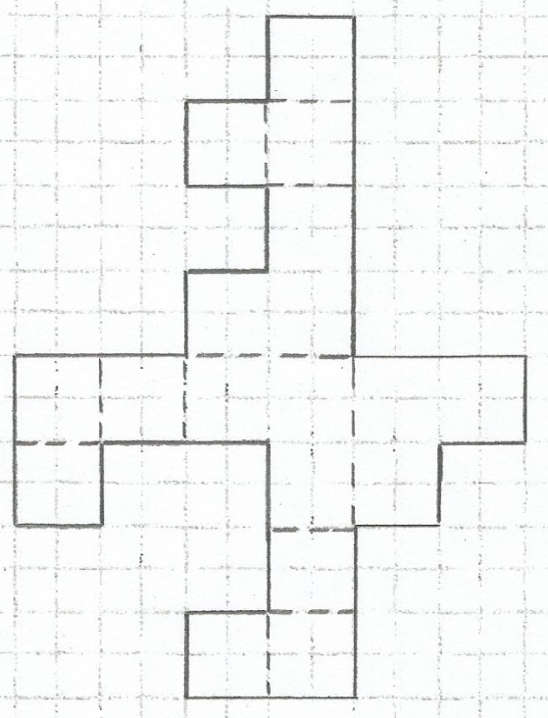
Opening Exercise
What is the area of the composite figure in the diagram? Is the diagram a net for a three-dimensional image? If so, sketch the image. If not, explain why.

Example 1
The pyramid in the picture has a square base, and its lateral faces are triangles that are exact copies of one another. Find the surface area of the pyramid.
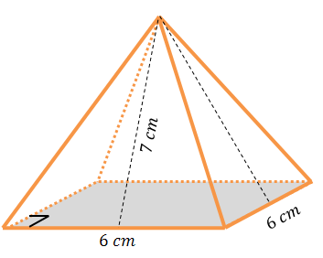

Example 2: Using Cube
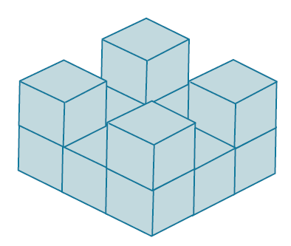
There are $13$ cubes glued together forming the solid in the diagram. The edges of each cube are$\frac{1}{4}$ inch in length. Find the surface area of the solid.

Example 3
Find the total surface area of the wooden jewelry box. The sides and bottom of the box are all$\frac{1}{4}$ inch thick.
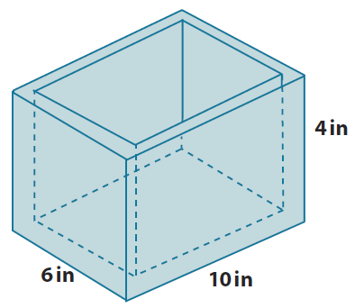
What are the faces that make up this box?

How does this box compare to other objects that you have found the surface area of?

Large Prism Small Prism

Surface Area of the Box

Problem Set

- For each of the following nets, draw (or describe) the solid represented by the net and find its surface area.
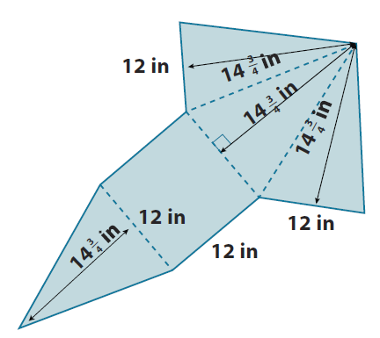
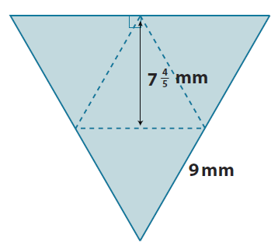
  - The equilateral triangles are exact copies. b.

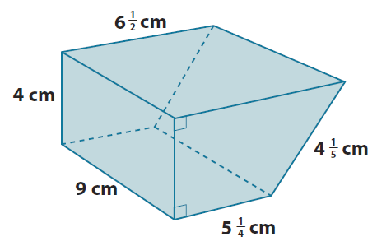
- Find the surface area of the following prism.

- The net below is for a specific object. The measurements shown are in meters. Sketch (or describe) the object, and then find its surface area.
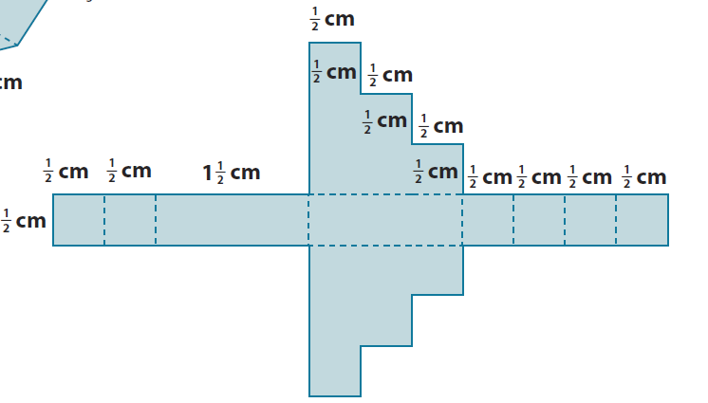

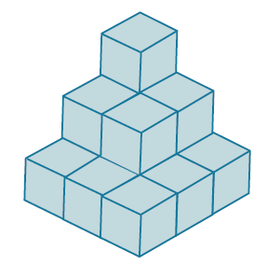
- In the diagram, there are $14$cubes glued together to form a solid. Each cube has a volume of $\frac{1}{8}{in}^{2}$. Find the surface area of the solid.

- The nets below represent three solids. Sketch (or describe) each solid and find its surface area.
a.
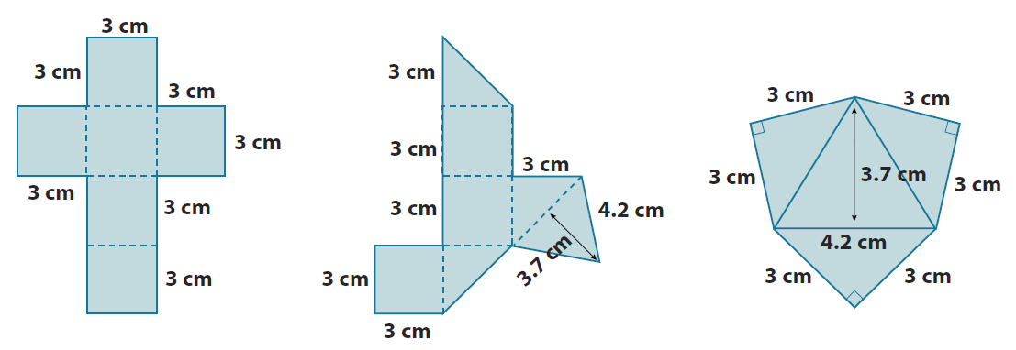
c.
b.
  - How are figures (b) and (c) related to figure (a)?

- Find the surface area of the solid shown in the diagram. The solid is a right triangular prism (with right triangular bases) with a smaller right triangular prism removed from it.
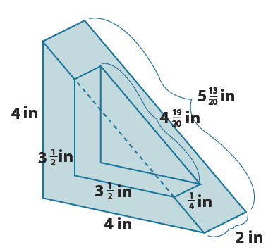

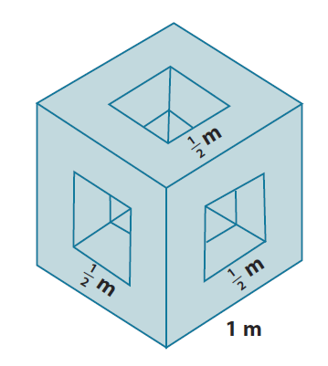
- The diagram shows a cubic meter that has had three square holes punched completely through the cube on three perpendicular axes. Find the surface area of the remaining solid.

