Lesson 22: Surface Area

Student Outcomes
- Students find the surface area of three-dimensional objects whose surface area is composed of triangles and quadrilaterals, specifically focusing on pyramids. They use polyhedron nets to understand that surface area is simply the sum of the area of the lateral faces and the area of the base(s).

Lesson Notes
Before class, teachers need to make copies of the composite figure for the Opening Exercise on cardstock. To save class time, they could also cut these nets out for students.

Classwork
Opening Exercise (5 minutes)
Make copies of the composite figure on cardstock and have students cut and fold the net to form the three-dimensional object.
Opening Exercise
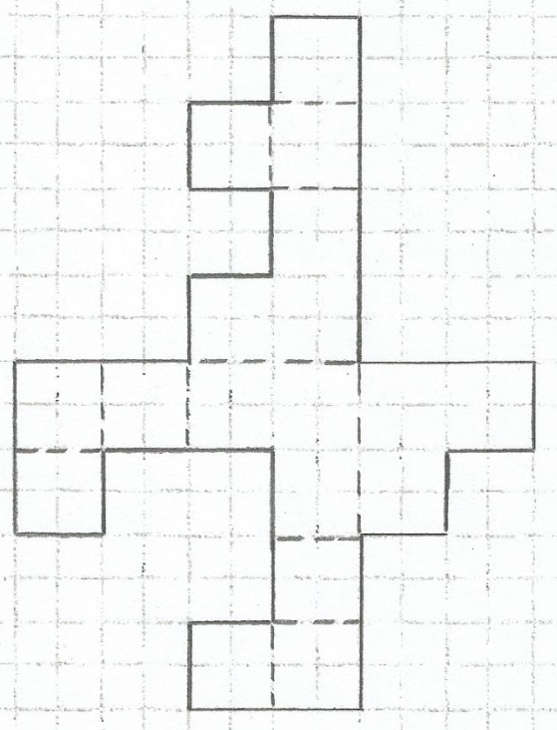
What is the area of the composite figure in the diagram? Is the diagram a net for a three-dimensional image? If so, sketch the image. If not, explain why.
There are four unit squares in each square of the figure. There are $18$total squares that make up the figure, so the total area of the composite figure is
$A=18∙4 units^{2}=72 units^{2}.$
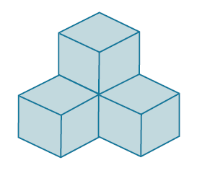
The composite figure does represent the net of a three-dimensional figure. The figure is shown below.

Example 1 (5 minutes)
Pyramids are formally defined and explored in more depth in Module 6. Here, we simply introduce finding the surface area of a pyramid and ask questions designed to elicit the formulas from students. For example, ask how many lateral faces there are on the pyramid; then, ask for the triangle area formula. Continue leading students toward stating the formula for total surface area on their own.
Example 1
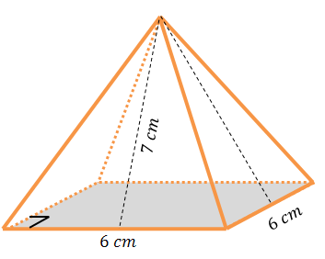
The pyramid in the picture has a square base, and its lateral faces are triangles that are exact copies of one another. Find the surface area of the pyramid.
The surface area of the pyramid consists of one square base and four lateral triangular faces.
$LA=4\left(\frac{1}{2}bh\right)$ $B=s^{2}$
$LA=4∙\frac{1}{2}\left(6 \text{cm}∙7 \text{cm}\right)$ $B={\left(6 \text{cm}\right)}^{2}$
$LA=2\left(6 \text{cm}∙7\text{ cm}\right)$ $B=36\text{ c}{\text{m}}^{\text{2}}$
$LA=2\left(42 \text{c}{\text{m}}^{\text{2}}\right)$ The pyramid’s base area is $36 \text{c}{\text{m}}^{\text{2}}$.
$LA=84 \text{c}{\text{m}}^{\text{2}}$
The pyramid’s lateral area is $84\text{ c}{\text{m}}^{\text{2}}$. $SA=LA+B$
$SA=84 \text{c}{\text{m}}^{\text{2}}+36 \text{c}{\text{m}}^{\text{2}}=120 \text{c}{\text{m}}^{\text{2}}$
The surface area of the pyramid is $120\text{ c}{\text{m}}^{\text{2}}$.

Example 2 (4 minutes): Using Cubes
Consider providing $13$ interlocking cubes to small groups of students so they may construct a model of the diagram shown. Remind students to count faces systematically. For example, first consider only the bottom $9$ cubes. This structure has a surface area of $30$ ($9$ at the top, $9$ at the bottom, and $3$ on each of the four sides). Now consider the four cubes added at the top. Since we have already counted the tops of these cubes, we just need to add the four sides of each. $30+16=46$ total square faces, each with side length$\frac{1}{4}$ inch.
Example 2: Using Cubes
There are $13$ cubes glued together forming the solid in the diagram. The edges of each cube are$\frac{1}{4}$ inch in length. Find the surface area of the solid.
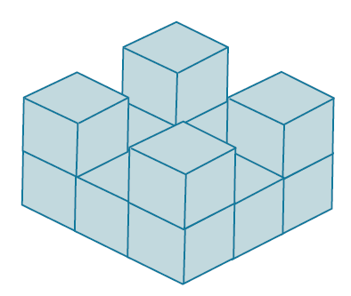
The surface area of the solid consists of $46$ square faces, all having side lengths of$\frac{1}{4}$ inch. The area of a square having sides of length$\frac{1}{4}$ inch is $\frac{1}{16}\text{i}{\text{n}}^{\text{2}}$ .
$$SA=46∙A_{square} \\ SA=46∙\frac{1}{16} in^{2} \\ SA=\frac{46}{16} in^{2} \\ SA=2\frac{14}{16} in^{2}$$$SA=2\frac{7}{8} in^{2}$ The surface are of the solid is $2\frac{7}{8}in^{2}$
- Compare and contrast the methods for finding surface area for pyramids and prisms. How are the methods similar?
  - When finding the surface area of a pyramid and a prism, we find the area of each face and then add these areas together.
- How are they different?
  - Calculating the surface area of pyramids and prisms is different because of the shape of the faces. A prism has two bases and lateral faces that are rectangles. A pyramid has only one base and lateral faces that are triangles.

Example 3 (15 minutes)
Example 3
Find the total surface area of the wooden jewelry box. The sides and bottom of the box are all$\frac{1}{4}$ inch thick.
What are the faces that make up this box?  The box has a rectangular bottom, rectangular lateral faces, and a rectangular top that has a smaller rectangle removed from it. There are also rectangular faces that make up the inner lateral faces and the inner bottom of the box.  How does this box compare to other objects that you have found the surface area of?  The box is a rectangular prism with a smaller rectangular prism removed from its inside. The total surface area will be equal to the surface area of the larger right rectangular prism plus the lateral area of the smaller right rectangular prism. | 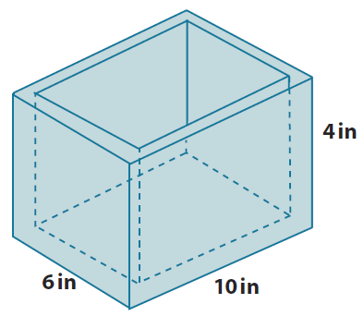
Large Prism: The surface area of the large right rectangular prism makes up the outside faces of the box, the rim of the box, and the inside bottom face of the box.  $SA=LA+2B$  $LA=P∙h$ $B=lw$  $LA=32 \text{in.}∙4\text{ in.}=128 \text{i}{\text{n}}^{\text{2}}$ $B=10 \text{in.}∙6\text{ in.}$  The lateral area is $128\text{ i}{\text{n}}^{\text{2}}$. $B=60\text{ i}{\text{n}}^{\text{2}}$  The base area is $60\text{ i}{\text{n}}^{\text{2}}$.  $SA=LA+2B$  $SA=128\text{ i}{\text{n}}^{\text{2}}+2(60 \text{i}{\text{n}}^{\text{2}})$  $SA=128\text{ i}{\text{n}}^{\text{2}}+120 \text{i}{\text{n}}^{\text{2}}=248 \text{i}{\text{n}}^{\text{2}}$  The surface area of the larger prism is $248\text{ i}{\text{n}}^{\text{2}}$. | Small Prism: The smaller prism is $\frac{1}{2} \text{in.}$ smaller in length and width, and $\frac{1}{4}\text{ in.}$ smaller in height due to the thickness of the sides of the box.  $SA=LA+1B$  $LA=P∙h$  $$LA=2\left(9\frac{1}{2}\text{ in.}+5\frac{1}{2}\text{ in.}\right)∙3\frac{3}{4}\text{ in.} \\ LA=2\left(14 \text{in.}+1 \text{in.}\right)∙3\frac{3}{4} \text{in.} \\ LA=2\left(15 \text{in.}\right)∙3\frac{3}{4} \text{in}. \\ LA=30\text{ in.}∙3\frac{3}{4}\text{ in. } \\ LA=90\text{ i}{\text{n}}^{\text{2}}+\frac{90}{4}\text{ i}{\text{n}}^{\text{2}} \\ LA=90\text{ i}{\text{n}}^{\text{2}}+22\frac{1}{2} \text{i}{\text{n}}^{\text{2}} \\ LA=112\frac{1}{2} \text{i}{\text{n}}^{\text{2}}$$  The lateral area is $112\frac{1}{2}\text{ i}{\text{n}}^{\text{2}}$.
Surface Area of the Box
$SA_{box}=SA+LA$
$SA_{box}=248 \text{i}{\text{n}}^{\text{2}}+112\frac{1}{2} \text{i}{\text{n}}^{\text{2}}$
$SA_{box}=360\frac{1}{2} \text{i}{\text{n}}^{\text{2}}$
The total surface area of the box is $360\frac{1}{2}\text{i}{\text{n}}^{\text{2}}$.
Discussion (5 minutes): Strategies and Observations from Example 3
Scaffolding:
To help students visualize the various faces involved on this object, consider constructing a similar object by placing a smaller shoe box inside a slightly larger shoe box. This will also help students visualize the inner surfaces of the box as the lateral faces of the smaller prism that is removed from the larger prism.
Call on students to provide their answers to each of the following questions. To encourage a discussion about strategy, patterns, arguments, or observations, call on more than one student for each of these questions.
- What ideas did you have to solve this problem? Explain.
  - Answers will vary.
- Did you make any mistakes in your solution? Explain.
  - Answers will vary; examples include the following:
    - Subtracted$\frac{1}{2}$ inch from the depth of the box instead of$\frac{1}{4}$ inch;
    - Subtracted only$\frac{1}{4}$ inch from the length and width because I didn’t account for both sides.
- Describe how you found the surface area of the box and what that surface area is.
  - Answers will vary.

Closing (2 minutes)
- What are some strategies for finding the surface area of solids?
  - Answers will vary but include creating nets, adding the areas of polygonal faces, counting square faces and adding their areas, etc.

Exit Ticket (9 minutes)
Name Date
Lesson 22: Surface Area

Exit Ticket

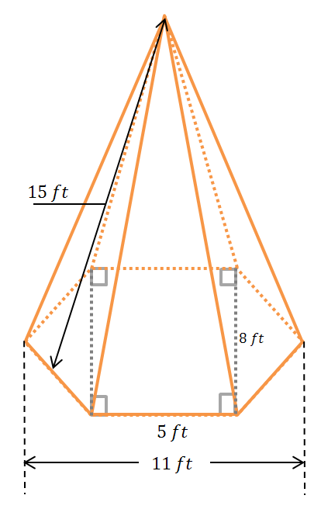
- The right hexagonal pyramid has a hexagon base with equal-length sides. The lateral faces of the pyramid are all triangles (that are exact copies of one another) with heights of $15 ft$. Find the surface area of the pyramid.

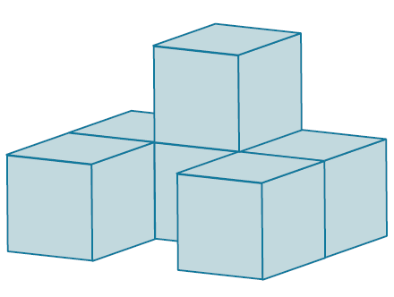
- Six cubes are glued together to form the solid shown in the diagram. If the edges of each cube measure $1\frac{1}{2}$ inches in length, what is the surface area of the solid?

Exit Ticket Sample Solutions

- The right hexagonal pyramid has a hexagon base with equal-length sides. The lateral faces of the pyramid are all triangles (that are exact copies of one another) with heights of $15 ft$. Find the surface area of the pyramid.
$SA=LA+1B$
$LA=6∙\frac{1}{2}\left(bh\right)$ $B=A_{\text{rectangle}}+2A_{\text{triangle}}$
$LA=6∙\frac{1}{2}\left(5 \text{ft.}∙15\text{ ft.}\right)$ $B=\left(8 \text{ft.}∙5 \text{ft.}\right)+2∙\frac{1}{2}\left(8\text{ ft.}∙3\text{ ft.}\right)$
$LA=3∙75\text{ f}{\text{t}}^{\text{2}}$ $B=40 \text{f}{\text{t}}^{\text{2}}+(8\text{ ft.}∙3 \text{ft.})$
$LA=225 \text{f}{\text{t}}^{\text{2}}$ $B=40\text{ f}{\text{t}}^{\text{2}}+24 \text{f}{\text{t}}^{\text{2}}$
$B=64 \text{f}{\text{t}}^{\text{2}}$
$SA=LA+1B$
$SA=225\text{ f}{\text{t}}^{\text{2}}+64 \text{f}{\text{t}}^{\text{2}}=289\text{ f}{\text{t}}^{\text{2}}$
The surface area of the pyramid is $289 \text{f}{\text{t}}^{\text{2}}$.

- Six cubes are glued together to form the solid shown in the diagram. If the edges of each cube measure $1\frac{1}{2}$ inches in length, what is the surface area of the solid?
There are $26$ square cube faces showing on the surface area of the solid ($5$ each from the top and bottom view, $4$ each from the front and back view, $3$ each from the left and right side views, and $2$ from the “inside” of the front).
$A=s^{2}$ $SA=26∙\left(2\frac{1}{4} \text{i}{\text{n}}^{\text{2}}\right)$
$A={\left(1\frac{1}{2}\text{ in.}\right)}^{2}$ $SA=52\text{ i}{\text{n}}^{\text{2}}+\frac{26}{4} \text{i}{\text{n}}^{\text{2}}$
$A=\left(1\frac{1}{2}\text{ in.}\right)\left(1\frac{1}{2} \text{in.}\right)$ $SA=52 \text{i}{\text{n}}^{\text{2}}+6\text{ i}{\text{n}}^{\text{2}}+\frac{1}{2} \text{i}{\text{n}}^{\text{2}}$
$A=1\frac{1}{2} \text{in.}\left(1 \text{in.}+\frac{1}{2}\text{ in.}\right)$ $SA=58\frac{1}{2} \text{i}{\text{n}}^{\text{2}}$
$A=\left(1\frac{1}{2}\text{ in.}∙1\text{ in.}\right)+\left(\left.1\frac{1}{2}\right.\text{ in.}∙\frac{1}{2} \text{in.}\right)$
$A=1\frac{1}{2}\text{ i}{\text{n}}^{\text{2}}+\frac{3}{4}\text{ i}{\text{n}}^{\text{2}}$
$A=1\frac{2}{4}\text{ i}{\text{n}}^{\text{2}}+\frac{3}{4} \text{i}{\text{n}}^{\text{2}}=1\frac{5}{4}\text{ i}{\text{n}}^{\text{2}}=2\frac{1}{4} \text{i}{\text{n}}^{\text{2}}$ The surface area of the solid is $58\frac{1}{2}\text{ i}{\text{n}}^{\text{2}}$.

Problem Set Sample Solutions

- For each of the following nets, draw (or describe) the solid represented by the net and find its surface area.
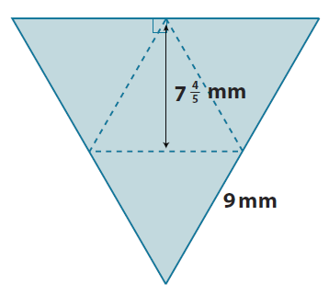
  - The equilateral triangles are exact copies.
The net represents a triangular pyramid where the three lateral faces are congruent to each other and the triangular base.
$SA=4B$ since the faces are all the same size and shape.
$B=\frac{1}{2}bh$ $SA=4B$
$B=\frac{1}{2}∙9 \text{mm}∙7\frac{4}{5} \text{mm}$ $SA=4\left(35\frac{1}{10} \text{m}{\text{m}}^{\text{2}}\right)$
$B=\frac{9}{2}\text{ mm}∙7\frac{4}{5}\text{ mm}$ $SA=140 \text{m}{\text{m}}^{\text{2}}+\frac{4}{10}\text{ m}{\text{m}}^{\text{2}}$
$B=\frac{63}{2}\text{ m}{\text{m}}^{\text{2}}+\frac{36}{10} \text{m}{\text{m}}^{\text{2}}$ $SA=140\frac{2}{5}\text{ m}{\text{m}}^{\text{2}}$
$B=\frac{315}{10} \text{m}{\text{m}}^{\text{2}}+\frac{36}{10} \text{m}{\text{m}}^{\text{2}}$
$B=\frac{351}{10}\text{ m}{\text{m}}^{\text{2}}$ The surface area of the triangular pyramid is $140\frac{2}{5}\text{ m}{\text{m}}^{\text{2}}$
$$B=35\frac{1}{10}\text{ mm}$$
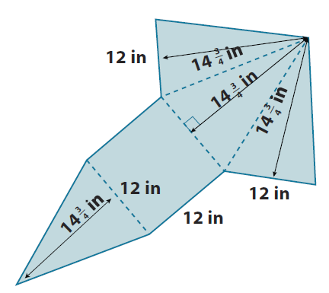
  - The net represents a square pyramid that has four congruent lateral faces that are triangles. The base is a square.
$SA=LA+B$
$LA=4∙\frac{1}{2}\left(bh\right)$ $B=s^{2}$
$LA=4∙\frac{1}{2}\left(12\text{ in.}∙14\frac{3}{4} \text{in.}\right)$ $B={\left(12\text{ in.}\right)}^{2}$
$LA=2\left(12 \text{in.}∙14\frac{3}{4} \text{in.}\right)$ $B=144 \text{i}{\text{n}}^{\text{2}}$
$LA=2\left(168 \text{i}{\text{n}}^{\text{2}}+9\text{ i}{\text{n}}^{\text{2}}\right)$
$LA=336 \text{i}{\text{n}}^{\text{2}}+18 \text{i}{\text{n}}^{\text{2}}$
$LA=354\text{ i}{\text{n}}^{\text{2}}$
$SA=LA+B$
$SA=354 \text{i}{\text{n}}^{\text{2}}+144 \text{i}{\text{n}}^{\text{2}}=498 \text{i}{\text{n}}^{\text{2}}$
The surface area of the square pyramid is $498\text{ i}{\text{n}}^{\text{2}}$.
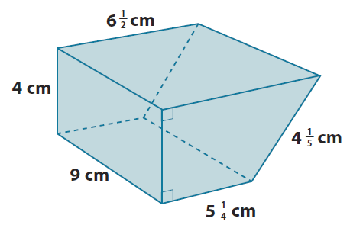
- Find the surface area of the following prisms.
$$SA=LA+2B$$
$LA=P∙h$
$LA=\left(4 \text{cm}+6\frac{1}{2} \text{cm}+4\frac{1}{5} \text{cm}+5\frac{1}{4} \text{cm}\right)∙9 \text{cm}$
$LA=\left(19 \text{cm}+\frac{1}{2} \text{cm}+\frac{1}{5} \text{cm}+\frac{1}{4} \text{cm}\right)∙9 \text{cm}$
$LA=\left(19 \text{cm}+\frac{10}{20}\text{ cm}+\frac{4}{20}\text{ cm}+\frac{5}{20}\text{ cm}\right)∙9\text{ cm}$
$LA=\left(19\text{ cm}+\frac{19}{20}\text{ cm}\right)∙9\text{ cm}$
$LA=171 \text{c}{\text{m}}^{\text{2}}+\frac{171}{20} \text{c}{\text{m}}^{\text{2}}$
$LA=171\text{ c}{\text{m}}^{\text{2}}+8\frac{11}{20} \text{c}{\text{m}}^{\text{2}}$
$LA=179\frac{11}{20} \text{c}{\text{m}}^{\text{2}}$

$B=A_{\text{rectangle}}+A_{\text{triangle}}$ $SA=LA+2B$
$B=\left(5\frac{1}{4}\text{ cm}∙4\text{ cm}\right)+\frac{1}{2}\left(4 \text{cm}∙1\frac{1}{4} \text{cm}\right)$ $SA=179\frac{11}{20}\text{ c}{\text{m}}^{\text{2}}+2\left(23\frac{1}{2} \text{c}{\text{m}}^{\text{2}}\right)$
$B=\left(20 \text{c}{\text{m}}^{\text{2}}+1 \text{c}{\text{m}}^{\text{2}}\right)+\left(2 \text{cm}∙1\frac{1}{4}\text{ cm}\right)$ $SA=179\frac{11}{20} \text{c}{\text{m}}^{\text{2}}+47 \text{c}{\text{m}}^{\text{2}}$
$B=21 \text{c}{\text{m}}^{\text{2}}+2\frac{1}{2} \text{c}{\text{m}}^{\text{2}}$ $SA=226\frac{11}{20} \text{c}{\text{m}}^{\text{2}}$
$B=23\frac{1}{2} \text{c}{\text{m}}^{\text{2}}$
The surface area of the prism is $226\frac{11}{20}\text{ c}{\text{m}}^{\text{2}}$.

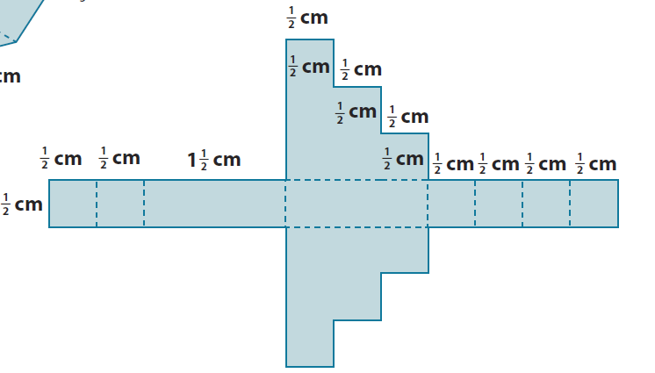
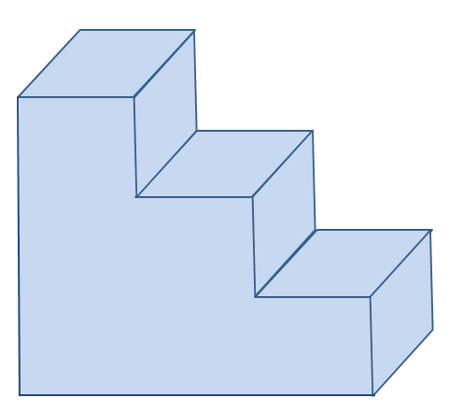
- The net below is for a specific object. The measurements shown are in meters. Sketch (or describe) the object, and then find its surface area.
(3-Dimensional Form)
$SA=LA+2b$
$LA=P∙h$ $b=\left(\frac{1}{2} \text{cm}∙\frac{1}{2} \text{cm}\right)+\left(\frac{1}{2}\text{ cm}∙1 \text{cm}\right)+\left(\frac{1}{2}\text{ cm}∙1\frac{1}{2}\text{ cm}\right)$ $SA=LA+2b$
$LA=6\text{ cm}∙\frac{1}{2}\text{ cm}$ $b=\left(\frac{1}{4} {\text{cm}}^{\text{2}}\right)+\left(\frac{1}{2}\text{ c}{\text{m}}^{\text{2}}\right)+\left(\frac{3}{4} \text{c}{\text{m}}^{\text{2}}\right)$ $SA=3 {\text{cm}}^{\text{2}}+2\left(1\frac{1}{2}\text{ c}{\text{m}}^{\text{2}}\right)$
$LA=3 \text{c}{\text{m}}^{\text{2}}$ $b=\left(\frac{1}{4}{\text{ cm}}^{\text{2}}\right)+\left(\frac{2}{4}{\text{ cm}}^{\text{2}}\right)+\left(\frac{3}{4}{\text{ cm}}^{\text{2}}\right)$ $SA=3 {\text{cm}}^{\text{2}}+3\text{ c}{\text{m}}^{\text{2}}$
$b=\frac{6}{4} \text{c}{\text{m}}^{\text{2}}$ $SA=6 {\text{cm}}^{\text{2}}$
$b=1\frac{1}{2} {\text{cm}}^{\text{2}}$
The surface area of the object is $6 {\text{cm}}^{\text{2}}$.

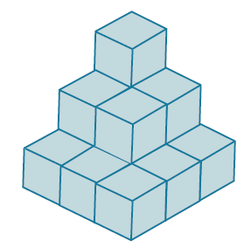
- In the diagram, there are $14$cubes glued together to form a solid. Each cube has a volume of $\frac{1}{8} in^{2}$. Find the surface area of the solid.
The volume of a cube is $s^{3}$, and$\frac{1}{8}={\left(\frac{1}{2}\right)}^{3}$, so the cubes have edges that are $\frac{1}{2} \text{in.}$ long. The cube faces have area $s^{2}$, or ${\left(\frac{1}{2}\text{ in.}\right)}^{2}=\frac{1}{4}\text{ i}{\text{n}}^{\text{2}}$. There are $42$cube faces that make up the surface of the solid.
$SA=\frac{1}{4}\text{ i}{\text{n}}^{\text{2}}∙42$
$SA=10\frac{1}{2} \text{i}{\text{n}}^{\text{2}}$
The surface area of the solid is $10\frac{1}{2} \text{i}{\text{n}}^{\text{2}}$.

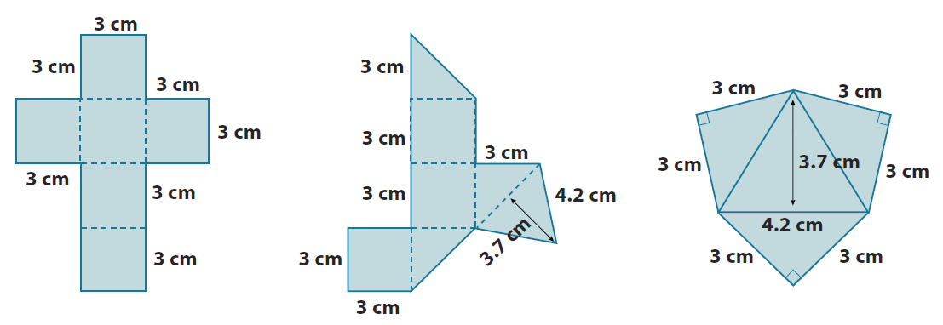
- The nets below represent three solids. Sketch (or describe) each solid and find its surface area.
c.
a.
b.
$SA=LA+2B$  $LA=P∙h$  $LA=12∙3=36 {\text{cm}}^{\text{2}}$  $B=s^{2}$  $B={(3 \text{cm})}^{2}=9 {\text{cm}}^{\text{2}}$  $SA=36 \text{c}{\text{m}}^{\text{2}}+2(9 \text{c}{\text{m}}^{\text{2}})$  $$SA=36 \text{c}{\text{m}}^{\text{2}}+18 \text{c}{\text{m}}^{\text{2}}$$  $SA=54 {\text{cm}}^{\text{2}}$ | $SA={3A}_{square}+3A_{rt triangle}+A_{equ triangle}$  $A_{square}=s^{2}$  $A_{square}={(3 \text{cm})}^{2}=9 {\text{cm}}^{\text{2}}$  $$A_{rt triangle}=\frac{1}{2}bh$$  $$A_{rt triangle}=\frac{1}{2}∙3\text{ cm}∙3 \text{cm}$$  $$A_{rt triangle}=\frac{9}{2}=4\frac{1}{2} {\text{cm}}^{\text{2}}$$  $$A_{equ triangle}=\frac{1}{2}bh$$  $$A_{equ triangle}=\frac{1}{2}∙\left(4\frac{1}{5} \text{cm}\right)∙\left(3\frac{7}{10} \text{cm}\right)$$  $$A_{equ triangle}=2\frac{1}{10}\text{cm}∙3\frac{7}{10} \text{cm}$$  $$A_{equ triangle}=\frac{21}{10} \text{cm}∙\frac{37}{10} \text{cm}$$  $$A_{equ triangle}=\frac{777}{100} {\text{cm}}^{\text{2}}=7\frac{77}{100} {\text{cm}}^{\text{2}}$$  $$SA=3\left(9 {\text{cm}}^{\text{2}}\right)+3\left(4\frac{1}{2} {\text{cm}}^{\text{2}}\right)+7\frac{77}{100} {\text{cm}}^{\text{2}}$$  $$SA=27 {\text{cm}}^{\text{2}}+\left(12+\frac{3}{2}\right) {\text{cm}}^{\text{2}}+7\frac{77}{100} {\text{cm}}^{\text{2}}$$  $$SA=47 {\text{cm}}^{\text{2}}+\frac{1}{2} {\text{cm}}^{\text{2}}+\frac{77}{100} {\text{cm}}^{\text{2}}$$  $$SA=47 {\text{cm}}^{\text{2}}+\frac{50}{100} {\text{cm}}^{\text{2}}+\frac{77}{100} {\text{cm}}^{\text{2}}$$  $$SA=47 {\text{cm}}^{\text{2}}+\frac{127}{100} {\text{cm}}^{\text{2}}$$ | $SA=3A_{rt triangle}+A_{equ triangle}$  $$SA=3\left(4\frac{1}{2}\right) {\text{cm}}^{\text{2}}+7\frac{77}{100} {\text{cm}}^{\text{2}}$$  $$SA=12 {\text{cm}}^{\text{2}}+\frac{3}{2} {\text{cm}}^{\text{2}}+7 {\text{cm}}^{\text{2}}+\frac{77}{100} {\text{cm}}^{\text{2}}$$  $$SA=20 {\text{cm}}^{\text{2}}+\frac{1}{2} {\text{cm}}^{\text{2}}+\frac{77}{100} {\text{cm}}^{\text{2}}$$  $$SA=20 {\text{cm}}^{\text{2}}+1 {\text{cm}}^{\text{2}}+\frac{27}{100} {\text{cm}}^{\text{2}}$$  $$SA=21\frac{27}{100} {\text{cm}}^{\text{2}}$$  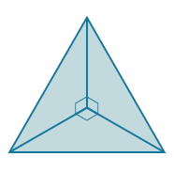  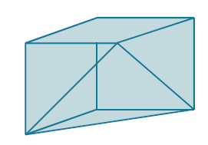
 | $$SA=47 {\text{cm}}^{\text{2}}+1 {\text{cm}}^{\text{2}}+\frac{27}{100} {\text{cm}}^{\text{2}}=48\frac{27}{100} {\text{cm}}^{\text{2}}$$

  - How are figures (b) and (c) related to figure (a)?
If the equilateral triangular faces of figures (b) and (c) were matched together, they would form the cube in part (a).
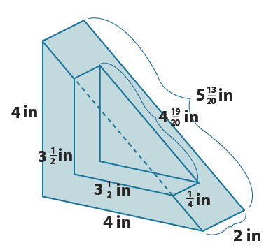
- Find the surface area of the solid shown in the diagram. The solid is a right triangular prism (with right triangular bases) with a smaller right triangular prism removed from it.
$SA=LA+2B$
$LA=P∙h$
$$LA=\left(4 \text{in.}+4\text{ in.}+5\frac{13}{20}\text{ in.}\right)∙2 \text{in.}$$
$$LA=\left(13\frac{13}{20} \text{in.}\right)∙2 \text{in.}$$
$$LA=26 \text{i}{\text{n}}^{\text{2}}+\frac{13}{10} \text{i}{\text{n}}^{\text{2}}$$
$$LA=26\text{ i}{\text{n}}^{\text{2}}+1\text{ i}{\text{n}}^{\text{2}}+\frac{3}{10}\text{ i}{\text{n}}^{\text{2}}$$
$$LA=27\frac{3}{10} \text{i}{\text{n}}^{\text{2}}$$
The $\frac{1}{4}\text{ in.}$ by $4\frac{19}{20}\text{ in.}$ rectangle has to be taken away from the lateral area:
$A=lw$ $27\frac{3}{10} \text{i}{\text{n}}^{\text{2}}-1\frac{19}{80} \text{i}{\text{n}}^{\text{2}}$
$A=4\frac{19}{20}\text{ in.}∙\frac{1}{4} \text{in.}$ $27\frac{24}{80} \text{i}{\text{n}}^{\text{2}}-1\frac{19}{80}\text{ i}{\text{n}}^{\text{2}}$
$A=1 \text{i}{\text{n}}^{\text{2}}+\frac{19}{80} \text{i}{\text{n}}^{\text{2}}$ $26\frac{5}{80} \text{i}{\text{n}}^{\text{2}}$
$A=1\frac{19}{80} \text{i}{\text{n}}^{\text{2}}$ $26\frac{1}{16} \text{i}{\text{n}}^{\text{2}}$

Two lateral faces of the smaller triangular prism must be added.
$$SA=26\frac{1}{16} \text{i}{\text{n}}^{\text{2}}+2\left(3\frac{1}{2} \text{in.}∙\frac{1}{4}\text{ in.}\right)$$
$$SA=26\frac{1}{16}\text{ i}{\text{n}}^{\text{2}}+2∙\frac{1}{4} \text{in.}∙3\frac{1}{2} \text{in.}$$
$$SA=26\frac{1}{16} \text{i}{\text{n}}^{\text{2}}+\frac{1}{2} \text{in.}∙3\frac{1}{2} \text{in.}$$
$$SA=26\frac{1}{16}\text{ i}{\text{n}}^{\text{2}}+\left(\frac{3}{2} \text{i}{\text{n}}^{\text{2}}+\frac{1}{4} \text{i}{\text{n}}^{\text{2}}\right)$$
$$SA=26\frac{1}{16}\text{ i}{\text{n}}^{\text{2}}+1\text{ i}{\text{n}}^{\text{2}}+\frac{8}{16} \text{i}{\text{n}}^{\text{2}}+\frac{4}{16}\text{ i}{\text{n}}^{\text{2}}$$
$$SA=27\frac{13}{16} \text{i}{\text{n}}^{\text{2}}$$
The surface area of the solid is $27\frac{13}{16} \text{i}{\text{n}}^{\text{2}}$.

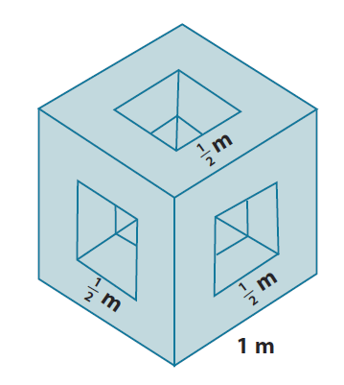
- The diagram shows a cubic meter that has had three square-holes punched completely through the cube on three perpendicular axes. Find the surface area of the remaining solid.
Exterior surfaces of the cube ${(SA}_{1})$:
$$SA_{1}=6{\left(1 \text{m}\right)}^{2}-6{\left(\frac{1}{2} \text{m}\right)}^{2}$$
$$SA_{1}=6\left(1 {\text{m}}^{\text{2}}\right)-6\left(\frac{1}{4} {\text{m}}^{\text{2}}\right)$$
$$SA_{1}=6{\text{ m}}^{\text{2}}-\frac{6}{4} {\text{m}}^{\text{2}}$$
$$SA_{1}=6 {\text{m}}^{\text{2}}-\left(1\frac{1}{2} {\text{m}}^{\text{2}}\right)$$
$$SA_{1}=4\frac{1}{2}{\text{ m}}^{\text{2}}$$
Just inside each square hole are four intermediate surfaces that can be treated as the lateral area of a rectangular prism. Each has a height of $\frac{1}{4}$ inch and perimeter of $\frac{1}{2} \text{m}+\frac{1}{2} \text{m}+\frac{1}{2} \text{m}+\frac{1}{2} \text{m}=2 \text{m}$.
$SA_{2}=6(LA)$
$$SA_{2}=6\left(2 \text{m}∙\frac{1}{4} \text{m}\right)$$
$$SA_{2}=6∙\frac{1}{2} {\text{m}}^{\text{2}}$$
$SA_{2}=3 {\text{m}}^{\text{2}}$

The total surface area of the remaining solid is the sum of these two areas:
$SA_{T}=SA_{1}+SA_{2}$.
$$SA_{T}=4\frac{1}{2} {\text{m}}^{\text{2}}+3 {\text{m}}^{\text{2}}$$
$$SA_{T}=7\frac{1}{2} {\text{m}}^{\text{2}}$$
The surface area of the remaining solid is $7\frac{1}{2} {\text{m}}^{\text{2}}$.

