Lesson 21: Surface Area

Classwork

**Opening Exercise: Surface Area of a Right Rectangular Prism**

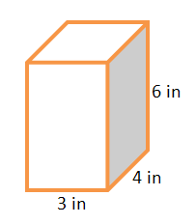On the provided grid, draw a net representing the surfaces of the right rectangular prism (assume each grid line represents inch). Then, find the surface area of the prism by finding the area of the net.



Exercise 1

Marcus thinks that the surface area of the right triangular prism will be half that of the right rectangular prism and wants to use the modified formula . Do you agree or disagree with Marcus? Use nets of the prisms to support your argument.

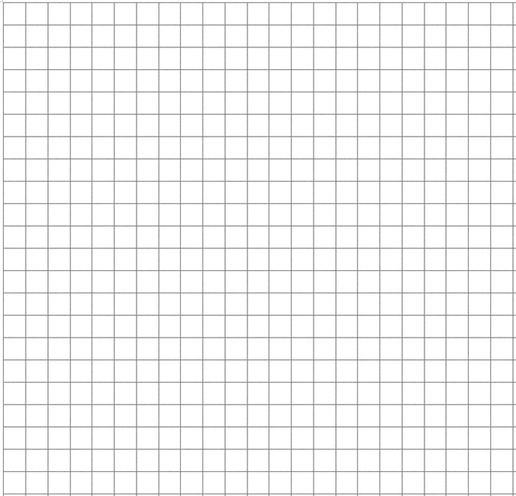

Example 1: Lateral Area of a Right Prism

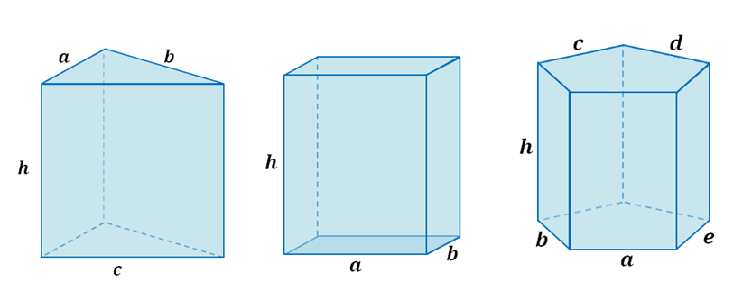A right triangular prism, a right rectangular prism, and a right pentagonal prism are pictured below, and all have equal heights of .

* 1. Write an expression that represents the lateral area of the right triangular prism as the sum of the areas of its lateral faces.
  2. Write an expression that represents the lateral area of the right rectangular prism as the sum of the areas of its lateral faces.
  3. Write an expression that represents the lateral area of the right pentagonal prism as the sum of the areas of its lateral faces.
  4. What value appears often in each expression and why?
  5. Rewrite each expression in factored form using the distributive property and the height of each lateral face.
  6. What do the parentheses in each case represent with respect to the right prisms?
  7. How can we generalize the lateral area of a right prism into a formula that applies to all right prisms?

Relevant Vocabulary

**Right Prism:** Let and be two parallel planes. Let be a triangular or rectangular region or a region that is the union of such regions in the plane . At each point of , consider the segment perpendicular to , joining to a point of the plane . The union of all these segments is a solid called a *right prism*.

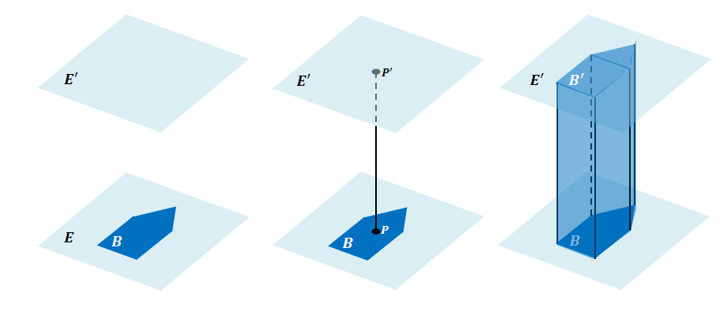There is a region in that is an exact copy of the region . The regions and are called the base faces(or just bases) of the prism. The rectangular regions between two corresponding sides of the bases are called lateral facesof the prism*.* In all, the boundary of a right rectangular prism has *faces*: base faces and lateral faces. All adjacent faces intersect along segments called edges (base edges and lateral edges).

**Cube:**  A *cube* is a right rectangular prism all of whose edges are of equal length.

**Surface:** The *surface of a prism* is the union of all of its faces (the base faces and lateral faces).

**Net (description):** A *net* is a two-dimensional diagram of the surface of a prism.

1. Why are the lateral faces of right prisms always rectangular regions?
2. What is the name of the right prism whose bases are rectangles?
3. How does this definition of right prism include the interior of the prism?

Problem Set

Lesson Summary

The surface area of a right prism can be obtained by adding the areas of the lateral faces to the area of the bases. The formula for the surface area of a right prism is , where represents surface area of the prism, represents the area of the lateral faces, and represents the area of one base. The lateral area can be obtained by multiplying the perimeter of the base of the prism times the height of the prism.

1. For each of the following nets, highlight the perimeter of the lateral area, draw the solid represented by the net, indicate the type of solid, and then find the solid’s surface area.
   1. 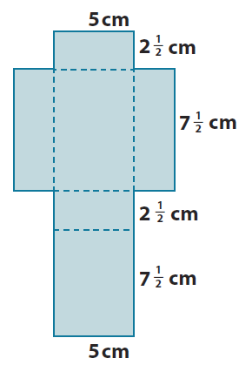
   2. 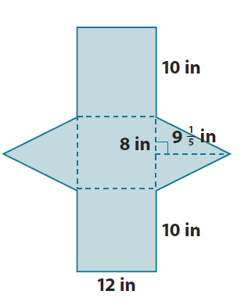
2. Given a cube with edges that are inch long:
   1. Find the surface area of the cube.
   2. Joshua makes a scale drawing of the cube using a scale factor of . Find the surface area of the cube that Joshua drew.
   3. What is the ratio of the surface area of the scale drawing to the surface area of the actual cube, and how does the value of the ratio compare to the scale factor?
3. Find the surface area of each of the following right prisms using the formula .

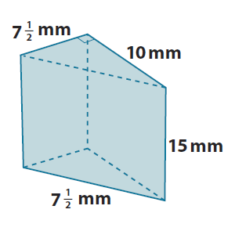

**mm**

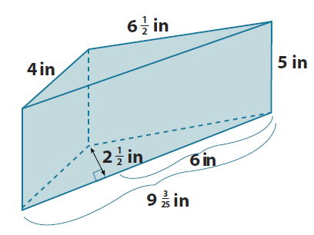

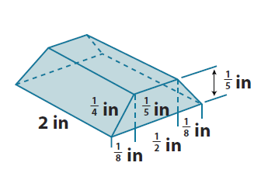

* 1. 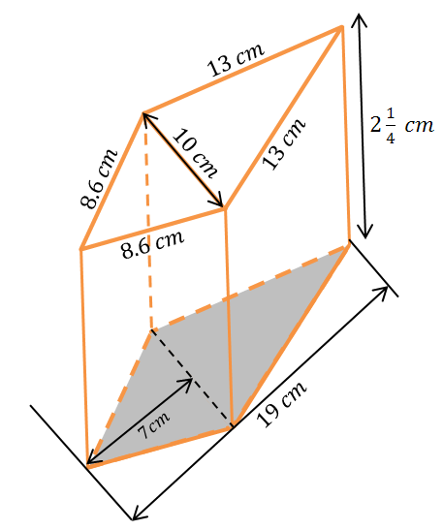

1. A cube has a volume of . What is the cube’s surface area?
2. The height of a right rectangular prism is . The length and width of the prism’s base are and . Use the formula to find the surface area of the right rectangular prism.
3. The surface area of a right rectangular prism is . The dimensions of its base are and . Use the formula and to find the unknown height of the prism.
4. A given right triangular prism has an equilateral triangular base. The height of that equilateral triangle is approximately . The distance between the bases is . The surface area of the prism is . Find the approximate lengths of the sides of the base.