Lesson 20: Composite Area Problems

Classwork
Example 1
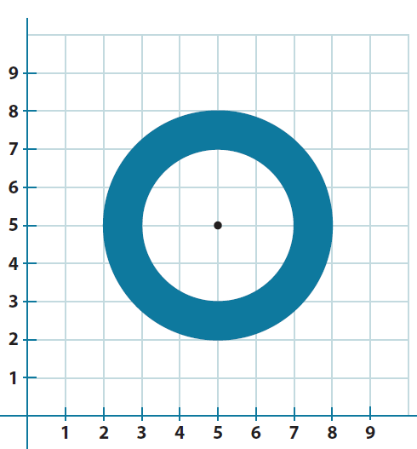
Find the composite area of the shaded region. Use $3.14$ for $π$.

Exercise 1
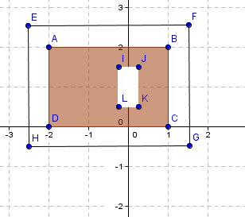
A yard is shown with the shaded section indicating grassy areas and the unshaded sections indicating paved areas. Find the area of the space covered with grass in units².

Example 2
Find the area of the figure that consists of a rectangle with a semicircle on top. Use $3.14$for $π$.
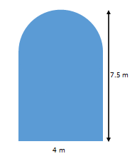

Exercise 2
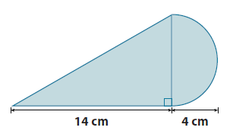
Find the area of the shaded region. Use$3.14$ for $π$.

Example 3
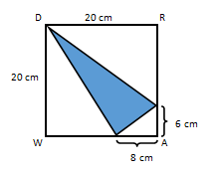
Find the area of the shaded region.

Redraw the figure separating the triangles; then, label the lengths discussing the calculations.

Exercise 3
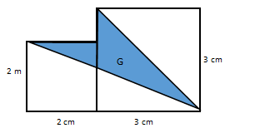
Find the area of the shaded region. The figure is not drawn to scale.

Problem Set

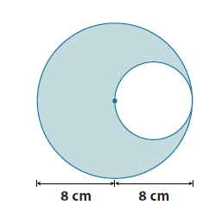
- Find the area of the shaded region. Use $3.14$ for$π$.

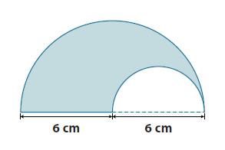
- The figure shows two semicircles. Find the area of the shaded region. Use $3.14$ for $π.$

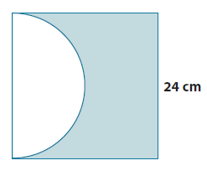
- The figure shows a semicircle and a square. Find the area of the shaded region. Use $3.14$ for $π.$

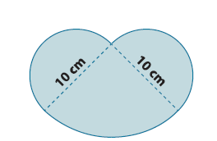
- The figure shows two semicircles and a quarter of a circle. Find the area of the shaded region. Use $3.14$ for$π$.

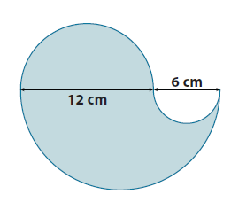
- Jillian is making a paper flower motif for an art project. The flower she is making has four petals; each petal is formed by three semicircles as shown below. What is the area of the paper flower? Provide your answer in terms of $π$.

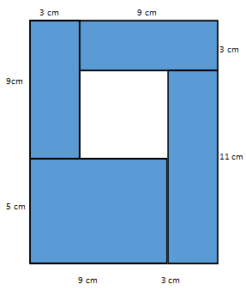
- The figure is formed by five rectangles. Find the area of the unshaded rectangular region.

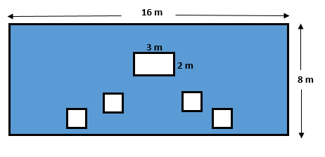
- The smaller squares in the shaded region each have side lengths of $1.5 m$. Find the area of the shaded region.

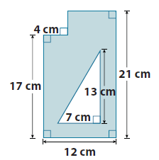
- Find the area of the shaded region.

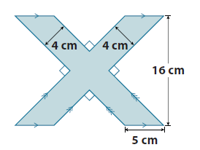
  - Find the area of the shaded region.

  - Draw two ways the figure above can be divided in four equal parts.
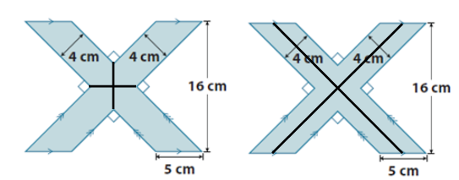

  - What is the area of one of the parts in (b)?

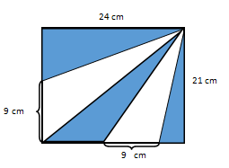
- The figure is a rectangle made out of triangles. Find the area of the shaded region.
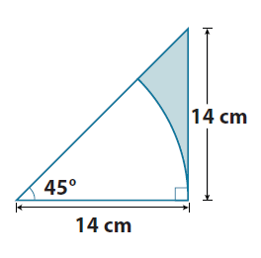
- The figure consists of a right triangle and an eighth of a circle. Find the area of the shaded region. Use $\frac{22}{7}$ for $π.$

