Lesson 20: Composite Area Problems

Student Outcomes
- Students find the area of regions in the coordinate plane with polygonal boundaries by decomposing the plane into triangles and quadrilaterals, including regions with polygonal holes.
- Students find composite area of regions in the coordinate plane by decomposing the plane into familiar figures (triangles, quadrilaterals, circles, semi-circles, and quarter circles).

Lesson Notes
In Lessons 17 through 20, students learned to find the areas of various regions, including quadrilaterals, triangles, circles, semicircles, and ones plotted on coordinate planes. Students will use prior knowledge to use the sum and/or difference of the areas to find unknown composite areas.

Classwork
Example 1 (5 minutes)
Scaffolding:
For struggling students, display posters around the room displaying the visuals and the formulas of the area of a circle, a triangle, and a quadrilateral for reference.
Example 1
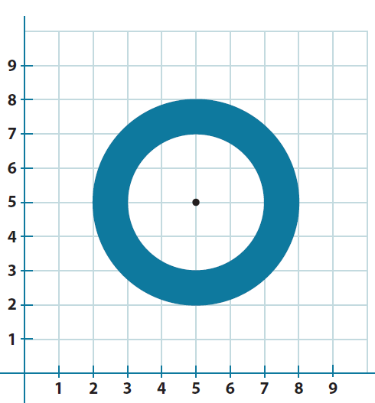
Find the composite area of the shaded region. Use $3.14$ for $π$.

Allow students to look at the problem and find the area independently before solving as a class.
- What information can we take from the image?
MP.1
  - Two circles are on the coordinate plane. The diameter of the larger circle is $6$ units, and the diameter of the smaller circle is $4$ units.
- How do we know what the diameters of the circles are?
  - We can count the units along the diameter of the circles, or we can subtract the coordinate points to find the length of the diameter.

- What information do we know about circles?
MP.1
  - The area of a circle is equal to the radius squared times$π$. We can approximate $π$ as $3.14$or $\frac{22}{7}$.
- After calculating the two areas, what is the next step, and how do you know?
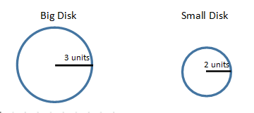
  - The non-overlapping regions add, meaning that the Area(small disk) $+$ Area(ring) $=$ Area(big disk)... Rearranging this results in this: Area(ring) $=$ Area(big disk) $-$Area(small disk). So, the next step is to take the difference of the disks.
- What is the area of the figure?
  - $9π-4π =5π$; the area of the figure is equal to $15.7$ square units.

Exercise 1 (5 minutes)
Exercise 1
A yard is shown with the shaded section indicating grassy areas and the unshaded sections indicating paved areas. Find the area of the space covered with grass in units².
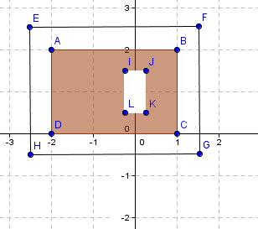
Area of rectangle $ABCD-$ area of rectangle $IJKL=$ area of shaded region
$$\left(3∙2\right)-\left(\frac{1}{2}∙1\right)$$
$$6-\frac{1}{2}=5\frac{1}{2}$$
The area of the space covered with grass is $5\frac{1}{2}$ units².
Example 2 (7 minutes)
Example 2
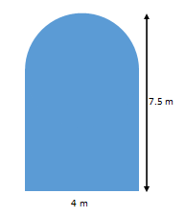
Find the area of the figure that consists of a rectangle with a semicircle on top. Use $3.14$for $π$.
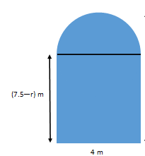
- What do we know from reading the problem and looking at the picture?
  - There is a semicircle and a rectangle.
- What information do we need to find the areas of the circle and the rectangle?
  - We need to know the base and height of the rectangle and the radius of the semicircle. For this problem, let the radius for the semicircle be $r$ meters.
- How do we know where to draw the diameter of the circle?
  - The diameter will be parallel to the bottom base of the rectangle because we know that the figure includes a semicircle.
- What is the diameter and radius of the circle?
  - The diameter of the circle is equal to the base of the rectangle, $4$ m. The radius is half of $4$ m, which is $2$ m.
- What would a circle with a diameter of $4$ m look like relative to the figure?
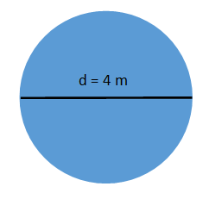

- What is the importance of labeling the known lengths of the figure?
  - This helps us keep track of the lengths when we need to use them to calculate different parts of the composite figure. It also helps us find unknown lengths because they may be the sum or the difference of known lengths.
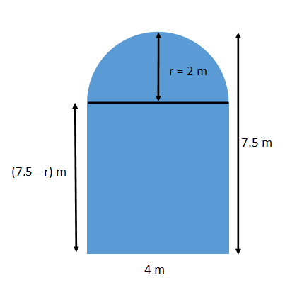
- How do we find the base and height of the rectangle?
  - The base is labeled $4 m$, but the height of the rectangle is combined with the radius of the semicircle. The difference of the height of the figure, $7.5 m$, and the radius of the semicircle equals the height of the rectangle. Thus, the height of the rectangle is $(7.5-2) m$, which equals $5.5 m$.
- What is the area of the rectangle?
  - The area of the rectangle is $5.5 m$ times $4 m$. The area is $22.0$ $m^{2}$.
- What is the area of the semicircle?
  - The area of the semicircle is half the area of a circle with a radius of $2 m$. The area is $4\left(3.14\right)m^{2}$divided by $2$, which equals $6.28 m^{2}$.
- Do we subtract these areas as we did in Example 1?
  - No, we combine the two. The figure is the sum of the rectangle and the semicircle.
- What is the area of the figure?
  - $28.28$ $m^{2}$

Exercise 2 (5 minutes)
Students will work in pairs to decompose the figure into familiar shapes and find the area.
Exercise 2
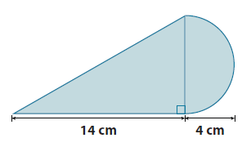
Find the area of the shaded region. Use$3.14$ for $π$.
Area of the triangle $+$ area of the semicircle $=$ area of the shaded region
$$\left(\frac{1}{2} b×h\right)+\left(\frac{1}{2}\right)\left(πr^{2}\right)$$
$$\left(\frac{1}{2}∙14 cm∙8 cm\right)+\left(\frac{1}{2}\right)\left(3.14∙({4 cm)}^{2}\right)$$
$$56{ cm}^{2}+25.12 {cm}^{2}=81.12 {cm}^{2}$$
The area is approximately $1.12$ $cm^{2}$.

Example 3 (10 minutes)
Using the figure below, have students work in pairs to create a plan to find the area of the shaded region and to label known values. Emphasize to students that they should label known lengths to assist in finding the areas. Reconvene as a class to discuss the possible ways of finding the area of the shaded region. Discern which discussion questions to address depending on the level of the students.
Example 3
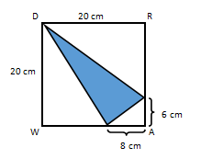
Find the area of the shaded region.

- What recognizable shapes are in the figure?
  - A square and a triangle.
- What else is created by these two shapes?
  - There are three right triangles.
- What specific shapes comprise the square?
  - Three right triangles and one non-right triangle.
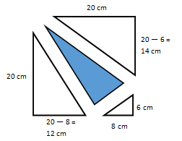
Redraw the figure separating the triangles; then, label the lengths discussing the calculations.

- Do we know any of the lengths of the acute triangle?
  - No.
- Do we have information about the right triangles?
  - Yes, because of the given lengths, we can calculate unknown sides.
- Is the sum or difference of these parts needed to find the area of the shaded region?
  - Both are needed. The difference of the square and the sum of the three right triangles is the area of the shaded triangle.
- What is the area of the shaded region?
  - $400 cm^{2}-\left(\left(\frac{1}{2}×20 cm×12 cm\right)+\left(\frac{1}{2}×20 cm×14 cm\right)+\left(\frac{1}{2}×8 cm×6 cm\right)\right)=116 cm^{2}$
The area is $116 cm²$.

Exercise 3 (5 minutes)
Exercise 3
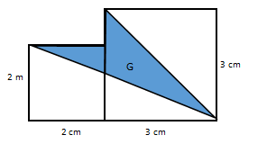
Find the area of the shaded region. The figure is not drawn to scale.
Area of squares – (area of the bottom right triangle + area of the top right triangle)
$$\left(\left(2 cm×2 cm\right)+\left(3 cm×3 cm\right)\right)-\left(\left(\frac{1}{2}×5 cm×2 cm\right)+\left(\frac{1}{2}×3 cm×3 cm\right)\right)$$
$$13{ cm}^{2}-9.5{ cm}^{2}=3.5{ cm}^{2}$$
The area is $3.5 cm^{2}$.
There are multiple solution paths for this problem. Explore them with your students.

Closing (3 minutes)
- What are some helpful methods to use when finding the area of composite areas?
  - Composing and decomposing the figure into familiar shapes is important. Recording values that are known and marking lengths that are unknown is also very helpful to organize information.
- What information and formulas are used in all of the composite area problems?
  - Usually, the combination of formulas of triangles, rectangles, and circles are used to make up the area of shaded areas. The areas for shaded regions are generally the difference of the area of familiar shapes. Other figures are the sum of the areas of familiar shapes.

Exit Ticket (5 minutes)

Name Date
Lesson 20: Composite Area Problems

Exit Ticket

The unshaded regions are quarter circles. Approximate the area of the shaded region. Use $π≈3.14.$

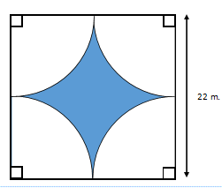

Exit Ticket Sample Solutions
The unshaded regions are quarter circles. Approximate the area of the shaded region. Use $π≈3.14.$
Area of the square $-$ area of the $4$ quarter circles $=$ area of the shaded region
$$(22 m∙22 m)-((1{1 m)}^{2}∙3.14)$$
$484{ m}^{2}-379.94 m^{2}=104. 06 m^{2}$
The area of the shaded region is approximately $04.06$ $m²$.

Problem Set Sample Solutions

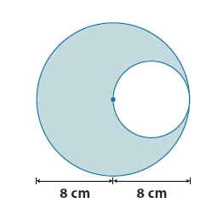
- Find the area of the shaded region. Use $3.14$ for$π$.
Area of large circle– area of small circle
$$\left(π×({8 cm)}^{2}\right)-\left(π×({4 cm)}^{2}\right)$$
$$\left(3.14\right)\left(64 {cm}^{2}\right)-\left(3.14\right)\left(16 {cm}^{2}\right)$$
$$200.96 {cm}^{2}-50.24 {cm}^{2}=150.72 {cm}^{2}$$
The area of the region is approximately $150.72 cm^{2}.$

- The figure shows two semicircles. Find the area of the shaded region. Use $3.14$ for $π.$
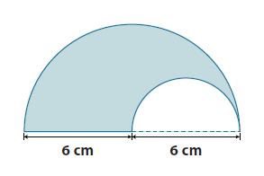
Area of large semicircle region $-$ area of small semicircle region $=$ area of the shaded region
$$\left(\frac{1}{2}\right)\left(π×{(6 cm)}^{2}\right)-\left(\frac{1}{2}\right)\left(π×{(3 cm)}^{2}\right)$$
$$\left(\frac{1}{2}\right)\left(3.14\right)\left(36 {cm}^{2}\right)-\left(\frac{1}{2}\right)\left(3.14\right)\left(9 {cm}^{2}\right)$$
$$56.52 {cm}^{2}-14.13 {cm}^{2}=42.39{ cm}^{2}$$
The area is approximately$42.39 cm^{2}$.

- The figure shows a semicircle and a square. Find the area of the shaded region. Use $3.14$ for $π.$
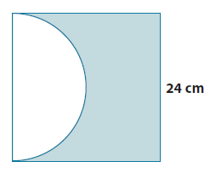
Area of the square $-$ area of the semicircle
$$\left(24 cm×24 cm\right)-\left(\frac{1}{2}\right)( π×{(12 cm)}^{2})$$
$$576 {cm}^{2}-\left(\frac{1}{2}\right)\left(3.14×144 {cm}^{2}\right)$$
$$576 {cm}^{2}-226.08 {cm}^{2}=349.92 {cm}^{2}$$
The area is approximately $349.92 cm^{2}$.

- The figure shows two semicircles and a quarter of a circle. Find the area of the shaded region. Use $3.14$ for$π$.
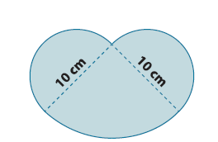
Area of two semicircles + area of quarter of the larger circle
$$2\left(\frac{1}{2}\right)\left(π×({5 cm)}^{2}\right)+\left(\frac{1}{4}\right)\left(π×{(10 cm)}^{2}\right)$$
$$\left(3.14\right)\left(25 {cm}^{2}\right)+(3.14)(25 {cm}^{2})$$
$$78.5 {cm}^{2}+78.5 {cm}^{2}=157$$
The area is approximately $157 cm²$.

- Jillian is making a paper flower motif for an art project. The flower she is making has four petals; each petal is formed by three semicircles as shown below. What is the area of the paper flower? Provide your answer in terms of $π$.
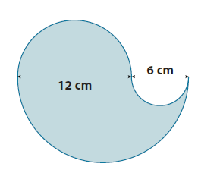
Area of medium semicircle $+$ (area of larger semicircle $-$ area of small semicircle)
$$\left(\frac{1}{2}\right)\left(π×{(6 cm)}^{2}\right)+\left(\left(\frac{1}{2}\right)\left(π×{(9 cm)}^{2}\right)-\left(\frac{1}{2}\right)\left(π×{\left(3 cm\right)}^{2}\right)\right)$$
$$18π {cm}^{2}+40.5π {cm}^{2}-4.5π {cm}^{2}=54π {cm}^{2}$$
$54π {cm}^{2}×4=216π{ cm}^{2}$
The area is $16π$ $cm²$.

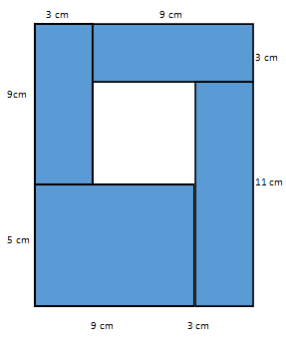
- The figure is formed by five rectangles. Find the area of the unshaded rectangular region.

Area of the whole rectangle $-$ area of the sum of the shaded rectangles $=$ area of the unshaded rectangular region
$$\left(12 cm×14 cm\right)-\left(2\left(3 cm×9 cm\right)+\left(11 cm×3 cm\right)+\left(5 cm×9 cm\right)\right)$$
$$168 {cm}^{2}-\left(54 {cm}^{2}+33 {cm}^{2}+45 {cm}^{2}\right)$$
$$168{ cm}^{2}-132{ cm}^{2}=36 {cm}^{2}$$
The area is $36 cm^{2}$.

- The smaller squares in the shaded region each have side lengths of $1.5 m$. Find the area of the shaded region.
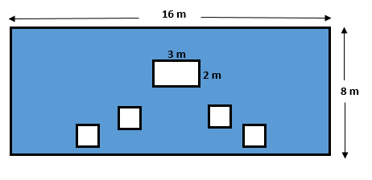
Area of the $16 m$by $8 m$ rectangle $-$ the sum of the area of the smaller unshaded rectangles $=$ area of the shaded region
$$\left(16 m×8 m\right)-\left(\left(3 m×2 m\right)+\left(4\left(1.5 m×1.5 m\right)\right)\right)$$
$$128 m^{2}-\left(6{ m}^{2}+4\left(2.25{ m}^{2}\right)\right)$$
$$128 m^{2}-15 m^{2}=113 m^{2}$$
$$113 m^{2}$$
The area is $113 m^{2}$.

- Find the area of the shaded region.
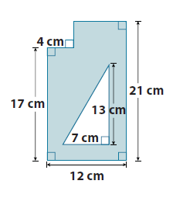
Area of the sum of the rectangles $-$ area of the right triangle$=$ area of shaded region
$$\left(\left(17 cm×4 cm\right)+\left(21 cm×8 cm\right)\right)-\left(\left(\frac{1}{2}\right)\left(13 cm×7 cm\right)\right)$$
$$\left(68 {cm}^{2}+168 {cm}^{2}\right)-\left(\frac{1}{2}\right)\left(91 {cm}^{2}\right)$$
$$236 {cm}^{2}-45.5{ cm}^{2}=190.5 {cm}^{2}$$
The area is$190.5 cm^{2}$.

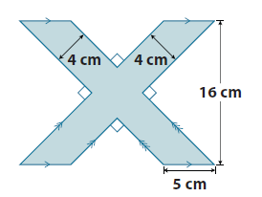
  - Find the area of the shaded region.
Area of the two parallelograms $-$ area of square in the center $=$ area of the shaded region
$$2\left(5 cm×16 cm\right)-\left(4 cm×4 cm\right)$$
$$160 {cm}^{2}-16 {cm}^{2}=144{ cm}^{2}$$
The area is $144 cm^{2}$.

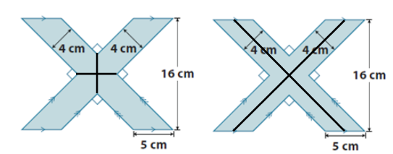
  - Draw two ways the figure above can be divided in four equal parts.

  - What is the area of one of the parts in (b)?
$$144{ cm}^{2}÷4=36 {cm}^{2}$$
The area of one of the parts in (b) is $6$ $cm^{2}$.

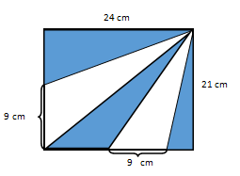
- The figure is a rectangle made out of triangles. Find the area of the shaded region.
Area of the rectangle $-$ area of the unshaded triangles $=$ area of the shaded region
$$\left(24 cm×21 cm\right)-\left(\left(\frac{1}{2}\right)\left(9 cm×21 cm\right)+\left(\frac{1}{2}\right)\left(9 cm×24 cm\right)\right)$$
$$504 {cm}^{2}-\left(94.5{ cm}^{2}+108{ cm}^{2}\right)$$
$$504 {cm}^{2}-202.5 {cm}^{2}=301.5 {cm}^{2}$$
The area is $301.5 cm^{2}$.

- The figure consists of a right triangle and an eighth of a circle. Find the area of the shaded region. Use $\frac{22}{7}$ for $π.$
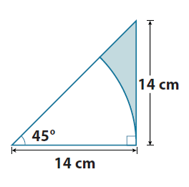
Area of right triangle – area of eighth of the circle= area of shaded region
$$\left(\frac{1}{2}\right)\left(14 cm×14 cm\right)-\left(\frac{1}{8}\right)\left(π×14 cm×14 cm\right)$$
$$\left(\frac{1}{2}\right)(196 {cm}^{2})-\left(\frac{1}{8}\right)\left(\frac{22}{7}\right)\left(2 cm×7 cm×2 cm×7 cm\right)$$
$$98 {cm}^{2}-77 {cm}^{2}=21 {cm}^{2}$$
The area is approximately$21 cm^{2}$.

