Lesson 19: Unknown Area Problems on the Coordinate Plane

Classwork
Example: Area of a Parallelogram
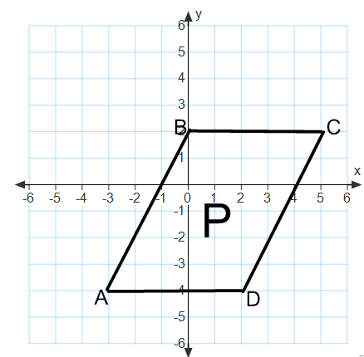
The coordinate plane below contains figure $P$, parallelogram $ABCD$.
  - Write the ordered pairs of each of the vertices next to the vertex points.

  - Draw a rectangle surrounding figure $P$ that has vertex points of $A$ and $C$. Label the two triangles in the figure as$S$ and $T$.

  - Find the area of the rectangle.

  - Find the area of each triangle.

  - Use these areas to find the area of parallelogram $ABCD$.

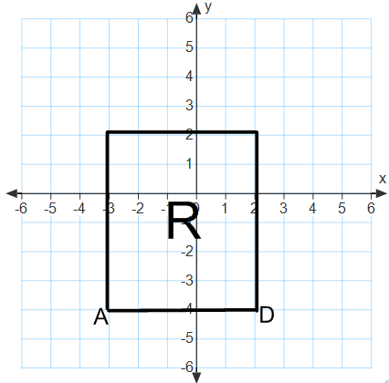
The coordinate plane below contains figure $R$, a rectangle with the same base as the parallelogram above.

  - Draw triangles $S$and $T$ and connect to figure $R$ so that you create a rectangle that is the same size as the rectangle you created on the first coordinate plane.

  - Find the area of rectangle $R$.

  - What do figures $R$ and $P$have in common?

Exercises
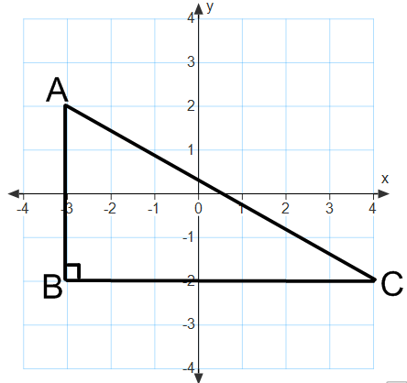
- Find the area of triangle $ABC$.

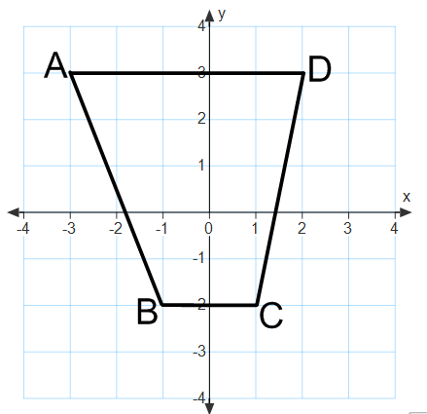
- Find the area of quadrilateral $ABCD$ two different ways.

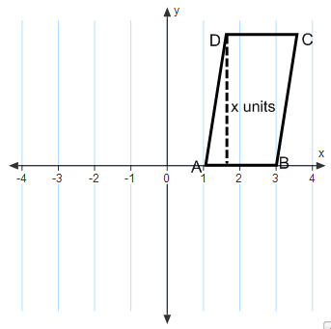
- The area of quadrilateral $ABCD=12$ sq. units. Find$x$.

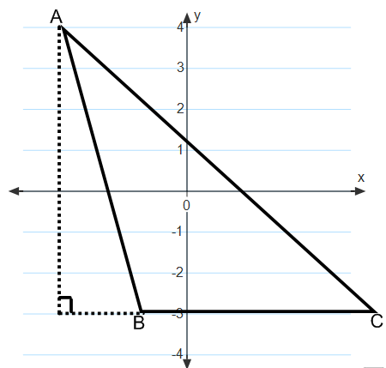
- The area of triangle $ABC=14$ sq. units. Find the length of side $BC$.

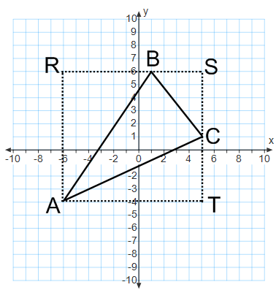
- Find the area of triangle $ABC$.

Problem Set

Find the area of each figure.
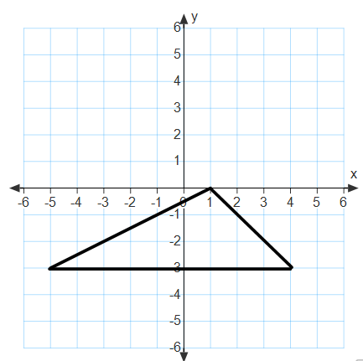 | 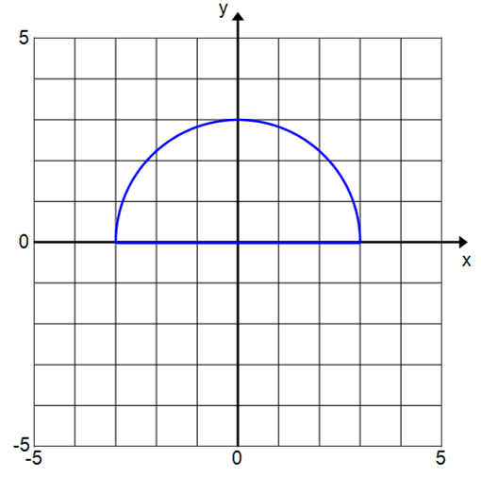
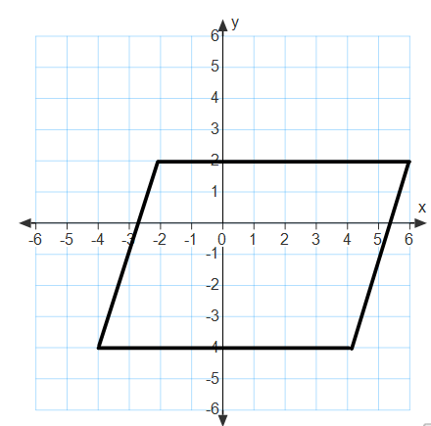 | 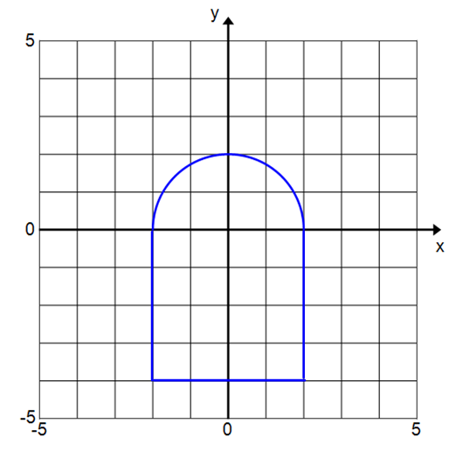
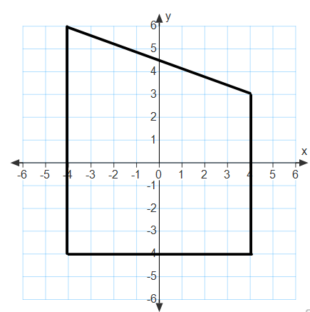 | 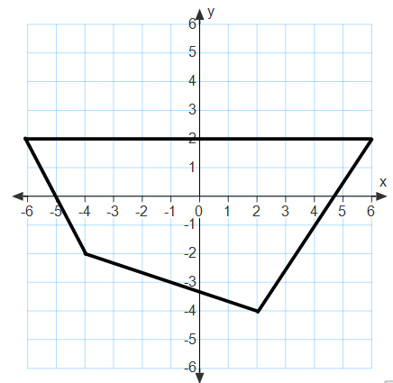

For Problems 7–9, draw a figure in the coordinate plane that matches each description.
- A rectangle with area $=18$ sq. units | - A parallelogram with area $=50$ sq. units | - A triangle with area $= 25$ sq. units
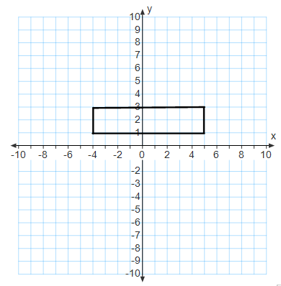
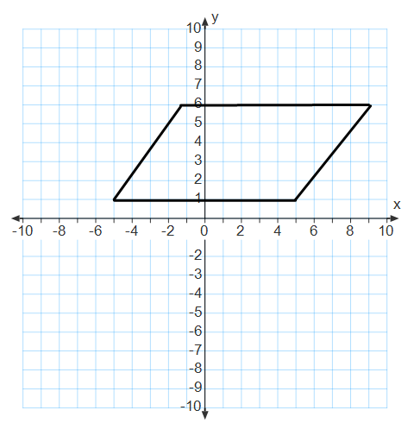
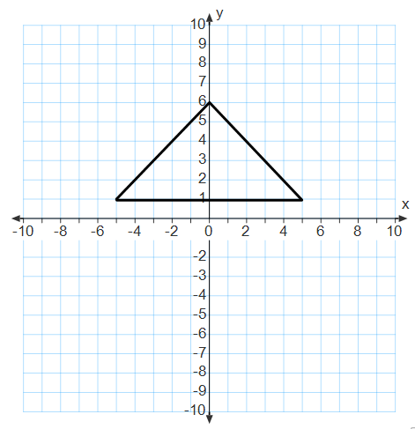

Find the unknown value labelled as $x$ on each figure.
- The rectangle has an area of $80$ sq. units.
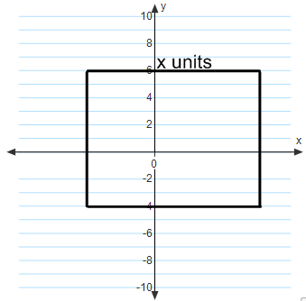

- The trapezoid has an area of $115$ sq. units.
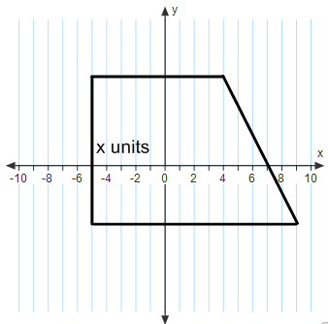

- Find the area of triangle $ABC$.
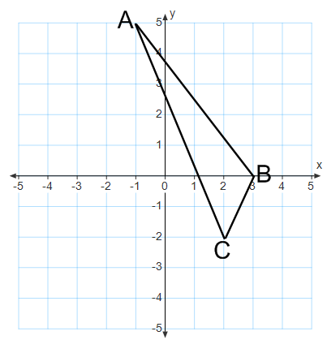

- Find the area of the quadrilateral using two different methods. Describe the methods used and explain why they result in the same area.
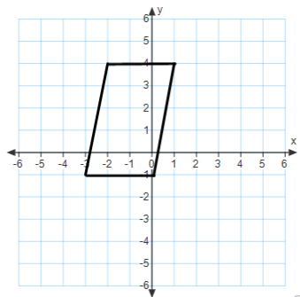

- Find the area of the quadrilateral using two different methods. What are the advantages or disadvantages of each method?
