Lesson 19: Unknown Area Problems on the Coordinate Plane

Student Outcomes
- Students find the areas of triangles and simple polygonal regions in the coordinate plane with vertices at grid points by composing into rectangles and decomposing into triangles and quadrilaterals.

Lesson Notes
Students will extend their knowledge of finding area to figures on a coordinate plane. The lesson begins with a proof of the area of a parallelogram. In Grade 6, students proved the area of a parallelogram through a different approach. This lesson will draw heavily on MP.7 (look for and make use of structure). Students will notice and take advantage of figures composed of simpler ones to determine area.

Classwork
Example (20 minutes): Area of a Parallelogram
Allow students to work through parts (a)–(e) of the example either independently or in groups. Circulate around the room to check student progress and to ensure that students are drawing the figures correctly. Debrief before having them move on to part (f).
Example: Area of a Parallelogram
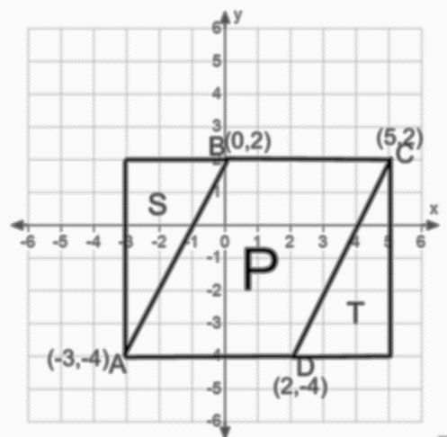
The coordinate plane below contains figure $P$, parallelogram $ABCD$.
  - Write the ordered pairs of each of the vertices next to the vertex points.
See figure.

  - Draw a rectangle surrounding figure $P$ that has vertex points of $A$ and $C$. Label the two triangles in the figure as$S$ and $T$.
See figure.

  - Find the area of the rectangle.
Base$=8$ units
Height $=6$ units
Area $=8$units$×6$units $=48$sq. units

  - Find the area of each triangle.
Figure $S$ Figure $T$
Base $= 3$ units Base$= 3$ units
Height $= 6$ units Height$= 6$ units
Area $=$ $\frac{1}{2}×3$units$×6$ units Area$=$ $\frac{1}{2}×3$units$×6$units
$=9$ sq. units $=9$ sq. units

  - Use these areas to find the area of parallelogram $ABCD$.
Area $P=$Area of rectangle $-$Area $S-$ Area $T$
$= 48$ sq. units $- 9$sq. units $- 9$ sq. units $=30$ sq. units

Stop students here and discuss responses.
- How did you find the base and height of each figure?
  - By using the scale on the coordinate plane.
- How did you find the area of the parallelogram?
  - By subtracting the areas of the triangles from the area of the rectangle.
Assist students with part (f) if necessary and then give them time to finish the exploration.
The coordinate plane below contains figure $R$, a rectangle with the same base as the parallelogram above.
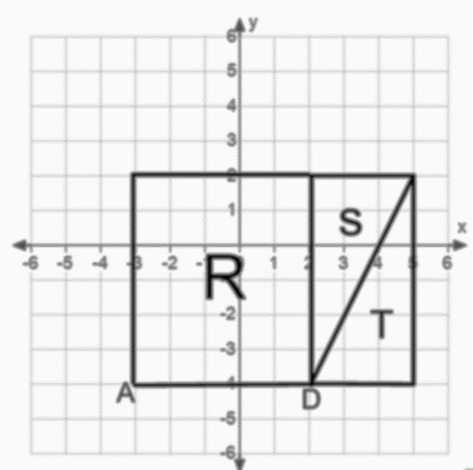
  - Draw triangles $S$and $T$ and connect to figure $R$ so that you create a rectangle that is the same size as the rectangle you created on the first coordinate plane.
See figure.

  - Find the area of rectangle $R$.
Base $= 5$ units
Height $= 6$units
Area $= 30$ sq. units

  - What do figures $R$ and $P$have in common?
They have the same area. They share the same base and have the same height.

Debrief and allow students to share responses. Draw the height of the parallelogram to illustrate that it has the same height as rectangle $R$.
- Since the larger rectangles are the same size, their areas must be equal. Write this on the board:
Area of $P+$ Area of $S+$ Area of $T=$ Area of $R+$ Area of $S+$ Area of $T$
- Based on the equation, what must be true about the area of $P$?
  - Area of $P=$ Area of$R$
- How can we find the area of a parallelogram?
  - Area of Parallelogram$=$base $×$ height
Exercises (17 minutes)
Have students work on the exercises independently and then check answers with a partner. Then, discuss results as a class.
Exercises
- Find the area of triangle $ABC$.
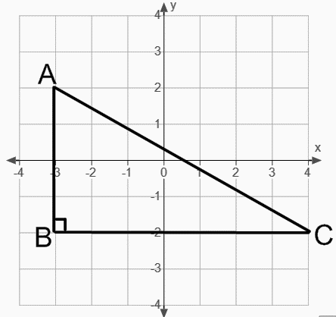
$$A =\frac{1}{2} × 7 units × 4 units=14 sq. units$$

- Find the area of quadrilateral $ABCD$ two different ways.
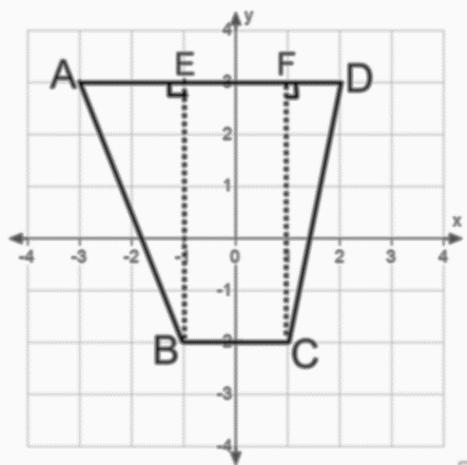  $$\frac{1}{2}×2×5+2×5+\frac{1}{2}×1×5=5+10+2.5=17.5$$  The area is $17.5 sq. units.$ | 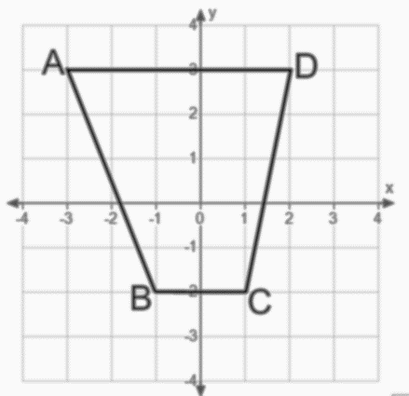  $$\frac{1}{2}×\left(5+2\right)×5=17.5$$  The area is $17.5 sq. units$.

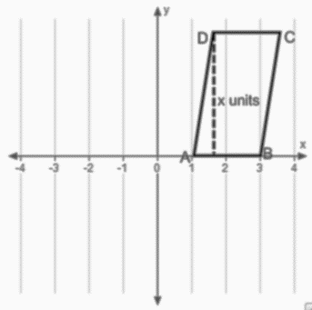
- The area of quadrilateral $ABCD = 12$ sq. units. Find$x$.

$$Area=base×height \\ 12 sq. units =2x \\ 6 units=x$$

- The area of triangle $ABC=14$ sq. units. Find the length of side $BC$.
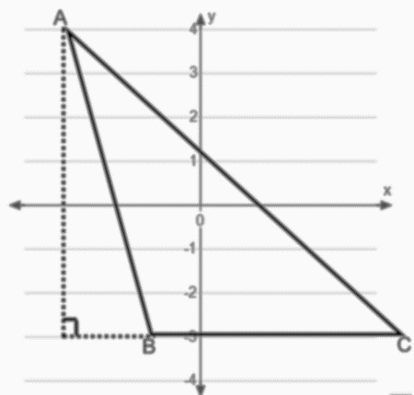
$$Area=\frac{1}{2}×base×height \\ 14 sq. units=\frac{1}{2}×BC×\left(7 units\right) \\ BC=4 units$$

- Find the area of triangle $ABC$.
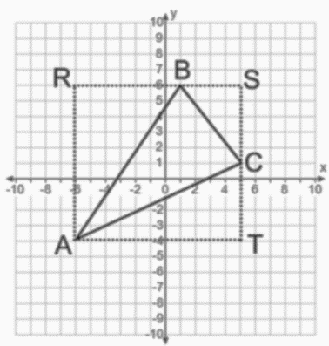
Area of rectangle $ARST=$ $11 units×10 units=110 sq. units$
Area of triangle $ARB=$ $\frac{1}{2}×7 units×10 units=35 sq. units$
Area of triangle $BSC=$ $\frac{1}{2}×4 units×5 units=10 sq. units$
Area of triangle $ATC=$ $\frac{1}{2}×11 units×5 units=27.5 sq. units$

Area of triangle$ABC=$ Area of $ARST-$ Area of$ARB-$Area of $BSC-$Area of $ATC = 37.5 sq. units$

- What shape is the quadrilateral in Exercise 2?
  - Trapezoid.
- What methods did you use to find the area?
MP.7
  - Decomposing the figure into two right triangles and a rectangle or using the area formula for a trapezoid.
- Which method was easier for finding the area?
  - Answers will vary.
- For Exercise 4, what piece of information was missing? Why couldn’t we find it using the coordinate plane?
  - The base was missing. We could measure the height but not the base because no scale was given on the $x$-axis.
- For Exercise 5, why couldn’t we find the area of triangle$ABC$by simply using its base and height?
  - Because of the way the triangle was oriented, we could not measure the exact length of the base or the height using the coordinate plane.

Closing (3 minutes)
Review relevant vocabulary and formulas from this lesson. These terms and formulas should be a review from earlier grades and previous lessons in this module.

Relevant Vocabulary:
Quadrilateral Parallelogram Trapezoid
Rectangle Square Altitude and base of a triangle
Semicircle Diameter of a circle

Area formulas:
Area of parallelogram $=$base $×$ height Area of rectangle $=$ base $×$ height
Area of a triangle $=$ $\frac{1}{2}×$ base $×$ height Area of a trapezoid $=$ $\frac{1}{2}×$ (base 1 $+$ base 2) $×$ height
Area of a circle $=$ $π×r^{2}$

- Why is it useful to have a figure on a coordinate plane?
  - The scale can be used to measure the base and height.
- What are some methods for finding the area of a quadrilateral?
  - Use a known area formula, deconstruct the figure into shapes with known area formulas, make the figure a part of a larger shape and then subtract areas.

Exit Ticket (5 minutes)

Name Date
Lesson 19: Unknown Area Problems on the Coordinate Plane

Exit Ticket

The figure $ABCD$ is a rectangle. $AB=2$ units, $AD=4$ units, and $AE=FC=1$ unit.

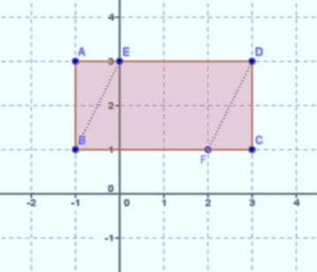

- Find the area of rectangle $ABCD$.

- Find the area of triangle $ABE$. | - Find the area of triangle $DCF$.
- Find the area of the parallelogram $BEDF$ two different ways.

Exit Ticket Sample Solutions

The figure $ABCD$ is a rectangle. $AB=2$ units, $AD=4$ units, and $AE=FC=1$ unit.
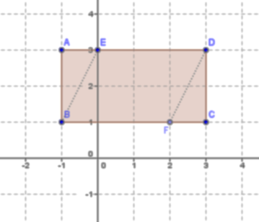

- Find the area of rectangle $ABCD$.
Area $= 4$units$× 2$units $= 8$ sq. units

- Find the area of triangle $ABE$.  Area $=\frac{1}{2}×1$unit $× 2$ units $=1$ sq. unit | - Find the area of triangle $DCF$.  Area $=$ $\frac{1}{2}×1$ unit $×2$ units $=1$ sq. unit
- Find the area of the parallelogram $BEDF$ two different ways.
Area $=$Area of $ABCD$ – Area of $ABE$ – Area of $DCF$  $=$ $(8-1-1)$ sq. units $=6$ sq. units | Area $=$ base $×$ height  $=$ $3$ units $×2$ units $=6$ sq. units

Problem Set Sample Solutions

Find the area of each figure.
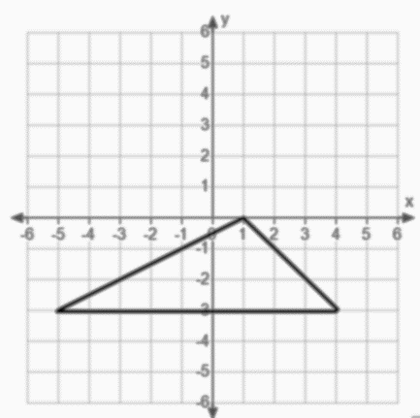  Area $=13.5$ sq. units | 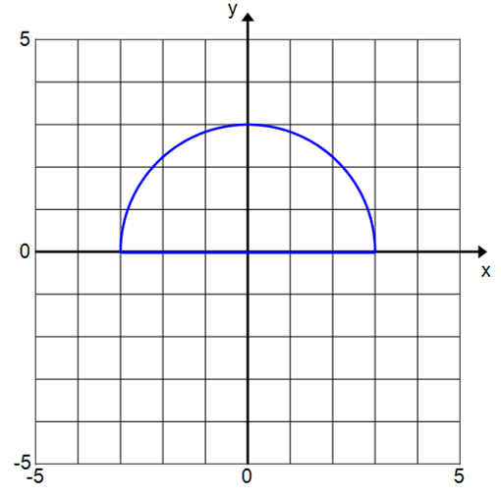  Area $= 4.5π$sq. units$≈14.13$ sq. units
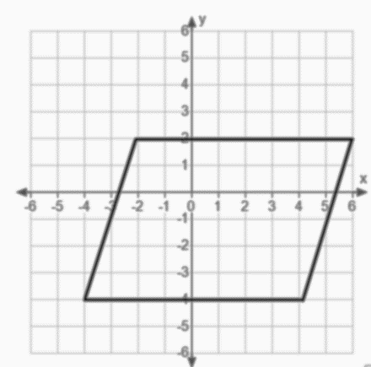  Area $=48$sq. units | 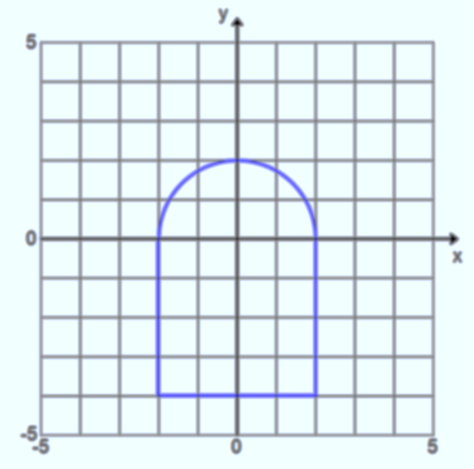  Area $=$ $\left(2π+16\right)$ sq. units $≈22.28$ sq. units
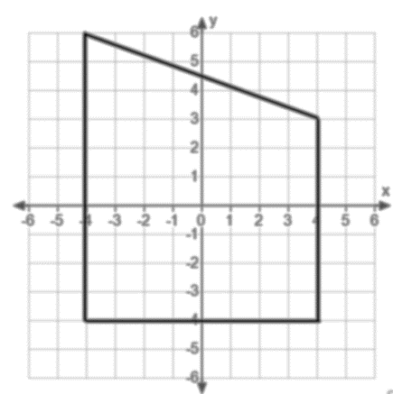  Area $=68$ sq. units | 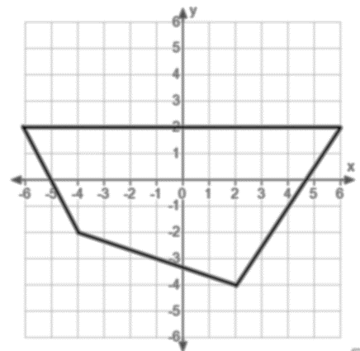  Area $=46$ sq. units

For Problems 7–9, draw a figure in the coordinate plane that matches each description.
- A rectangle with area $=18$ sq. units | - A parallelogram with area $=50$ sq. units | - A triangle with area $= 25$ sq. units
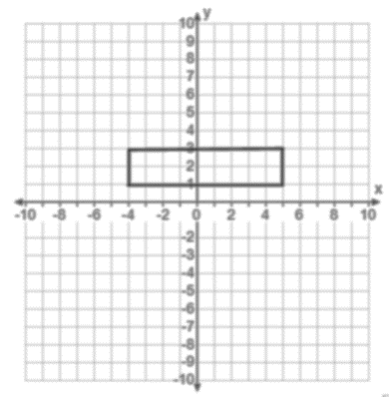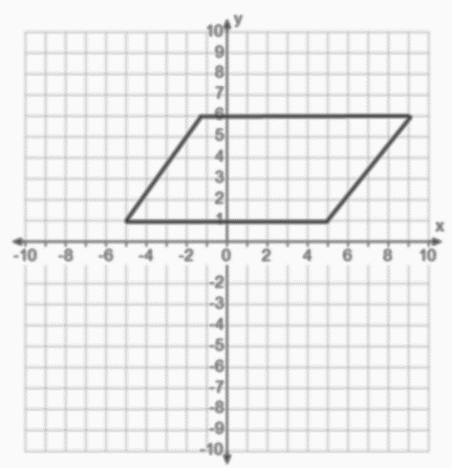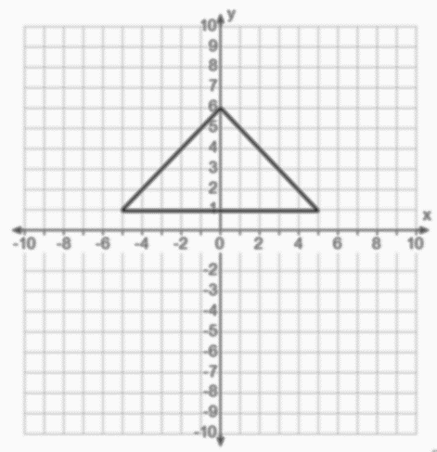

Find the unknown value labled as $x$ on each figure.
- The rectangle has an area of $80$ sq. units.  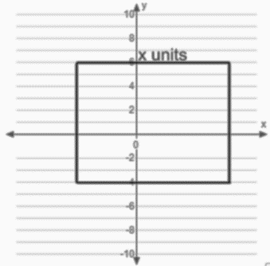  $$x=8$$ | - The trapezoid has an area of $115$ sq. units.  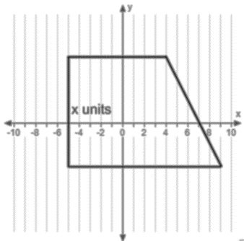  $$x=10$$

- Find the area of triangle $ABC$.
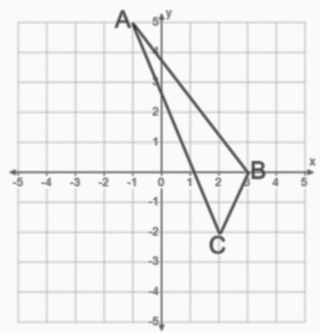
Area $=6.5$ sq. units

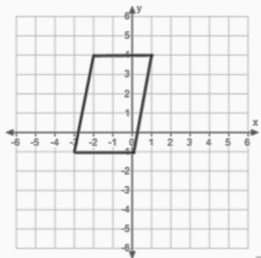
- Find the area of the quadrilateral using two different methods. Describe the methods used and explain why they result in the same area.
Area $=15$ sq. units
One method is by drawing a rectangle around the figure. The area of the parallelogram is equal to the area of the rectangle minus the area of the two triangles. A second method is to use the area formula for a parallelogram (Area $=$ base $×$ height).
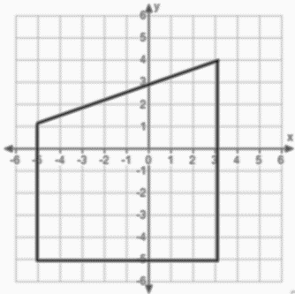
- Find the area of the quadrilateral using two different methods. What are the advantages or disadvantages of each method?
Area $=$ $60$sq. units
One method is to use the area formula for a trapezoid, $A=\frac{1}{2}\left(base 1+base 2\right)×height$. The second method is to split the figure into a rectangle and a triangle. The second method required more calculations. The first method required first recognizing the figure as a trapezoid and recalling the formula for the area of a trapezoid.

