Lesson 18: More Problems on Area and Circumference

Classwork
Opening Exercise
Draw a circle with a diameter of $12 cm$ and a square with a side length of $12 cm$ on grid paper. Determine the area of the square and the circle.

Brainstorm some methods for finding half the area of the square and half the area of the circle.

Find the area of half of the square and half of the circle, and explain to a partner how you arrived at the area.

What is the ratio of the new area to the original area for the square and for the circle?

Find the area of one-fourth of the square and one-fourth of the circle, first by folding and then by another method. What is the ratio of the new area to the original area for the square and for the circle?

Write an algebraic expression that will express the area of a semicircle and the area of a quarter circle.

Example 1
Find the area of the following semicircle. Use $π≈\frac{22}{7}$.
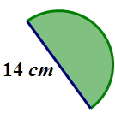

What is the area of the quarter circle?
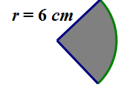

Example 2
Marjorie is designing a new set of placemats for her dining room table. She sketched a drawing of the placement on graph paper. The diagram represents the area of the placemat consisting of a rectangle and two semicircles at either end. Each square on the grid measures $4$ inches in length.
Find the area of the entire placemat. Explain your thinking regarding the solution to this problem.
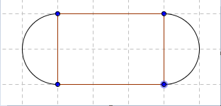

If Marjorie wants to make six placemats, how many square inches of fabric will she need? Assume there is no waste.

Marjorie decides that she wants to sew on a contrasting band of material around the edge of the placemats. How much band material will Marjorie need?

Example 3
The circumference of a circle is $24π cm$. What is the exact area of the circle?
Draw a diagram to assist you in solving the problem.

What information is needed to solve the problem?

Next, find the area.

Exercises
- Find the area of a circle with a diameter of $42 cm$. Use $π≈\frac{22}{7}$.

- The circumference of a circle is $9π cm$.
  - What is the diameter?

  - What is the radius?

  - What is the area?

- If students only know the radius of a circle, what other measures could they determine? Explain how students would use the radius to find the other parts.

- Find the area in the rectangle between the two quarter circles if $AF=7 ft.$, $FB=9 ft.$, and $HD=7 ft$. Use $π≈\frac{22}{7}$. Each quarter circle in the top-left and lower-right corners have the same radius.
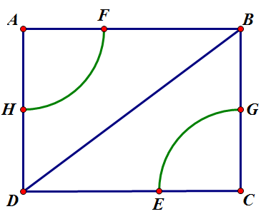

Problem Set
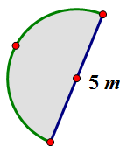
- Mark created a flowerbed that is semicircular in shape, as shown in the image. The diameter of the flower bed is $5 m$.
  - What is the perimeter of the flower bed? (Approximate $π$ to be $3.14$.)
  - What is the area of the flowerbed? (Approximate $π$ to be $3.14$.)

- A landscape designer wants to include a semicircular patio at the end of a square sandbox. She knows that the area of the semicircular patio is $25.12 {cm}^{2}$.
  - Draw a picture to represent this situation.
  - What is the length of the side of the square?

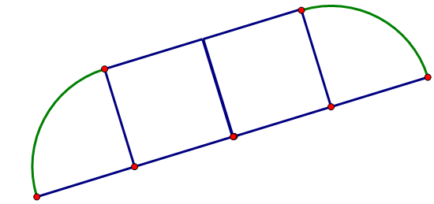
- A window manufacturer designed a set of windows for the top of a two-story wall. If the window is comprised of $2$ squares and $2$ quarter circles on each end, and if the length of the span of windows across the bottom is $12$ feet, approximately how much glass will be needed to complete the set of windows?

- Find the area of the shaded region. (Approximate $π$ to be $\frac{22}{7}$.)
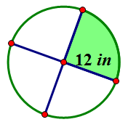

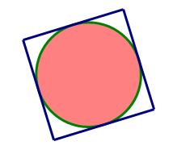
- The figure below shows a circle inside of a square. If the radius of the circle is $8 cm$, find the following and explain your solution.
  - The circumference of the circle.
  - The area of the circle.
  - The area of the square.

- Michael wants to create a tile pattern out of three quarter circles for his kitchen backsplash. He will repeat the three quarter circles throughout the pattern. Find the area of the tile pattern that Michael will use. Approximate $π$ as $3.14$.
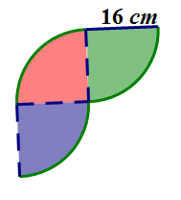

- A machine shop has a square metal plate with sides that measure $4 cm$ each. A machinist must cut four semicircles, with a radius of$\frac{1}{2}cm$ and four quarter circles with a radius of $1 cm$ from its sides and corners. What is the area of the plate formed? Use$\frac{22}{7}$ to approximate $π$.
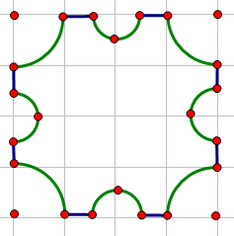

- A graphic artist is designing a company logo with two concentric circles (two circles that share the same center but have different radii). The artist needs to know the area of the shaded band between the two concentric circles. Explain to the artist how he would go about finding the area of the shaded region.
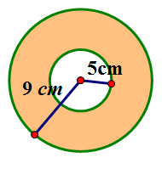

- Create your own shape made up of rectangles, squares, circles, or semicircles and determine the area and perimeter.

