Lesson 18: More Problems on Area and Circumference

Student Outcomes
- Students examine the meaning of quarter circle and semicircle.
- Students solve area and perimeter problems for regions made out of rectangles, quarter circles, semicircles, and circles, including solving for unknown lengths when the area or perimeter is given.

Classwork
Opening Exercise (5 minutes)
Students use prior knowledge to find the area of circles, semicircles, and quarter circles and compare their areas to areas of squares and rectangles.
Opening Exercise
MP.1
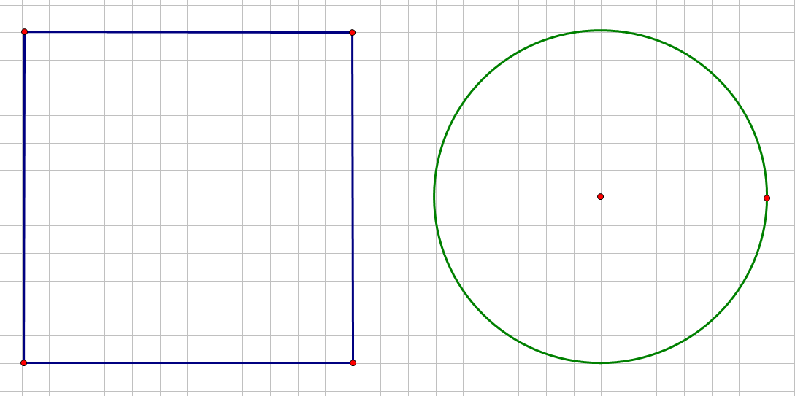
Draw a circle with a diameter of $12 cm$ and a square with a side length of $12 cm$ on grid paper. Determine the area of the square and the circle.

Area of square: $A={(12 cm)}^{2}=144 {cm}^{2}$; Area of circle: $A=π∙{(6 cm)}^{2}=36π {cm}^{2}$

Brainstorm some methods for finding half the area of the square and half the area of the circle.
Some methods include folding in half and counting the grid squares, cutting each in half and counting the squares, etc.

Find the area of half of the square and half of the circle, and explain to a partner how you arrived at the area.
The area of half of the square is $72 {cm}^{2}$. The area of half of the circle is $18π {cm}^{2}$. Some students may count the squares; others may realize that half of the square is a rectangle with side lengths of $12 cm$ and $6$ $cm$ and use $A=l∙w$to determine the area. Some students may fold the square vertically, and some may fold it horizontally. Some students will try to count the grid squares in the semicircle and find that it is easiest to take half of the area of the circle.

What is the ratio of the new area to the original area for the square and for the circle?
The ratio of the areas of the rectangle (half of the square) to the square is $\frac{72 {cm}^{2}}{144 {cm}^{2}}$ or $\frac{1}{2}$. The ratio for the areas of the circles is $\frac{18π cm^{2}}{36π cm^{2}}$ or $\frac{1}{2}$.

Find the area of one-fourth of the square and one-fourth of the circle, first by folding and then by another method. What is the ratio of the new area to the original area for the square and for the circle?
Folding the square in half and then in half again will result in one-fourth of the original square. The resulting shape is a square with a side length of $6 cm$ and an area of $36 cm^{2}$. Repeating the same process for the circle will result in an area of $9π cm^{2}$. The ratio for the areas of the squares is $\frac{36 {cm}^{2}}{72 {cm}^{2}}$ or $\frac{1}{4}$. The ratio for the areas of the circles is $\frac{9π{ cm}^{2}}{36π{ cm}^{2}}$ or $\frac{1}{4}$.

Write an algebraic expression that will express the area of a semicircle and the area of a quarter circle.
Semicircle: $A=\frac{1}{2}πr^{2}$; Quarter circle: $A=\frac{1}{4}πr^{2}$

Example 1 (8 minutes)
Example 1
Find the area of the following semicircle. Use $π≈\frac{22}{7}$.
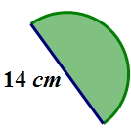
If the diameter of the circle is $14$ cm, then the
radius is $7$cm. The area of the semicircle is half
of the area of the circular region.
$$A≈\frac{1}{2}∙\frac{22}{7}∙(7 c{m)}^{2} \\ A≈\frac{1}{2}∙\frac{22}{7}∙49 cm^{2} \\ A≈77 {cm}^{2}$$

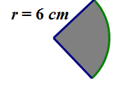
What is the area of the quarter circle? Use $π≈\frac{22}{7}$.
$$A≈\frac{1}{4}∙\frac{22}{7}{\left(6 cm\right)}^{2}$$
$$A≈\frac{1}{4}∙\frac{22}{7}∙36 {cm}^{2}$$
$$A≈\frac{198}{7} {cm}^{2}$$

Let students reason out and vocalize that the area of a quarter circle must be one-fourth of the area of an entire circle.

Discussion
Students should recognize that composition area problems involve the decomposition of the shapes that make up the entire region. It is also very important for students to understand that there are several perspectives in decomposing each shape and that there is not just one correct method. There is often more than one “correct” method; therefore, a student may feel that his/her solution (which looks different than the one other students present) is incorrect. Alleviate that anxiety by showing multiple correct solutions. For example, cut an irregular shape into squares and rectangles as seen below.

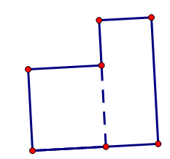
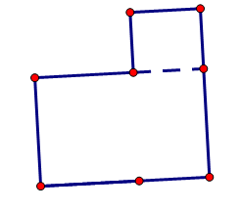

Example 2 (8 minutes)
Example 2
Marjorie is designing a new set of placemats for her dining room table. She sketched a drawing of the placement on graph paper. The diagram represents the area of the placemat consisting of a rectangle and two semicircles at either end. Each square on the grid measures $4$ inches in length.
Find the area of the entire placemat. Explain your thinking regarding the solution to this problem.
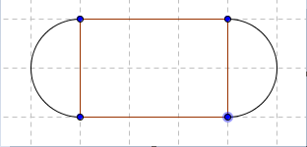

The length of one side of the rectangular section is $12$ inches in length, while the width is $8$ inches. The radius of the semicircular region is $4$inches. The area of the rectangular part is $(8 in.)∙(12 in.)=96 {in}^{2}$. The total area must include the two semicircles on either end of the placemat. The area of the two semi-circular regions is the same as the area of one circle with the same radius. The area of the circular region is$A=π∙(4 {in.)}^{2}=16π {in}^{2}$. In this problem, using $π≈3.14$ will make more sense because there are no fractions in the problem. The area of the semicircular regions is approximately$50.24 {in}^{2}$. The total area for the placemat is the sum of the areas of the rectangular region and the two semicircular regions, which is approximately$\left(96+50.24\right) {in}^{2}=146.24 {in}^{2}$.

Common Mistake: Ask students to determine how to solve this problem and arrive at an incorrect solution of $196.48 {in}^{2}$. A student would arrive at this answer by including the area of the circle twice instead of once
$(50.24+50.24+96)$.

If Marjorie wants to make six placemats, how many square inches of fabric will she need? Assume there is no waste.
There are $6$ placemats that are each $146.24 {in}^{2}$, so the fabric needed for all is $6∙146.24 {in}^{2}=877.44 {in}^{2}$.

Marjorie decides that she wants to sew on a contrasting band of material around the edge of the placemats. How much band material will Marjorie need?
The length of the band material needed will be the sum of the lengths of the two sides of the rectangular region and the circumference of the two semicircles (which is the same as the circumference of one circle with the same radius).
$P=\left(l+l+2πr\right) in.$
$P=\left(12+12+2∙π∙4\right) in.=49.12 in.$

Example 3 (4 minutes)
Example 3
The circumference of a circle is $24π$cm. What is the exact area of the circle?
Draw a diagram to assist you in solving the problem.
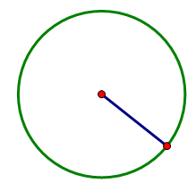

What information is needed to solve the problem?
The radius is needed to find the area of the circle. Let the radius be $r$ cm. Find the radius by using the circumference formula.
$C=2πr$
$24π =2πr$
If $24π =2πr$, then $\left(\frac{1}{2π}\right)24π cm=\left(\frac{1}{2π}\right)2πr$.
This yields $r=12$ cm.

Next, find the area.
$A=π r^{2}$
$A=π{\left(12\right)}^{2}=144π$
The exact area of the circle is $144π$ cm².

Exercises (10 minutes)
Students should solve these problems individually at first and then share with their cooperative groups after every other problem.
Exercises
- Find the area of a circle with a diameter of $42$ cm. Use $π≈\frac{22}{7}$.
If the diameter of the circle is $42$ cm, then the radius is $21$ cm.
$$A=πr^{2} \\ A≈\frac{22}{7}(21 {cm)}^{2} \\ A≈1386 {cm}^{2}$$

- The circumference of a circle is $9π$cm.
  - What is the diameter?
If $C=πd$, then $9π$cm$=πd$.
Solving the equation for the diameter, $d$, $\frac{1}{π}∙9π$cm$=\frac{1}{π}π∙d.$
So, $9$cm$=d$.

  - What is the radius?
If the diameter is $9$ cm, then the radius is half of that or$\frac{9}{2}$ cm.

  - What is the area?
The area of the circle is$A=π∙{\left(\frac{9}{2}cm\right)}^{2}$, so $=\frac{81}{4}π$ cm².

- If students only know the radius of a circle, what other measures could they determine? Explain how students would use the radius to find the other parts.
If students know the radius, then they can find the diameter. The diameter is twice as long as the radius. The circumference can be found by doubling the radius and multiplying the result by $π$. The area can be found by multiplying the radius times itself and then multiplying that product by $π$.

- Find the area in the rectangle between the two quarter circles if $AF=7$ ft., $FB=9$ ft., and $HD=7$ ft. Use
$π≈\frac{22}{7}$. Each quarter circle in the top-left and lower-right corners have the same radius.
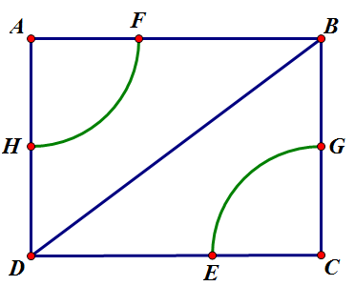
The area between the quarter circles can be found by subtracting the area of the two quarter circles from the area of the rectangle. The area of the rectangle is the product of the length and the width. Side $AB$has a length of $16$ ft. and Side$AD$ has a length of $14 ft.$ The area of the rectangle is $A=16 ft. ∙ 14 ft.=224 {ft}^{2}$. The area of the two quarter circles is the same as the area of a semicircle, which is half the area of a circle. $A=\frac{1}{2} πr^{2}.$
$$A≈\frac{1}{2}∙\frac{22}{7}∙{(7 ft.)}^{2} \\ A≈\frac{1}{2}∙\frac{22}{7}∙49{ft}^{2} \\ A≈77 {ft}^{2}$$
The area between the two quarter circles is$224 {ft}^{2}-77 {ft}^{2}=147 {ft}^{2}$.

Closing (5 minutes)
- The area of a semicircular region is$\frac{1}{2}$ of the area of a circle with the same radius.
- The area of a quarter of a circular region is$\frac{1}{4}$of the area of a circle with the same radius.
- If a problem asks you to use$\frac{22}{7}$ for $π$, look for ways to use fraction arithmetic to simplify your computations in the problem.
- Problems that involve the composition of several shapes may be decomposed in more than one way.

Exit Ticket (5 minutes)

Name ___________________________________________________ Date____________________
Lesson 18: More Problems on Area and Circumference

Exit Ticket

- Ken’s landscape gardening business creates odd-shaped lawns that include semicircles. Find the area of this semicircular section of the lawn in this design. Use$\frac{22}{7}$for $π$.
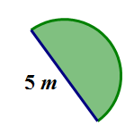

- In the figure below, Ken’s company has placed sprinkler heads at the center of the two small semicircles. The radius of the sprinklers is $5 ft$. If the area in the larger semicircular area is the shape of the entire lawn, how much of the lawn will not be watered? Give your answer in terms of $π$and to the nearest tenth. Explain your thinking.

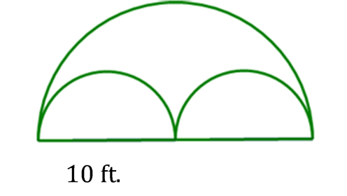

Exit Ticket Sample Solutions

- Ken’s landscape gardening business creates odd-shaped lawns that include semicircles. Find the area of this semicircular section of the lawn in this design. Use $\frac{22}{7}$for $π$.
If the diameter is $5 m$, then the radius is $\frac{5}{2} m.$ Using the formula for area of a semicircle, $A=\frac{1}{2}πr^{2}$, $A≈\frac{1}{2}∙\frac{22}{7}{∙\left(\frac{5}{2}cm\right)}^{2}$. Using the order of operations,
$A≈\frac{1}{2}∙\frac{22}{7}∙\frac{25}{4}{cm}^{2}≈\frac{550}{56}≈9.8 m^{2}.$

- In the figure below, Ken’s company has placed sprinkler heads at the center of the two small semi-circles. The radius of the sprinklers is $5$ft. If the area in the larger semicircular area is the shape of the entire lawn, how much of the lawn will not be watered? Give your answer in terms of $π$and to the nearest tenth. Explain your thinking.
The area not covered by the sprinklers would be the area between the larger semicircle and the two smaller ones. The area for the two semicircles is the same as the area of one circle with the same radius of $5$ ft. The area not covered by the sprinklers can be found by subtracting the area of the two smaller semicircles from the area of the large semicircle.

$$Area Not Covered=Area of large semicircle-Area of two smaller semicircles$$
$$A= \frac{1}{2}π∙{\left(10 ft.\right)}^{2}-\left(2∙\left(\frac{1}{2}\left(π∙{\left(5 ft.\right)}^{2}\right)\right)\right) \\ A= \frac{1}{2}π∙100 {ft}^{2}- π∙25 {ft}^{2} \\ A= 50π {ft}^{2}-25π {ft}^{2.}=25π {ft}^{2}$$
Let $π≈3.14$
$$A≈78.5{ ft}^{2}$$
The sprinklers will not cover $25π {ft}^{2 }$or $78.5 ft^{2}$ of the lawn.

Problem Set Sample Solutions

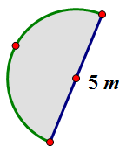
- Mark created a flowerbed that is semicircular in shape. The diameter of the flower bed is $5$ m.

  - What is the perimeter of the flower bed? (Approximate $π$ to be $3.14$.)
The perimeter of this flower bed is the sum of the diameter and one-half the circumference of a circle with the same diameter.
$$P=diameter+\frac{1}{2}π∙diameter \\ P≈5 m+ \frac{1}{2}∙3.14∙5 m \\ P≈12.85 m$$

  - What is the area of the flowerbed? (Approximate $π$ to be $3.14$.)
$$A=\frac{1}{2}π {(2.5 m)}^{2} \\ A=\frac{1}{2}π (6.25 m^{2}) \\ A≈0.5∙3.14∙6.25 m^{2} \\ A≈9.8 m^{2}$$

- A landscape designer wants to include a semicircular patio at the end of a square sandbox. She knows that the area of the semicircular patio is $25.12 {cm}^{2}$.
  - Draw a picture to represent this situation.
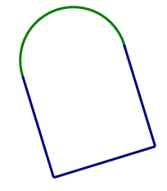

  - What is the length of the side of the square?
If the area of the patio is $25.12 {cm}^{2}$, then we can find the radius by solving the equation $A=\frac{1}{2}πr^{2}$ and substituting the information that we know. If we approximate $π$ to be $3.14$ and solve for the radius, $r$, then $25.12{ cm}^{2}≈\frac{1}{2}πr^{2}$.
$$\frac{2}{1}∙25.12 { cm}^{2}≈\frac{2}{1}∙\frac{1}{2}πr^{2} \\ 50.24 { cm}^{2}≈3.14r^{2} \\ \frac{1}{3.14}∙50.24 { cm}^{2}≈\frac{1}{3.14}∙3.14r^{2} \\ 16 { cm}^{2}≈r^{2} \\ 4 cm≈r$$
The length of the diameter is $8 cm$; therefore, the length of the side of the square is $8 cm$.

- A window manufacturer designed a set of windows for the top of a two-story wall. If the window is comprised of $2$ squares and $2$ quarter circles on each end, and if the length of the span of windows across the bottom is $12$ feet, approximately how much glass will be needed to complete the set of windows?
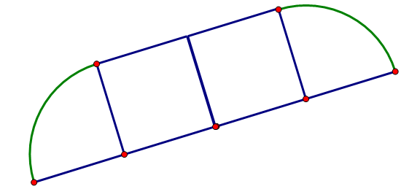

The area of the windows is the sum of the areas of the two quarter circles and the two squares that make up the bank of windows. If the span of windows is $12$ feet across the bottom, then each window is $3$ feet wide on the bottom. The radius of the quarter circles is $3$ feet, so the area for one quarter circle window is
$A=\frac{1}{4}π∙{(3 ft.)}^{2}$or $A≈7.065 {ft}^{2}$. The area of one square window is $A{=(3 ft.)}^{2}$or$9 {ft}^{2}$. The total area is $2\left(area of quarter circle\right)+2\left(area of square\right)$, or $A≈\left(2∙7.065 {ft}^{2}\right)+\left(2∙9 {ft}^{2}\right)≈32.13 {ft}^{2}$.

- Find the area of the shaded region. (Approximate $π$ to be $\frac{22}{7}$.)
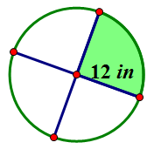
$$A=\frac{1}{4}π{(12 in)}^{2} \\ A=\frac{1}{4}π ∙144 {in}^{2} \\ A≈\frac{1}{4}∙\frac{22}{7}∙144 {in}^{2} \\ A≈\frac{792}{7}{in}^{2} \text{or} 113.1 in.$$

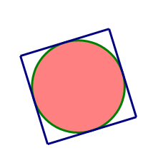
- The figure below shows a circle inside of a square. If the radius of the circle is $8 cm$, find the following and explain your solution.
  - The circumference of the circle
$$C=2π∙8 cm$$
$$C=16π cm$$

  - The area of the circle
$$A=π∙{(8 cm)}^{2}$$
$$A=64 π {cm}^{2}$$

  - The area of the square
$$A=16 cm∙16 cm$$
$$A=256 {cm}^{2}$$

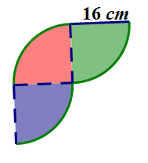
- Michael wants to create a tile pattern out of three quarter circles for his kitchen backsplash. He will repeat the three quarter circles throughout the pattern. Find the area of the tile pattern that Michael will use. Approximate $π$ as $3.14$.
There are three quarter circles in the tile design. The area of one quarter circle multiplied by $3$ will result in the total area.
$$A=\frac{1}{4}π∙{(16 cm)}^{2} \\ A≈\frac{1}{4}∙3.14∙{256 cm}^{2} \\ A≈200.96 {cm}^{2}$$
The area of the tile pattern is $A≈3∙200.96=602.88{ cm}^{2}$.

- A machine shop has a square metal plate with sides that measure $4 cm$ each. A machinist must cut four semicircles with a radius of $\frac{1}{2} cm$ and four quarter circles with a radius of $1$cm from its sides and corners. What is the area of the plate formed? Use $\frac{22}{7}$ to approximate $π$.
The area of the metal plate is determined by subtracting the four quarter circles (corners) and the four half-circles (on each side) from the area of the square. Area of the square: $A={(4 cm)}^{2}=16{ cm}^{2}$.
The area of four quarter circles is the same as the area of a circle with a radius of
$1 cm$: $A≈\frac{22}{7}{\left(1 cm\right)}^{2}≈\frac{22}{7}{ cm}^{2}.$
The area of the four semicircles with radius $\frac{1}{2} cm$ is
$$A≈4∙\frac{1}{2}∙\frac{22}{7}{∙\left(\frac{1}{2} cm\right)}^{2} \\ A≈4∙\frac{1}{2}∙\frac{22}{7}{∙\frac{1}{4} cm}^{2}≈\frac{11}{7}{cm}^{2}.$$
Area of metal plate:
$$A≈16 {cm}^{2}-\frac{22}{7}{ cm}^{2}-\frac{11}{7}{ cm}^{2}≈\frac{79}{7} {cm}^{2}$$

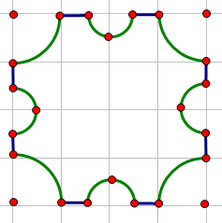

- A graphic artist is designing a company logo with two concentric circles (two circles that share the same center but have different radii). The artist needs to know the area of the shaded band between the two concentric circles. Explain to the artist how he would go about finding the area of the shaded region.
The artist should find the areas of both the larger and smaller circles. Then, the artist should subtract the area of the smaller circle from the area of the larger circle to find the area between the two circles. The area of the larger circle is
$A=π∙{(9 cm)}^{2}$ or $81π {cm}^{2}$.
The area of the smaller circle is
$A=π{(5 cm)}^{2}$ or $25π {cm}^{2}$.
The area of the region between the circles is $81π {cm}^{2}-25π{ cm}^{2}=56π {cm}^{2}$. If we approximate $π$to be $3.14$, the then $A≈175.84 {cm}^{2}$.
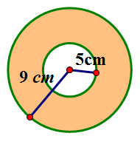

- Create your own shape made up of rectangles, squares, circles, or semicircles and determine the area and perimeter.
Student answers may vary.

