Lesson 17: The Area of a Circle

Classwork
Exercises 1–3
Solve the problem below individually. Explain your solution.
- Find the radius of the following circle if the circumference is $37.68$ inches. Use $π≈3.14.$

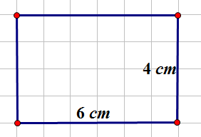
- Determine the area of the rectangle below. Name two ways that can be used to find the area of the rectangle.

- Find the length of a rectangle if the area is $27$ cm² and the width is $3$cm.

Exploratory Challenge
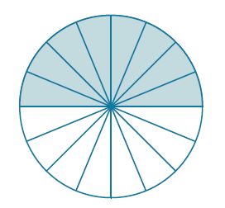
To find the formula for the area of a circle, cut a circle into $16$equal pieces.

Arrange the triangular wedges by alternating the “triangle” directions and sliding them together to make a “parallelogram.” Cut the triangle on the left side in half on the given line, and slide the outside half of the triangle to the other end of the parallelogram in order to create an approximate “rectangle.”
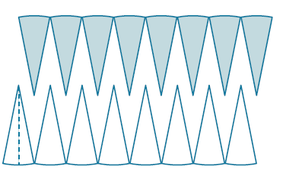
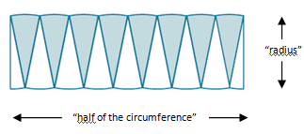
Move half to the other end.

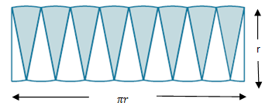

The circumference is$2πr$, where the radius is “$r$.” Therefore, half of the circumference is $πr$.
What is the area of the “rectangle” using the side lengths above?

Are the areas of the rectangle and the circle the same?

If the area of the rectangular shape and the circle are the same, what is the area of the circle?

Example 1
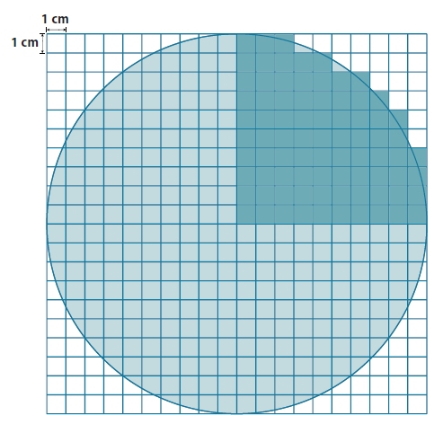
Use the shaded square centimeter units to approximate the area of the circle.

What is the radius of the circle?

What would be a quicker method for determining the area of the circle other than counting all of the squares in the entire circle?

Using the diagram, how many squares were used to cover one-fourth of the circle?

What is the area of the entire circle?

Example 2
A sprinkler rotates in a circular pattern and sprays water over a distance of $12$ feet. What is the area of the circular region covered by the sprinkler? Express your answer to the nearest square foot.
Draw a diagram to assist you in solving the problem. What does the distance of $12$ feet represent in this problem?

What information is needed to solve the problem?

Example 3
Suzanne is making a circular table out of a square piece of wood. The radius of the circle that she is cutting is $3$ feet. How much waste will she have for this project? Express your answer to the nearest square foot.
Draw a diagram to assist you in solving the problem. What does the distance of $3$ feet represent in this problem?

What information is needed to solve the problem?

What information do we need to determine the area of the square and the circle?

How will we determine the waste?

Does your solution answer the problem as stated?

Exercises 4–6
- A circle has a radius of $2 cm$.
  - Find the exact area of the circular region.

  - Find the approximate area using $3.14$ to approximate $π$.

- A circle has a radius of $7 cm$.
  - Find the exact area of the circular region.

  - Find the approximate area using $\frac{22}{7}$to approximate $π$.

  - What is the circumference of the circle?

- Joan determined that the area of the circle below is $400π {cm}^{2}$. Melinda says that Joan’s solution is incorrect; she believes that the area is $100π {cm}^{2}$. Who is correct and why?
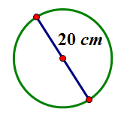

Relevant Vocabulary
Circular Region (or Disk): Given a point $C$ in the plane and a number $r>0$, the circular region (or disk) with center $C$ and radius $r$ is the set of all points in the plane whose distance from the point $C$ is less than or equal to $r$.
The boundary of a disk is a circle. The “area of a circle” refers to the area of the disk defined by the circle.

Problem Set

- The following circles are not drawn to scale. Find the area of each circle. (Use $\frac{22}{7}$ as an approximation for $π.$)
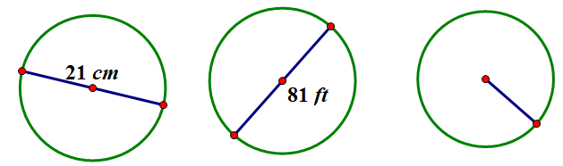
$$\frac{45}{2}cm$$

- A circle has a diameter of $20$ inches.
  - Find the exact area and find an approximate area using $π≈3.14$.
  - What is the circumference of the circle using$π$ $≈3.14$?
- A circle has a diameter of $11$ inches.
  - Find the exact area and an approximate area using $π≈3.14$.
  - What is the circumference of the circle using $π≈3.14$?
- Using the figure below, find the area of the circle.
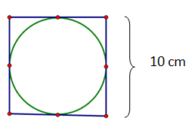

- A path bounds a circular lawn at a park. If the inner edge of the path is $132 ft.$ around, approximate the amount of area of the lawn inside the circular path. Use $π≈\frac{22}{7}$.
- The area of a circle is $36π{ cm}^{2}$. Find its circumference.
- Find the ratio of the area of two circles with radii $3 cm$ and $4 cm$.
- If one circle has a diameter of $10 cm$ and a second circle has a diameter of $20 cm$, what is the ratio of the area of the larger circle to the area of the smaller circle?
- Describe a rectangle whose perimeter is $132 ft.$ and whose area is less than $1 {ft}^{2}$. Is it possible to find a circle whose circumference is $132 ft.$ and whose area is less than $1 {ft}^{2}$? If not, provide an example or write a sentence explaining why no such circle exists.
- If the diameter of a circle is double the diameter of a second circle, what is the ratio of area of the first circle to the area of the second?

