Lesson 17: The Area of a Circle

Student Outcomes
- Students give an informal derivation of the relationship between the circumference and area of a circle.
- Students know the formula for the area of a circle and use it to solve problems.

Lesson Notes
- Remind students of the definitions for circle and circumference from the previous lesson. The Opening Exercise is a lead-in to the derivation of the formula for the area of a circle.
- Not only do students need to know and be able to apply the formula for the area of a circle, it is critical for them to also be able to draw the diagram associated with each problem in order to solve it successfully.
- Students must be able to translate words into mathematical expressions and equations and be able to determine which parts of the problem are known and which are unknown or missing.

Classwork
Exercises 1–3 (4 minutes)
Exercises 1–3
Solve the problem below individually. Explain your solution.
- Find the radius of the following circle if the circumference is $37.68$ inches. Use $π≈3.14.$
If $C=2πr$, then $37.68=2πr.$Solving the equation for $r$:
$$37.68=2πr \\ \left(\frac{1}{2π}\right)37.68= \left(\frac{1}{2π}\right)2πr \\ \frac{1}{6.28}\left(37.68\right)≈r \\ 6≈r$$
The radius of the circle is approximately $6 in$.

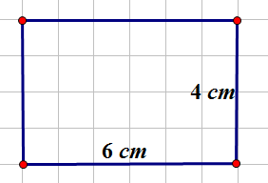
- Determine the area of the rectangle below. Name two ways that can be used to find the area of the rectangle.

The area of the rectangle is $24 cm^{2}$. The area can be found by counting the square units inside the rectangle or by multiplying the length ($6 cm$) by the width ($4 cm$).
- Find the length of a rectangle if the area is $27 cm^{2}$ and the width is $3 cm$.
If the area of the rectangle is $Area=length∙width$, then $27 {cm}^{2}=l∙3 cm$.
$$\frac{1}{3}∙27 {cm}^{2}=\frac{1}{3}∙l∙3 cm \\ 9 cm=l$$

Exploratory Challenge (10 minutes)
Scaffolding:
Provide a circle divided into $16$ equal sections for students to cut out and re-assemble as a rectangle.
Complete the exercise below.
Exploratory Challenge
To find the formula for the area of a circle, cut a circle into $16$equal pieces.
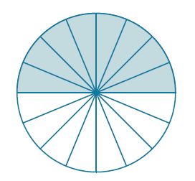

Arrange the triangular wedges by alternating the “triangle” directions and sliding them together to make a “parallelogram.” Cut the triangle on the left side in half on the given line, and slide the outside half of the triangle to the other end of the parallelogram in order to create an approximate “rectangle.”
MP.7
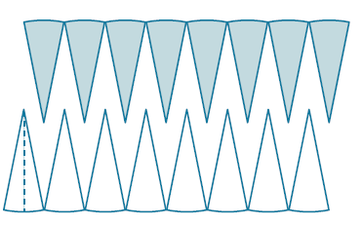
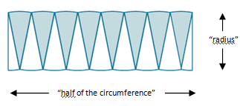
Move half to the other end.

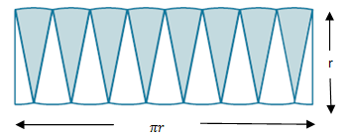
The circumference is$2πr$, where the radius is “$r$.” Therefore, half of the circumference is $πr$.

What is the area of the “rectangle” using the side lengths above?
The area of the “rectangle” is base times height, and, in this case, $A=πr∙r$.

Are the areas of the rectangle and the circle the same?
Yes, since we just rearranged pieces of the circle to make the “rectangle,” the area of the “rectangle” and the area of the circle are approximately equal. Note that the more sections we cut the circle into, the closer the approximation.

If the area of the rectangular shape and the circle are the same, what is the area of the circle?
The area of a circle is written as $A=πr∙r$, or $A=πr^{2}$.

Example 1 (4 minutes)
Example 1
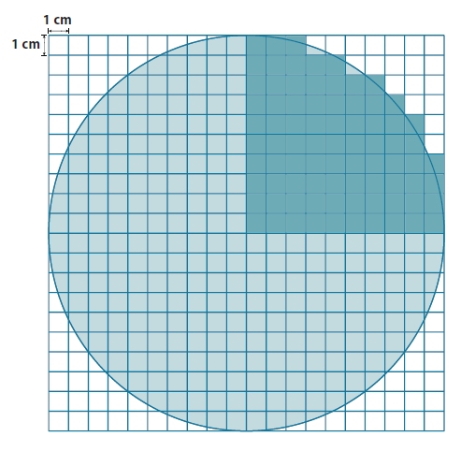
Use the shaded square centimeter units to approximate the area of the circle.
What is the radius of the circle?
$$10 cm$$

What would be a quicker method for determining the area of the circle other than counting all of the squares in the entire circle?
Count $\frac{1}{4}$ of the squares needed; then, multiply that by four in order to determine the area of the entire circle.

Using the diagram, how many squares were used to cover one-fourth of the circle?
The area of one-fourth of the circle is approx. $79 {cm}^{2}$.

What is the area of the entire circle?
$$A≈4∙79 {cm}^{2} \\ A≈316 {cm}^{2}$$
Example 2 (4 minutes)
Example 2
A sprinkler rotates in a circular pattern and sprays water over a distance of $12$ feet. What is the area of the circular region covered by the sprinkler? Express your answer to the nearest square foot.
Draw a diagram to assist you in solving the problem. What does the distance of $12$ feet represent in this problem?
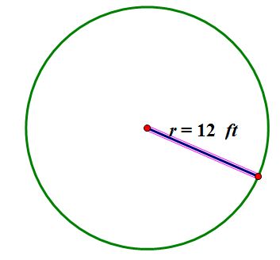
The radius is $12$ feet.

What information is needed to solve the problem?
The formula to find the area of a circle is $A=πr^{2}$. If the radius is $12 ft.$, then $A=π∙{\left(12 ft.\right)}^{2}=144π {ft}^{2}$, or approximately $452 ft^{2}$.

Make a point of telling students that an answer in exact form is in terms of $π,$ not substituting an approximation of pi.

Example 3 (4 minutes)
Example 3
Suzanne is making a circular table out of a square piece of wood. The radius of the circle that she is cutting is $3$ feet. How much waste will she have for this project? Express your answer to the nearest square foot.
Draw a diagram to assist you in solving the problem. What does the distance of $3$ feet represent in this problem?
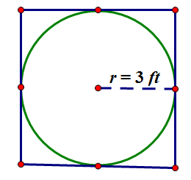
The radius of the circle is $3$ feet.

What information is needed to solve the problem?
The area of the circle and the area of the square are needed so that we can subtract the area of the square from the area of the circle to determine the amount of waste.

What information do we need to determine the area of the square and the circle?
Circle: just radius because $A=πr^{2}$. Square: one side length.
How will we determine the waste?
The waste will be the area left over from the square after cutting out the circular region. The area of the circle is $A=π∙({3 ft.)}^{2}=9π {ft}^{2} ≈28.26 {ft}^{2}$. The area of the square is found by first finding the diameter of the circle, which is the same as the side of the square. The diameter is $d=2r$; so, $d=2∙3 ft.$ or $6 ft$. The area of a square is found by multiplying the length and width; so, $A=6 ft. ∙6 ft.=36 {ft}^{2}$. The solution will be the difference between the area of the square and the area of the circle; so, $36 {ft}^{2}-28.26 {ft}^{2}≈7.74 {ft}^{2}$.

Does your solution answer the problem as stated?
Yes, the amount of waste is $7.74 {ft}^{2}$.

Exercises 4–6 (11 minutes)
Solve in cooperative groups of two or three.
Exercises 4–6
- A circle has a radius of $2$cm.
  - Find the exact area of the circular region.
$$A=π∙({2 cm)}^{2}=4π {cm}^{2}$$

  - Find the approximate area using $3.14$ to approximate $π$.
$$A=4∙π {cm}^{2}≈4{ cm}^{2}∙3.14≈12.56 cm^{2}$$

- A circle has a radius of $7$ cm.
  - Find the exact area of the circular region.
$$A=π∙({7 cm)}^{2}=49π {cm}^{2}$$

  - Find the approximate area using $\frac{22}{7}$ to approximate $π$.
$$A=49∙π {cm}^{2}≈\left(49∙\frac{22}{7}\right){cm}^{2}≈154 cm^{2}$$

  - What is the circumference of the circle?
$$C=2 π∙7 cm=14π cm≈43.96 cm$$

- Joan determined that the area of the circle below is $400π {cm}^{2}$. Melinda says that Joan’s solution is incorrect; she believes that the area is $100π {cm}^{2}$. Who is correct and why?
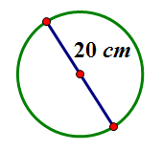
Melinda is correct. Joan found the area by multiplying $π$ by the square of $20 cm$(which is the diameter) to get a result of$400π cm^{2}$, which is incorrect. Melinda found that the radius was $10 cm$ (half of the diameter). Melinda multiplied $π$ by the square of the radius to get a result of $100π cm^{2}$.

Closing (3 minutes)
- Strategies for problem solving include drawing a diagram to represent the problem and identifying the given information and needed information to solve the problem.
- Using the original circle in this lesson, cut it into $64$ equal slices. Reassemble the figure. What do you notice?
  - It looks more like a rectangle.
Ask students to imagine repeating the slicing into even thinner slices (infinitely thin). Then, ask the next two questions.
- What does the length of the rectangle become?
  - An approximation of half of the circumference of the circle.
- What does the width of the rectangle become?
  - An approximation of the radius.
- Thus, we conclude that the area of the circle is $A=\frac{1}{2}Cr$.
- If $A=\frac{1}{2}Cr$, then $A=\frac{1}{2}∙2πr∙r$ or $A=πr^{2}$.
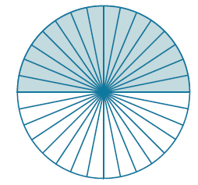
- Also see video link: http://www.youtube.com/watch?v=YokKp3pwVFc

Relevant Vocabulary
Circular Region (or Disk): Given a point $C$ in the plane and a number $r>0$, the circular region (or disk) with center $C$ and radius $r$ is the set of all points in the plane whose distance from the point $C$ is less than or equal to $r$.
The boundary of a disk is a circle. The “area of a circle” refers to the area of the disk defined by the circle.

Exit Ticket (4 minutes)

Name ___________________________________________________ Date____________________
Lesson 17: The Area of a Circle

Exit Ticket

Complete each statement using the words or algebraic expressions listed in the word bank below.
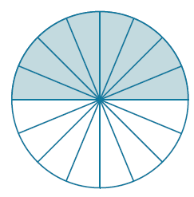 | - The length of the  of the rectangular region approximates the length of the of the circle.  - The of the rectangle approximates the length as one-half of the circumference of the circle. | 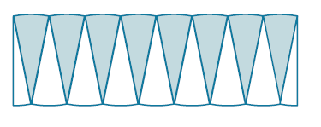

- The circumference of the circle is $_______________________$.

- The _________________ of the ___________________ is $2r$.

- The ratio of the circumference to the diameter is ______.

- Area (circle) $=$ Area of (_____________) $= \frac{1}{2}∙circumference∙r=\frac{1}{2}(2πr)∙r=π∙r∙r=$ _____________.

Exit Ticket Sample Solutions
Word bank
Radius Height Base $2πr$ Diameter Circle Rectangle $πr^{2}$ $π$

Complete each statement using the words or algebraic expressions listed in the word bank below.
- The length of the height of the rectangular region approximates the length of the radius of the circle.
- The base of the rectangle approximates the length as one-half of the circumference of the circle.
- The circumference of the circle is $2πr$.
- The diameter of the circle is $2r$.
- The ratio of the circumference to the diameter is $π$.
- Area (circle)$=$Area of (rectangle)$=\frac{1}{2}∙circumference∙r=\frac{1}{2}(2πr)∙r=$ $π∙r∙r$ $=$ $πr^{2}.$

Problem Set Sample Solutions

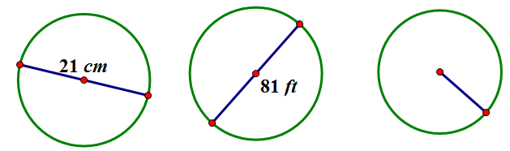
- The following circles are not drawn to scale. Find the area of each circle. (Use $\frac{22}{7}$ as an approximation for $π.$)
$$\frac{45}{2}cm$$
$346.5 {cm}^{2}$ $5,155.1 {ft}^{2}$ $1,591.1 {cm}^{2}$

- A circle has a diameter of $20$ inches.
  - Find the exact area and find an approximate area using $π≈3.14$.
If the diameter is $20 in.$, then the radius is $10 in$. If $A=πr^{2}$, then $A=π∙{(10 in.)}^{2}$ or $100π {in}^{2}.$
$$A≈\left(100∙3.14\right) {in}^{2}≈314 {in}^{2}.$$

  - What is the circumference of the circle using$π$ $≈3.14$ ?
If the diameter is $20 in.$, then the circumference is $C=πd$ or $C≈3.14∙20 in.$ $≈62.8 in.$

- A circle has a diameter of $11$ inches.
  - Find the exact area and an approximate area using$π≈3.14$.
If the diameter is $11 in.$, then the radius is$\frac{11}{2}$ in. If $A=πr^{2}$, then $A=π∙{\left(\frac{11}{2} in.\right)}^{2}$or$\frac{121}{4}π {in}^{2}.$
$$A≈\left(\frac{121}{4}∙3.14\right){in}^{2}≈94.985 {in}^{2}$$

  - What is the circumference of the circle using $π≈3.14$?
If the diameter is$11$inches, then the circumference is $C=πd$ or $C≈3.14∙11 in. ≈34.54 in.$

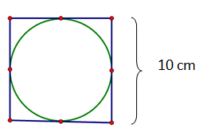
- Using the figure below, find the area of the circle.
In this circle, the diameter is the same as the length of the side of the square. The diameter is $10 cm$; so, the radius is$5 cm$. $A=πr^{2}$, so$A= π{(5 cm)}^{2}=25π {cm}^{2}$.

- A path bounds a circular lawn at a park. If the inner edge of the path is $132 ft.$ around, approximate the amount of area of the lawn inside the circular path. Use $π≈\frac{22}{7}$.
The length of the path is the same as the circumference. Find the radius from the circumference; then, find the area.
$$C=2πr \\ 132 ft.≈2∙\frac{22}{7}∙r \\ 132 ft.≈\frac{44}{7}r \\ \frac{7}{44}∙132 ft.≈\frac{7}{44}∙\frac{44}{7}r \\ 21 ft.≈r \\ A≈\frac{22}{7}∙{\left(21 ft.\right)}^{2} \\ A≈1386 {ft}^{2}$$

- The area of a circle is $36π{ cm}^{2}$. Find its circumference.
Find the radius from the area of the circle; then, use it to find the circumference.
$$A=πr^{2} \\ 36π{ cm}^{2}=πr^{2} \\ \frac{1}{π}∙36π {cm}^{2}=\frac{1}{π}∙πr^{2} \\ 36 {cm}^{2}=r^{2} \\ 6 cm=r \\ C=2πr \\ C=2π∙6 cm \\ C=12π cm$$

- Find the ratio of the area of two circles with radii $3 cm$ and $4 cm$.
The area of the circle with radius $3 cm$ is$9π {cm}^{2}$. The area of the circle with the radius $4 cm$ is$16π {cm}^{2}$. The ratio of the area of the two circles is $\frac{9π {cm}^{2}}{16π {cm}^{2}}$ or $\frac{9}{ 16}$.

- If one circle has a diameter of $10 cm$and a second circle has a diameter of $20 cm$, what is the ratio of the area of the larger circle to the area of the smaller circle?
The area of the circle with the diameter of $10 cm$ will have a radius of $5 cm$. The area of the circle with the diameter of $10 cm$ is $π∙{(5 cm)}^{2}$ or $25π{ cm}^{2}$. The area of the circle with the diameter of $20 cm$ will have a radius of $10 cm$. The area of the circle with the diameter of $20 cm$ is $π∙{(10 cm)}^{2}$ or $100π {cm}^{2}$. The ratio of the diameters is $20$ to $10$ or $2:1,$ while the ratio of the areas is $100π {cm}^{2} t$o $25π {cm}^{2}$ or $4:1$.
- Describe a rectangle whose perimeter is $132 ft.$ and whose area is less than $1 {ft}^{2}.$Is it possible to find a circle whose circumference is $132 ft.$ and whose area is less than $1 {ft}^{2}$? If not, provide an example or write a sentence explaining why no such circle exists.
A rectangle that has a perimeter of $132 ft.$ can have a length of $65.995 ft.$ and a width of $0 .005 ft$. The area of such a rectangle is $0.329975$ ${ft}^{2}$, which is less than $1 {ft}^{2}$. No, because a circle that has a circumference of $132 ft.$ will have a radius of approximately $21 ft$.
$$A=πr^{2}=π{(21)}^{2}=1387.96≠1$$

- If the diameter of a circle is double the diameter of a second circle, what is the ratio of the area of the first circle to the area of the second?
If I choose a diameter of $24 cm$ for the first circle, then the diameter of the second circle is $12 cm$. The first circle has a radius of $12 cm$ and an area of $144π cm^{2}$. The second circle has a radius of $6$ $cm$ and an area of $36π cm^{2}$. The ratio of the area of the first circle to the second is $144π cm^{2}$ to $36π cm^{2}$, which is a $4$ to $1$ ratio. The ratio of the diameters is $2$, while the ratio of the areas is the square of $2$, or $4$.

