Lesson 16: The Most Famous Ratio of All

Classwork
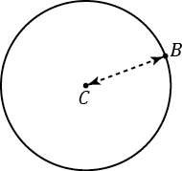
Opening Exercise
  - Using a compass, draw a circle like the picture to the right.

$C$ is the center of the circle.
The distance between $C$ and $B$ is the radius of the circle.

  - Write your own definition for the term circle.

  - Extend segment $CB$ to a segment $AB$ in part (a), where $A$ is also a point on the circle.

The length of the segment $AB$ is called the diameter of the circle.

  - The diameter is ______________________ as long as radius.

  - Measure the radius and diameter of each circle. The center of each circle is labeled $C$.
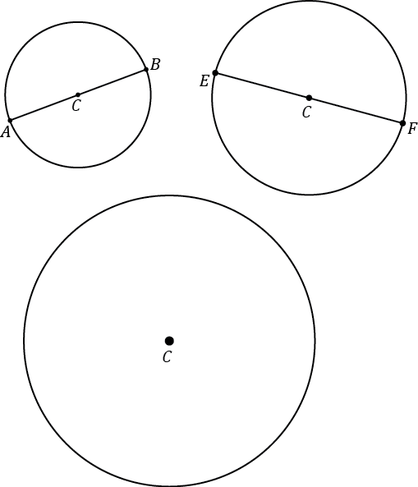

  - Draw a circle of radius $6 cm$.

Mathematical Modeling Exercise
The ratio of the circumference to its diameter is always the same for any circle. The value of this ratio, $\frac{Circumference}{Diameter}$ , is called the number pi and is represented by the symbol $π$.
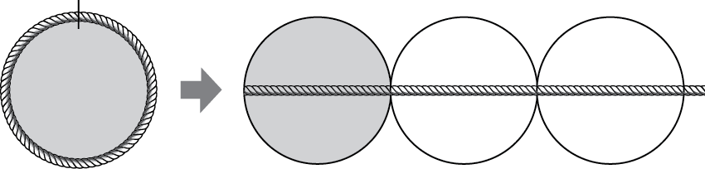

Since the circumference is a little greater than $3$ times the diameter, $π$ is a number that is a little greater than $3$. Use the symbol $π$ to represent this special number. Pi is a non-terminating, non-repeating decimal, and mathematicians use the symbol $π$ or approximate representations as more convenient ways to represent pi.
- $π≈3.14$ or $\frac{22}{7}$.
- The ratios of the circumference to the diameter and $π :1$ are equal.
- $Circumference of a Circle=π×Diameter$.

Exercise 2
  - The following circles are not drawn to scale. Find the circumference of each circle. (Use $\frac{22}{7}$ as an approximation for $π$.)
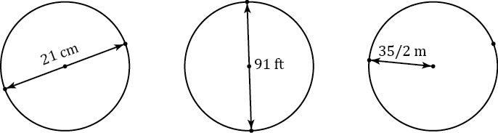

  - The radius of a paper plate is $11.7 cm$. Find the circumference to the nearest tenth. (Use $3.14$ as an approximation for $π$.)

  - The radius of a paper plate is $11.7 cm$. Find the circumference to the nearest hundredth. (Use the $π$ button on your calculator as an approximation for $π$.)

  - A circle has a radius of $r$ cm and a circumference of $C cm$. Write a formula that expresses the value of $C$ in terms of $r$ and $π$.

  - The figure below is in the shape of a semicircle. A semicircle is an arc that is “half” of a circle. Find the perimeter of the shape. (Use $3.14$ for $π$.)
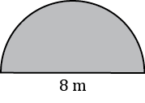

Relevant Vocabulary
Circle: Given a point $C$ in the plane and a number $r > 0$, the circle with center $C$ and radius $r$ is the set of all points in the plane that are distance $r$ from the point $C$.
Radius of a circle: The radius is the length of any segment whose endpoints are the center of a circle and a point that lies on the circle.
Diameter of a circle: The diameter of a circle is the length of any segment that passes through the center of a circle whose endpoints lie on the circle. If $r$is the radius of a circle, then the diameter is $2r$.
The word diameter can also mean the segment itself. Context determines how the term is being used: “the diameter” usually refers to the length of the segment, while “a diameter” usually refers to a segment. Similarly, “a radius” can refer to a segment from the center of a circle to a point on the circle.
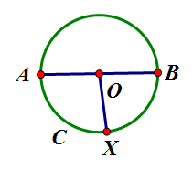  Circle C  Radii: $\overline{OA}, \overline{OB}, \overline{OX}$  Diameter: $\overline{AB}$ | 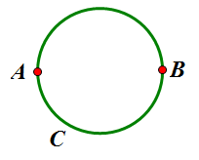  Circumference
Circumference: The circumference of a circle is the distance around a circle.
Pi: The number pi, denoted by $π$, is the value of the ratio given by the circumference to the diameter, that is
$π=\frac{circumference}{diameter}$. The most commonly used approximations for $π$ is $3.14$ or $\frac{22}{7}.$
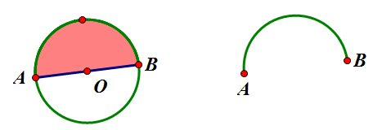
Semicircle: Let $C$ be a circle with center $O$, and let $A$ and $B$ be the endpoints of a diameter. A semicircle is the set containing $A$, $B$, and all points that lie in a given half-plane determined by $AB$ (diameter) that lie on circle $C$.
Semicircle
Half-plane
Problem Set

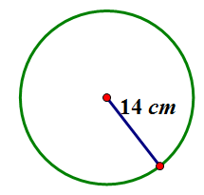
- Find the circumference.
  - Give an exact answer in terms of $π$.
  - Use $π≈\frac{22}{7}$ and express your answer as a fraction in lowest terms.
  - Use $the π$ button on your calculator and express your answer to the nearest hundredth.

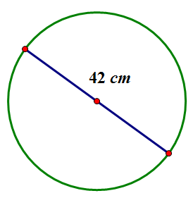
- Find the circumference.
  - Give an exact answer in terms of $π$.
  - Use $π≈\frac{22}{7}$ and express your answer as a fraction in lowest terms.

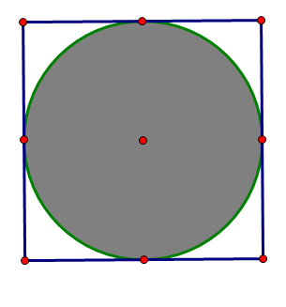
$$16 in.$$
- The figure shows a circle within a square. Find the circumference of the circle. Let $π≈3.14$.

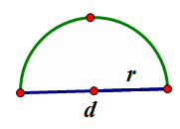
- Consider the diagram of a semicircle shown.
  - Explain in words how to determine the perimeter of a semicircle.
  - Using “$d$” to represent the diameter of the circle, write an algebraic expression that will result in the perimeter of a semicircle.
  - Write another algebraic expression to represent the perimeter of a semicircle using $r$ to represent the radius of a semicircle.

- Find the perimeter of the semicircle. Let $π≈3.14$.
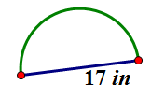

- Ken’s landscape gardening business makes odd-shaped lawns that include semicircles. Find the length of the edging material needed to border the two lawn designs. Use $3.14$ for $π$.
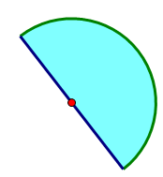
  - The radius of this flower bed is $2.5 m$.
  - The diameter of the semicircular section is $10 m$, and the lengths of the sides of the two sides are $6 m$.
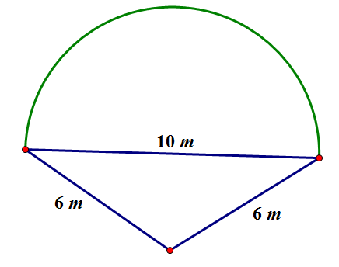

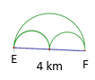
- Mary and Margaret are looking at a map of a running path in a local park. Which is the shorter path from $E$ to $F$, along the two semicircles or along the larger semicircle? If one path is shorter, how much shorter is it? Let $π≈3.14$.

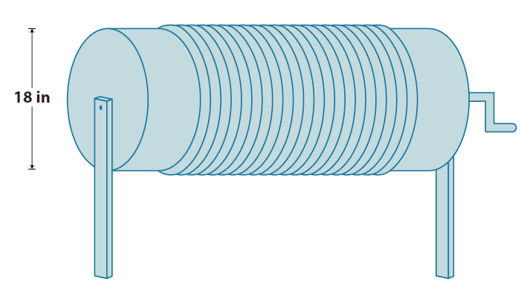
- Alex the electrician needs $34$ yards of electrical wire to complete a job. He has a coil of wiring in his workshop. The coiled wire is $18$ inches in diameter and is made up of $21$ circles of wire. Will this coil be enough to complete the job? Let $π≈3.14$.

