Lesson 16: The Most Famous Ratio of All

Student Outcomes
- Students develop the definition of a circle using diameter and radius.
- Students know that the distance around a circle is called the circumference and discover that the ratio of the circumference to the diameter of a circle is a special number called pi, written$π$.
- Students know the formula for the circumference $C$ of a circle of diameter $d$ and radius $r$. They use scale models to derive these formulas.
- Students use $\frac{22}{7}$ and $3.14$ as estimates for $π$ and informally show that $π$ is slightly greater than $3$.

Lesson Notes
Although students were introduced to circles in Kindergarten and worked with angles and arcs measures in Grades 4 and 5, they have not examined a precise definition of a circle. This lesson will combine the definition of a circle with the application of constructions with a compass and straight edge to examine the ideas associated with circles and circular regions.

Classwork
Opening Exercise (10 minutes)
Materials: Each student has a compass and metric ruler.
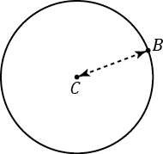
Opening Exercise
  - Using a compass, draw a circle like the picture to the right.

$C$ is the center of the circle.
The distance between $C$ and $B$ is the radius of the circle.

  - Write your own definition for the term circle.
Student responses will vary. Many might say, “It is round.” “It is curved.” “It has an infinite number of sides.” “The points are always the same distance from the center.” Analyze their definitions, showing how other figures such as ovals are also “round” or “curved.” Ask them what is special about the compass they used. (Answer: The distance between the spike and the pencil is fixed when drawing the circle.) Let them try defining a circle again with this new knowledge.

Present the following information about a circle.
- Circle: Given a point $C$ in the plane and a number $r>0$, the circle with center $C$ and radius $r$ is the set of all points in the plane that are distances $r$ from point $C$.

- What does the distance between the spike and the pencil on a compass represent in the definition above?
  - The radius $r$
- What does the spike of the compass represent in the definition above?
  - The center $C$
- What does the image drawn by the pencil represent in the definition above?
  - The “set of all points”

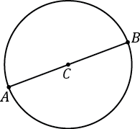
  - Extend segment $CB$ to a segment $AB$, where $A$ is also a point on the circle.

The length of the segment $AB$ is called the diameter of the circle.
  - The diameter is twice, or $2$ times, as long as radius.

After each student measures and finds that the diameter is twice as long as the radius, display several student examples of different-sized circles to the class. Did everyone get a measure that was twice as long? Ask if a student can use the definition of a circle to explain why the diameter must be twice as long.
MP.3

  - Measure the radius and diameter of each circle. The center of each circle is labeled $C$.
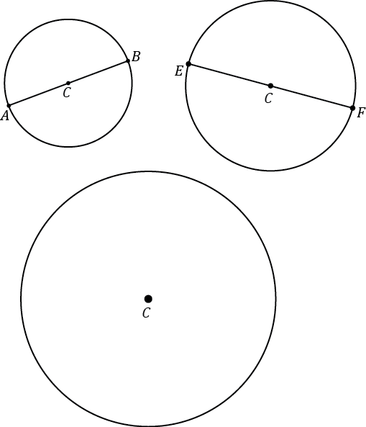
$CB$ $=1.5 cm$, $AB=3 cm$, $CF=2$ $cm$, $EF=4 cm$
The radius of circle $C$ is $3 cm$. The diameter is $6 cm$.

  - Draw a circle of radius $6$ $cm$.

Part (f) may not be as easy as it seems. Let students grapple with how to measure $6 cm$ with a compass. One difficulty they might encounter is trying to measure $6 cm$ by putting the spike of the compass on the edge of the ruler, i.e., the
“$0$ $cm$” mark. Suggest either: (1) measure the compass from the $1 cm$ mark to the $7 cm$ mark, or (2) mark two points $6 cm$ apart on the paper first; then, use one point as the center.

Mathematical Modeling Exercise (15 minutes)
Materials: a bicycle wheel (as large as possible), tape or chalk, a length of string long enough to measure the circumference of the bike wheel
Activity: Invite the entire class to come up to the front of the room to measure a length of string that is the same length as the distance around the bicycle wheel. Give them the tape or chalk and string, but do not tell them how to use these materials to measure the circumference, at least not yet. Your goal is to set up several “ah-ha” moments for your students. Give them time to try to wrap the string around the bicycle wheel. They will quickly find that this way of trying to measure the circumference is unproductive (the string will pop off). Lead them to the following steps for measuring the circumference, even if they do succeed with wrapping the string:
- Mark a point on the wheel with a piece of masking tape or chalk.
- Mark a starting point on the floor, align it with the mark on the wheel, and carefully roll the wheel so that it rolls one complete revolution.
- Mark the end point on the floor with a piece of masking tape or chalk.
Dramatically walk from the beginning mark to the ending mark on the floor, declaring, “The length between these two marks is called the circumference of the wheel; it is the distance around the wheel. We can now easily measure that distance with string.” First, ask two students to measure a length of string using the marks; then, ask them to hold up the string directly above the marks in front of the rest of the class. Students are ready for the next “ah-ha” moment.
- Why is this new way of measuring the string better than trying to wrap the string around the wheel? (Because it leads to an accurate measurement of the circumference.)
- The circumference of any circle is always the same multiple of the diameter. Mathematicians call this number pi. It is one of the few numbers that is so special it has its own name. Let’s see if we can estimate the value of pi.
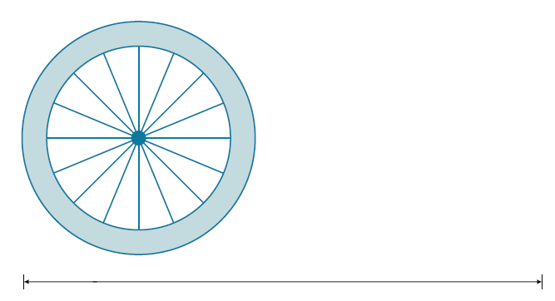
Take the wheel and carefully measure three diameter lengths using the wheel itself, as in the picture below.
Mark the three diameter lengths on the rope with a marker. Then, have students wrap the rope around the wheel itself.
If the circumference was measured carefully, students will see that the string is three wheel diameters plus “a little bit extra” at the end. Have students estimate how much the extra bit is; guide them to report, “It’s a little more than a tenth of the bicycle diameter.”

- The circumference of any circle is a little more than $3$ times its diameter. The number pi is a little greater than $3$.
- Use the symbol $π$ to represent this special number. Pi is a non-terminating, non-repeating decimal, and mathematicians use the symbol $π$ or approximate representations as more convenient ways to represent pi.
Mathematical Modeling Exercise
The ratio of the circumference to its diameter is always the same for any circle. The value of this ratio, $\frac{Circumference}{Diameter}$, is called the number pi and is represented by the symbol $π$.
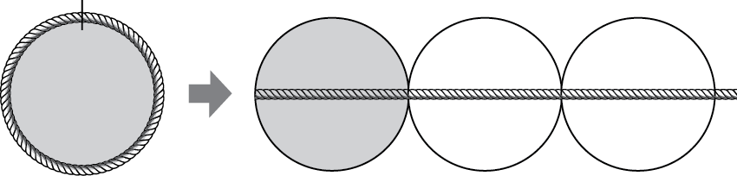

Since the circumference is a little greater than $3$ times the diameter, $π$ is a number that is a little greater than $3$. Use the symbol $π$ to represent this special number. Pi is a non-terminating, non-repeating decimal, and mathematicians use the symbol $π$ or approximate representations as more convenient ways to represent pi.
- $π≈3.14$ or $\frac{22}{7}$.
- The ratios of the circumference to the diameter and $π :1$ are equal.
- $Circumference of a Circle =π×Diameter$.

Example (10 minutes)
Note that both $3.14$ and$\frac{22}{7}$ are excellent approximations to use in the classroom: one helps students’ fluency with decimal number arithmetic, and the second helps students’ fluency with fraction arithmetic. After learning about $π$ and its approximations, have students use the $π$ button on their calculators as another approximation for $π$. Students should use all digits of $π$in the calculator and round appropriately.
Example
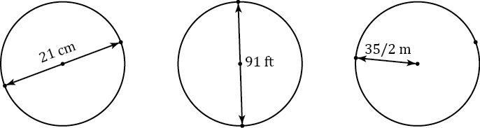
  - The following circles are not drawn to scale. Find the circumference of each circle. (Use$\frac{22}{7}$ as an approximation for $π$.)

$66 cm$; $286 ft$.; $110 m$; You might ask your students if these numbers are roughly three times the diameters.

  - The radius of a paper plate is $11.7 cm$. Find the circumference to the nearest tenth. (Use $3.14$ as an approximation for $π$.)
Diameter: $23.4 cm$; circumference: $73.5 cm$

Extension for this problem: Bring in paper plates and ask students how to find the center of a paper plate. This is not as easy as it sounds because the center is not given. Answer: Fold the paper plate in half twice. The intersection of the two folds is the center. Afterwards, have students fold their paper plate several more times. Explore what happens. Ask the students why the intersection of both lines is guaranteed to be the center. Answer: The first fold guarantees that the crease is a diameter, the second fold divides that diameter in half, but the midpoint of a diameter is the center.

  - The radius of a paper plate is $11.7 cm$. Find the circumference to the nearest hundredth. (Use the $π$ button on your calculator as an approximation for $π$.)
Circumference: $73.51 cm$

  - A circle has a radius of $r$ cm and a circumference of $C cm$. Write a formula that expresses the value of $C$ in terms of $r$ and $π$.
$C=π∙2r$, or $C=2πr$.

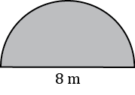
  - The figure below is in the shape of a semicircle. A semicircle is an arc that is “half” of a circle. Find the perimeter of the shape. (Use $3.14$ for $π$.)
$$8 m+\frac{8\left(3.14\right)}{2} m = 20.56 m$$

Closing (5 minutes)
Relevant Vocabulary
Circle: Given a point $C$ in the plane and a number $r>0$, the circle with center $C$ and radius $r$ is the set of all points in the plane that are distance $r$ from the point $C$.
Radius of a circle: The radius is the length of any segment whose endpoints are the center of a circle and a point that lies on the circle.
Diameter of a circle: The diameter of a circle is the length of any segment that passes through the center of a circle whose endpoints lie on the circle. If $r$is the radius of a circle, then the diameter is $2r$.
The word diameter can also mean the segment itself. Context determines how the term is being used: “the diameter” usually refers to the length of the segment, while “a diameter” usually refers to a segment. Similarly, “a radius” can refer to a segment from the center of a circle to a point on the circle.

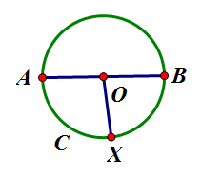  Circle C  Radii: $\overline{OA}, \overline{OB}, \overline{OX}$  Diameter: $\overline{AB}$ | 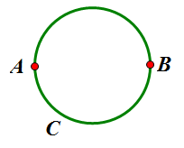  Circumference
Circumference: The circumference of a circle is the distance around a circle.
Pi: The number pi, denoted by $π$, is the value of the ratio given by the circumference to the diameter, that is
$π=\frac{circumference}{diameter}$. The most commonly used approximations for $π$ is $3.14$ or$\frac{22}{7}.$
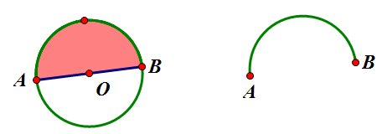
Semicircle: Let $C$ be a circle with center $O$, and let $A$ and $B$ be the endpoints of a diameter. A semicircle is the set containing $A$, $B$, and all points that lie in a given half-plane determined by $AB$ (diameter) that lie on circle $C$.
Semicircle
Half-plane

Exit Ticket (5 minutes)
The Exit Ticket calls on students to synthesize their knowledge of circles and rectangles. A simpler alternative is to have students sketch a circle with a given radius and then have them determine the diameter and circumference of that circle.

Name ___________________________________________________ Date____________________
Lesson 16: The Most Famous Ratio of All

Exit Ticket

Brianna’s parents built a swimming pool in the back yard. Brianna says that the distance around the pool is $120$ feet.
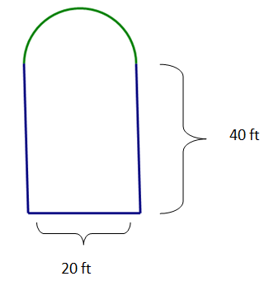
- Is she correct? Explain why or why not.

- Explain how Brianna would determine the distance around the pool so that her parents would know how many feet of stone to buy for the edging around the pool.

- Explain the relationship between the circumference of the semicircular part of the pool and the width of the pool.

Exit Ticket Sample Solutions

Brianna’s parents built a swimming pool in the back yard. Brianna says that the distance around the pool is $120$ feet.
- Is she correct? Explain why or why not.
Brianna is incorrect. The distance around the pool is $131.4 ft$. She found the distance around the rectangle only and did not include the distance around the semicircular part of the pool.

- Explain how Brianna would determine the distance around the pool so that her parents would know how many feet of stone to buy for the edging around the pool.
In order to find the distance around the pool, Brianna must first find the circumference of the semicircle, which is $C=\frac{1}{2}∙π∙20 ft.$, or$10π ft.$, or about$31.4 ft$. The sum of the three other sides is $\left(20 ft.+40 ft.+40 ft.=100 ft.\right)$; the perimeter is $(100 ft.+31.4 ft.)$ $=131.4 ft$.

- Explain the relationship between the circumference of the semicircular part of the pool and the width of the pool.
The relationship between the circumference of the semicircular part and the width of the pool is the same as half of $π$ because this is half the circumference of the entire circle.

Problem Set Sample Solutions
Students should work in cooperative groups to complete the tasks for this exercise.

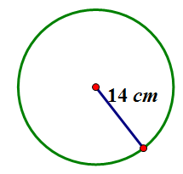
- Find the circumference.
  - Give an exact answer in terms of $π$.
$$C=2πr \\ C=2π∙14 cm \\ C=28π cm$$

  - Use $π≈\frac{22}{7}$ and express your answer as a fraction in lowest terms.
$$C≈2∙\frac{22}{7}∙14 cm \\ C≈88 cm$$

  - Use $the π$ button on your calculator and express your answer to the nearest hundredth.
$$C≈2∙π∙14 cm$$
$$C≈87.96 cm$$

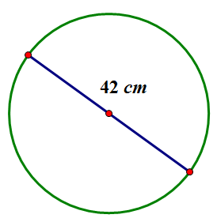
- Find the circumference.
  - Give an exact answer in terms of $π$.
$$d=42 cm \\ C=πd \\ C=42π cm$$

  - Use $π≈\frac{22}{7}$ and express your answer as a fraction in lowest terms.
$$C≈42 cm∙\frac{22}{7} \\ C≈132 cm$$

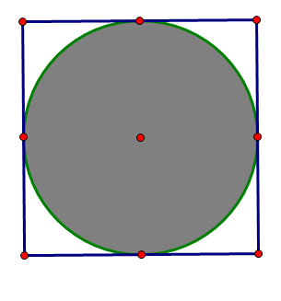
- The figure shows a circle within a square. Find the circumference of the circle. Let $π≈3.14$.
The diameter of the circle is the same as the length of the side of the square.
$$C=πd \\ C=π∙16 \\ C≈3.14∙16 in. \\ C≈50.24 in.$$
$16 in$.

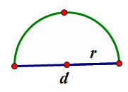
- Consider the diagram of a semicircle shown.

  - Explain in words how to determine the perimeter of a semicircle.
The perimeter is the sum of the length of the diameter and half of the circumference of a circle with the same diameter.

  - Using “$d$” to represent the diameter of the circle, write an algebraic expression that will result in the perimeter of a semicircle.
$$P=d+ \frac{1}{2}πd$$

  - Write another algebraic expression to represent the perimeter of a semicircle using $r$ to represent the radius of a semicircle.
$$P=2r+\frac{1}{2}π∙2r \\ P=2r+πr$$

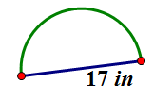
- Find the perimeter of the semicircle. Let $π≈3.14$.
$$P=d+\frac{1}{2}πd \\ P≈17+\frac{1}{2}∙3.14∙17 \\ P≈17+ 26.69 in. \\ P≈43.69 in.$$

- Ken’s landscape gardening business makes odd-shaped lawns that include semicircles. Find the length of the edging material needed to border the two lawn designs. Use $3.14$ for $π$.
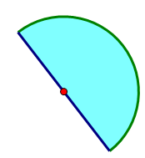
  - The radius of this flowerbed is $2.5 m$.
A semicircle has half of the circumference of a circle. If the circumference of the semicircle is $C=\frac{1}{2}(π∙2∙2.5 m)$, then the circumference approximates $7.85 m$. The length of the edging material must include the circumference and the diameter $(7.85 m+5 m=12.85 m)$. Ken needs $12.85$ meters of edging to complete his design.

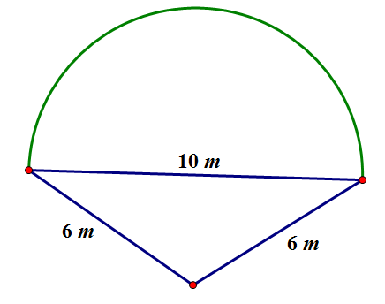
  - The diameter of the semicircular section is $10 m$, and the lengths of the two sides are $6 m$.
The circumference of the semicircular part has half of the circumference of a circle. The circumference of the semicircle is$C=\frac{1}{2}π∙10$, which is approximately $15.7 m$. The length of the edging material must include the circumference of the semicircle and the perimeter of two sides of the triangle$(15.7 m+6 m+6 m=27.7 m)$. Ken needs $27.7$ meters of edging to complete his design.

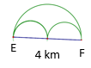
- Mary and Margaret are looking at a map of a running path in a local park. Which is the shorter path from $E$ to $F$, along the two semicircles or along the larger semicircle? If one path is shorter, how much shorter is it? Let
$π≈3.14$.
A semicircle has half of the circumference of a circle. The circumference of the large semicircle is $C=\frac{1}{2}π∙4 km$ or $6.28 km$. The diameter of the two smaller semicircles is $2 km$. The total circumference would be the same as the circumference for a whole circle with the same diameter. If$C=π∙2 km$, then$C=6.28 km$. The distance around the larger semicircle is the same as the distance around both of the semicircles. So, both paths are equal in distance.
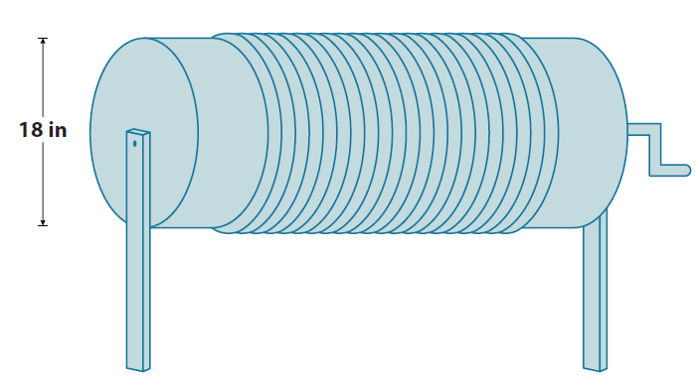
- Alex the electrician needs $34$ yards of electrical wire to complete a job. He has a coil of wiring in his workshop. The coiled wire is $18$ inches in diameter and is made up of $21$ circles of wire. Will this coil be enough to complete the job? Let $π≈3.14$.
The circumference of the coil of wire is $C=π∙18 in.$, or approximately $56.52 in$. If there are $21$ circles of wire, then the number of circles times the circumference will yield the total number of inches of wire in the coil. If $56.52 in. ∙21≈1186.92 in.$, then $\frac{ 1186.92 in.}{36 in.}≈32.97 yd.$ ($1 yd. =3 ft.=36 in.$ When converting inches to yards, you must divide the total inches by the number of inches in a yard, which is $36$inches.) Alex will not have enough wire for his job in this coil of wire.

