Lesson 11: Angle Problems and Solving Equations

Classwork

Opening Exercise

* 1. In a complete sentence, describe the angle relationship in the diagram. Write an equation for the angle relationship shown in the figure and solve for . Confirm your answers by measuring the angle with a protractor.



* 1. and are intersecting lines. In a complete sentence, describe the angle relationship in the diagram. Write an equation for the angle relationship shown in the figure and solve for . Confirm your answers by measuring the angle with a protractor.



* 1. In a complete sentence, describe the angle relationship in the diagram. Write an equation for the angle relationship shown in the figure and solve for. Confirm your answers by measuring the angle with a protractor.



* 1. The following figure shows three lines intersecting at a point. In a complete sentence, describe the angle relationship in the diagram. Write an equation for the angle relationship shown in the figure and solve for . Confirm your answers by measuring the angle with a protractor.



* 1. 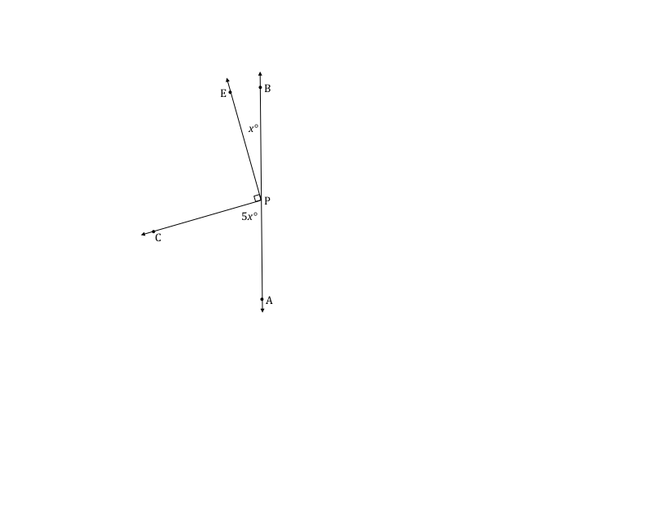Write an equation for the angle relationship shown in the figure and solve for . In a complete sentence, describe the angle relationship in the diagram. Find the measurements of and . Confirm your answers by measuring the angle with a protractor.

**Example 1**

****The following figure shows three lines intersecting at a point. In a complete sentence, describe the angle relationship in the diagram. Write an equation for the angle relationship shown in the figure and solve for . Confirm your answers by measuring the angle with a protractor.

Exercise 1

****The following figure shows four lines intersecting at a point. In a complete sentence, describe the angle relationships in the diagram. Write an equation for the angle relationship shown in the figure and solve for and . Confirm your answers by measuring the angle with a protractor.

**Example 2**

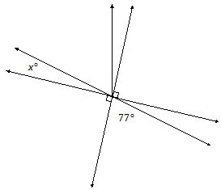In a complete sentence, describe the angle relationships in the diagram. You may label the diagram to help describe the angle relationships. Write an equation for the angle relationship shown in the figure and solve for . Confirm your answers by measuring the angle with a protractor.

Exercise 2

In a complete sentence, describe the angle relationships in the diagram. Write an equation for the angle relationship shown in the figure and solve for and . Confirm your answers by measuring the angle with a protractor.



**Example 3**

****In a complete sentence, describe the angle relationships in the diagram. Write an equation for the angle relationship shown in the figure and solve for . Find the measures of and . Confirm your answers by measuring the angle with a protractor.

Exercise 3

In a complete sentence, describe the angle relationships in the diagram. Write an equation for the angle relationship shown in the figure and solve for . Find the measures of and . Confirm your answers by measuring the angle with a protractor.



**Example 4**

In the accompanying diagram, is four times the measure of .

* 1. Label as and as . Write an equation that describes the relationship between and .
  2. Find the value of .
  3. Find the measures of , , , , and
  4. What is the measure of ? Identify the angle relationship used to get your answer.

Problem Set

In a complete sentence, describe the angle relationships in each diagram. Write an equation for the angle relationship(s) shown in the figure, and solve for the indicated unknown angle. You can check your answers by measuring each angle with a protractor.

1. Find the measures of, , and .



1. Find the measure of .



1. Find the measures of and .



1. Find the measure of .



1. Find the measures of and .



1. The measure of. The measure of is five more than two times . The measure of is twelve less than eight times . Find the measures of , , and .



1. Find the measures of and .



1. The measures of three angles at a point are in the ratio of . Find the measures of the angles.
2. The sum of the measures of two adjacent angles is . The ratio of the smaller angle to the larger angle is . Find the measures of each angle.
3. Find the measures of and .

