|  |
| --- |
|  |

Lesson 11: Angle Problems and Solving Equations

Student Outcomes

* Students use facts about supplementary, complementary, vertical, and adjacent angles in a multistep problem to write and solve simple equations for an unknown angle in a figure.

Lesson Notes

Lesson 11 continues where Lesson 10 ended and incorporates slightly more difficult problems. At the heart of each problem is the need to model the angle relationships in an equation, and then solve for the unknown angle. The diagrams are all drawn to scale; students should verify their answers by using a protractor to measure relevant angles.

Classwork

Opening Exercise (8 minutes)

Students describe the angle relationship in the diagram and set up and solve an equation that models it. Have students verify their answers by measuring the unknown angle with a protractor.

*Note to Teacher:*

You may choose or offer a choice of difficulty to students in the Opening Exercise.

Opening Exercise

* 1. In a complete sentence, describe the angle relationship in the diagram. Write an equation for the angle relationship shown in the figure and solve for . Confirm your answers by measuring the angle with a protractor.

***The angles marked by , , and are angles on a line and have a sum of .***



* 1. and are intersecting lines. In a complete sentence, describe the angle relationship in the diagram. Write an equation for the angle relationship shown in the figure and solve for . Confirm your answers by measuring the angle with a protractor.

***The adjacent angles marked by and together form the angle that is vertically opposite and equal to the angle measuring .***

* 1. In a complete sentence, describe the angle relationship in the diagram. Write an equation for the angle relationship shown in the figure and solve for . Confirm your answers by measuring the angle with a protractor.

***The adjacent angles marked by °, , , , and are angles at a point and together have a sum of .***

* 1. The following figure shows three lines intersecting at a point. In a complete sentence, describe the angle relationship in the diagram. Write an equation for the angle relationship shown in the figure and solve for . Confirm your answers by measuring the angle with a protractor.

***The angles marked by , , and are angles on a line and have a sum of .***

* 1. 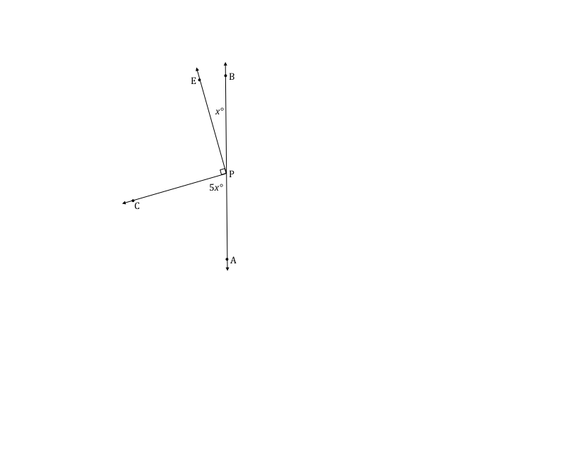Write an equation for the angle relationship shown in the figure and solve for . In a complete sentence, describe the angle relationship in the diagram. Find the measurements of and . Confirm your answers by measuring the angle with a protractor.

, , and **are angles on a line and have a sum of .**

Example 1 (4 minutes)

Example 1

The following figure shows three lines intersecting at a point. In a complete sentence, describe the angle relationship in the diagram. Write an equation for the angle relationship shown in the figure and solve for . Confirm your answers by measuring the angle with a protractor.

The angles , , and the angle between them, which is vertically opposite and equal in measure to , **are angles on a line and have a sum of .**

Exercise 1 (5 minutes)

Exercise 1

The following figure shows four lines intersecting at a point. In a complete sentence, describe the angle relationships in the diagram. Write an equation for the angle relationship shown in the figure and solve for and . Confirm your answers by measuring the angle with a protractor.

The angles , , , and are angles on a line and have a sum of ; the angle marked is vertically opposite and equal to .

**, vert. s**

Example 2 (4 minutes)

Example 2

In a complete sentence, describe the angle relationships in the diagram. You may label the diagram to help describe the angle relationships. Write an equation for the angle relationship shown in the figure and solve for . Confirm your answers by measuring the angle with a protractor.



The angle formed by adjacent angles and is vertically opposite to the angle. The angles , , and are adjacent angles that have a sum of (since the adjacent angle is a right angle and together the angles are on a line).

Exercise 2 (4 minutes)

Exercise 2

In a complete sentence, describe the angle relationships in the diagram. Write an equation for the angle relationship shown in the figure and solve for and . Confirm your answers by measuring the angle with a protractor.

Angles and have a sum of ; angles and have a sum of .

Example 3 (5 minutes)

Example 3

In a complete sentence, describe the angle relationships in the diagram. Write an equation for the angle relationship shown in the figure and solve for . Find the measures of and . Confirm your answers by measuring the angle with a protractor.

The sum of the degree measurements of ,, , and the arc that subtends  **is .**

Exercise 3 (4 minutes)

Exercise 3

In a complete sentence, describe the angle relationships in the diagram. Write an equation for the angle relationship shown in the figure and solve for . Find the measure of . Confirm your answers by measuring the angle with a protractor.

The sum of the degree measurements of ,, , and the arc that subtends  **is .**

**Example 4 (5 minutes)**

Example 4

In the accompanying diagram, is four times the measure of .

* 1. Label as and as . Write an equation that describes the relationship between and .
  2. Find the value of .
  3. Find the measures of , , , ,and.
  4. What is the measure of ? Identify the angle relationship used to get your answer.

To determine the measure of , you need to add the measures of adjacent angles and

Exit Ticket (6 minutes)

Name ___________________________________________________ Date____________________

Lesson 11: Angle Problems and Solving Equations

Exit Ticket

Write an equation for the angle relationship shown in the figure and solve for . Find the measures of and .



Exit Ticket Sample Solutions

Write an equation for the angle relationship shown in the figure and solve for . Find the measures of and .

Problem Set Sample Solutions

In a complete sentence, describe the angle relationships in each diagram. Write an equation for the angle relationship(s) shown in the figure, and solve for the indicated unknown angle. You can check your answers by measuring each angle with a protractor.

1. Find the measures of, , and .

,, , and are angles on a line and have a sum of

1. Find the measure of .

Angles , , , and are angles at a point and have a sum of .

1. Find the measures of and .

Angles and and angles and have a sum of .

1. Find the measure of .

Adjacent angles and together are vertically opposite from and are equal to angle .

1. Find the measures of and .

Adjacent angles and have a sum of the measurement of , which is vertically opposite from and equal to the measurement of .

1. The measure of. The measure of is five more than two times . The measure of is twelve less than eight times . Find the measures of , , and .

, , and are angles on a line and have a sum of .

1. Find the measures of and .

,, and are adjacent angles that have a sum of .

1. The measures of three angles at a point are in the ratio of . Find the measures of the angles.

Angle A , Angle B , Angle C

Angle A °

Angle B °

Angle C °

1. The sum of the measures of two adjacent angles is . The ratio of the smaller angle to the larger angle is . Find the measures of each angle.

Angle A , Angle B

Angle A

Angle B



1. Find the measures of and .