Lesson 10: Angle Problems and Solving Equations

Classwork

**Angle Facts and Definitions**

|  |  |  |
| --- | --- | --- |
| **Name of Angle Relationship** | **Angle Fact** | **Diagram** |
| Adjacent Angles |  |  |
| Vertical Angles  (vert. s) |  |  |
| Angles on a Line  (s on a line) |  |  |
| Angles at a Point  (s at a point) |  |  |

Opening Exercise

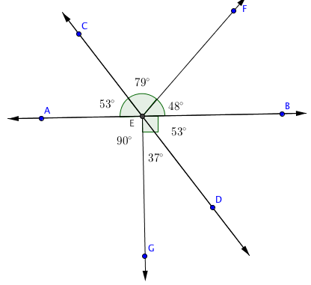Use the diagram to complete the chart.

|  |  |
| --- | --- |
| **Name the Angles that are …** | |
| Vertical |  |
| Adjacent |  |
| Angles on a line |  |
| Angles at a point |  |

**Example 1**

Estimate the measurement of . ________

In a complete sentence, describe the angle relationship in the diagram.

Write an equation for the angle relationship shown in the figure and solve for . Then find the measures of and confirm your answers by measuring the angle with a protractor.

Exercise 1

In a complete sentence, describe the angle relationship in the diagram.

Find the measurements of and .

****Example 2

In a complete sentence, describe the angle relationship in the diagram.

Write an equation for the angle relationship shown in the figure and solve for and . Find the measurements of and .

Exercise 2

In a complete sentence, describe the angle relationships in the diagram.

Write an equation for the angle relationship shown in the figure and solve for .

Example 3

****In a complete sentence, describe the angle relationships in the diagram.

Write an equation for the angle relationship shown in the figure and solve for . Find the measurement of and confirm your answers by measuring the angle with a protractor.

Exercise 3

In a complete sentence, describe the angle relationships in the diagram.

Find the measurement of .

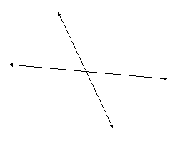**Example 4**

The following two lines intersect. The ratio of the measurements of the obtuse angle to the acute angle in any adjacent angle pair in this figure is   
. In a complete sentence, describe the angle relationships in the diagram.

Label the diagram with expressions that describe this relationship. Write an equation that models the angle relationship and solve for . Find the measurements of the acute and obtuse angles.

Exercise 4

****The ratio of to is . In a complete sentence, describe the angle relationships in the diagram.

Find the measures of and .

Relevant Vocabulary

Adjacent Angles: Two angles and with a common side are *adjacent angles* if belongs to the interior of .

Vertical Angles: Two angles are *vertical angles* (or *vertically opposite angles)* if their sides form two pairs of opposite rays.

Angles on a Line: The sum of the measures of adjacent *angles on a line* is .

Angles at a Point: The sum of the measures of adjacent *angles at a point* is .

Problem Set

For each question, use angle relationships to write an equation in order to solve for each variable. Determine the indicated angles. You can check your answers by measuring each angle with a protractor.

1. In a complete sentence, describe the relevant angle relationships in the following diagram. Find the measurement of.
2. 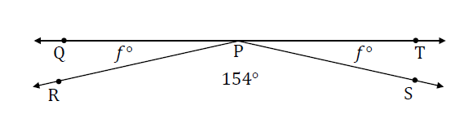In a complete sentence, describe the relevant angle relationships in the following diagram. Find the measurement of .
3. In a complete sentence, describe the relevant angle relationships in the following diagram. Find the measurements of and .
4. ****In a complete sentence, describe the relevant angle relationships in the following diagram. Find the measure of.
5. In a complete sentence, describe the relevant angle relationships in the following diagram. Find the measures of and .
6. In a complete sentence, describe the relevant angle relationships in the following diagram. Find the measures of and .
7. In a complete sentence, describe the relevant angle relationships in the following diagram. Find the measures of and .
8. In a complete sentence, describe the relevant angle relationships in the following diagram. Find the measure of .
9. The ratio of the measures of a pair of adjacent angles on a line is .
   1. Find the measures of the two angles.
   2. Draw a diagram to scale of these adjacent angles. Indicate the measurements of each angle.
10. The ratio of the measures of three adjacent angles on a line is .
    1. Find the measures of the three angles.
    2. Draw a diagram to scale of these adjacent angles. Indicate the measurements of each angle.
    3. Draw a diagram to scale of these adjacent angles. Indicate the measurements of each angle.