Lesson 3: Writing Products as Sums and Sums as Products

Classwork
Opening Exercise
Solve the problem using a tape diagram. A sum of money was shared between George and Brian in a ratio of $3:4$. If the sum of money was $\$56.00$, how much did George get?

Example 1
Represent $3+2$using a tape diagram.

Represent $x+2$ using a tape diagram.

Draw a rectangular array for $3\left(3+2\right)$.

Draw an array for $3(x+2)$.

Exercise 1
Key Terms
Distributive Property: The distributive property can be written as the identity
$a\left(b+c\right)=ab+ac$ for all numbers $a, b,$ and $c.$
Determine the area of each region using the distributive property.
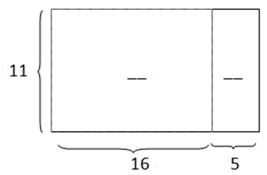

Example 2
Draw a tape diagram to represent each expression.
  - $(x+y)+(x+y)+(x+y)$

  - $(x+x+x)+(y+y+y)$

  - $3x+3y$

  - $3(x+y)$

Example 3
Find an equivalent expression by modeling with a rectangular array and applying the distributive property to the expression $5(8x+3)$.

Exercise 2
For parts (a) and (b), draw an array for each expression and apply the distributive property to expand each expression. Substitute the given numerical values to demonstrate equivalency.
  - $2(x+1)$, $x=5$

  - $10(2c+5)$, $c=1$

For parts (c) and (d), apply the distributive property. Substitute the given numerical values to demonstrate equivalency.
  - $3\left(4f-1\right)$, $f=2$

  - $9(-3r-11)$, $r=10$

Example 4
Rewrite the expression $(6x+15)÷3$ in standard form using the distributive property.

Exercise 3
Rewrite the expressions as a sum.
  - $\left(2b+12\right)÷2$

  - $(20r-8)÷4$

  - $(49g-7)÷7$

Example 5
Expand the expression $4\left(x+y+z\right).$

Exercise 4
Expand the expression from a product to a sum by removing grouping symbols using an area model and the repeated use of distributive property: $3\left(x+2y+5z\right)$.

Example 6
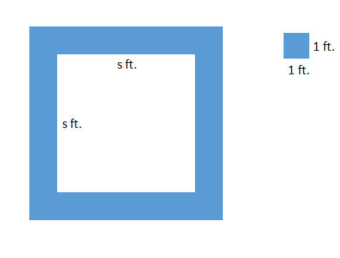
A square fountain area with side length $s$ $ft.$ is bordered by a single row of square tiles as shown. Express the total number of tiles needed in terms of $s$ three different ways.

Problem Set

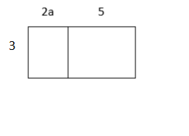
  - Write two equivalent expressions that represent the rectangular array below.
  - Verify informally that the two equations are equivalent using substitution.

- You and your friend made up a basketball shooting game. Every shot made from the free throw line is worth $3$ points, and every shot made from the half-court mark is worth $6$ points. Write an equation that represents the total amount of points, $P$, if $f$ represents the number of shots made from the free throw line, and $h$ represents the number of shots made from half-court. Explain the equation in words.

- Use a rectangular array to write the products in standard form.
  - $2\left(x+10\right)$
  - $3(4b+12c+11)$

- Use the distributive property to write the products in standard form.
- $3(2x-1)$  - $10\left(b+4c\right)$  - $9(g-5h)$  - $7(4n-5m-2)$  - $a\left(b+c+1\right)$  - $(8j-3l+9)6$ | - $\left(40s+100t\right)÷10$  - $\left(48p+24\right)÷6$  - $\left(2b+12\right)÷2$  - $(20r-8)÷4$  - $(49g-7)÷7$  - $\left(14g+ 22h\right)÷\frac{1}{2}$

- Write the expression in standard form by expanding and collecting like terms.
  - $4\left(8m-7n\right)+6\left(3n-4m\right)$
  - $9\left(r-s\right)+5(2r-2s)$
  - $12\left(1-3g\right)+8(g+f)$

