Lesson 3: Writing Products as Sums and Sums as Products

Student Outcomes
- Students use an area and rectangular array models and the distributive property to write products as sums and sums as products.
- Students use the fact that the opposite of a number is the same as multiplying by $-1$ to write the opposite of a sum in standard form.
- Students recognize that rewriting an expression in a different form can shed light on the problem and how the quantities in it are related.

Classwork
Opening Exercise (4 minutes)
Students create tape diagrams to represent the problem and solution.
Opening Exercise
Solve the problem using a tape diagram. A sum of money was shared between George and Brian in a ratio of $3∶4$. If the sum of money was $\$56.00$, how much did George get?
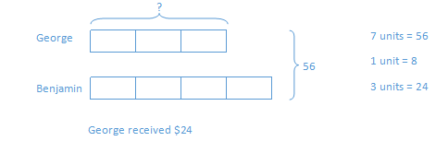
Have students label one unit as “$x$” in the diagram.
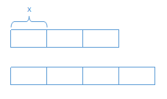
- What does the rectangle labeled $x$ represent?
  - $\$8.00$

Example 1 (3 minutes)
Example 1
Represent $3+2$using a tape diagram.
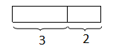
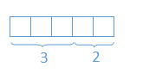
Represent it also in this fashion:

- Now, let’s represent another expression, $x+2$. Make sure the units are the same size when you are drawing the known $2$ units.
Represent $x+2$ using a tape diagram.
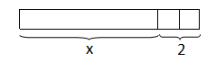

- Note the size of the units that represent $2$ in the expression $x+2$. Using the size of these units, can you predict what value $x$ represents?
  - Approximately six units.
Draw a rectangular array for $3\left(3+2\right)$.
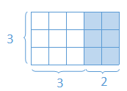

Then, have students draw a similar array for $3\left(x+2\right).$
Draw an array for $3(x+2)$.
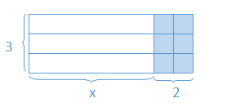

- Determine the area of the shaded region.
  - $6$
- Determine the area of the non-shaded region.
  - $3x$
Record the areas of each region:
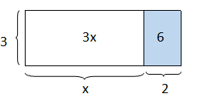
Introduce the term distributive property in the Key Terms box from the Student Materials.
Key Terms
Distributive Property: The distributive property can be written as the identity
$a\left(b+c\right)=ab+ac$ for all numbers $a, b,$ and $c.$

Exercise 1 (3 minutes)
Exercise 1
Determine the area of each region using the distributive property.
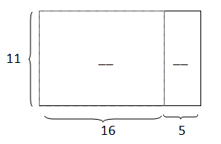

Answers: $176$, $55$

Draw in the units in the diagram for the students.
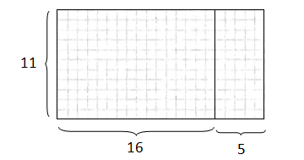
- Is it easier to just imagine the $176$ and $55$ square units?
  - Yes.
Example 2 (5 minutes)
Model the creation of the tape diagrams for the following expressions. Students will draw the tape diagrams on the student pages and use the models for discussion.
Example 2
Draw a tape diagram to represent each expression.
- $\left(x+y\right)+\left(x+y\right)+\left(x+y\right)$
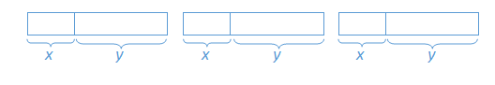
- $(x+x+x)+(y+y+y)$
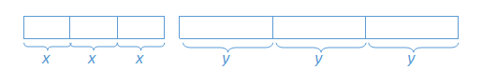
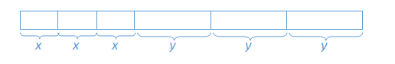
- $3x+3y$
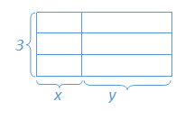
Or

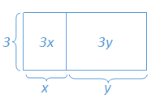
- $3(x+y)$

Ask students to explain to their neighbors why all of these expressions are equivalent.
Discuss how to rearrange the units representing $x$ and $y$ into each of the configurations above.
- What can we conclude about all of these expressions?
  - They are all equivalent.
- How does $3\left(x+y\right)=3x+3y$?
  - Three groups of $\left(x+y\right)$ is the same as multiplying $3$ with the $x$ and the $y.$
- How do you know the three representations of the expressions are equivalent?
  - The arithmetic, algebraic, and graphic representations are equivalent. Problem (c) is the standard form of problems (b) and (d). Problem (a) is the equivalent of problems (b) and (c) before the distributive property is applied. Problem (b) is the expanded form before collecting like terms.
- Under which conditions would each representation be most useful?
  - Either $3\left(x+y\right)$or$3x+3y$ because it is clear to see that there are $3$ groups of $\left(x+y\right)$, which is the product of the sum of $x$ and $y$, or that the 2nd expression is the sum of $3x$ and$3y.$
- Which model best represents the distributive property?

Summarize the distributive property.

Example 3 (5 minutes)
Example 3
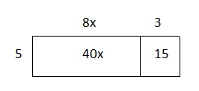
Find an equivalent expression by modeling with a rectangular array and applying the distributive property to the expression $5(8x+3)$.
Scaffolding:
For the struggling student, draw a rectangular array for $5\left(3\right).$ The number of squares in the rectangular array is the product because the factors are $5$ and $3$. Therefore,
$5\left(3\right)=15$is represented.

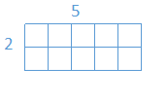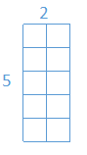

Distribute the factor to all the terms. $5 (8x+3)$
Multiply . $5\left(8x\right)+5(3)$
$$40x+15$$
Substitute given numerical values to demonstrate equivalency. Let $x=2$
$$5\left(8x+3\right)=5 \left(8\left(2\right)+3\right)=5\left(16+3\right)=5\left(19\right)=95$$ $40x+15=40\left(2\right)+15=80+15=95$
Both equal $95$, so the expressions are equal.

Exercise 2 (3 minutes)
Allow students to work on the problems independently and share aloud their equivalent expressions. Substitute numerical values to demonstrate equivalency.

Exercise 2
For parts (a) and (b), draw an array for each expression and apply the distributive property to expand each expression. Substitute the given numerical values to demonstrate equivalency.
  - $2(x+1)$, $x=5$
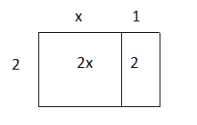

$2x+2$,$12$

  - $10(2c+5)$, $c=1$
 | $$2c$$ | $$5$$
$$10$$ | $$20c$$ | $$50$$

$20c+50$, $70$

For parts (c) and (d), apply the distributive property. Substitute the given numerical values to demonstrate equivalency.
  - $3\left(4f-1\right)$, $f=2$
$12f-3$, $21$

  - $9(-3r-11)$, $r=10$
$-27r-99$, $-369$

Example 4 (3 minutes)
Example 4
Rewrite the expression $(6x+15)÷3$ in standard form using the distributive property.
$\left(6x+15\right)×\frac{1}{3}$
$\left(6x\right)\frac{1}{3}+\left(15\right)\frac{1}{3}$
$2x+5$

- How can we rewrite the expression so that the distributive property can be used?
  - We can change from dividing by $3$ to multiplying by $\frac{1}{3}.$

Exercise 3 (3 minutes)
Exercise 3
Rewrite the expressions in standard form.
  - $\left(2b+12\right)÷2$
$$\frac{1}{2}\left(2b+12\right)$$
$$\frac{1}{2}\left(2b\right)+\frac{1}{2}(12)$$
$$b+6$$

  - $(20r-8)÷4$
$$\frac{1}{4}\left(20r-8\right)$$
$$\frac{1}{4}\left(20r\right)-\frac{1}{4}(8)$$
$$5r-2$$

  - $(49g-7)÷7$
$$\frac{1}{7}\left(49g-7\right)$$
$$\frac{1}{7}\left(49g\right)-\frac{1}{7}(7)$$
$$7g-1$$

Example 5 (3 minutes)
Model the following exercise with the use of rectangular arrays. Discuss:
- What is a verbal explanation of $4\left(x+y+z\right)?$
  - There are $4$ groups of the sum of $x, y,$ and $z.$
Example 5
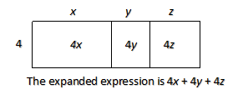
Expand the expression $4\left(x+y+z\right)$.

Exercise 4 (3 minutes)
Instruct students to complete the exercise individually.
Exercise 4
Expand the expression from a product to a sum by removing grouping symbols using an area model and the repeated use of distributive property: $3\left(x+2y+5z\right)$.
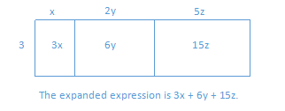
Repeated use of distributive property: Visually:
$$3\left(x+2y+5z\right)$$
$$3∙x+3∙2y+3∙5z$$
$$3x+3∙2∙y+3∙5∙z$$
$$3x+6y+15z$$

Example 6 (5 minutes)
After reading the problem aloud with the class, use different lengths to represent $s$ in order to come up with expressions with numerical values.
Example 6
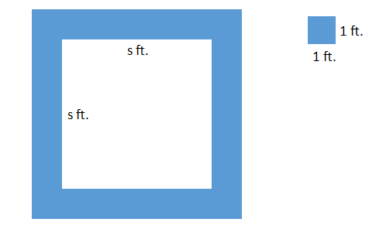
A square fountain area with side length $s ft.$ is bordered by a single row of square tiles as shown. Express the total number of tiles needed in terms of $s$ three different ways.

- What if $s=4$? How many tiles would you need to border the fountain?
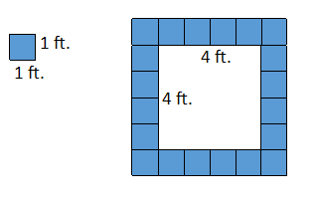
  - I would need $20$ tiles to border the fountain—four for each side and one for each corner.
- What if $s=2$? How many tiles would you need to border the fountain?
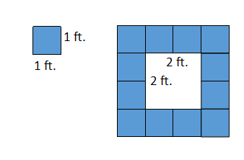
  - I would need $12$ tiles to border the fountain—two for each side and one for each corner.
- What pattern or generalization do you notice?
  - Answers may vary. Sample response: There is one tile for each corner and four times the amount of tiles to fit one side length.
After using numerical values, allow students two minutes to create as many expressions as they can think of to find the total number of tiles in the border in terms of $s$. Reconvene by asking students to share their expressions with the class from their seat.
- Which expressions would you use and why?
  - Although all the expressions are equivalent, $4\left(s+1\right)$, or $4s+4$, is useful because it is the most simplified, concise form. It is in standard form with all like terms collected.

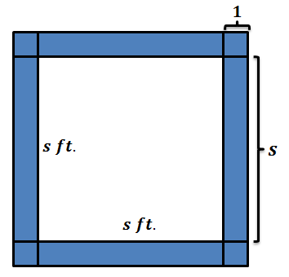
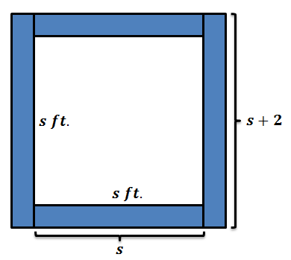
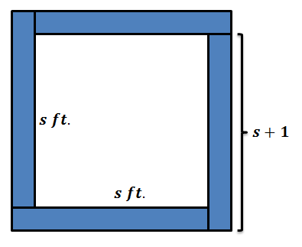
Sample Responses:
$2s+2(s+2)$

Explanation: There are $2$ opposite sides of $s$ tiles plus $2$ groups of a side of $s$ tiles plus $2$ corner tiles.
$s+s+s+s+4$.

Explanation: There are $4$ sides of $s$ tiles and $4$ extra tiles for the corners.
$4(s+1)$

Explanation: There are four groups of $s$ tiles plus $1$ corner tile.

Closing (3 minutes)
- What are some of the methods used to write products as sums?
  - We used the distributive property and rectangular arrays.
- In terms of a rectangular array and equivalent expressions, what does the product form represent, and what does the sum form represent?
  - The total area represents the expression written in sum form, and the length and width represent the expressions written in product form.

Exit Ticket (3 minutes)
Name ___________________________________________________ Date____________________
Lesson 3: Writing Products as Sums and Sums as Products

Exit Ticket

A square fountain area with side length $s ft.$ is bordered by two rows of square tiles along its perimeter as shown. Express the total number of grey tiles (only in the second rows) needed in terms of $s$ three different ways.
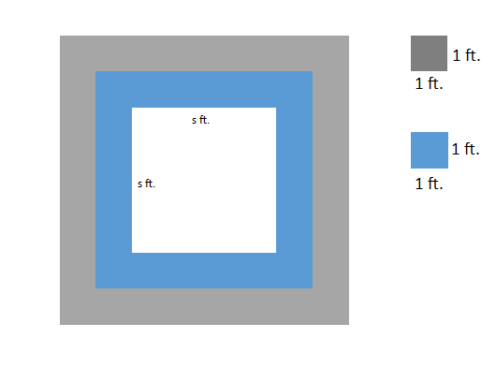

Exit Ticket Sample Solutions

A square fountain area with side length $s ft.$ is bordered by two rows of square tiles along its perimeter as shown. Express the total number of grey tiles (the second border of tiles) needed in terms of $s$ three different ways.
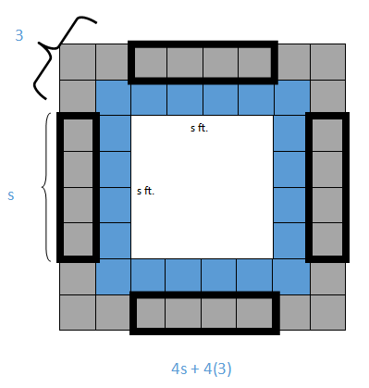
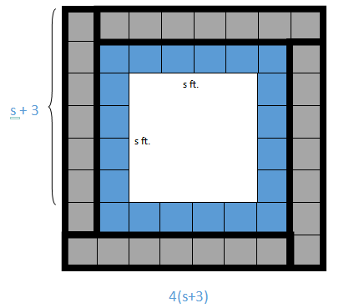
or $s+s+s+s+12$
Problem Set Sample Solutions

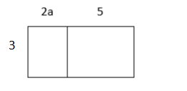
  - Write two equivalent expressions that represent the rectangular array below.
$$3\left(2a+5\right)=6a+15$$

  - Verify informally that the two equations are equivalent using substitution.
Let $a=4$.
$$3\left(2a+5\right)$$  $$3\left(2\left(4\right)+5\right)$$  $$3\left(8+5\right)$$  $$3\left(13\right)=39$$ | $$6a+15$$  $$6\left(4\right)+15$$  $$24+15$$  $$39$$

- You and your friend made up a basketball shooting game. Every shot made from the free throw line is worth $3$ points, and every shot made from the half-court mark is worth $6$ points. Write an equation that represents the total amount of points, $P$, if $f$ represents the number of shots made from the free throw line, and $h$ represents the number of shots made from half-court. Explain the equation in words.
$P=3f+6h$ or $P=3(f+2h)$
The total number of points can be determined by multiplying each free throw shot by $3$ and then adding that to the product of each half-court shot multiplied by $6$.
The total number of points can also be determined by adding the number of free throw shots to twice the number of half-court shots and then multiplying the sum by three.

- Use a rectangular array to write the products in standard form.
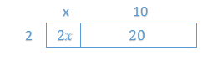
  - $2\left(x+10\right)$
$$2x+20$$

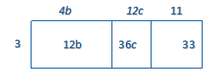
  - $3(4b+12c+11)$
$$12b+36c+33$$
- Use the distributive property to write the products in standard form.
- $3(2x-1)$  $$6x-3$$  - $10\left(b+4c\right)$  $$10b+40c$$  - $9(g-5h$)  $$9g-45h$$  - $7(4n-5m-2)$  $$28n-35m-14$$  - $a\left(b+c+1\right)$  $$ab+ac+a$$  - $(8j-3l+9)6$  $$48j-18l+54$$ | - $\left(40s+100t\right)÷10$  $$4s+10t$$  - $\left(48p+24\right)÷6$  $$8p+4$$  - $\left(2b+12\right)÷2$  $$b+6$$  - $(20r-8)÷4$  $$5r-2$$  - $(49g-7)÷7$  $$7g-1$$  - $(14g+ 22h)÷\frac{1}{2}$  $$28g+44h$$

- Write the expression in standard form by expanding and collecting like terms.
  - $4\left(8m-7n\right)+6\left(3n-4m\right)$
$$8m-10n$$

  - $9\left(r-s\right)+5(2r-2s)$
$$19r-19s$$

  - $12\left(1-3g\right)+8(g+f)$
$$-28g+8f+12$$

