Lesson 20: Investments—Performing Operations with Rational Numbers

Classwork
Mathematical Modeling Exercise: College Investments
Justin and Adrienne deposited $\$20,000$into an investment account for $5$ years. They hoped the money invested and the money made on their investment would amount to at least $\$30,000$to help pay for their daughter’s college tuition and expenses. The account they chose has several benefits and fees associated with it. Every $6$ months, a summary statement is sent to Justin and Adrienne. The statement includes the amount of money either gained or lost. Below are semi-annual (twice a year) statements for a period of $5$ years. In addition to the statements, the following information is needed to complete the task:
- Every statement, there is an administrative fee of $\$15$ to cover costs such as secretarial work, office supplies, postage, etc.
- If there is a withdrawal made, a broker’s fee is deducted from the account. The amount of the broker’s fee is $2\%$ of the transaction amount.

TASK: Using the above information, semi-annual statements, register, and beginning balance, do the following:
- Record the beginning balance and all transactions from the account statements into the register.
- Determine the annual gain or loss as well as the overall $5$-year gain/loss.
- Determine if there is enough money in the account after $5$ years to cover $\$30,000$of college expenses for Justin and Adrienne’s daughter. Write a summary to defend your answer. Be sure to indicate how much money is in excess, or the shortage that exists.
- Answer the related questions that follow.

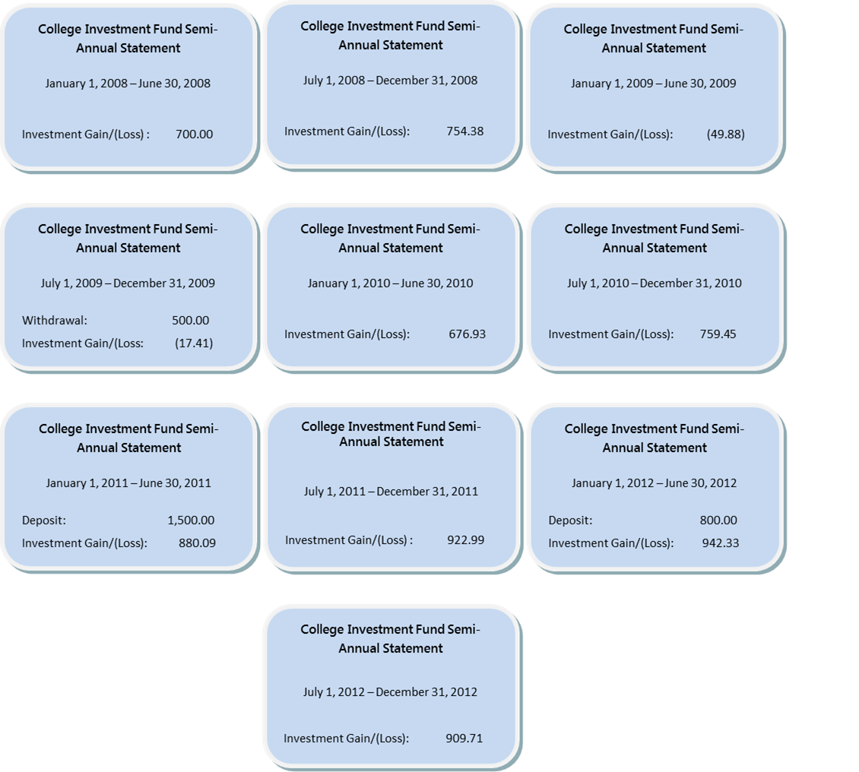

- Register
DATE | DESCRIPTION OF TRANSACTION | WITHDRAWAL | DEPOSIT | BALANCE | EXPRESSION
 | Beginning Balance | --- | --- | $$\$20,000.00$$ | $$\$20,000.00$$
Jan. – June: $2008$
July – Dec.: $2008$
Jan. – June: $2009$
July – Dec.: $2009$
`
Jan. – June: $2010$
July – Dec.: $2010$
Jan. – June: $2011$
July – Dec.: $2011$
Jan. – June: $2012$
July – Dec.: $2012$
- Annual Gain/Loss Summary
Year | Total Gain/(Loss) | Numerical Expression
$$2008$$
$$2009$$
$$2010$$
$$2011$$
$$2012$$
$5$-Year Gain/Loss

- Summary

- Related Questions
  - For the first half of $2009$, there was a $\$700$ gain on the initial investment of $\$20,000$. Represent the gain as a percentage of the initial investment.

  - Based on the gains and losses on their investment during this $5$-year period, over what period of time was their investment not doing well? How do you know? What factors might contribute to this?

  - In math class, Jaheim and Frank were working on finding the total amount of the investment after $5$years. As a final step, Jaheim subtracted $\$150$ for administrative fees from the balance he arrived at after adding in all the deposits and subtracting out the one withdrawal and Broker’s fee. For every semi-annual statement, Frank subtracted $\$15$ from the account balance for the administrative fee. Both boys arrived at the same ending five-year balance. How is this possible? Explain.

  - Based on the past statements for their investment account, predict what activity you might expect to see on Adrienne and Justin’s January–June $2013$ account statement. Then record it in the register to arrive at the balance as of June $30$, $2013$.

  - Using the answer from part (d), if their daughter’s college bill is due in September of $2013$, how much money do you estimate will be in their investment account at the end of August $2013$ before the college bill is paid? Support your answer.

Exercise
Below is a transaction log of a business entertainment account. The transactions are completed and the ending balance in the account is $\$525.55$. Determine the beginning balance.

DATE | DESCRIPTION OF TRANSACTION | PAYMENT | DEPOSIT | BALANCE
 | Beginning Balance | --- | ---
$$12/1/10$$ | Bargain Electronic (I-Pod) | $$199.99$$
$$12/5/10$$ | Lenny’s Drive-Up (Gift Certificate) | $$75.00$$
$$12/7/10$$ | Check from Customer: Reynolds |  | $$200.00$$
$$12/15/10$$ | Pasta House (Dinner) | $$285.00$$
$$12/20/10$$ | Refund from Clear’s Play House |  | $$150.00$$
$$12/22/10$$ | Gaffney’s Tree Nursery | $$65.48$$ |  | $$525.55$$

Lesson Summary
- Calculations with rational numbers are used when recording investment transactions.
- Deposits are added to an account balance; money is deposited into the account.
- Gains are added to an account balance; they are positive returns on the investment.
- Withdrawals are subtracted from an account balance; money is taken out of the account.
- Losses are subtracted from an account balance; they are negative returns on the investment.
- Fees are subtracted from an account balance; the bank or financial company is charging you for a service.

Problem Set

- You are planning a fundraiser for your student council. The fundraiser is a Glow in the Dark Dance. Solve each entry below and complete the transaction log to determine the ending balance in the student account.
  - The cost of admission to the dance is $\$7$ per person. Write an expression to represent the total amount of money collected for admission. Evaluate the expression if $250$ people attended the dance.
  - The following expenses were necessary for the dance, and checks were written to each company.
- DJ for the dance – “Music Madness DJ” costs $\$200$
- Glow Sticks for “Glow World Inc.” for the first $100$ entrants. Cost of glow sticks were $\$0.75$ each plus $8\%$ sales tax.
Complete the transaction log below based on this information
DATE | DESCRIPTION OF TRANSACTION | PAYMENT | DEPOSIT | BALANCE
 | Beginning Balance | --- | --- | $$1,243.56$$

  - Write a numerical expression to determine the cost of the glow sticks.

Analyze the results.
  - Write an algebraic expression to represent the profit earned from the fundraiser. (Profit is the amount of money collected in admissions minus all expenses.)
  - Evaluate the expression to determine the profit if $250$ people attended the dance. Use the variable $p$ to represent the number of people attending the dance (from part (a)).
  - Using the transaction log above, what was the amount of the profit earned?

- The register below shows a series of transactions made to an investment account. Vinnie and Anthony both completed the register in hopes of finding the beginning balance. As you can see, they do not get the same answer. Who was correct? What mistake did the other person make? What was the monthly gain or loss?

Original Register
DATE | DESCRIPTION OF TRANSACTION | PAYMENT | DEPOSIT | BALANCE
 | Beginning Balance | --- | ---
$$3/1/11$$ | Broker’s Fee | $$250.00$$
$$3/10/11$$ | Loan Withdrawal | $$895.22$$
$$3/15/11$$ | Refund – Misc. Fee |  | $$50.00$$
$$3/31/11$$ | Investment Results |  | $$2,012.22$$ | $$18,917.00$$

Vinnie’s Work
DATE | DESCRIPTION OF TRANSACTION | PAYMENT | DEPOSIT | BALANCE
 | Beginning Balance | --- | --- | $$18,000.00$$
$$3/1/11$$ | Broker’s Fee | $$250.00$$ |  | $$17,750.00$$
$$3/10/11$$ | Loan Withdrawal | $$895.22$$ |  | $$16,854.78$$
$$3/15/11$$ | Refund – Misc. Fee |  | $$50.00$$ | $$16,904.78$$
$$3/31/11$$ | Investment Results |  | $$2,012.22$$ | $$18,917.00$$

Anthony’s Work
DATE | DESCRIPTION OF TRANSACTION | PAYMENT | DEPOSIT | BALANCE
 | Beginning Balance | --- | --- | $$19,834.00$$
$$3/1/11$$ | Broker’s Fee | $$250.00$$ |  | $$20,084.00$$
$$3/10/11$$ | Loan Withdrawal | $$895.22$$ |  | $$20,979.22$$
$$3/15/11$$ | Refund – Misc. Fee |  | $$50.00$$ | $$20,929.22$$
$$3/31/11$$ | Investment Results |  | $$2,012.22$$ | $$18,917.00$$

