|  |
| --- |
|  |

Lesson 20: Investments—Performing Operations with Rational Numbers

**Student Outcomes**

* Students perform various calculations involving rational numbers to solve a problem related to the change in an investment’s balance over time.
* Students recognize and use mathematics as a tool to solve real-life problems.

Classwork

**Mathematical Modeling Exercise (25 minutes): College Investments**

Students are given records for an investment fund over the past years. The records include beginning balance, semi-annual statements, and additional fees. Students have a -part task:

1. Determine the balance at the end of years.
2. Determine the annual gain or loss and the overall -year gain or loss.
3. Analyze the result and write a comparative conclusion, defending or refuting their conclusion.
4. Answer questions related to the investment data.

Familiarize students with the format of the register. Discuss how to complete the register by completing the first six months as a class together. Then have students individually complete the rest of the register for the remaining time.

Suggestion: Allow students to use calculators to assist in the arithmetic.

Mathematical Modeling Exercise: College Investments

Justin and Adrienne deposited into an investment account for years. They hoped the money invested and the money made on their investment would amount to at least to help pay for their daughter’s college tuition and expenses. The account they chose has several benefits and fees associated with it. Every months, a summary statement is sent to Justin and Adrienne. The statement includes the amount of money either gained or lost. Below are semi-annual (twice a year) statements for a period of years. In addition to the statements, the following information is needed to complete the task:

* Every statement, there is an administrative fee of to cover costs such as secretarial work, office supplies, postage, etc.
* If there is a withdrawal made, a broker’s fee is deducted from the account. The amount of the broker’s fee is of the transaction amount.

TASK: Using the above information, semi-annual statements, register, and beginning balance, do the following:

1. Record the beginning balance and all transactions from the account statements into the register.
2. Determine the annual gain or loss as well as the overall -year gain/loss.
3. Determine if there is enough money in the account after years to cover of college expenses for Justin and Adrienne’s daughter. Write a summary to defend your answer. Be sure to indicate how much money is in excess, or the shortage that exists.
4. Answer the related questions that follow.

(Note: This activity may be adapted for use with spreadsheet software.)

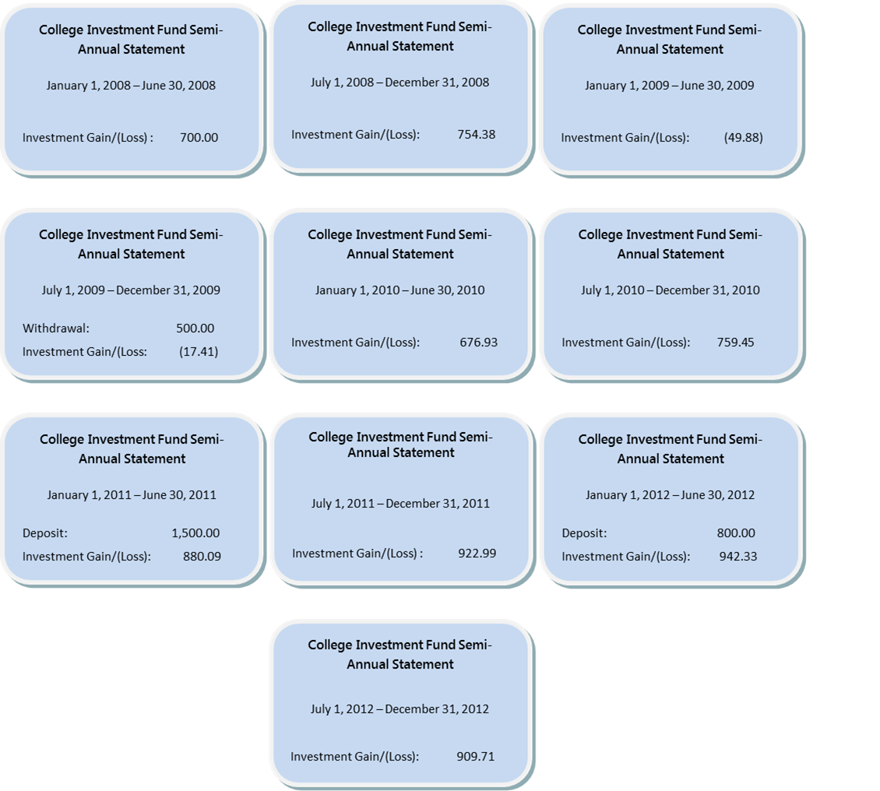

1. Register

|  |  |  |  |  |  |
| --- | --- | --- | --- | --- | --- |
| **DATE** | **DESCRIPTION OF TRANSACTION** | **WITHDRAWAL** | **DEPOSIT** | **BALANCE** | **EXPRESSION** |
|  | Beginning Balance | --- | --- |  |  |
| **Jan. – June:** | ***Gain on investment*** |  |  |  |  |
|  | ***Administrative fee*** |  |  |  |  |
| **July – Dec.:** | ***Gain on investment*** |  |  |  |  |
|  | ***Administrative fee*** |  |  |  |  |
| **Jan. – June:** | ***Loss on investment*** |  |  |  |  |
|  | ***Administrative fee*** |  |  |  |  |
| **July – Dec.:** | ***Withdrawal*** |  |  |  |  |
|  | ***Broker fee*** |  |  |  |  |
|  | ***Loss on investment*** |  |  |  |  |
| **`** | ***Administrative fee*** |  |  |  |  |
| **Jan. – June:** | ***Gain on investment*** |  |  |  |  |
|  | ***Administrative fee*** |  |  |  |  |
| **July – Dec.:** | ***Gain on investment*** |  |  |  |  |
|  | ***Administrative fee*** |  |  |  |  |
| **Jan. – June:** | ***Deposit*** |  |  |  |  |
|  | ***Gain on investment*** |  |  |  |  |
|  | ***Administrative fee*** |  |  |  |  |
| **July – Dec.:** | ***Gain on investment*** |  |  |  |  |
|  | ***Administrative fee*** |  |  |  |  |
| **Jan. – June:** | ***Deposit*** |  |  |  |  |
|  | ***Gain on investment*** |  |  |  |  |
|  | ***Administrative fee*** |  |  |  |  |
| **July – Dec.:** | ***Gain on investment*** |  |  |  |  |
|  | ***Administrative fee*** |  |  |  |  |
| ***Prediction:*** |  |  |  |  |  |
| ***Jan. – June:*** | ***Gain on investment*** |  |  |  |  |
|  | ***Administrative fee*** |  |  |  |  |
|  |  |  |  |  |  |

* Describe the process of completing the register.
  + *Starting with the beginning balance, fill in the description of the transaction and the amount. If the transaction is an investment loss, withdrawal, or fee, then the amount is recorded in the payment column. If the transaction is an investment gain or deposit then the amount is recorded in the deposit column. To obtain the new balance, subtract the payment amount or add the deposit amount from the balance on the preceding line. Record the new balance and use that balance to complete the next line.*

*Scaffolding:*

Discuss what a register is and how it is used to organize a series of transactions. Also, discuss how a loss can be represented by using parenthesis (e.g., ()).

* Describe how to find the broker’s fee.
  + *The broker’s fee is of the transaction amount. To find the broker’s fee, you must first find the total of the transaction amount. Once you have that, write the percent as a fraction out of and multiply the fraction by the transaction amount. This result is the amount of the broker’s fee, which is then subtracted from the preceding balance.*

*Example: of*

* Compare your register with the person next to you. Did each of you list the transactions in the same order? Does it make a difference?
  + *The order is probably not the same. The order of the transactions for each-month period does not make a difference.*
* Continue to compare your registers. Do you both get the same balance at the end of ? If not, switch papers and check to see if you can find your neighbor’s mistake.

1. Annual Gain/Loss Summary

|  |  |  |
| --- | --- | --- |
| **Year** | **Total Gain/(Loss)** | **Numerical Expression** |
|  |  |  |
|  |  |  |
|  |  |  |
|  |  |  |
|  |  |  |
|  |  |  |
| -Year Gain/Loss |  |  |

* How do you find the annual gain or loss for each year?
  + *Subtract the ending balance from the beginning balance. If the beginning balance is smaller than the ending balance, then the difference is a gain. If the beginning balance is larger than the ending balance, then the difference is a loss and written within ( ).*
* In what year was the greatest gain? In what year was the greatest loss?
  + *The greatest gain was in . The greatest loss was in , because of the withdrawal ofand the losses on the investment.*
* How does knowing the overall gain or loss assist in writing the comparative conclusion?
  + *Once you know the gain or loss, you can find the ending balance. Since the ending balance was not at least , there was not enough money to cover the college expenses.*
* Using the -year total gain or loss figures, write an expression using positive and negative rational numbers that can be solved to find the total gain or loss.

1. Summary

*Scaffolding:*

* Review or reiterate that the operation associated with payments is subtraction, and the operation associated with deposits is addition.

There is not enough money in the account at the end of years to cover the college expenses, but it is close. They needed at least in the account to cover the expenses, and there was leaving a shortage of .

1. Related Questions
   1. For the first half of , there was a gain on the initial investment of . Represent the gain as a percentage of the initial investment.

The gain was of .

* 1. Based on the gains and losses on their investment during this -year period, over what period of time was their investment not doing well? How do you know? What factors might contribute to this?

The investment was not doing well in . There were losses on the investment for both halves of the year, and was taken out of the account. It could be because the economy was doing badly, and a recession affected the investment’s performance.

* 1. In math class, Jaheim and Frank were working on finding the total amount of the investment after years. As a final step, Jaheim subtracted for administrative fees from the balance he arrived at after adding in all the deposits and subtracting out the one withdrawal and Broker’s fee. For every semi-annual statement, Frank subtracted from the account balance for the administrative fee. Both boys arrived at the same ending 5-year balance. How is this possible? Explain.

Jaheim took the fee and multiplied it by , since there were statements, and deducted the total. Frank subtracted from the account balance for each statement. That was times. So, both ways produce the same result: reducing the account balance by , overall.

* 1. Based on the past statements for their investment account, predict what activity you might expect to see on Adrienne and Justin’s January–June account statement. Then record it in the register to arrive at the balance as of June , .

I predict the account will continue to produce gains. The gains have been around for the past fourstatements, so I predict it will be about again, since it decreased by a little bit the last time, and there was again the last time. If I take away for the administrative fee, the balance would go up by and it would be .

* 1. Using the answer from part (d), if their daughter’s college bill is due in September of , how much money do you estimate will be in their investment account at the end of August before the college bill is paid? Support your answer.

Their investment could gain more money for July and August. Right now, it is gaining about per statement. If I divide that by , it equals (which is the average gain per month). So, for July and August I estimate that it will earn about another (including the fee), so there might be in the account.

Exercise (10 minutes)

Students are given a transaction log of a business entertainment account. The transactions are completed for the students and the ending balance is given as well. Students are required to work “backwards” to find the beginning balance.

MP.2

Exercise

Below is a transaction log of a business entertainment account. The transactions are completed and the ending balance in the account is . Determine the beginning balance.

|  |  |  |  |  |
| --- | --- | --- | --- | --- |
| **DATE** | **DESCRIPTION OF TRANSACTION** | **PAYMENT** | **DEPOSIT** | **BALANCE** |
|  | Beginning Balance | --- | --- |  |
|  | Bargain Electronic (I-Pod) |  |  |  |
|  | Lenny’s Drive-Up (Gift Certificate) |  |  |  |
|  | Check from Customer: Reynolds |  |  |  |
|  | Pasta House (Dinner) |  |  |  |
|  | Refund from Clear’s Play House |  |  |  |
|  | Gaffney’s Tree Nursery |  |  |  |

* When the beginning balance was given, the transactions were subtracted from the balance if a payment was made and the deposits were added to the balance if a deposit was made. How does that process change when the ending balance is given and the challenge is to find the beginning balance?
  + *If the ending balance is given and a payment was made then you need to add the payment to the ending balance to get the beginning balance. Likewise, if the ending balance is given and a deposit was made, then you need to subtract the payment from the ending balance to get the beginning balance.*
* Model the process described in the previous question by writing and solving an equation for the deposit made from the refund from Clear’s Play House. Assume the preceding balance was .
* *Refund from Clear’s Play House:*

* What happens if the deposit amount is greater than the ending balance? How can this be written?
  + *If the deposit is greater than the ending balance then the beginning balance would be less than and written as a negative number. This negative number indicates owing money.*

Closing (5 minutes)

Answer any remaining questions.

* What role do rational numbers play in solving real-world problems?
  + *Answers will vary, but students will most likely talk about recording investments and transactions.*

Lesson Summary

* **Calculations with rational numbers are used when recording investment transactions.**
* **Deposits are added to an account balance; money is deposited into the account.**
* **Gains are added to an account balance; they are positive returns on the investment.**
* **Withdrawals are subtracted from an account balance; money is taken out of the account.**
* **Losses are subtracted from an account balance; they are negative returns on the investment.**
* **Fees are subtracted from an account balance; the bank or financial company is charging you for a service.**

Exit Ticket (5 minutes)

Name ___________________________________________________ Date____________________

Lesson 20: Investments—Performing Operations with Rational Numbers

Exit Ticket

1. Using the incomplete register below, work forward and backward to determine the beginning and ending balances after the series of transactions listed.

|  |  |  |  |  |
| --- | --- | --- | --- | --- |
| DATE | DESCRIPTION OF TRANSACTION | PAYMENT | DEPOSIT | BALANCE |
|  | Beginning Balance | --- | --- |  |
|  | Paycheck |  |  |  |
|  | Gillian’s Chocolate Factory (Candy) |  |  |  |
|  | Main Street Jeweler’s |  |  |  |
|  | Saratoga Steakhouse |  |  |  |

1. Write an expression to represent the balance after the paycheck was deposited on. Let represent the beginning balance.
2. Write a numerical expression to represent the balance after the transaction for Main Street Jeweler’s was made.

Exit Ticket Sample Solutions

1. Using the incomplete register below, work forwards and backwards to determine the beginning and ending balances after the series of transactions listed.

|  |  |  |  |  |
| --- | --- | --- | --- | --- |
| DATE | DESCRIPTION OF TRANSACTION | PAYMENT | DEPOSIT | BALANCE |
|  | Beginning Balance | --- | --- |  |
|  | Paycheck |  |  |  |
|  | Gillian’s Chocolate Factory (Candy) |  |  |  |
|  | Main Street Jeweler’s |  |  |  |
|  | Saratoga Steakhouse |  |  |  |

1. Write an expression to represent the balance after the paycheck was deposited on . Let represent the beginning balance.
2. Write a numerical expression to represent the balance after the transaction for Main Street Jeweler’s was made.

Problem Set Sample Solutions

1. You are planning a fundraiser for your student council. The fundraiser is a Glow in the Dark Dance. Solve each entry below and complete the transaction log to determine the ending balance in the student account.
   1. The cost of admission to the dance is per person. Write an expression to represent the total amount of money collected for admission. Evaluate the expression if people attended the dance.

= number of people attending dance

* 1. The following expenses were necessary for the dance, and checks were written to each company.
* DJ for the dance – “Music Madness DJ” costs
* Glow Sticks for “Glow World Inc.” for the first entrants. Cost of glow sticks were each plus sales tax.

Complete the transaction log below based on this information

|  |  |  |  |  |
| --- | --- | --- | --- | --- |
| DATE | DESCRIPTION OF TRANSACTION | PAYMENT | DEPOSIT | BALANCE |
|  | Beginning Balance | --- | --- |  |
|  | Dance Admission |  |  |  |
|  | DJ Music Madness |  |  |  |
|  | Glow Sticks from Glow World |  |  |  |

* 1. Write a numerical expression to determine the cost of the glow sticks.

*cost each*

Analyze the results

* 1. Write an algebraic expression to represent the profit earned from the fundraiser. (Profit is the amount of money collected in admissions minus all expenses.)

or

* 1. Evaluate the expression to determine the profit if people attended the dance. Use the variable to represent the number of people attending the dance (from part (a)).

The profit is .

* 1. Using the transaction log above, what was the amount of the profit earned?

The profit is.

1. The register below shows a series of transactions made to an investment account. Vinnie and Anthony both completed the register in hopes of finding the beginning balance. As you can see, they do not get the same answer. Who was correct? What mistake did the other person make? What was the monthly gain or loss?

Original Register

|  |  |  |  |  |
| --- | --- | --- | --- | --- |
| DATE | DESCRIPTION OF TRANSACTION | PAYMENT | DEPOSIT | BALANCE |
|  | Beginning Balance | --- | --- |  |
|  | Broker’s Fee |  |  |  |
|  | Loan Withdrawal |  |  |  |
|  | Refund – Misc. Fee |  |  |  |
|  | Investment Results |  |  |  |

Vinnie’s Work

|  |  |  |  |  |
| --- | --- | --- | --- | --- |
| DATE | DESCRIPTION OF TRANSACTION | PAYMENT | DEPOSIT | BALANCE |
|  | Beginning Balance | --- | --- |  |
|  | Broker’s Fee |  |  |  |
|  | Loan Withdrawal |  |  |  |
|  | Refund – Misc. Fee |  |  |  |
|  | Investment Results |  |  |  |

Anthony’s Work

|  |  |  |  |  |
| --- | --- | --- | --- | --- |
| DATE | DESCRIPTION OF TRANSACTION | PAYMENT | DEPOSIT | BALANCE |
|  | Beginning Balance | --- | --- |  |
|  | Broker’s Fee |  |  |  |
|  | Loan Withdrawal |  |  |  |
|  | Refund – Misc. Fee |  |  |  |
|  | Investment Results |  |  |  |

The correct register is Vinnie’s.

Anthony made the mistake of using the operations for moving forward. He added the deposits and subtracted the payments, but since he was working backward in the problem, he needed to do just the opposite.

The monthly gain was . This was a gain because the ending balance was greater than the beginning balance, and the amount of the gain was calculated by .