Lesson 19: Writing, Evaluating, and Finding Equivalent Expressions with Rational Numbers

Classwork
Example 1: Tic-Tac-Toe Review
Fill in the $9$ spaces with one expression from the list below. Use one expression per space. You will use $9$ of the expressions:
$$12-4x$$
$$8x+4-12x$$
$$8\left(\frac{1}{2}x-2\right)$$
$$12-6x+2x$$
$$-4x+4$$
$$x-2+2x-4$$
$$4x-12$$
$$4(x-4)$$
$$3(x-2)$$
$$0.1\left(40x\right)-\frac{1}{2}(24)$$

Example 2
Original Price $(100\%)$ | Discount Amount  $(20\%)$ Off | New Price (Pay $80\%$) | Expression
$$100$$
$$50$$
$$28$$
$$14.50$$
$$x$$

Example 3
An item that has an original price of $x$ dollars is discounted $33\%$.
- Write an expression that represents the amount of the discount.

- Write two equivalent expressions that represent the new, discounted price.

- Use one of your expressions to calculate the new, discounted price if the original price was $\$56$.

- How would the expressions you created in parts (a) and (b) have to change if the item’s price had increased by $33\%$ instead of decreased by $33\%$?

Example 4

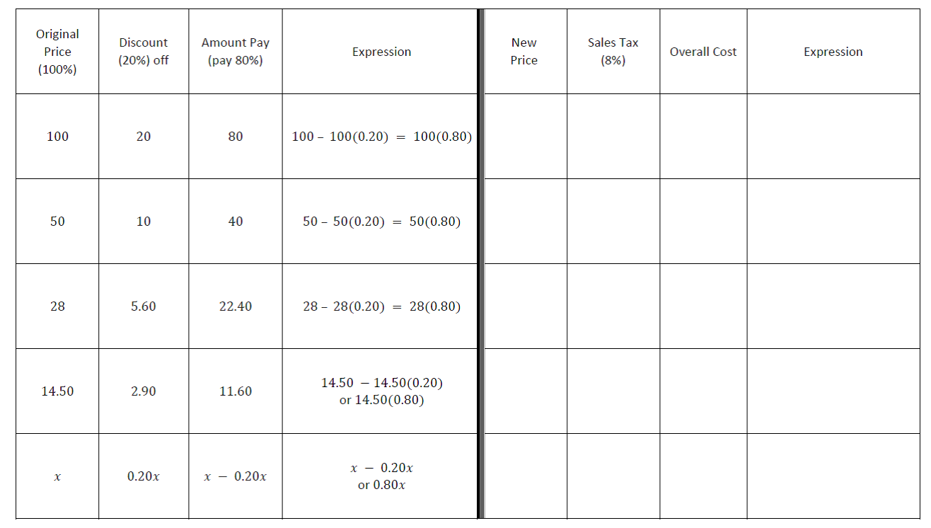
Lesson Summary
- Two expressions are equivalent if they yield the same number for every substitution of numbers for the letters in each expression.
- The expression that allows us to find the cost of an item after the discount has been taken and the sales tax has been added is written by representing the discount price added to the discount price multiplied by the sales tax rate.

Problem Set

Solve the following problems. If necessary, round to the nearest penny.
- A family of $12$ went to the local Italian restaurant for dinner. Every family member ordered a drink and meal, $3$ ordered an appetizer, and $6$ people ordered cake for dessert.
  - Write an expression that can be used to figure out the cost of the bill. Include the definitions for the variables the server used.
  - The waitress wrote on her ordering pad the following expression: $3(4d+4m+a+2c)$.
Was she correct? Explain why or why not.
  - What is the cost of the bill if a drink costs $\$3$, a meal costs $\$20$, an appetizer costs $\$5.50$, and a slice of cake costs $\$3.75$?
  - Suppose the family had a $10\%$ discount coupon for the entire check and then left an $18\%$ tip. What is the total?

- Sally designs web pages for customers. She charges $\$135.50$ per web page; however, she must pay a monthly rental fee of $\$650$ for her office. Write an expression to determine her take-home pay after expenses. If Sally designed $5$web pages last month, what was her take-home pay after expenses?

- While shopping, Megan and her friend Rylie find a pair of boots on sale for $25\%$ off of the original price. Megan calculates the final cost of the boots by first deducting the $25\%$, and then adding the $6\%$sales tax. Rylie thinks Megan will pay less if she pays the $6\%$ sales tax first and then takes the $25\%$ discount.
  - Write an expression to represent each girl’s scenario if the original price of the boots was $x$ dollars.
  - Evaluate each expression if the boots originally cost $\$200$.
  - Who was right? Explain how you know.
  - Explain how both girls’ expressions are equivalent.

