Lesson 14: Converting Rational Numbers to Decimals Using Long Division

Student Outcomes
- Students understand that every rational number can be converted to a decimal.
- Students represent fractions as decimal numbers that either terminate in zeros or repeat. Students then also represent repeating decimals using a bar over the shortest sequence of repeating digits.
- Students interpret word problems and convert between fraction and decimal forms of rational numbers.

Lesson Notes
Each student will need a calculator to complete this lesson.

Classwork
Example 1 (6 minutes): Can All Rational Numbers Be Written as Decimals?
- Can we find the decimal form of $\frac{1}{6}$ by writing it as an equivalent fraction with only factors of $2$ or $5$ in the denominator?
- $\frac{1}{6}=\frac{1}{2 × 3}$ . There are no factors of $3$ in the numerator, so the factor of $3$ has to remain in the denominator. This means we cannot write the denominator as a product of only $2$’s and $5$’s; therefore, the denominator cannot be a power of ten. The equivalent fraction method will not help us write $\frac{1}{6}$ as a decimal.
- Is there another way to convert fractions to decimals?
  - A fraction is interpreted as its numerator divided by its denominator. Since $\frac{1}{6}$ is a fraction, we can divide the numerator $1$ by the denominator $6$.
- Use the division button on your calculator to divide $1$ by $6$.
- What do you notice about the quotient?
- It does not terminate and almost all of the decimal places have the same number in them.

Example 1: Can All Rational Numbers Be Written as Decimals?
  - Using the division button on your calculator, explore various quotients of integers $1$ through $11$. Record your fraction representations and their corresponding decimal representations in the space below.
Fractions will vary. Examples:
$$\frac{1}{2}=0.5$$ | $$\frac{1}{3}=0.3333333…$$ | $$\frac{1}{4}=0.25$$ | $$\frac{1}{5}=0.2$$ | $$\frac{1}{6}=0.1666666…$$
$$\frac{1}{7}=0.1428571428…$$ | $$\frac{1}{8}=0.125$$ | $$\frac{1}{9}=0.111111111$$ | $$\frac{1}{10}=0.1$$ | $$\frac{1}{11}=0.0909090909…$$

  - What two types of decimals do you see?
Some of the decimals stop and some fill up the calculator screen (or keep going).

- Define terminating and non-terminating.
  - Terminating decimals are numbers where the digits after the decimal point come to an end, they have a finite number of digits.
  - Non-terminating decimals are numbers where the digits after the decimal point do not end.
- Did you find any quotients of integers that do not have decimal representations?
  - No. Dividing by zero is not allowed. All quotients have decimal representations but some do not terminate (end).
- All rational numbers can be represented in the form of a decimal. We have seen already that fractions with powers of ten in their denominators (and their equivalent fractions) can be represented as terminating decimals. Therefore, other fractions must be represented by decimals that do not terminate.

Example 2 (4 minutes): Decimal Representations of Rational Numbers
Example 2: Decimal Representations of Rational Numbers
In the chart below, organize the fractions and their corresponding decimal representation listed in Example 1 according to their type of decimal.
Terminating | Non-terminating
$$\frac{1}{2}=0.5$$ | $$\frac{1}{3}=0.3333333…$$
$$\frac{1}{4}=0.25$$ | $$\frac{1}{6}=0.1666666…$$
$$\frac{1}{5}=0.2$$ | $$\frac{1}{7}=0.14285741258714…$$
$$\frac{1}{8}=0.125$$ | $$\frac{1}{9}=0.1111111…$$
$$\frac{1}{10}=0.1$$ | $$\frac{1}{11}=0.0909090909…$$
What do these fractions have in common? | What do these fractions have in common?
Each denominator is a product of only the factors $2$ and/or $5$. | Each denominator contains at least one factor other than a $2$ or a $5$.
Example 3 (3 minutes): Converting Rational Numbers to Decimals Using Long Division
(Part 1: Terminating Decimals)
Scaffolding for ELL Learners:
- Review vocabulary of long division, i.e., algorithm, dividend, divisor, remainder.

Example 3: Converting Rational Numbers to Decimals Using Long Division
Use the long division algorithm to find the decimal value of $-\frac{3}{4}$ .
The fraction is a negative value so its decimal representation will be as well.
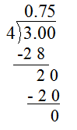

$$-\frac{3}{4}=-0.75$$

We know that $-\left(\frac{3}{4}\right)=-\frac{3}{4}=\frac{3}{-4}$, so we use our rules for dividing integers. Dividing $3$ by $4$ gives us $0.75$, but we know the value must be negative.
Answer: $-0.75$

Exercise 1 (4 minutes)
Scaffolding:
- For long division calculations, provide students with graph paper to aid with organization of numbers and decimal placement.
Exercise 1
Students convert each rational number to its decimal form using long division.
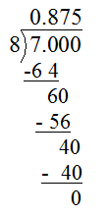
  - $-\frac{7}{8}=$

$$-\frac{7}{8}=-0.875$$
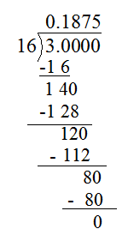

  - $\frac{3}{16}=$

$$\frac{3}{16}=0.1875$$

Example 4 (5 minutes): Converting Rational Numbers to Decimals Using Long Division
(Part 2: Repeating Decimals)
Example 4: Converting Rational Numbers to Decimals Using Long Division
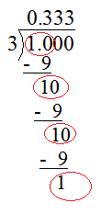
Use long division to find the decimal representation of $\frac{1}{3}$.
The remainders repeat, yielding the same dividend remainder in each step. This repeating remainder causes the numbers in the quotient to repeat as well. Because of this pattern, the decimal will go on forever, so we cannot write the exact quotient.
MP.8

- Students notice that since the remainders repeat, the quotient takes on a repeating pattern of $3$’s. We cannot possibly write the exact value of the decimal because it has an infinite number of decimal places. Instead, we indicate that the decimal has a repeating pattern by placing a bar over the shortest sequence of repeating digits (called the repetend).
  - Answer: $0.333…$ $=0.\overline{3}$
- What part of your calculations causes the decimal to repeat?
- When a remainder repeats, the calculations that follow must also repeat in a cyclical pattern, causing the digits in the quotient to also repeat in a cyclical pattern.
- Circle the repeating remainders.
Refer to the graphic above.

Exercise 2 (8 minutes)
Exercise 2
Calculate the decimal values of the fraction below using long division. Express your answers using bars over the shortest sequence of repeating digits.
Scaffolding:
- For long division calculations, provide students with graph paper to aid with organization of numbers and decimal placement.
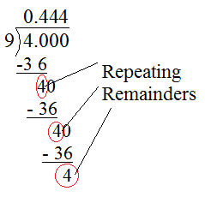
  - $-\frac{4}{9}$

$$-\frac{4}{9}=-0.4444…=-0.\overline{4}$$

  - $-\frac{1}{11}$

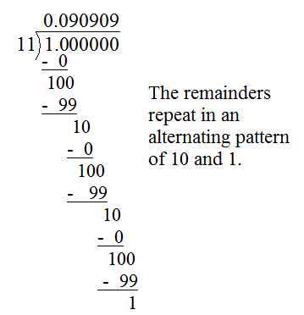

$$-\frac{1}{11}=-0.090909…=-0.\overline{09}$$

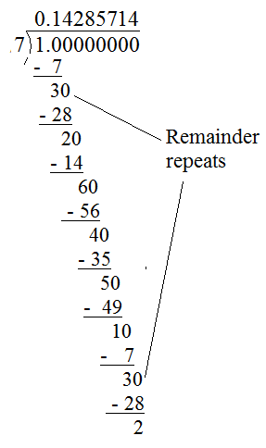

  - $\frac{1}{7}$

$$\frac{1}{7}=0.142857148…=0.\overline{142857}$$

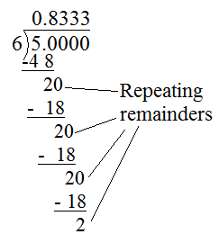
  - $-\frac{5}{6}$

$$-\frac{5}{6}=-0.833333…=-0.8\overline{3}$$

Example 5 (4 minutes): Fractions Represent Terminating or Repeating Decimals
- The long division algorithm will either terminate with a zero remainder or the remainder will repeat. Why?
- Case 1: The long division algorithm terminates with a remainder of $0$.
  - The decimal also terminates.
- Case 2: The long division algorithm does not terminate with a remainder of $0$.
- Consider $\frac{1}{7}$ from Exercise 2. There is no zero remainder, so the algorithm continues. The remainders cannot be greater than or equal to the divisor, $7$, so there are only six possible non-zero remainders: $1$, $2$, $3$, $4$, $5$, and $6$. This means that the remainder must repeat within six steps.
MP.2
Students justify the claim in student materials.
Example 5: Fractions Represent Terminating or Repeating Decimals
How do we determine whether the decimal representation of a quotient of two integers, with the divisor not equal to zero, will terminate or repeat?
In the division algorithm, if the remainder is zero then the algorithm terminates resulting in a terminating decimal.
If the value of the remainder is not zero, then it is limited to whole numbers $1$,$2$,$3$,$…$,$\left(d-1\right)$. This means that the value of the remainder must repeat within $\left(d-1\right)$ steps. (For example, given a divisor of $9$, the non-zero remainders are limited to whole numbers $1$ through $8$, so the remainder must repeat within $8$ steps.) When the remainder repeats, the calculations that follow will also repeat in a cyclical pattern causing a repeating decimal.

Example 6 (5 minutes): Using Rational Number Conversions in Problem Solving
Example 6: Using Rational Number Conversions in Problem Solving
  - Eric and four of his friends are taking a trip across the New York State Thruway. They decide to split the cost of tolls equally. If the total cost of tolls is $\$8$, how much will each person have to pay?
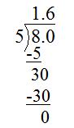
There are five people taking the trip. The friends will each be responsible for $\$1.60$ of the tolls due.

  - Just before leaving on the trip, two of Eric’s friends have a family emergency and cannot go. What is each person’s share of the $\$8$ tolls now?
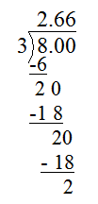
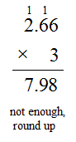
There are now three people taking the trip. The resulting quotient is a repeating decimal because the remainders repeat as $2$’s. The resulting quotient is $\frac{8}{3}=2.66666…=2.\overline{6}$. If each friend pays $\$2.66$, they will be $\$0.02$ shy of $\$8$, so the amount must be rounded up to $\$2.67$ per person.

Closing (2 minutes)
- What should you do if the remainders of a quotient of integers do not seem to repeat?
MP.1
- Double check your work for computational errors, but if all is well, keep going! If you are doing the math correctly, the remainders eventually have to terminate or repeat.
- What is the form for writing a repeating decimal?
- Use a bar to cover the shortest sequence of repeating digits.

Lesson Summary
The real world requires that we represent rational numbers in different ways depending on the context of a situation. All rational numbers can be represented as either terminating decimals or repeating decimals using the long division algorithm. We represent repeating decimals by placing a bar over the shortest sequence of repeating digits.

Exit Ticket (4 minutes)

Name ___________________________________________________ Date____________________
Lesson 14: Converting Rational Numbers to Decimals Using Long Division

Exit Ticket

- What is the decimal value of $\frac{4}{11}$?

- How do you know that $\frac{4}{11}$ is a repeating decimal?

- What causes a repeating decimal in the long division algorithm?
Exit Ticket Sample Solutions

- What is the decimal value of $\frac{4}{11}$?
$$\frac{4}{11}=0.\overline{36}$$

- How do you know that $\frac{4}{11}$ is a repeating decimal?
The prime factor in the denominator is $11$. Fractions that correspond with terminating decimals have only factors $2$ and $5$ in the denominator in simplest form.

- What causes a repeating decimal in the long division algorithm?
When a remainder repeats, the division algorithm takes on a cyclic pattern causing a repeating decimal.

Problem Set Sample Solutions

- Convert each rational number into its decimal form.
 |  | $$\frac{1}{9}=0.\overline{1}$$
 | $$\frac{1}{6}=0.1\overline{6}$$
 |  | $$\frac{2}{9}=0.\overline{2}$$
$$\frac{1}{3}=0.\overline{3}$$ | $$\frac{2}{6}=0.\overline{3}$$ | $$\frac{3}{9}=0.\overline{3}$$
 |  | $$\frac{4}{9}=0.\overline{4}$$
 | $$\frac{3}{6}=0.5$$
 |  | $$\frac{5}{9}=0.\overline{5}$$
$$\frac{2}{3}=0.\overline{6}$$ | $$\frac{4}{6}=0.\overline{6}$$ | $$\frac{6}{9}=0.\overline{6}$$
 |  | $$\frac{7}{9}=0.\overline{7}$$
 | $$\frac{5}{6}=0.8\overline{3}$$
 |  | $$\frac{8}{9}=0.\overline{8}$$

One of these decimal representations is not like the others. Why?
$\frac{3}{6}$ in its simplest form is $\frac{1}{2}$ (the common factor of $3$ divides out, leaving a denominator of $2$, which in decimal form will terminate.
Enrichment:
- Chandler tells Aubrey that the decimal value of $-\frac{1}{17}$ is not a repeating decimal. Should Aubrey believe him? Explain.
No, Aubrey should not believe Chandler. The divisor $17$ is a prime number containing no factors of $2$ or $5$, and therefore, cannot be written as a terminating decimal. By long division, $-\frac{1}{17}=-0.\overline{0588235294117647}$ ; The decimal appears as though it is not going to take on a repeating pattern because all $16$ possible non-zero remainders appear before the remainder repeats. The seventeenth step produces a repeat remainder causing a cyclical decimal pattern.

- Complete the quotients below without using a calculator and answer the questions that follow.
  - Convert each rational number in the table to its decimal equivalent.
$$\frac{1}{11}=0.\overline{09}$$ | $$\frac{2}{11}=0.\overline{18}$$ | $$\frac{3}{11}=0.\overline{27}$$ | $$\frac{4}{11}=0.\overline{36}$$ | $$\frac{5}{11}=0.\overline{45}$$
$$\frac{6}{11}=0.\overline{54}$$ | $$\frac{7}{11}=0.\overline{63}$$ | $$\frac{8}{11}=0.\overline{72}$$ | $$\frac{9}{11}=0.\overline{81}$$ | $$\frac{10}{11}=0.\overline{90}$$

Do you see a pattern? Explain.
The two digits that repeat in each case have a sum of nine. As the numerator increases by one, the first of the two digits increases by one as the second of the digits decreases by one.

  - Convert each rational number in the table to its decimal equivalent.
$$\frac{0}{99}=0$$ | $$\frac{10}{99}=0.\overline{10}$$ | $$\frac{20}{99}=0.\overline{20}$$ | $$\frac{30}{99}=0.\overline{30}$$ | $$\frac{45}{99}=0.\overline{45}$$
$$\frac{58}{99}=0.\overline{58}$$ | $$\frac{62}{99}=0.\overline{62}$$ | $$\frac{77}{99}=0.\overline{7}$$ | $$\frac{81}{99}=0.\overline{81}$$ | $$\frac{98}{99}=0.\overline{98}$$

Do you see a pattern? Explain.
The $2$-digit numerator in each fraction is the repeating pattern in the decimal form.

  - Can you find other rational numbers that follow similar patterns?
Answers will vary.

