Lesson 11: Develop Rules for Multiplying Signed Numbers

Student Outcomes
- Students understand the rules for multiplication of integers and that multiplying the absolute values of integers results in the absolute value of the product. The sign, or absolute value, of the product is positive if the factors have the same sign and negative if they have opposite signs.
- Students realize that $(-1)(-1)=(1)$ and see that it can be proven mathematically using the distributive property and the additive inverse.
- Students use the rules for multiplication of signed numbers and give real-world examples.

Classwork
Example 1 (17 minutes): Extending Whole Number Multiplication to the Integers
Part A: Students complete only the right half of the table in the student materials. They do this by calculating the total change to a player’s score using the various sets of matching cards. Students complete the table with these values to reveal patterns in multiplication.
Students describe, using Integer Game scenarios, what the right quadrants of the table represent and record this in the student materials.
Example 1: Extending Whole Number Multiplication to the Integers
Part A: Complete quadrants $I$ and $IV$ of the table below to show how sets of matching integer cards will affect a player’s score in the Integer Game. For example, three $2$’s would increase a player’s score by $0+2+2+2=6$ points.
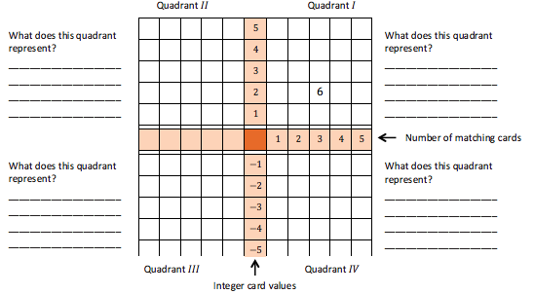

Number of matching cards
Integer card values
What does this quadrant represent?
Picking up positive value cards.

What does this quadrant represent?
Picking up negative value cards.

What does this quadrant represent?
Removing positive
value cards.
What does this quadrant represent?
Removing negative
value cards.
Quadrant $I$
Quadrant $II$
Quadrant $III$
Quadrant $IV$
$$-25$$ | $$-20$$ | $$-15$$ | $$-10$$ | $$-5$$ | $$5$$ | $$5$$ | $$10$$ | $$15$$ | $$20$$ | $$25$$
$$-20$$ | $$-16$$ | $$-12$$ | $$-8$$ | $$-4$$ | $$4$$ | $$4$$ | $$8$$ | $$12$$ | $$16$$ | $$20$$
$$-15$$ | $$-12$$ | $$-9$$ | $$-6$$ | $$-3$$ | $$3$$ | $$3$$ | $$6$$ | $$9$$ | $$12$$ | $$15$$
$$-10$$ | $$-8$$ | $$-6$$ | $$-4$$ | $$-2$$ | $$2$$ | $$2$$ | $$4$$ | $$6$$ | $$8$$ | $$10$$
$$-5$$ | $$-4$$ | $$-3$$ | $$-2$$ | $$-1$$ | $$1$$ | $$1$$ | $$2$$ | $$3$$ | $$4$$ | $$5$$
$$-5$$ | $$-4$$ | $$-3$$ | $$-2$$ | $$-1$$ | $$0$$ | $$1$$ | $$2$$ | $$3$$ | $$4$$ | $$5$$
$$5$$ | $$4$$ | $$3$$ | $$2$$ | $$1$$ | $$-1$$ | $$-1$$ | $$-2$$ | $$-3$$ | $$-4$$ | $$-5$$
$$10$$ | $$8$$ | $$6$$ | $$4$$ | $$2$$ | $$-2$$ | $$-2$$ | $$-4$$ | $$-6$$ | $$-8$$ | $$-10$$
$$15$$ | $$12$$ | $$9$$ | $$6$$ | $$3$$ | $$-3$$ | $$-3$$ | $$-6$$ | $$-9$$ | $$-12$$ | $$-15$$
$$20$$ | $$16$$ | $$12$$ | $$8$$ | $$4$$ | $$-4$$ | $$-4$$ | $$-8$$ | $$-12$$ | $$-16$$ | $$-20$$
$$25$$ | $$20$$ | $$15$$ | $$10$$ | $$5$$ | $$-5$$ | $$-5$$ | $$-10$$ | $$-15$$ | $$-20$$ | $$-25$$

  - What patterns do you see in the right half of the table?
The products in quadrant $I$ are positive and the products in quadrant $IV$ are negative. When looking at the absolute values of the products, quadrants $I$ and $IV$ are a reflection of each other with respect to the middle row.

  - Enter the missing integers in the left side of the middle row and describe what they represent.
The numbers represent how many matching cards are being discarded or removed.
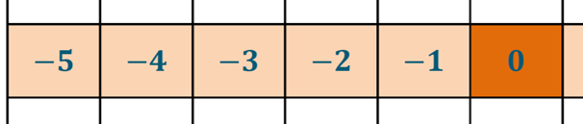

Part B: Students complete quadrant $II$ of the table.
Students describe, using an Integer Game scenario, what quadrant $II$ of the table represents and record this in the student materials.

Part B: Complete quadrant $II$ of the table.
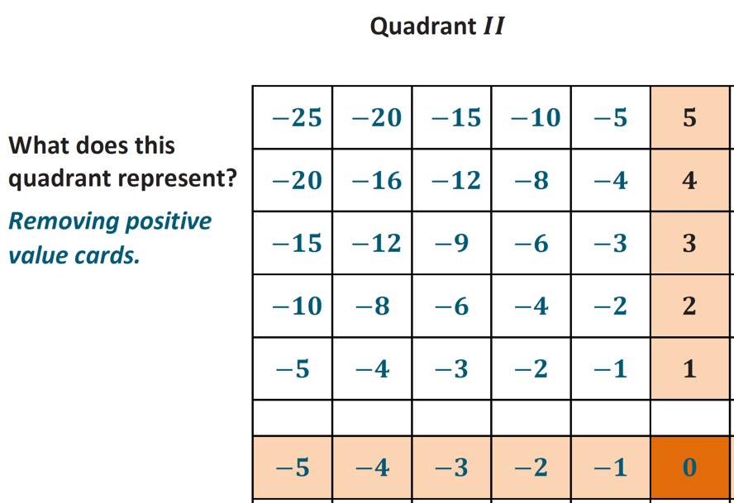

Students answer the following questions:

  - What relationships or patterns do you notice between the produtcs (values) in quadrant $II$ and the products (values) in quadrant $I$?
The products in quadrant $II$ are all negative values. Looking at the absolute values of the products, quadrant $I$ and $II$ are a reflection of each other with respect to the center column.

  - What relationships or patterns do you notice between the products (values) in quadrant $II$ and the products (values) in quadrant $IV$?
MP.7
The products in quadrants $II$ and $IV$ are all negative values. Each product of integers in quadrant $II$ is equal to the product of their opposites in quadrant $IV$.

  - Use what you know about the products (values) in quadrants $I$, $II$, and $IV$ to describe what quadrant $III$ will look like when its products (values) are entered.
The reflection symmetry of quadrant $I$ to quadrants $II$ and $IV$ suggests that there should be similar relationships between quadrant $II$, $III$, and $IV$. The number patterns in quadrants $II$ and $IV$ also suggest that the products in quadrant $III$ are positive values.

Part C: Discuss the following question, then instruct students to complete the final quadrant of the table.
- In the Integer Game, what happens to a player’s score when he removes a matching set of cards with negative values from his hand?
- His score increases because the negative cards that cause the score to decrease are removed.
Scaffolding:
- Create an “anchor poster” showing the quadrants with the new rules for multiplying integers.
Students describe, using an Integer Game scenario, what quadrant $III$ of the table represents and complete the quadrant in the student materials.

Part C: Complete the quadrant $III$ of the table.
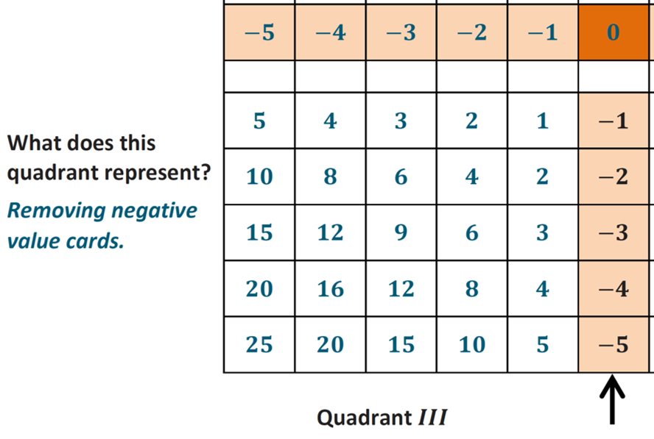
Refer to the completed table to help you answer the following questions:

Students refer to the completed table to answer parts (f) and (g).

  - Is it possible to know the sign of a product of two integers just by knowing in which quadrant each integer is located? Explain.
Yes, it is possible to know the sign of a product of two integers just by knowing each integer’s quadrant because the signs of the values in each of the quadrants are consistent. Two quadrants contain positive values, and the other two quadrants contain negative values.

  - Which quadrants contain which values? Describe an integer game scenario represented in each quadrant.
Quadrants $I$ and $III$ contain all positive values. Picking up three $4$’s is represented in quadrant $I$ and increases your score. Removing three $-4$’s is represented in quadrant $III$ and also increases your score. Quadrants $II$ and $IV$ contain all negative values. Picking up three $-4$’s is represented in quadrant $IV$ and decreases your score. Removing three $4$’s is represented in quadrant $II$ and also decreases your score.

Example 2 (10 minutes): Using Properties of Arithmetic to Explain Multiplication of Negative Numbers
Teacher guides students to verify their conjecture that the product of two negative integers is positive using the distributive property and the additive inverse property.
- We have used the Integer Game to explain that adding a number multiple times has the same effect as removing the opposite value the same number of times. What is $\left(-1\right)×\left(-1\right)$?
  - Removing a $-1$ card is the same as adding a $1$ card. So, $\left(-1\right)×\left(-1\right)=1$.
- Why are $1$ and $-1$ called additive inverses? Write an equation that shows this property.
  - The sum of $1$ and $-1$ is $0$; $1+\left(-1\right)=0$.

We are now going to show$-1×(-1)=1$using properties of arithmetic.
- We know $1+\left(-1\right)=0$ is true.
- We will show that $\left(-1\right)×\left(-1\right)$is the additive inverse of $-1$ which is $1$.

If $-1×0=0$ By the zero product property,
Scaffolding:
- Use color or highlight steps to help students organize and understand the manipulations.
then $-1×\left(1+\left(-1\right)\right)=0$ By substitution of $\left(1+\left(-1\right)\right)$ for $0$
$\left(-1×1\right)+\left(-1×\left(-1\right)\right)=0$ Distributive property
$-1+\left(-1×\left(-1\right)\right)=0$ Multiplication by $1$
- Since $-1$ and $\left(-1×\left(-1\right)\right)$ have a sum of zero, they are additive inverses of each other; but, the additive inverse of $-1$ is $1$.
- Because $\left(-1×\left(-1\right)\right)$ is the additive inverse of $-1$, we conclude that $\left(-1\right)×\left(-1\right)=1$. This fact can be used to show that $-1×a=-a$ for any integer and that $–a×b=-(a×b)$ for any integers $a$ and $b$.

Exercise 1 (8 minutes): Multiplication of Integers in the Real World
Students create real-world scenarios for expressions given in the student materials. Students may use an Integer Game scenario as a reference.
Exercise 1: Multiplication of Integers in the Real World
Generate real-world situations that can be modeled by each of the following multiplication problems. Use the Integer Game as a resource.
Scaffolding:
- For ELL students, create teacher/student T-chart on which the teacher writes a real-world situation that corresponds with a product, and students write similar situations using different numbers.

  - $-3×5$
I lost three $\$5$ bills, and now I have $-\$15$.

  - $-6×\left(-3\right)$
I removed six $-3$’s from my hand in the Integer Game, and my score increased $18$ points.

  - $4×(-7)$
If I lose $7$ lb. per month for $4$ months, my weight will change $-28$ lb. total.

Closing (5 minutes)
- How do we determine if the product of two signed numbers will be positive or negative?
  - If the factors have the same sign, the product will be positive, and if the factors have opposite signs, the product will be negative.
- Why does the product of two negative values result in a positive value? Explain using the Integer Game.
  - The product of two negative numbers represents removing negative cards during the Integer Game. When negative cards are removed from someone’s hand their score increases, therefore, the product is positive.
Lesson Summary
To multiply signed numbers, multiply the absolute values to get the absolute value of the product. The sign of the product is positive if the factors have the same sign and negative if they have opposite signs.

Exit Ticket (5 minutes)
Name ___________________________________________________ Date____________________
Lesson 11: Develop Rules for Multiplying Signed Numbers

Exit Ticket

- Create a real-life example that can be modeled by the expression $-2×4$, and then state the product.

- Two integers are multiplied and their product is a positive number. What must be true about the two integers?

Exit Ticket Sample Solutions

- Create a real-life example that can be modeled by the expression $-2×4$, and then state the product.
Answers will vary. Tobi wants to lose $2$ lb. each week for four weeks. Write an integer to represent Tobi’s weight change after four weeks. Tobi’s weight changes by $-8$ lb. after four weeks.

- Two integers are multiplied and their product is a positive number. What must be true about the two integers?
Both integers must be positive numbers, or both integers must be negative numbers.

Problem Set Sample Solutions

- Complete the problems below. Then, answer the question that follows.
$$3× 3 = 9$$ | $$3×2 = 6$$ | $$3×1 = 3$$ | $3×0 =$ $0$ | $$3× (-1)=-3$$ | $$3×(-2)=-6$$
$$2×3 = 6$$ | $$2×2 = 4$$ | $$2×1 = 2$$ | $$2×0 = 0$$ | $$2×(-1)=-2$$ | $$2×(-2)=-4$$
$$1×3 = 3$$ | $$1×2 = 2$$ | $$1×1 = 1$$ | $$1×0 = 0$$ | $$1×(-1) = -1$$ | $$1×(-2)=-2$$
$$0×3=0$$ | $$0×2 = 0$$ | $$0×1 = 0$$ | $$0×0 = 0$$ | $$0×(-1) = 0$$ | $$0×(-2)=0$$
$$-1×3 = -3$$ | $$-1×2 = -2$$ | $$-1×1 =-1$$ | $$-1×0 = 0$$ | $$-1×(-1) =1$$ | $$-1×(-2) =2$$
$$-2×3 = -6$$ | $$-2×2 = -4$$ | $$-2×1 =-2$$ | $$-2×0 = 0$$ | $$-2×(-1) =2$$ | $$-2×(-2) =4$$
$$-3×3=-9$$ | $$-3×2 = -6$$ | $$-3×1 =-3$$ | $$-3×0 = 0$$ | $$-3×(-1) =3$$ | $$-3×(-2) =6$$

Which row shows the same pattern as the outlined column? Are the problems similar or different? Explain.
The row outlined shows the same pattern as the outlined column. The problems have the same answers, but the signs of the integer factors are switched. For example, $3×(-1)=-3×1$. This shows that the product of two integers with opposite signs is equal to the product of their opposites.

- Explain why $\left(-4\right)×\left(-5\right)=20$. Use patterns, an example from the Integer Game, or the properties of operations to support your reasoning.
Answers may vary. Losing four $-5$ cards will increase a score in the Integer Game by $20$ because a negative value decreases a score, but the score increases when it is removed.

- Each time that Samantha rides the commuter train, she spends $\$4$ for her fare. Write an integer that represents the change in Samantha’s money from riding the commuter train to and from work for $13$ days. Explain your reasoning.
If Samantha rides to and from work for $13$ days, then she rides the train a total of $26$ times. The cost of each ride can be represented by $-4$. So, the change to Samantha’s money is represented by $-4×26=-104$. The change to Samantha’s money after $13$ days of riding the train to and from work is $-\$104$.

- Write a real-world problem that can be modeled by $4×(-7).$
Answers will vary. Every day, Alec loses $7$ pounds of air pressure in a tire on his car. At that rate, what is the change in air pressure in his tire after $4$ days?

Challenge:
- Use properties to explain why for each integer $a$, $-a=-1×a$. (Hint: What does $\left(1+\left(-1\right)\right)×a$ equal? What is the additive inverse of $a$?)
$0×a=0$ Zero product property
$\left(1+\left(-1\right)\right)×a=0$ Substitution
$a+\left(-1×a\right)=0$ Distributive property
Since $a$ and $\left(-1×a\right)$ have a sum of zero, they must be additive inverses. By definition, the additive inverse of $a$ is $-a$, so $\left(-1×a\right)=-a$.

