Lesson 2: Using the Number Line to Model the Addition of Integers

Classwork
Exercise 1: Real-World Introduction to Integer Addition
Answer the questions below.
- Suppose you received $\$10$ from your grandmother for your birthday. You spent $\$4$ on snacks. Using addition, how would you write a number sentence to represent this situation?

- How would you model your equation on a number line to show your answer?

Example 1: Modeling Addition on the Number Line
Complete the steps to finding the sum of $-2+3$ by filling in the blanks. Model the number sentence using straight arrows called vectors on the number line below.

  - Place the tail of the arrow on ________.

  - Draw the arrow $2$ units to the left of $0$, and stop at ________. The direction of the arrow is to the ________ since you are counting down from $0$.

  - Start the next arrow at the end of the first arrow, or at ________.

  - Draw the second arrow ________ units to the right since you are counting up from $-2$.

  - Stop at ________.

  - Circle the number at which the second arrow ends to indicate the ending value.

  - Repeat the process from parts (a)–(f) for the expression $3+(-2).$

  - What can you say about the sum of $-2+3$ and $3+(-2)$? Does order matter when adding numbers? Why or why not?

Example 2: Expressing Absolute Value as the Length of an Arrow on the Real Number Line
  - How does absolute value determine the arrow length for $-2$?

  - How does the absolute value determine the arrow length for $3$?

  - How does absolute value help you to represent $-10$ on a number line?

Exercise 2
Create a number line model to represent each of the expressions below.
  - $-6+4$

  - $3+(-8)$

Example 3: Finding Sums on a Real Number Line Model
Find the sum of the integers represented in the diagram below.
$$-2$$
$$5$$
$$3$$

  - Write an equation to express the sum.

  - What three cards are represented in this model? How did you know?

  - In what ways does this model differ from the ones we used in Lesson 1?

  - Can you make a connection between the sum of $6$ and where the third arrow ends on the number line?

  - Would the sum change if we changed the order in which we add the numbers, for example, $(-2)+3+5$?

  - Would the diagram change? If so, how?

Exercise 3
Play the Integer Game with your group. Use a number line to practice “counting on”.

Lesson Summary
- On a number line, arrows are used to represent integers; they show length and direction.
- The length of an arrow on the number line is the absolute value of the integer.
- Adding several arrows is the same as combining integers in the Integer Game.
- The sum of several arrows is the final position of the last arrow.

Problem Set

For Questions 1–3, represent each of the following problems using both a number line diagram and an equation.
- David and Victoria are playing the Integer Card Game. David drew three cards, $-6$, $12$, and $-4$. What is the sum of the cards in his hand? Model your answer on the number line below.

- In the Integer Card Game, you drew the cards, $2$,$8$, and $-11.$ Your partner gave you a $7$ from his hand.
  - What is your total? Model your answer on the number line below.

  - What card(s) would you need to get your score back to zero? Explain. Use and explain the term “additive inverse” in your answer.

- If a football player gains$40$ yards on a play, but on the next play, he loses $10$ yards, what would his total yards be for the game if he ran for another $60$ yards? What did you count by to label the units on your number line?
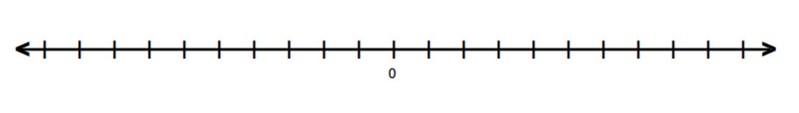
- Find the sums.
  - $-2+9$
  - $-8+-8$
  - $-4+(-6)+10$
  - $5+7+(-11)$

- Mark an integer between $1$ and $5$ on a number line, and label it point $Z$. Then, locate and label each of the following points by finding the sums.

  - Point $A$: $Z+5$
  - Point $B$: $Z+(-3)$
  - Point $C$: $(-4)+(-2)+Z$
  - Point $D$: $-3+Z+1$

- Write a story problem that would model the sum of the arrows in the number diagram below.

- Do the arrows correctly represent the equation $4+(-7)+5=2$? If not, draw a correct model below.

