Lesson 22: An Exercise in Changing Scales

Classwork
Using the new scale drawing of your dream room, list the similarities and differences between this drawing and the original drawing completed for Lesson 20.
Similarities Differences

Original Scale Factor: ___________________ New Scale Factor: _______________________
What is the relationship between these scale factors?

Key Idea:
Two different scale drawings of the same top-view of a room are also scale drawings of each other. In other words, a scale drawing of a different scale can also be considered a scale drawing of the original scale drawing.

Example 1: Building a Bench
To surprise her mother, Taylor helped her father build a bench for the front porch. Taylor’s father had the instructions with drawings but Taylor wanted to have her own copy. She enlarged her copy to make it easier to read. Using the following diagram, fill in the missing information. To complete the first row of the table, write the scale factor of the bench to the bench, the bench to the original diagram, and the bench to Taylor's diagram. Complete the remaining rows similarly.
The pictures below show the diagram of the bench shown on the original instructions and the diagram of the bench shown on Taylor’s enlarged copy of the instruction.
Original Drawing of Bench (top view) Taylor’s Drawing (top view) Scale factor to bench: $\frac{1}{12}$
$2$ inches $6$ inches

Scale Factors
 | Bench | Original Diagram | Taylor’s Diagram
Bench | $$1$$
Original Diagram |  | $$1$$
Taylor’s Diagram |  |  | $$1$$

Exercise 1
Carmen and Jackie were driving separately to a concert. Jackie printed a map of the directions on a piece of paper before the drive, and Carmen took a picture of Jackie’s map on her phone. Carmen’s map had a scale factor to the actual distance of $\frac{1}{563,270}$. Using the pictures, what is the scale of Carmen’s map to Jackie’s map? What was the scale factor of Jackie’s printed map to the actual distance?
Jackie’s Map Carmen’s Map

$26$ cm
$4$ cm

Exercise 2
Ronald received a special toy train set for his birthday. In the picture of the train on the package, the boxcar has the following dimensions: length is $4\frac{5}{16}$ inches; width is $1\frac{1}{8}$ inches; and height is $1\frac{5}{8}$ inches. The toy boxcar that Ronald received has dimensions $l$ is $17.25$ inches; $w$ is $4.5$ inches; and$h$ is $6.5$ inches. If the actual boxcar is $50$ feet long:
  - Find the scale factor of the picture on the package to the toy set.

  - Find the scale factor of the picture on the package to the actual boxcar.

  - Use these two scale factors to find the scale factor between the toy set and the actual boxcar.

  - What are the width and height of the actual boxcar?

Lesson Summary
The scale drawing of a different scale is a scale drawing of the original scale drawing.
To find the scale factor for the original drawing, write a ratio to compare the drawing length from the original drawing to its corresponding actual length from the second scale drawing.
Refer to the example below where we compare the drawing length from the Original Scale drawing to its corresponding actual length from the New Scale drawing:
$6$ inches represents $12$ feet or $0.5$ feet represent $12$ feet
This gives an equivalent ratio of $\frac{1}{24}$ for the scale factor of the original drawing.
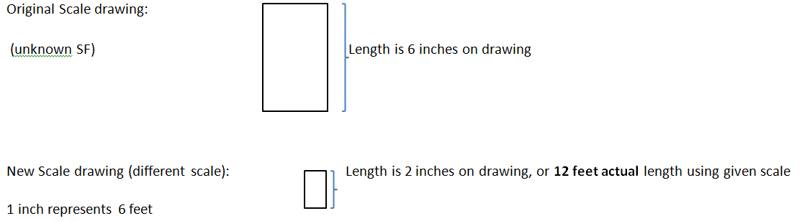

Problem Set

- For the scale drawing, the actual lengths are labeled onto the scale drawing. Measure the lengths, in centimeters, of the scale drawing with a ruler, and draw a new scale drawing with a scale factor ($SD2$ to $SD1$) of $\frac{1}{2}$ .

$10$ ft.
$2$ ft.

$4$ ft.

- Compute the scale factor of the new scale drawing ($SD2$) to the first scale drawing ($SD1$) using the information from the given scale drawings.
  - Original Scale Factor: $\frac{6}{35}$ New Scale Factor: $\frac{1}{280}$
$8$ ft.
$2$ in.
$2.125$ in.
$8.5$ft.
$2.25$ in.

$9$ ft.

Scale Factor: _____________

  - Original Scale Factor: $\frac{1}{12}$ New Scale Factor: $3$
$\frac{1}{2}$ in. $1.5$ ft.
$9$ ft.
$3$ in. $3$ in.
$9$ ft.

Scale Factor: _______________

  - Original Scale Factor: $20$ New Scale Factor: $25$

$1$ m $1$ m $125$ cm $125$ cm

Scale Factor: _______________

