Lesson 22: An Exercise in Changing Scales

Student Outcomes
- Given a scale drawing, students produce a scale drawing of a different scale.
- Students recognize that the scale drawing of a different scale is a scale drawing of the original scale drawing.
- For the scale drawing of a different scale, students compute the scale factor for the original scale drawing.

Classwork
Exploratory Challenge: Reflection on Scale Drawings (15 minutes)
Ask students to take out the original scale drawing and new scale drawing of their dream rooms they completed as part of the Problem Sets from Lessons $20$ and $21$. Have students discuss their answers with a partner. Discuss as a class:
- How are the two drawings alike?
- How are the two drawings different?
- What is the scale factor of the new scale drawing to the original scale drawing?
Direct students to fill-in-the blanks with the two different scale factors. Allow pairs of students to discuss the posed question, “What is the relationship?” for $3$ minutes and share responses for $4$ minutes. Summarize the Key Idea with students.
Using the new scale drawing of your dream room, list the similarities and differences between this drawing and the original drawing completed for Lesson $20$.
Similarities Differences
- Same room shape - One is bigger than the other
- Placement of furniture - Different scale factors
- Space between furniture
- Drawing of the original room
- Proportional

Original Scale Factor:_______ $\frac{1}{120}$ __________ New Scale Factor:_______ $\frac{1}{30}$ ______________
What is the relationship between these scale factors? $\frac{1}{4}$
Key Idea:
Two different scale drawings of the same top-view of a room are also scale drawings of each other. In other words, a scale drawing of a different scale can also be considered a scale drawing of the original scale drawing.

Example 1 (10 minutes): Building a Bench
Students are given the following information: the scale factor of Taylor’s scale drawing to the actual bench is $\frac{1}{12}$, Taylor’s scale drawing, and the measurements of the corresponding lengths ($2$ in. and $6$ in. as shown). Ask the students the following questions:
- What information is important in the diagram?
  - The scale factor of Taylor’s reproduction
- What information can be accessed from the given scale factor?
  - The actual length of the bench can be computed from the scale length of Taylor’s drawing.
- What are the process used to find the original scale factor to the actual bench?
  - Take the length of the new scale drawing, $6$ inches, and divide by the scale factor, $\frac{1}{12}$, to get the actual length of the bench, $72$ inches. The original scale factor, $\frac{1}{36}$, can be computed by dividing the original scale length, $2$ inches, by the actual length, $72$ inches.
- What is the relationship of Taylor’s drawing to the original drawing?
  - Taylor’s drawing is $3$ times as big as her father’s original drawing. The lengths corresponding to the actual length, which is $72$ inches, are $6$ inches from Taylor’s drawing and $2$ inches from the original drawing. $\frac{6}{2}$ is $3$; therefore, the scale factor is $3$.
Example 1: Building a Bench
To surprise her mother, Taylor helped her father build a bench for the front porch. Taylor’s father had the instructions with drawings, but Taylor wanted to have her own copy. She enlarged her copy to make it easier to read. Using the following diagram, fill in the missing information. To complete the first row of the table, write the scale factor of the bench to the bench, the bench to the original diagram, and the bench to Taylor's diagram. Complete the remaining rows similarly.
The pictures below show the diagram of the bench shown on the original instructions and the diagram of the bench shown on Taylor’s enlarged copy of the instruction.
Original Drawing of Bench (top view) Taylor’s Drawing (top view) Scale factor to bench: $\frac{1}{12}$
$2$ inches $6$ inches

Scale Factors
 | Bench | Original Diagram | Taylor’s Diagram
Bench | $$1$$ | $$36$$ | $$12$$
Original Diagram | $$\frac{1}{36}$$ | $$1$$ | $$\frac{1}{3}$$
Taylor’s Diagram | $$\frac{1}{12}$$ | $$3$$ | $$1$$

Exercise 1 (5 minutes)
Allow students to work problem with partners for $3$ minutes. Discuss for $2$ minutes:
- How did you find the original scale factor?
  - Divide the Carmen’s map distance, $4$ cm, by the scale factor,$\frac{1}{563,270},$ to get the actual distance, $2,253,080$ cm. Take the distance from Jackie’s map, $26$ cm, and divide by the actual distance to get the original scale factor, $\frac{1}{86,657 }$.
- What are the steps to find the scale of new to original scale drawing?
  - Divide the new scale distance, $4$ cm, by the corresponding original scale distance, $26$ cm, to get $\frac{2}{13}$.
- What is the actual distance in miles?
  - $2,253,080$ cm divided by $2.54$ cm gives $887,039.37$ inches. Divide $887,039.37$ by $12$ to get $73,919.95$feet. Then, divide $73,919.95$ by $5280$to get around $14$ miles.
- Would it make more sense to answer in centimeters or miles?
  - Although both are valid units, miles would be a more useful unit to describe the distance driven in a car.
Exercise 1
Carmen and Jackie were driving separately to a concert. Jackie printed a map of the directions on a piece of paper before the drive, and Carmen took a picture of Jackie’s map on her phone. Carmen’s map had a scale factor of $\frac{1}{563,270}$. Using the pictures, what is the scale of Carmen’s map to Jackie’s map? What was the scale factor of Jackie’s printed map to the actual distance?
Jackie’s Map Carmen’s Map

$26$ cm
$4$ cm

Scale Factor of $SD2$ to $SD1$: $\frac{4}{26}=\frac{2}{13}$ Scale Factor of $SD1$ to actual distance: $\frac{\frac{\frac{1}{563,270}}{2}}{13}=\frac{1}{563,270}×\frac{13}{2}$
$$= \frac{13}{1,126,540}$$

Exercise 2 (10 minutes)
Allow students to work in pairs to find the solutions.
- What is another way to find the scale factor of the toy set to the actual boxcar?
  - Take the length of the toy set and divide it by the actual length.
- What is the purpose of the question in part (c)?
  - To take notice of the relationships between all the scale factors
Exercise 2
Ronald received a special toy train set for his birthday. In the picture of the train on the package, the boxcar has the following dimensions: length is $4\frac{5}{16}$inches; width is $1\frac{1}{8}$inches; height is $1\frac{5}{8}$inches. The toy boxcar that Ronald received has dimensions $l$ is $17.25$ inches; $w$ is $4.5$ inches; $h$ is $6.5$ inches. If the actual boxcar is $50$ feet long:
- Find the scale factor of the picture on the package to the toy set.
$$\frac{4\frac{5}{16}}{17\frac{1}{4}}=4\frac{5}{16}÷17\frac{1}{4}=\frac{69}{16}×\frac{4}{69}=\frac{1}{4}$$

- Find the scale factor of the picture on the package to the actual boxcar.
$$\frac{4\frac{5}{16}}{50×12}=\frac{4\frac{5}{16}}{600}=\frac{69}{16}×\frac{1}{600}=\frac{23}{3200}$$

- Use these two scale factors to find the scale factor between the toy set and the actual boxcar.
$$\frac{4\frac{5}{16}}{600}÷\frac{4\frac{5}{16}}{17\frac{1}{4} }=\frac{23}{3200} ÷\frac{1}{4}=\frac{23}{3200}×4=\frac{23}{800}$$

- What is the width and height of the actual boxcar?
$$w\text{:} 4\frac{1}{2}÷\frac{23}{800}=\frac{9}{2}×\frac{800}{23}= 156 \frac{12}{23}\text{in}\text{.}$$
$$h\text{: } 6 \frac{1}{2}÷\frac{23}{800}=\frac{13}{2}×\frac{800}{23}= 226\frac{2}{23}\text{in.}$$

Closing (5 minutes)
- What is the relationship between the scale drawing of a different scale to the original scale drawing?
  - The scale drawing of a different scale is a scale drawing of the original scale drawing. If the scale factor of one of the drawings is known, the other scale factor can be computed.
- Describe the process of computing the scale factor for the original scale drawing from the scale drawing at a different scale.
  - Find corresponding known lengths and compute the actual length from the given scale factor using the new scale drawing. To find the scale factor for the original drawing, write a ratio to compare a drawing length from the original drawing to its corresponding actual length from the second scale drawing.
Lesson Summary
The scale drawing of a different scale is a scale drawing of the original scale drawing.
To find the scale factor for the original drawing, write a ratio to compare a drawing length from the original drawing to its corresponding actual length from the second scale drawing.
Refer to the example below where we compare the drawing length from the Original Scale drawing to its corresponding actual length from the New Scale drawing:
$6$ inches represents $12$ feet or $0.5$ feet represents $12$ feet
This gives an equivalent ratio of $\frac{1}{24}$for the scale factor of the original drawing.
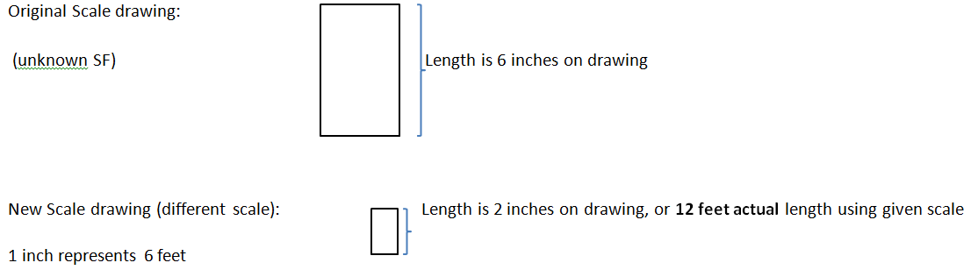

Exit Ticket (5 minute)

Name ___________________________________________________ Date____________________
Lesson 22: An Exercise in Changing Scales

Exit Ticket

The school is building a new wheelchair ramp for one of the remodeled bathrooms. The original drawing was created by the contractor, but the principal drew another scale drawing to see the size of the ramp relative to the walkways surrounding it. Find the missing values on the table.

Original Scale Drawing Principal’s Scale Drawing
New Scale Factor of $SD2$ to the actual ramp: $\frac{1}{700}$

$12$ in. $3$ in.

 | Actual Ramp | Original Scale Drawing | Principal’s Scale Drawing
Actual Ramp | $$1$$
Original Scale Drawing |  | $$1$$ | $$4$$
Principals’ Scale Drawing

Exit Ticket Sample Solutions

The school is building a new wheelchair ramp for one of the remodeled bathrooms. The original drawing was created by the contractor, but the principal drew another scale drawing to see the size of the ramp relative to the walkways surrounding it. Find the missing values on the table.

Original Scale Drawing Principal’s Scale Drawing
New Scale Factor of SD2 to the actual ramp: $\frac{1}{700}$

$12$ in. $3$ in.
Scale Factor Table
 | Actual Ramp | Original Scale Drawing | Principals’ Scale Drawing
Actual Ramp | $$1$$ | $$175$$ | $$700$$
Original Scale Drawing | $$\frac{1}{175}$$ | $$1$$ | $$4$$
Principal’s’ Scale Drawing | $$\frac{1}{700}$$ | $$\frac{1}{4}$$ | $$1$$

Problem Set Sample Solutions

- For the scale drawing, the actual lengths are labeled onto the scale drawing. Measure the lengths, in centimeters, of the scale drawing with a ruler, and draw a new scale drawing with a scale factor (SD2 to SD1) of $\frac{1}{2}$.
$10$ft.
$2$ ft.
$4$ ft.

$2.25$ cm
$0.4$ cm
$0.75$ cm

- Compute the scale factor of the new scale drawing ($SD2$) to the first scale drawing ($SD1$) using the information from the given scale drawings.
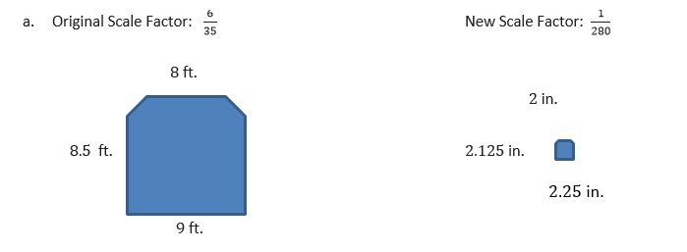
Scale Factor: ___ $\frac{1}{48}$ ________

Scale Factor:______ $36$ _______

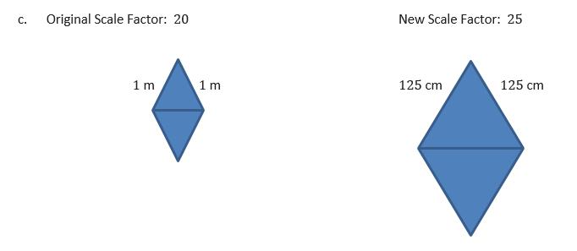

Scale Factor:_____$\frac{5}{4}$__________

