Lesson 21: An Exercise in Changing Scales

Classwork
How does your scale drawing change when a new scale factor is presented?

Exploratory Challenge: A New Scale Factor
The school plans to publish your work on the dream classroom in the next newsletter. Unfortunately, in order to fit the drawing on the page in the magazine, it must be $\frac{1}{4}$ its current length. Create a new drawing ($SD2$) in which all of the lengths are $\frac{1}{4}$ those in the original scale drawing ($SD1$) from Lesson $20$.

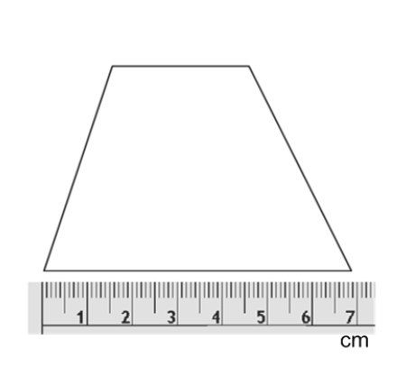
Exercise
The picture shows an enlargement or reduction of a scale drawing of a trapezoid.

Using the scale factor written on the card you chose, draw your new scale drawing with correctly calculated measurements.

  - What is the scale factor between the original scale drawing and the one you drew?

  - The longest base length of the actual trapezoid is $10$ cm. What is the scale factor between original scale drawing and the actual trapezoid?

  - What is the scale factor between the new scale drawing you drew and the actual trapezoid?
Lesson Summary
Variations of Scale Drawings with different scale factors are scale drawings of an original scale drawing.
From a scale drawing at a different scale, the scale factor for the original scale drawing can be computed without information of the actual object, figure, or picture.
- For example, if scale drawing one has a scale factor of $\frac{1}{24}$ and scale drawing two has a scale factor of $\frac{1}{72}$, then the scale factor relating scale drawing two to scale drawing one is
$$\frac{1}{72}\text{ to }\frac{1}{24}=\frac{\frac{1}{72}}{\frac{1}{24}}= \frac{1}{72}∙\frac{24}{1}=\frac{1}{3}.$$
Scale drawing two has lengths that are $\frac{1}{3}$ the size of the lengths of scale drawing one.

Changing Scale Factors:
- To produce a scale drawing at a different scale, you must determine the new scale factor. The new scale factor is found by dividing the different (new drawing) scale factor by the original scale factor.
- To find each new length, you can multiply each length in the original scale drawing by this new scale factor.
Steps:
- Find each scale factor.
- Divide the new scale factor by the original scale factor.
- Divide the given length by the new scale factor (the quotient from the prior step).

Problem Set

- Jake reads the following problem: If the original scale factor for a scale drawing of a square swimming pool is $\frac{1}{90}$, and the length of the original drawing measured to be $8$ inches, what is the length on the new scale drawing if the scale factor of the new scale drawing length to actual length is $\frac{1}{144}$?
He works out the problem like so:
$8 ÷$ $\frac{1}{90}$ = $720$ inches.
$720 ×$ $\frac{1}{144}$ = $5$ inches.
Is he correct? Explain why or why not.

- What is the scale factor of the new scale drawing to the original scale drawing ($SD2$ to $SD1$)?

- Using the scale, if the length of the pool measures $10$ cm on the new scale drawing:
  - Using the scale factor from Problem 1, $\frac{1}{144},$find the actual length of the pool in meters?
  - What is the surface area of the floor of the actual pool? Rounded to the nearest tenth.
  - If the pool has a constant depth of $1.5$ meters, what is the volume of the pool? Rounded to the nearest tenth.
  - If $1$ cubic meter of water is equal to $264.2$ gallons, how much water will the pool contain when completely filled? Rounded to the nearest unit.

- Complete a new scale drawing of your dream room from the Problem Set in Lesson 20 by either reducing by $\frac{1}{4}$ or enlarging it by $4$.

