Lesson 20: An Exercise in Creating a Scale Drawing

Student Outcomes
- Students create their own scale drawings of the top-view of a furnished room or building.

Classwork
Preparation (Before Instructional Time): Prepare sheets of grid paper ($8.5$ $×11$ inches), rulers, and furniture catalogs for student use. Measure the perimeter of the room to give to students beforehand.
Today you will be applying your knowledge from working with scale drawings to create a floor plan for your idea of the dream classroom.

Exploratory Challenge (37 minutes): Your Dream Classroom
Inform students they will be working in pairs to create their dream classroom. The principal is looking for ideas to create spaces conducive to enjoyable and increased learning. Be as creative as you can be! Didn’t you always think there should be nap time? Now, you can create an area for it!
Instruction: Allow each student to work at his or her own pace. Guidelines are provided in the Student Pages.
Exploratory Challenge: Your Dream Classroom
Guidelines
Scaffolding:
- Have some students measure the perimeter of the classroom for the class beforehand.
- For struggling students: Model the measuring and recording of the perimeter of the classroom.
- Extension: Have students choose flooring and record the costs. Including the furniture, students can calculate the cost of the designed room.
Take measurements: All students will work with the perimeter of the classroom as well as the doors and windows. Give students the dimensions of the room. Have students use the table provided to record the measurements.
Create your dream classroom, and use the furniture catalog to pick out your furniture: Students will discuss what their ideal classroom will look like with their partners and pick out furniture from the catalog. Students should record the actual measurements on the given table.
Determine the scale and calculate scale drawing lengths and widths: Each pair of students will determine its own scale. The calculation of the scale drawing lengths, widths, and areas is to be included.
Scale Drawing: Using a ruler and referring back to the calculated scale length, students will draw the scale drawing including the doors, windows, and furniture.

Measurements

 | Classroom Perimeter | Windows | Door | Additional Furniture  Chairs | Rug | Storage | Bean Bags | Independent Work Tables ($×4$) | Board
Actual Length: | $40$ft. | $5$ft. | $3$ft. | $1$ft. | $$13\frac{1}{3}\text{ft.}$$ | $$15\text{ ft.}$$ | $$2\text{ ft.}$$ | $$10\text{ ft.}$$ | $$6\text{ ft.}$$
Width: | $$30\text{ ft.}$$ | / | / | $$1 \text{ft.}$$ | $$10\text{ ft.}$$ | $$2.5 \text{ft.}$$ | $$2 \text{ft.}$$ | $$3 \text{ft.}$$ | /
Scale Drawing Length: | $$4\text{ in.}$$ | $$\frac{60}{120}$$  $$\frac{1}{2}\text{in.}$$ | $$\frac{36}{120}$$  $$\frac{3}{10}\text{in.}$$ | $$\frac{12}{120}$$  $$\frac{1}{10}in.$$ | $$\frac{160}{120}$$  $$1\frac{1}{3}\text{in.}$$ | $$\frac{180}{120}$$  $1$ $\frac{1}{2}$ $\text{ in.}$ | $$\frac{24}{120}$$  $$\frac{1}{5}\text{in.}$$ | $$\frac{120}{120}$$  $$1 \text{in.}$$ | $$\frac{72}{120}$$  $$\frac{3}{5}\text{in.}$$
Width: | $$3 \text{in.}$$ | / | / | $$\frac{1}{10}\text{in.}$$ | $$\frac{120}{120}$$  $$1 \text{in.}$$ | $$\frac{30}{120}$$  $$\frac{1}{4}\text{in.}$$ | $$\frac{1}{5}\text{in.}$$ | $$\frac{36}{120}$$  $$\frac{3}{10}\text{in.}$$ | /
Scale:_____$\frac{1}{120}$_____________
Initial Sketch: Use this space to sketch the classroom perimeter, draw out your ideas and play with the placement of the furniture.
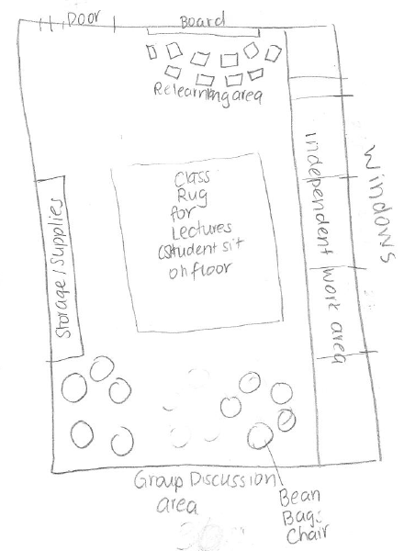

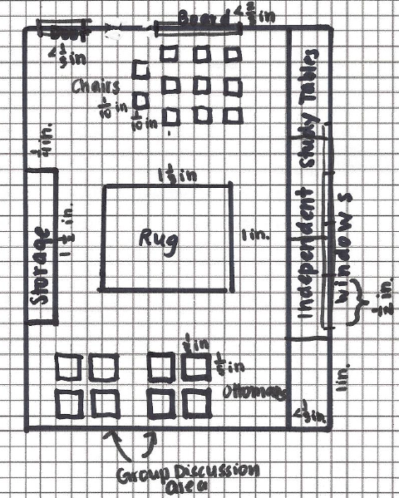

Area
 | Classroom | Chairs | Rug | Storage | Bean Bags | Independent Work Tables
Actual Area: | $$40×30=1200 \text{f}{\text{t}}^{\text{2}}$$ | $$1×1=1 \text{f}{\text{t}}^{\text{2}}$$ | $$13\frac{1}{3}×10=133\frac{1}{3} \text{f}{\text{t}}^{\text{2}}$$ | $$15×2.5=37.5 \text{f}{\text{t}}^{\text{2}}$$ | $$2×2=4\text{ f}{\text{t}}^{\text{2}}$$ | $$10×3=30 \text{f}{\text{t}}^{\text{2}}$$
Scale Drawing Area: | $$4×3=12 {\text{in}}^{\text{2}}$$ | $$\frac{1}{10}×\frac{1}{10}=\frac{1}{100} {\text{in}}^{\text{2}}$$ | $$1×1\frac{1}{3}=1\frac{1}{3} {\text{in}}^{\text{2}}$$ | $$1\frac{1}{2}×\frac{1}{4}=$$  $$\frac{3}{2}×\frac{1}{4}=\frac{3}{8} \text{i}{\text{n}}^{\text{2}}$$ | $$\frac{1}{5}×\frac{1}{5 }=\frac{1}{25} \text{i}{\text{n}}^{\text{2}}$$ | $$1×\frac{3}{10}=\frac{3}{10} {\text{in}}^{\text{2}}$$

Closing (3 minutes)
- Why are scale drawings used in construction and design projects?
  - Scale drawings can be used to rearrange furniture, find appropriate sizes for new items, and reconfigure room size and building size without having to refer back to the actual room or building being worked on.
- How can we double check our area calculations?
  - We can check to see if our calculations for area are equal to the number of boxes for each object on the graph paper.
- What were the biggest challenges you faced when creating your floor plan? How did you overcome these challenges?
  - It was challenging to select furniture and arrange it in a way that would fit the space.

Lesson Summary
Scale Drawing Process:
- Measure lengths and widths carefully with a ruler or tape measure. Record measurements in an organized table.
- Calculate the scale drawing lengths, widths, and areas using what was learned in previous lessons.
- Calculate the actual areas.
- Begin by drawing the perimeter, windows, and doorways.
- Continue to draw the pieces of furniture making note of placement of objects (distance from nearest wall).
- Check for reasonableness of measurements and calculations.

Exit Ticket (5 minutes)

Name ___________________________________________________ Date____________________
Lesson 20: An Exercise in Creating a Scale Drawing

Exit Ticket

- Your sister has just moved into a loft style apartment in Manhattan and has asked you to be her designer. Indicate the placement of the following objects on the floorplan using the appropriate scale: queen-size bed ($60$ in. by $80$ in.), sofa ($36$ in. by $64$ in.), and dining table ($48$ in. by $48$ in.). In the following scale drawing, $1$ cm represents $2$ ft. Each square on the grid is $1$ cm².
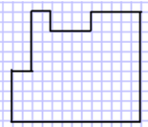

- Choose one object and explain the procedure to find the scale lengths.

Exit Ticket Sample Solutions

- Your sister has just moved into a loft style apartment in Manhattan and has asked you to be her designer. Indicate the placement of the following objects on the floorplan using the appropriate scale: queen-size bed ($60$ in. by $80$ in.), sofa ($36$ in. by $64$ in.), and dining table ($48$ in. by $48$ in.). In the following scale drawing, $1$ cm represents $2$ ft. Each square on the grid is $1$ cm².
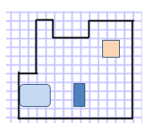
Queen Bed: $60÷12=5$, $5÷2=2\frac{1}{2}$ cm
$80÷12=6\frac{2}{3}$,$6\frac{2}{3}÷2=3\frac{1}{3}$ cm
Sofa: $36÷12=3$,$3÷2=1\frac{1}{2}$ cm
$64÷12=5\frac{1}{3}$,$5\frac{1}{3}÷2=2\frac{2}{3}$ cm

Dining Table: $48÷12=4$,$4÷2=2 cm$

- Choose one object and explain the procedure to find the scale lengths.
Take the actual measurements in inches and divide by $12$ inches to express the value in feet. Then divide the actual length in feet by $2$ since $2$ feet represents $1$ centimeter. The resulting quotient is the scale length.

Problem Set Sample Solutions

Interior Designer:
You won a spot on a famous interior designing TV show! The designers will work with you and your existing furniture to redesign a room of your choice. Your job is to create a top-view scale drawing of your room and the furniture within it.
- With the scale factor being $\frac{1}{24}$, create a scale drawing of your room or other favorite room in your home on a sheet of $8.5×11$ inch graph paper.
- Include the perimeter of the room, windows, doorways, and three or more furniture pieces (such as tables, desks, dressers, chairs, bed, sofa, ottoman, etc.).
- Use the table to record lengths and include calculations of areas.
- Make your furniture “moveable” by duplicating your scale drawing and cutting out the furniture.
- Create a “before” and “after” to help you decide how to rearrange your furniture. Take a photo of your “before.”
- What changed in your furniture plans?
- Why do you like the “after” better than the “before”?
Answers will vary.
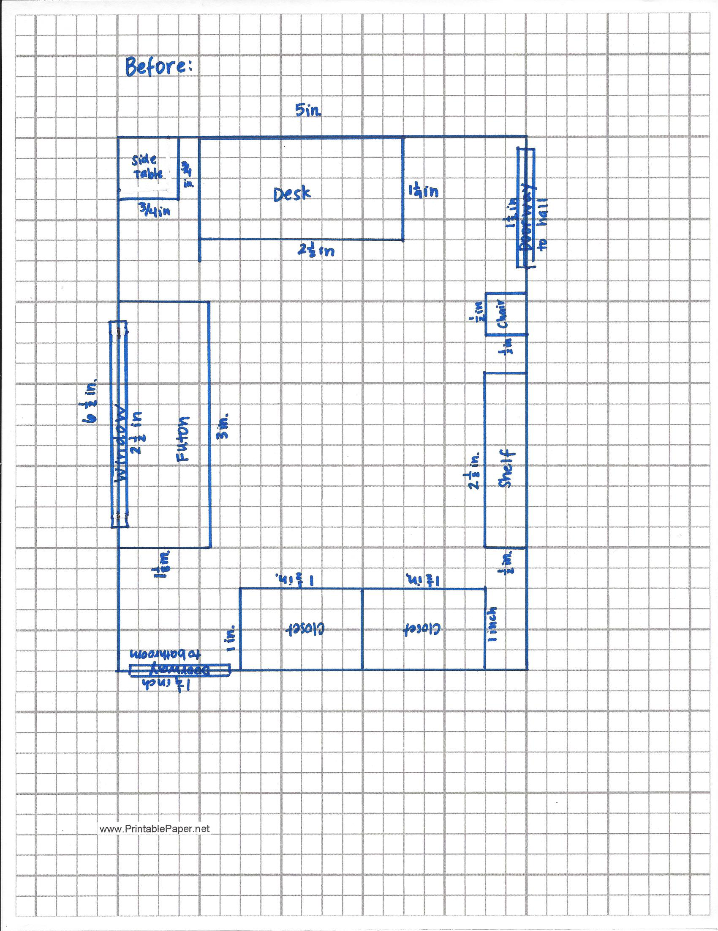

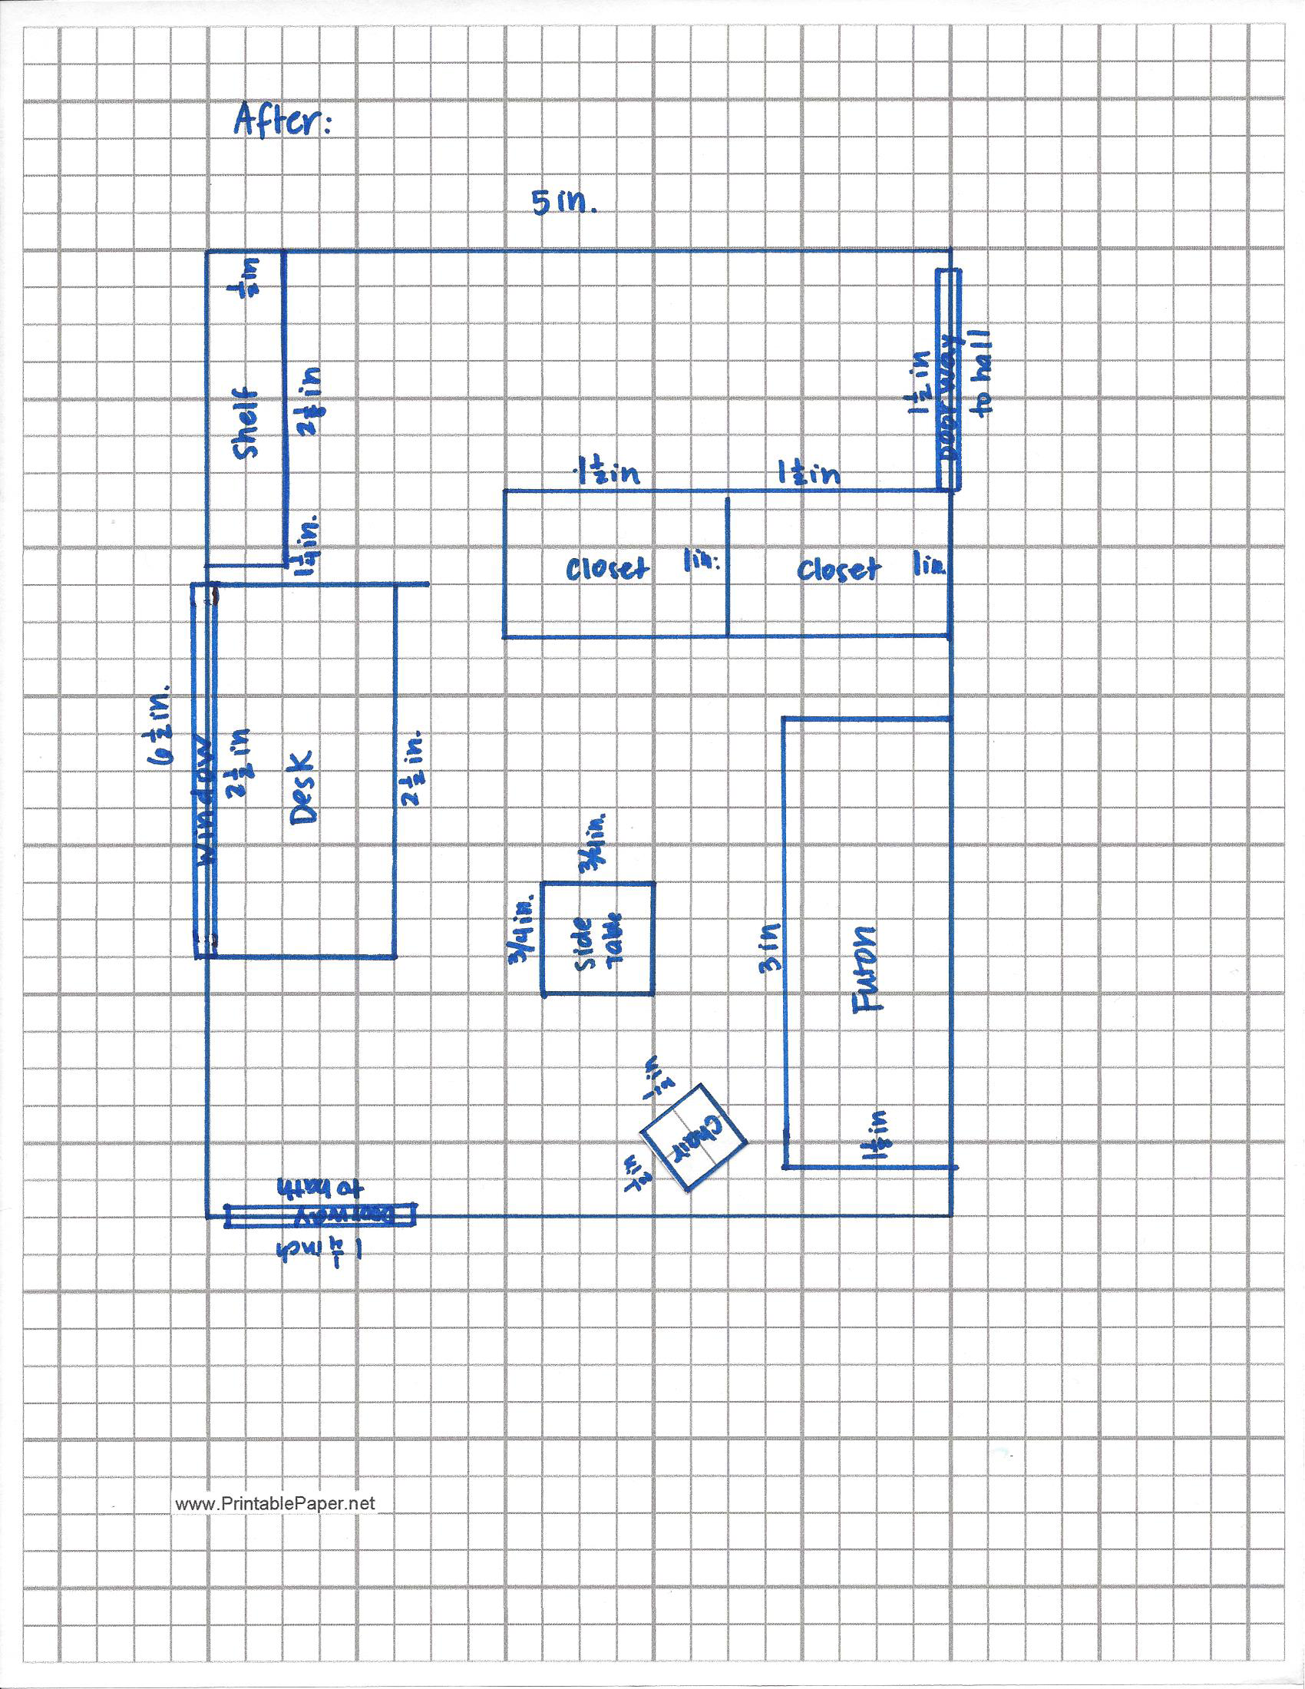

 | Entire Room | Windows | Doors | Desk/Tables | Seating | Storage | Bed | Shelf | Side Table
Actual Length: | $$10 \text{ft.}$$ | $$5 \text{ft.}$$ | $3$ft. | $5$ft. | $1$ft. | $3$ft. | $6$ft. | $$5 \frac{1}{4}\text{ft.}$$ | $$1 \frac{1}{2}\text{ft.}$$
Actual  Width: | $$13 \text{ft.}$$ | $$/$$ | $$/$$ | $$2 \frac{5}{12}\text{ft.}$$ | $1$ft. | $2$ft. | $$2 \frac{1}{4}\text{ft.}$$ | $1$ ft. | $$1 \frac{1}{2}\text{ft.}$$
Scale Drawing Length: | $$5 \text{in.}$$ | $$2\frac{1}{2}\text{in.}$$ | $$1 \frac{1}{2}\text{in.}$$ | $$2\frac{1}{2}\text{in.}$$ | $$\frac{1}{2}\text{in.}$$ | $$1\frac{1}{2}\text{in.}$$ | $$3 \text{in.}$$ | $$2 \frac{5}{8}\text{in.}$$ | $$\frac{3}{4}\text{in.}$$
Scale Drawing  Width: | $$6 \frac{1}{2}\text{in.}$$ | $$/$$ | $$/$$ | $$\sim 1\frac{1}{4}\text{in.}$$ | $$\frac{1}{2}\text{in.}$$ | $$1\text{ in.}$$ | $$1\frac{1}{8}\text{in.}$$ | $$\frac{1}{2}\text{in.}$$ | $$\frac{3}{4}\text{in.}$$
 | Entire Room Length | Desk/Tables | Seating | Storage | Bed | Shelf | Side Table
Actual Area: | $$10×13={\text{ft}}^{\text{2}}$$ | $$5×2\frac{5}{12}=$$  $$5×\frac{29}{12}=$$  $$\frac{145}{12}=12\frac{1}{12}{\text{ ft}}^{\text{2}}$$ | $$1×1=1 {\text{ft}}^{\text{2}}$$ | $$3×2=6 {\text{ft}}^{\text{2}}$$ | $$6×2\frac{1}{4}=$$  $$6×\frac{9}{4}=$$  $$\frac{27}{2}=13\frac{1}{2}{\text{ft}}^{\text{2}}$$ | $$5\frac{1}{4}×1=5\frac{1}{4}{\text{ft}}^{\text{2}}$$ | $$1\frac{1}{2}×1\frac{1}{2}=$$  $$\frac{3}{2}×\frac{3}{2}=\frac{9}{4}=2\frac{1}{4}{\text{ft}}^{\text{2}}$$
Scale Drawing Area: | $$5×6\frac{1}{2}=$$  $$5×\frac{13}{2}=$$  $$\frac{65}{2}=32\frac{1}{2}\text{i}{\text{n}}^{\text{2}}$$ | $$2\frac{1}{2}×1\frac{1}{4}=\frac{5}{2}×\frac{5}{4}=\frac{25}{8}=3\frac{1}{8} {\text{in}}^{\text{2}}$$ | $$\frac{1}{2}×\frac{1}{2}=\frac{1}{4}{\text{in}}^{\text{2}}$$ | 1$\frac{1}{2}×1=1\frac{1}{2}{\text{in}}^{\text{2}}$ | 3$×1\frac{1}{8}=3×\frac{9}{8}=\frac{27}{8}=3\frac{3}{8}{\text{in}}^{\text{2}}$ | $$2\frac{5}{8}×\frac{1}{2}=\frac{21}{8}×\frac{1}{2}=1\frac{5}{16}{\text{in}}^{\text{2}}$$ | $$\frac{3}{4}×\frac{3}{4}=\frac{9}{16}{\text{in}}^{\text{2}}$$

