Lesson 19: Computing Actual Areas from a Scale Drawing

Classwork
Examples: Exploring Area Relationships
Use the diagrams below to find the scale factor and then find the area of each figure.

Example 1
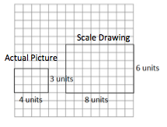

Scale factor: _________

Actual Area = ______________

Scale Drawing Area = ________________

Value of the Ratio of the Scale Drawing Area to the
Actual Area: _________

Example 2
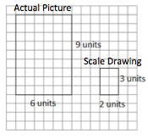
Scale factor: _________

Actual Area = ______________

Scale Drawing Area = ________________

Value of the Ratio of the Scale Drawing Area to the
Actual Area: _________

Example 3
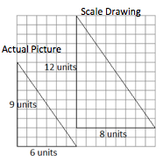

Scale factor: _________

Actual Area = ______________

Scale Drawing Area = ________________

Value of the Ratio of the Scale Drawing Area to the
Actual Area: _________

Results: What do you notice about the ratio of the areas in Examples 1–3? Complete the statements below.

When the scale factor of the sides was$2$, then the value of the ratio of the areas was _____________.
When the scale factor of the sides was $\frac{1}{3}$, then the value of the ratio of the areas was _____________.
When the scale factor of the sides was $\frac{4}{3}$, then the value of the ratio of the areas was _____________.
Based on these observations, what conclusion can you draw about scale factor and area?

If the scale factor of the sides is $r$, then the ratio of the areas is ___________________.

Example 4: They Said Yes!
The Student Government liked your half-court basketball plan. They have asked you to calculate the actual area of the court so that they can estimate the cost of the project.
Based on your drawing below, what will the area of the planned half-court be?

Scale Drawing: $1$ inch on the drawing corresponds to $15$ feet of actual length
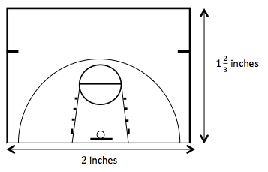

Does the actual area you found reflect the results we found from Examples 1–3? Explain how you know.

Exercises
- The triangle depicted by the drawing has an actual area of $36$ square units. What is the scale of the drawing? (Note: Each square on the grid has a length of $1$ unit.)

- Use the scale drawings of two different apartments to answer the questions. Use a ruler to measure.
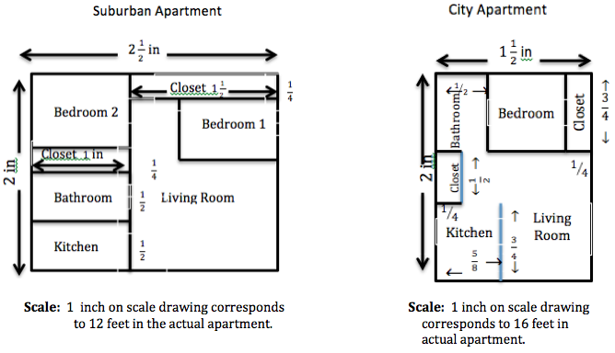

  - Find the scale drawing area for both apartments, and then use it to find the actual area of both apartments.

  - Which apartment has closets with more square footage? Justify your thinking.

  - Which apartment has the largest bathroom? Justify your thinking.

  - A one-year lease for the suburban apartment costs $\$750$ per month. A one-year lease for the city apartment costs$\$925$. Which apartment offers the greater value in terms of the cost per square foot?

Lesson Summary
Given the scale factor, $r$, representing the relationship between scale drawing length and actual length, the square of this scale factor, $r^{2}$, represents the relationship between the scale drawing area and the actual area.
For example, if $1$ inch on the scale drawing represents $4$ inches of actual length, then the scale factor, $r$, is $\frac{1}{4}$. On this same drawing, $1$ square inch of scale drawing area would represent $16$ square inches of actual area since $r^{2}$ is $\frac{1}{16}$.

Problem Set

- The shaded rectangle shown below is a scale drawing of a rectangle whose area is $288$ square feet. What is the scale factor of the drawing? (Note: Each square on grid has a length of $1$ unit.)

- A floor plan for a home is shown below where $\frac{1}{2}$ inch corresponds to $6$ feet of the actual home. Bedroom $2$ belongs to $13$-year old Kassie, and Bedroom $3$ belongs to $9$-year old Alexis. Kassie claims that her younger sister, Alexis, got the bigger bedroom, is she right? Explain.
Bedroom $1$
Bedroom $3$
Alexis
Bedroom $2$
Kassie
Bathroom

- On the mall floor plan, $\frac{1}{4}$ inch represents $3$ feet in the actual store.
  - Find the actual area of Store 1 and Store 2.
  - In the center of the atrium, there is a large circular water feature that has an area of $\left(\frac{9}{64}\right)π$ square inches on the drawing. Find the actual area in square feet.
Mall Entrance

Store 2
Store 1
To Atrium
and
Additional
Stores

- The greenhouse club is purchasing seed for the lawn in the school courtyard. The club needs to determine how much to buy. Unfortunately, the club meets after school, and students are unable to find a custodian to unlock the door. Anthony suggests they just use his school map to calculate the area that will need to be covered in seed. He measures the rectangular area on the map and finds the length to be $10$ inches and the width to be $6$ inches. The map notes the scale of $1$ inch representing $7$ feet in the actual courtyard. What is the actual area in square feet?

- The company installing the new in-ground pool in your backyard has provided you with the scale drawing shown below. If the drawing uses a scale of $1$ inch to $1\frac{3}{4}$ feet, calculate the total amount of two-dimensional space needed for the pool and its surrounding patio.

Swimming Pool and Patio Drawing

$11\frac{3}{7}$ in.

$22\frac{2}{7}$ in.

