Lesson 19: Computing Actual Areas from a Scale Drawing

Student Outcomes
- Students identify the scale factor.
- Given a scale drawing, students compute the area in the actual picture.

Classwork
Examples (13 minutes): Exploring Area Relationships
In this series of examples, students will identify the scale factor. Students can find the areas of the two figures and calculate the ratio of the areas. As students complete a few more examples, they can be guided to the understanding that the ratio of areas is the square of the scale factor.
Examples: Exploring Area Relationships
Use the diagrams below to find the scale factor and then find the area of each figure.
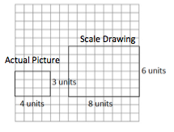
Example 1
Scale factor: $2$
Actual Area $=$ $12$ square units
Scale Drawing Area $=$ $48$ square units
Value of the Ratio of the Scale Drawing Area to the Actual Area:
$\frac{48}{12}=4$

Example 2
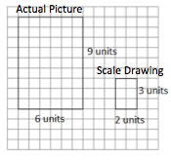
Scale factor: $\frac{1}{3}$
Actual Area $=$ $54$ square units
Scale Drawing Area $=$ $6$ square units
Value of the Ratio of the Scale Drawing Area to the Actual Area:
$\frac{6}{54}=\frac{1}{9}$

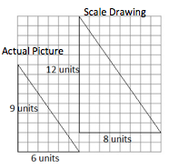
Example 3

Scale factor: $\frac{4}{3}$
Actual Area $=$ $27$ square units
Scale Drawing Area $=$ $48$ square units
Value of the Ratio of Scale Drawing Area to Actual Area:
$\frac{48}{27}=\frac{16}{9}$

Guide students through completing the results statements on the student materials.
Results: What do you notice about the ratio of the areas in Examples 1–3? Complete the statements below.
When the scale factor of the sides was $2$, then the value of the ratio of the areas was $4$ .
When the scale factor of the sides was $\frac{1}{3}$, then the value of the ratio of the areas was ____ $\frac{1}{9}$ ____.
When the scale factor of the sides was $\frac{4}{3}$, then the value of the ratio of the areas was ____ $\frac{16}{9}$____.
Based on these observations, what conclusion can you draw about scale factor and area?
The ratio of the areas is the scale factor multiplied by itself or squared.
If the scale factor is$r$, then the ratio of the areas is $r^{2}$ to $1$ .

- Why do you think this is? Why do you think it is squared (opposed to cubed or something else)?
  - When you are comparing areas, you are dealing with two dimensions instead of comparing one linear measurement to another.
- How might you use this information in working with scale drawings?
  - In working with scale drawings, you could take the scale factor, $r$, and calculate $r^{2}$ to determine the relationship between the area of the scale drawing and the area of the actual picture. Given a blueprint for a room, the scale drawing dimensions could be used to find the scale drawing area and could then be applied to determine the actual area. The actual dimensions would not be needed.
- Suppose a rectangle has an area of $12$ square meters. If the rectangle is enlarged by a scale factor of three, what is the area of the enlarged rectangle based on Examples 1–3? Look and think carefully!
  - If the scale factor is $3$, then the ratio of scale drawing area to actual area is $3^{2}$ to $1^{2}$ or $9$ to $1$. So, if its area is $12$ square meters before it is enlarged to scale, then the enlarged rectangle will have an area of $12•\left(\frac{9}{1}\right)$, or $12•9$, resulting in an area of $108$ square meters.

Example 4 (10 minutes): They Said Yes!
Complete Example 4 as a class, asking the guiding questions below. Have students use the space in their student materials to record calculations and work.
Give students time to answer the question, possibly choosing to apply what was discovered in Examples 1–3. Allow for discussion of approaches described below and for students to decide what method they prefer.
Example 4: They Said Yes!
The Student Government liked your half-court basketball plan. They have asked you to calculate the actual area of the court so that they can estimate the cost of the project.
Based on the drawing below, what will the area of the planned half-court be?
Scale Drawing: $1$ inch on the drawing corresponds to $15$ feet of actual length.
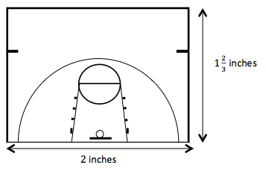

Method 1: Use the measurements we found in yesterday’s lesson to calculate the area of the half-court.
Actual area $=$ $25$ feet $×$ $30$ feet $=750$ square feet
MP.2
Method 2: Apply the newly discovered Ratio of Area relationship.
Note to teachers: This can be applied to the given scale with no unit conversions (shown on left) or to the scale factor (shown on right). Both options are included here as possible student work and would provide for a rich discussion of why they both work and what method is preferred. See guiding questions below.
Using Scale:  The Value of the Ratio of Areas: ${\left(\frac{15}{1}\right)}^{2}=225$  Scale Drawing Area $=2\text{ in.}×1\frac{2}{3} \text{in.}$  $$=\frac{10}{3} \text{square inches}$$  Let $x$ $=$ scale drawing area and let $y$ $=$ actual area  $$y=kx \\ y=225\left(\frac{10}{3}\right) \\ y=\frac{225}{1}⋅\frac{10}{3} \\ y=750 \text{square feet}$$ | Using Scale Factor:  The Value of the Ratio of Areas ${\left(\frac{180}{1}\right)}^{2}=32,400$  Scale Drawing Area $=$ $2 \text{in.}×1\frac{2}{3} \text{in.}$  $$=\frac{10}{3} \text{square inches}$$  Let $x$ = scale drawing area and let $y$ = actual area.  $$y = kx \\ y =32,400\left(\frac{10}{3}\right) \\ y=\frac{324,000}{3} \\ y=108,000$$  The actual area is $108,000$square inches,  or$\left(108,000\right)÷(144)$feet $=750$ square feet
Ask students to share how they found their answer. Use guiding questions to find all three options as noted above.
- What method do you prefer?
- Is there a time you would choose one method over the other?
  - If we don’t already know the actual dimensions, it might be faster to use Method 1 (ratio of areas). If we are re-carpeting a room based upon a scale drawing, we could just take the dimensions from the scale drawing, calculate area, and then apply the ratio of areas to find the actual amount of carpet we need to buy.
Guide students to complete the follow-up question in their student materials.
Does the actual area you found reflect the results we found from Examples 1–3? Explain how you know.
Yes, the scale of $1$ inch to $15$ feet has a scale factor of $180$, so the ratio of area should be ${\left(180\right)}^{2}$, or $32.400$
MP.2
The drawing area is $\left(2\right)\left(1\frac{2}{3}\right)$, or $\frac{10}{3}$ square inches.
The actual area is $25$ feet by $30$ feet, or $750$ square feet, or $108,000$ square inches.
The value of the ratio of the areas is $\frac{108,000}{\frac{10}{3}}$, or $\frac{324,000}{10}$, or $32,400$.

It would be more efficient to apply this understanding to the scale, eliminating the need to convert units.
Scaffolding:
What do you think the relationship is when considering three dimensions? For example, if the scale factor comparing length on a pair of cubes is $\frac{1}{3}$, what is the ratio of volumes for the same cubes?

If we use the scale of $\frac{15}{1}$, then the ratio of area is $\frac{225}{1}$.
The drawing area is $(2)(1\frac{2}{3})$, or $\frac{10}{3}$ square inches.
The actual area is$25$ feet by $30$ feet or $750$ square feet.
The ratio of area is $\frac{750}{\frac{10}{3}}$, $\frac{2250}{10}$, or $\frac{225}{1}$.
Exercises (15 minutes)
Allow time for students to answer independently then share results.
Exercises
- The triangle depicted by the drawing has an actual area of $36$ square units. What is the scale of the drawing? (Note: Each square on the grid has a length of $1$ unit.)
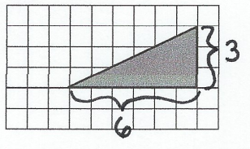

Scale Drawing Area: $\frac{1}{2}$ $∙ 6∙ 3=9$ square units. Ratio of Scale Drawing Area to Actual Area: $\frac{9}{36}$ $= r^{2}$
Therefore, $r$(scale factor) $=$ $\frac{3}{6}$ since $\frac{3}{6}∙\frac{3}{6}=\frac{9}{36}$. The scale factor is $\frac{1}{2}$. The scale is $1$ unit of drawing length represents$2$ units of actual length.
For Exercise 2, allow students time to measure the drawings of the apartments using a ruler and then compare measurements with a partner. Students then continue to complete parts (a)–(f) with a partner. Allow students time to share responses. Sample answers to questions are given below.
Scaffolding:
Guide students to choose measuring units based upon how the scale is stated. For example, since $1$ inch represents $12$ feet, it would make sense to measure the drawing in inches.

- Use the scale drawings of two different apartments to answer the questions. Use a ruler to measure.
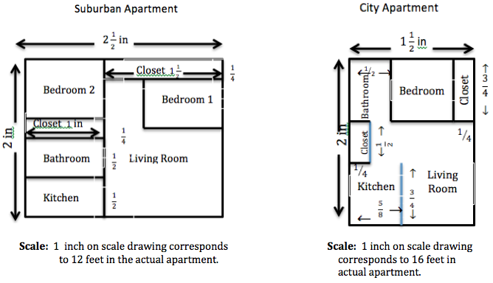

Scaffolding:
Since the given scale is different for each drawing, it is necessary that students compute the actual areas before comparing the areas in Exercise 2 parts (a)–(c).

  - Find the scale drawing area for both apartments, and then use it to find the actual area of both apartments.
 | Suburban | City
Scale Drawing Area | $$\left(2\frac{1}{2}\right)(2)$$  $=$ $5$ square inches | $$\left(2\right)\left(1\frac{1}{2}\right)$$  $=$ $3$ square inches
Actual Area | $$5(12^{2})$$  $5(144)=720$ square feet | $$3(16^{2})$$  $3(256)=768$ square feet

  - Which apartment has closets with more square footage? Justify your thinking.
 | Suburban | City
Scale Drawing Area | $$\left(1∙\frac{1}{4}\right)+\left(1\frac{1}{2}∙\frac{1}{4}\right)$$  $\frac{1}{4}+\frac{3}{8}=\frac{5}{8}$ square inches | $$\left(\frac{1}{4} ∙\frac{3}{4}\right)+\left(\frac{1}{2}∙\frac{1}{4}\right)$$  $\frac{3}{16}+\frac{1}{8}=\frac{5}{16}$ square inches
Actual Area | $\left(\frac{5}{8}\right)\left(144\right)=90$square feet | $\left(\frac{5}{16}\right)\left(256\right)=80$square feet
The suburban apartment has greater square footage in the closet floors.

  - Which apartment has the largest bathroom? Justify your thinking.
 | Suburban | City
Scale Drawing Area | $$\left(1∙\frac{1}{2}\right)$$  $=\frac{1}{2}$square inches | $$\left(\frac{3}{4}∙\frac{1}{2}\right)$$  = $\frac{3}{8}$ square inches
Actual Area | $$\left(\frac{1}{2}\right)\left(144\right)$$  $= 72$square feet | $$\left(\frac{3}{8}\right)\left(256\right)$$  $=96$square feet
The city apartment has the largest bathroom.
  - A one-year lease for the suburban apartment costs $\$750$ per month. A one-year lease for the city apartment costs $\$92$5. Which apartment offers the greater value in terms of the cost per square foot?
The suburban cost per square foot is $\frac{750}{720}$ or approximately $\$1.04$ per square foot. The city cost per square foot is $\frac{925}{768}$or approximately $\$1.20$ per square foot. The suburban apartment offers a greater value (cheaper cost per square foot), $\$1.04$ versus $\$1.20$.

Closing (2 minutes)
- When given a scale drawing, how do we go about finding the area of the actual object?
  - Method 1: Compute each actual length based upon the given scale and then use the actual dimensions to compute the actual area.
  - Method 2: Compute the area based upon the given scale drawing dimensions and then use the square of the scale to find actual area.
- Describe a situation where you might need to know the area of an object given a scale drawing or scale model.
  - A time where you might need to purchase materials that are priced per area, something that has a limited amount of floor space to take up, or when comparing two different blueprints
Lesson Summary
Given the scale factor, $r$, representing the relationship between scale drawing length and actual length, the square of this scale factor, $r^{2}$, represents the relationship between the scale drawing area and the actual area.
For example, if $1$ inch on the scale drawing represents $4$inches of actual length, then the scale factor,$r$, is $\frac{1}{4}$. On this same drawing, $1$ square inch of scale drawing area would represent $16$ square inches of actual area since $r^{2}$ is $\frac{1}{16}$.

Scaffolding:
Extension to Exit Ticket: Ask students to show multiple methods for finding the area of the dining room.
Exit Ticket (5 minutes)

Name ___________________________________________________ Date____________________
Lesson 19: Computing Actual Areas from a Scale Drawing

Exit Ticket

A $1$-inch length in the scale drawing below corresponds to a length of $12$ feet in the actual room.
$1$ in.

$\frac{3}{4}$ in.
Kitchen

$1\frac{1}{2}$in.

Dining Room

$1\frac{1}{2}$ in.

- Describe how the scale or the scale factor can be used to determine the area of the actual dining room.

- Find the actual area of the dining room.

- Can a rectangular table that is $7$ft. long and $4$ ft. wide fit into the narrower section of the dining room? Explain your answer.

Exit Ticket Sample Solutions

A $1$ inch length in the scale drawing below corresponds to a length of $12$feet in the actual room.
Dining Room
Kitchen
$1\frac{1}{2}$ in.
$1\frac{1}{2}$ in.
$\frac{3}{4}$ in.
$1$ in.

- Describe how the scale or the scale factor can be used to determine the area of the actual dining room.
The scale drawing will need to be enlarged to get the area or dimensions of the actual dining room. Calculate the area of the scale drawing, and then multiply by the square of the scale (or scale factor) to determine the actual area.

- Find the actual area of the dining room.
Scale drawing area of dining room: $\left(1\frac{1}{2} \text{by} \frac{3}{4}\right) +\left( \frac{3}{4} \text{by }\frac{1}{2}\right)$, or $\frac{12}{8}$ square inches
Actual area of the dining room: $\frac{12}{8}×144$ $=216$ square feet
Or similar work completing conversions and using scale factor

- Can a rectangular table that is $7$ft. long and$4$ft. wide fit into the narrower section of the dining room? Explain your answer.
The narrower section of dining room measures $\frac{3}{4}$ by $\frac{1}{2}$ in the drawing or $9$ feet by $6$ feet in the actual room. Yes, the table will fit; however, it will only allow for $1$ additional foot around all sides of the table for movement or chairs.

Problem Set Sample Solutions

- The shaded rectangle shown below is a scale drawing of a rectangle whose area is $288$ square feet. What is the scale factor of the drawing? (Note: Each square on the grid has a length of $1$ unit.)

The scale factor is $\frac{1}{3}$.

- A floor plan for a home is shown below where $\frac{1}{2}$ inch corresponds to $6$ feet of the actual home. Bedroom $2$ belongs to $13$-year old Kassie, and Bedroom $3$ belongs to $9$-year old Alexis. Kassie claims that her younger sister, Alexis, got the bigger bedroom, is she right? Explain.
$1\frac{1}{4}$ in.

$\frac{3}{4}$ in.
Bedroom $2$
Kassie
Bathroom
Bedroom $1$

Bedroom$3$
Alexis
$1$ in.

$1$ in.

Bedroom $2$ (Kassie) has an area of $135$ sq. ft., and Bedroom $3$ (Alexis) has an area of $144$ sq. ft. Therefore, the older sister is correct. Alexis got the bigger bedroom by a difference of $9$ square feet.

- On the mall floor plan, $\frac{1}{4}$ inch represents$3$ feet in the actual store.
To Atrium
and
Additional
Stores
Store 1
Store 2
Mall Entrance

  - Find the actual area of Store 1 and Store 2.
The dimensions of Store 1 measure $1\frac{7}{16}$inches by $1\frac{13}{16}$ inches. The actual measurements would be $17\frac{1}{4}$ feet by $21\frac{3}{4}$ feet. Store 1 has an area of $375$ $\frac{3}{16}$ square feet. The dimensions of Store 2 measure $1\frac{3}{16}$ inches by $1\frac{13}{16}$ inches. The actual measurements would be $14\frac{1}{4}$ feet by $21\frac{3}{4}$ feet. Store 2 has an area of $309$ $\frac{15}{16}$ square feet.

  - In the center of the atrium, there is a large circular water feature that has an area of $(\frac{9}{64})π$ square inches on the drawing. Find the actual area in square feet.
The water feature has an area of $\left(\frac{9}{64}\right)π•144$, or $\left(\frac{81}{4}\right)π$ square feet, approximately $63.6$ square feet.

- The greenhouse club is purchasing seed for the lawn in the school courtyard. The club needs to determine how much to buy. Unfortunately, the club meets after school, and students are unable to find a custodian to unlock the door. Anthony suggests they just use his school map to calculate the area that will need to be covered in seed. He measures the rectangular area on the map and finds the length to be $10$ inches and the width to be $6$ inches. The map notes the scale of $1$ inch representing $7$ feet in the actual courtyard. What is the actual area in square feet?
$70×42=2940$sq. ft.

- The company installing the new in-ground pool in your backyard has provided you with the scale drawing shown below. If the drawing uses a scale of $1$ inch to $1\frac{3}{4}$ feet, calculate the total amount of two-dimensional space needed for the pool and its surrounding patio.
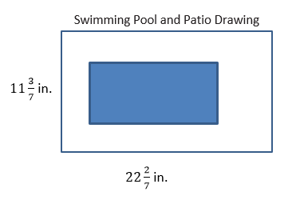
Area $=$ $780$square feet

