Lesson 17: The Unit Rate as the Scale Factor

Classwork
Example 1: Jake’s Icon
Jake created a simple game on his computer and shared it with his friends to play. They were instantly hooked, and the popularity of his game spread so quickly that Jake wanted to create a distinctive icon so that players could easily identify his game. He drew a simple sketch. From the sketch, he created stickers to promote his game, but Jake wasn’t quite sure if the stickers were proportional to his original sketch.
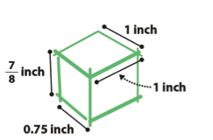
Original Sketch: Sticker:
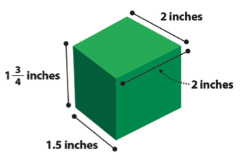

Key Idea:
The scale factor can be calculated from the ratio of any length in the scale drawing to its corresponding length in the actual picture. The scale factor corresponds to the unit rate and the constant of proportionality.
Scaling by factors greater than $1$ enlarge the segment, and scaling by factors less than $1$, reduce the segment.

Steps to check for proportionality for scale drawing and original object or picture:

Exercise 1: App Icon
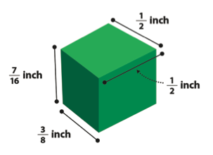

Example 2
Use a Scale Factor of $3$ to create a scale drawing of the picture below.
Picture of the flag of Colombia:

Exercise 2
Scale Factor = __________________________ Picture of the flag of Colombia:
Sketch and notes:

Example 3
Your family recently had a family portrait taken. Your aunt asks you to take a picture of the portrait using your phone and send it to her. If the original portrait is $3$ feet by $3$ feet, and the scale factor is $\frac{1}{18}$, draw the scale drawing that would be the size of the portrait on your phone.
Sketch and notes:

Exercise 3
John is building his daughter a doll house that is a miniature model of their house. The front of their house has a circular window with a diameter of $5$ feet. If the scale factor for the model house is $\frac{1}{30}$, make a sketch of the circular doll house window.

Problem Set

- Giovanni went to Los Angeles, California for the summer to visit his cousins. He used a map of bus routes to get from the airport to his cousin’s house. The distance from the airport to his cousin’s house is $56$ km. On his map, the distance is $4$ cm. What is the scale factor?

- Nicole is running for school president. Her best friend designed her campaign poster, which measured $3$ feet by $2$ feet. Nicole liked the poster so much, she reproduced the artwork on rectangular buttons that measured $2$ inches by$1\frac{1}{3}$ inches. What is the scale factor?

- Find the scale factor using the given scale drawings and measurements below.
Scale Factor: _________________________
Actual Picture Scale Drawing

$3$ cm
$5$ cm

- Find the scale factor using the given scale drawings and measurements below.
Scale Factor: _________________________
Actual Picture Scale Drawing
24 cm
6 cm

- Using the given scale factor, create a scale drawing from the actual pictures in centimeters:
  - Scale factor: $3$

$1$ in.

  - Scale factor: $\frac{3}{4}$

- Hayden likes building radio-controlled sailboats with her father. One of the sails, shaped like a right triangle, has side lengths measuring $6$ inches, $8$ inches and $10$ inches. To log her activity, Hayden creates and collects drawings of all the boats she and her father built together. Using the scale factor of $\frac{1}{4}$, create a scale drawing of the sail.

