Lesson 16: Relating Scale Drawings to Ratios and Rates

Classwork
Opening Exercise: Can You Guess the Image?
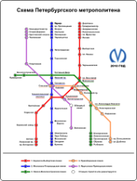
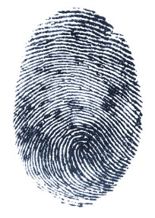
- 2.

Example 1
For the following problems, (a) is the actual picture and (b) is the drawing. Is the drawing an enlargement or a reduction of the actual picture?
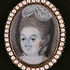
- a. b. 2. a.

b.

Scale Drawing: a reduced or enlarged two-dimensional drawing of an original two-dimensional drawing.
Example 2
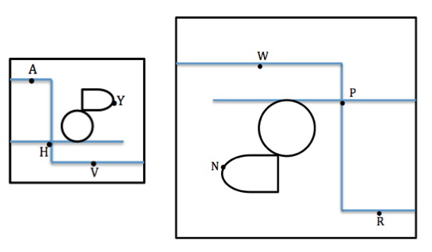
Derek’s family took a day trip to a modern public garden. Derek looked at his map of the park that was a reduction of the map located at the garden entrance. The dots represent the placement of rare plants. The diagram below is the top-view as Derek held his map while looking at the posted map.

What are the corresponding points of the scale drawings of the maps?

Point $A$ to _________ Point $V$ to ____________ Point $H$ to ____________ Point $Y$ to ____________

Exploratory Challenge
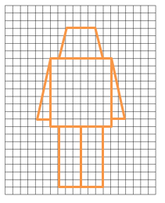
Create scale drawings of your own modern nesting robots using the grids provided.

Example 3
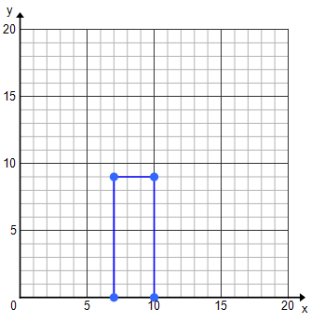
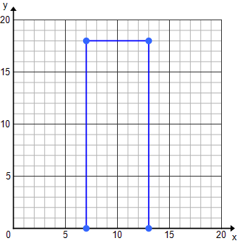
Celeste drew an outline of a building for a diagram she was making and then drew a second one mimicking her original drawing. State the coordinates of the vertices and fill in the table.
 | Height | Length
Original Drawing
Second Drawing

Notes:

Exercise
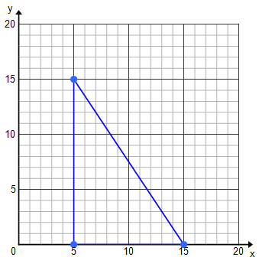
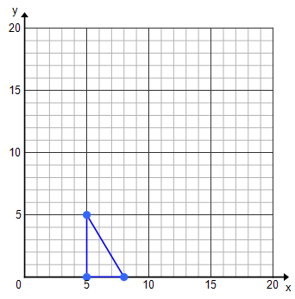
Luca drew and cut out a small right triangle for a mosaic piece he was creating for art class. His mother really took a liking to the mosaic piece and asked if he could create a larger one for their living room. Luca made a second template for his triangle pieces.

 | Height | Width
Original Image
Second Image

- Does a constant of proportionality exist? If so, what is it? If not, explain.

- Is Luca’s enlarged mosaic a scale drawing of the first image? Explain why or why not.

Problem Set
Lesson Summary
Scale Drawing: A drawing in which all lengths between points or figures in the drawing are reduced or enlarged proportional to the lengths in the actual picture. A constant of proportionality exists between corresponding lengths of the two images.
Reduction: The lengths in the scale drawing are smaller than those in the actual object or picture.
Enlargement/Magnification: The lengths in the scale drawing are larger than those in the actual object or picture.
One-to-One Correspondence: Each point in one figure corresponds to one and only one point in the second figure.

figures in the plane, and , are said to be in one-to-one correspondence if there

is a pairing between the points in and the points so that, each point of is

paired with one and only one point in and, likewise, each point in is paired

For Problems 1–3, identify if the scale drawing is a reduction or an enlargement of the actual picture.
- ___________________________
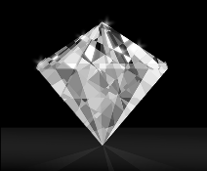
  - Actual Picture b. Scale Drawing
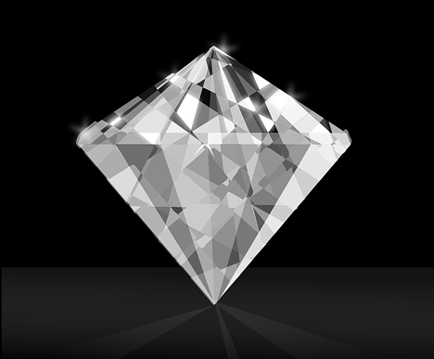

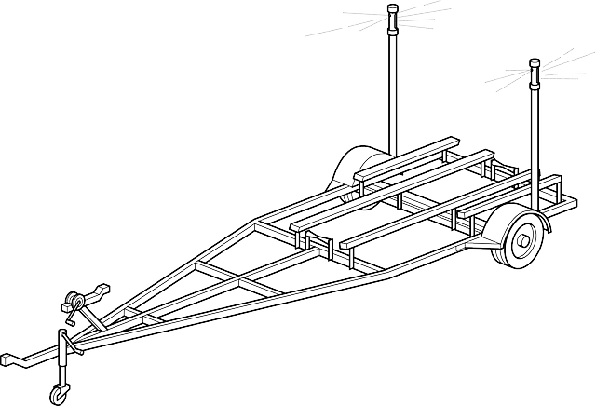
- ____________________________
- Actual Picture

- Scale Drawing

- __________________________
  - Actual Picture b. Scale Drawing
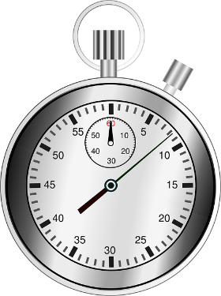
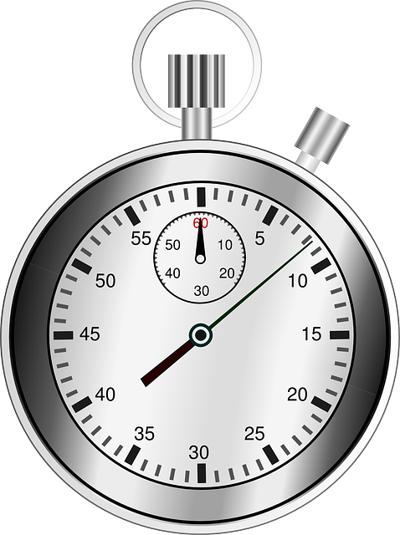

- Using the grid and the abstract picture of a face, answer the following questions:
 | $$A$$ | $$B$$ | $$C$$ | $$D$$
$$F$$
$G$
$$H$$
$$I$$

  - On the grid, where is the eye?
  - What is located in $DH$?
  - In what part of the square $BI$ is the chin located?

- Use the blank graph provided to plot the points and decide if the rectangular cakes are scale drawings of each other.
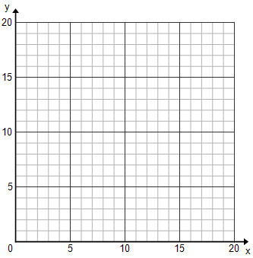
Cake 1: $(5,3)$,$(5,5)$,$(11,3)$, $(11, 5)$
Cake 2: $(1,6)$, $(1, 12)$,$(13,12)$, $(13, 6)$
How do you know?

