Opening Exercise
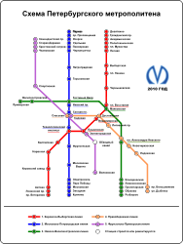
Can you guess the image? In each problem, the first image is from the student materials and the second image is the actual picture.

