Lesson 15: Equations of Graphs of Proportional Relationships Involving Fractions

Classwork
Example 1: Mother’s 10K Race
Sam’s mother has entered a $10$K race. Sam and his family want to show their support of their mother, but they need to figure out where they should go along the race course. They also need to determine how long it will take her to run the race so that they will know when to meet her at the finish line. Previously, his mother ran a $5$K race with a time of $1\frac{1}{2}$ hours. Assume Sam’s mother ran the same rate as the previous race in order to complete the chart.
Create a table that will show how far Sam’s mother has run after each half hour from the start of the race, and graph it on the coordinate plane to the right.
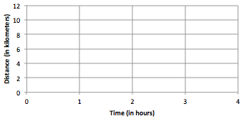
Mother’s 10K Race
Time  ($H$, in hours) | Distance Run ($D$, in km)

- What are some specific things you notice about this graph?

- What is the connection between the table and the graph?

- What does the ordered pair $\left(2, 6\frac{2}{3}\right)$ represent in the context of this problem?

Example 2: Gourmet Cooking
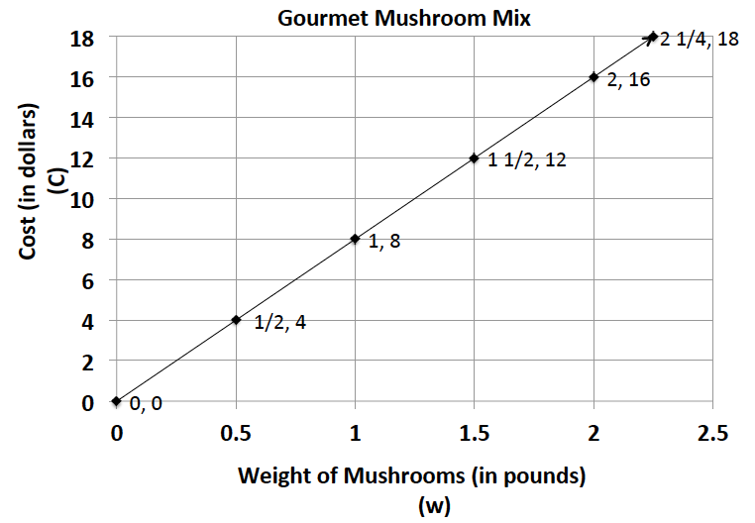
After taking a cooking class, you decide to try out your new cooking skills by preparing a meal for your family. You have chosen a recipe that uses gourmet mushrooms as the main ingredient. Using the graph below, complete the table of values and answer the following questions.
Weight  (in pounds) | Cost  (in dollars)
$$0$$ | $$0$$
$$\frac{1}{2}$$ | $$4$$
$$1$$
$$1\frac{1}{2}$$ | $$12$$
 | $$16$$
$$2 \frac{1}{4}$$ | $$18$$

  - Is this relationship proportional? How do you know from examining the graph?

  - What is the unit rate for cost per pound?

  - Write an equation to model this data.

  - What ordered pair represents the unit rate, and what does it mean?

  - What does the ordered pair $(2, 16)$ mean in the context of this problem?

  - If you could spend $\$10.00$ on mushrooms, how many pounds could you buy?

  - What would be the cost of $30$ pounds of mushrooms?
Lesson Summary
Proportional relationships can be represented through the use of graphs, tables, equations, diagrams, and verbal descriptions.
In a proportional relationship arising from ratios and rates involving fractions, the graph gives a visual display of all values of the proportional relationship, especially the quantities that fall between integer values.

Problem Set

- Students are responsible for providing snacks and drinks for the Junior Beta Club Induction Reception. Susan and Myra were asked to provide the punch for the $100$ students and family members who will attend the event. The chart below will help Susan and Myra determine the proportion of cranberry juice to sparkling water that will be needed to make the punch. Complete the chart, graph the data, and write the equation that models this proportional relationship.
Sparkling Water ($S$, in cups) | Cranberry Juice ($C$, in cups)
$$1$$ | $$\frac{4}{5}$$
$$5$$ | $$4$$
$$8$$
$$12$$ | $$9\frac{3}{5}$$
 | $$40$$
$$100$$

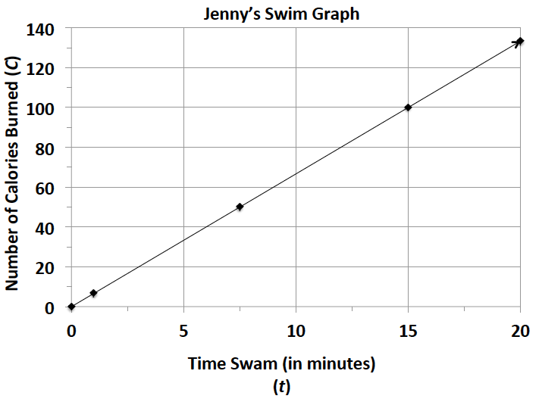
- Jenny is a member of a summer swim team.
  - Using the graph, determine how many calories she burns in one minute.
  - Use the graph to determine the equation that models the number of calories Jenny burns within a certain number of minutes.
  - How long will it take her to burn off a $480$-calorie smoothie that she had for breakfast?

- Students in a world geography class want to determine the distances between cities in Europe. The map gives all distances in kilometers. The students want to determine the number of miles between towns so that they can compare distances with a unit of measure with which they are already familiar. The graph below shows the relationship between a given number of kilometers and the corresponding number of miles.
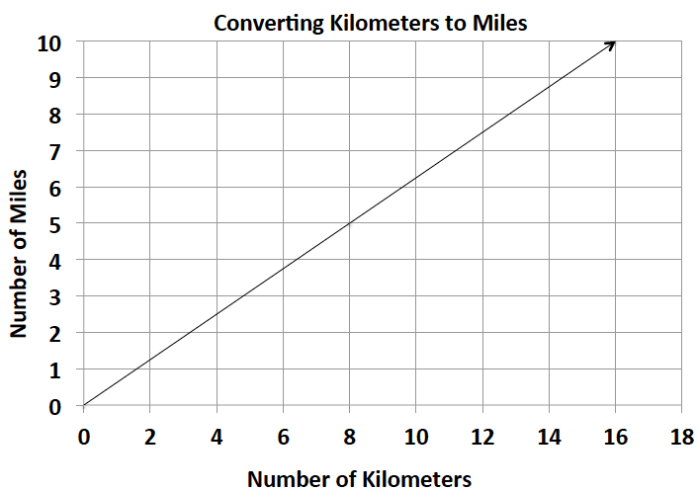

  - Find the constant of proportionality or the rate of miles per kilometer for this problem and write the equation that models this relationship.
  - What is the distance in kilometers between towns that are $5$ miles apart?
  - Describe the steps you would take to determine the distance in miles between two towns that are $200$ kilometers apart?

- During summer vacation, Lydie spent time with her grandmother picking blackberries. They decided to make blackberry jam for their family. Her grandmother said that you must cook the berries until they become juice and then combine the juice with the other ingredients to make the jam.
  - Use the table below to determine the constant of proportionality of cups of juice to cups of blackberries.
Cups of Blackberries | Cups of Juice
$$0$$ | $$0$$
$$4$$ | $$1 \frac{1}{3}$$
$$8$$ | $$2 \frac{2}{3}$$
$$12$$
 | $$8$$

  - Write an equation that will model the relationship between the number of cups of blackberries and the number of cups of juice.
  - How many cups of juice were made from $12$ cups of berries? How many cups of berries are needed to make $8$ cups of juice?

